Министерство образования и науки РФ

федеральное государственное бюджетное образовательное учреждение высшего образования

«Омский государственный технический университет»

|  |  |  |  |
| --- | --- | --- | --- |
| Факультет | | | *Информационных технологий и компьютерных систем* |
|  | | |  |
| Кафедра | *Информатики и вычислительной техники* | | |
|  | |  | |
| Дисциплина | | ***Программирование*** | |

**ЗАДАНИЕ**

**на выполнение курсового проекта**

|  |  |  |  |  |
| --- | --- | --- | --- | --- |
| Студенту (ке) | Шкаброву Даниле Андреевичу | | Группа | **ПИ-** |
|  | фамилия, имя, отчество полностью | |  | 182 |
|  |  | |  |  |
| Направление (специальность) | | *09.03.03 – Прикладная информатика* | | |
|  | | код, наименование | | |

|  |  |
| --- | --- |
| Тема проекта | Разработка электронной записной книжки и программы-игры |
|  |  |

|  |  |  |  |  |  |
| --- | --- | --- | --- | --- | --- |
| Срок сдачи проекта (работы) на кафедру | « 25 » 05 |  | 20 | 19 | г. |

|  |  |
| --- | --- |
| Исходные данные к проекту (работе) | Разработка электронной «Записной книжки» |
| с возможностью поиска данных и программы-игры «Покер» | |
|  | |

|  |
| --- |
| Содержание пояснительной записки (перечень подлежащих разработке вопросов) |
| ***Введение. 1. Постановка задач на проектирование. 2. Методика решения. 3. Разработка алгоритмов. 4. Особенности разработки программы. 5. Инструкция пользователя. 6. Результаты тестирования. Приложение (текст программы)*** |

|  |  |  |  |  |  |  |  |  |  |  |  |  |  |  |  |  |  |  |  |  |  |
| --- | --- | --- | --- | --- | --- | --- | --- | --- | --- | --- | --- | --- | --- | --- | --- | --- | --- | --- | --- | --- | --- |
| Перечень графического материала с указанием основных чертежей | | | | | | | | | | | | | | | | | | | | | |
| и (или) иллюстративного материала | | | | | | | ***Укрупненная схема алгоритма,*** | | | | | | | | | | | | | |
| ***схемы алгоритмов для функции*** | | | | | | | | | | | | | | | | | | | | |
| Методическая литература и иные информационные источники | | | | | | | | | | | | | |  | | | | | | |
| 1. *Павловская, Т. А. С/С++. Программирование на языке высокого уровня / Т. А. Павловская. – СПб.: Питер, 2012. – 544с.* | | | | | | | | | | | | | | | | | | | | |
| 1. *Восходящее и нисходящее программирование: метод. указания / ОмГТУ ; сост. О. П. Шафеева.– Омск : Изд-во ОмГТУ, 2015. – 1 эл. опт. диск (CD-ROM).* 2. *Программирование на языке Си: Метод. указания / Сост. О. П. Шафеева, Ю.Г. Каворина, Шукурова Г.С.: Изд-во ОмГТУ, 2008. – 72 с.* 3. *Системы программирования: Метод. указания / Сост. О.П. Шафеева, И.А. Волчкова, С.А.Гончаров. − Омск: ОмГТУ, 2012. – 32 с.* 4. *Шафеева, О.П. Технологии программирования. С++. Учебное пособие. – Омск, Изд-во ОмГТУ. 2007. – 80 с.* | | | | | | | | | | | | | | | | | | | | |
|  | | | | | | | | | | | | | | | | | | | | |
| Дата выдачи задания | « | *5* | | | » | *февраля* | | | | 20 | | 19 | г. | | | | | | | | | | |
| |  |  |  |  |  |  | | --- | --- | --- | --- | --- | --- | | Руководитель |  |  | *К.т.н., доцент Шафеева О.П.* |  |  | |  | подпись |  | ученая степень, звание, ФИО |  | дата | | Зав. кафедрой |  |  | *Д.т.н., профессор Потапов В.И.* |  |  | |  | подпись |  | ученая степень, звание, ФИО |  | дата | | | | | | | | | | | | | | | | | | | | | | | | | |
| Задание принял к  исполнению студент (ка) | | |  | | | | |  | | | **« 5** » 02 | | | |  | 20 | 19 | г. |
|  | | | | подпись | | | | |  | | | | | |  |  | | |  |  | | |

Министерство образования и науки РФ

федеральное государственное бюджетное образовательное учреждение высшего образования

«Омский государственный технический университет»

|  |  |
| --- | --- |
| Факультет (институт) | *Информационных технологий и компьютерных систем* |
|  |  |
| Кафедра | *Информатики и вычислительной техники* |
|  |  |

**КУРСОВОЙ ПРОЕКТ**

|  |  |
| --- | --- |
| по дисциплине | ***Программирование*** |
|  |  |
| на тему | Разработка электронной записной книжки и программы-игры |

**Пояснительная записка**

|  |  |
| --- | --- |
| Шифр проекта | **020-КП-09.03.03-28-ПЗ** |

|  |  |  |  |  |  |  |  |  |  |  |  |  |  |
| --- | --- | --- | --- | --- | --- | --- | --- | --- | --- | --- | --- | --- | --- |
|  |  |  | Студента (ки) | | | | **Шкаброва Данилы Андреевича** | | | | | | |
|  |  |  |  | | | | фамилия, имя, отчество полностью | | | | | | |
|  |  |  | Курс | ***1*** |  | | | Группа | | **ПИ-182** | | |  |
|  |  |  |  |  | |  | | |  |  | | |  |
|  |  |  | Направление (специальность) | | | | | | | *09.03.03 –* | | | |
|  |  |  | *Прикладная информатика* | | | | | | | | | | |
|  |  |  | код, наименование | | | | | | | | | | |
|  |  |  | Руководитель | | | | *к.т.н., доцент* | | | | | | |
|  |  |  |  | | | | ученая степень, звание | | | | | | |
|  |  |  | *Шафеева О.П.* | | | | | | | | | | |
|  |  |  | фамилия, инициалы | | | | | | | | | | |
|  |  |  | Выполнил (а) | | | |  | | | | | | |
|  |  |  |  | | | | дата, подпись студента (ки) | | | | | | |
|  |  |  | К защите | | | |  | | | | | | |
|  |  |  |  | | | | дата, подпись руководителя | | | | | | |
|  |  |  | Выполнение и подготовка к защите КП (КР) | | | | | Защита КП (КР) | | | | Итоговый рейтинг | |
|  |  |  |  | | | | |  | | | |  | |
|  |  |  | Проект (работа) защищен (а) с оценкой | | | | | | | |  | | |

Омск 2019

Министерство образования и науки РФ

федеральное государственное бюджетное образовательное учреждение высшего образования

«Омский государственный технический университет»

**ОТЗЫВ**

**на курсовой проект (работу)**

|  |  |  |  |  |  |  |  |  |  |  |  |  |  |  |  |  |  |
| --- | --- | --- | --- | --- | --- | --- | --- | --- | --- | --- | --- | --- | --- | --- | --- | --- | --- |
| Факультет | | | | | | | *Информационных технологий и компьютерных систем* | | | | | | | | | | |
|  | | | | | | |  | | | | | | | | | | |
| Кафедра | | | *Информатики и вычислительной техники* | | | | | | | | | | | | | | |
|  | | |  | | | | | | | | | | | | | | |
| Дисциплина | | | | ***Программирование*** | | | | | | | | | | | | | |
|  | | | |  | | | | | | | | | | | | | |
| Тема | **Разработка электронной записной книжки и программы-игры** | | | | | | | | | | | | | | | | |
|  | |  | | | | | | | | | | | | | | | |
| Студент | | | **Шкабров Данила Андреевич** | | | | | | | | | | | | | | |
|  | | | фамилия, имя, отчество полностью | | | | | | | | | | | | | | |
| Курс | ***1*** | | | | Группа | | | **ПИ-**182 |  | | | | | | | | |
|  | |  | | |  | | |  |  | | | | | | | | |
| Руководитель | | | | | *к.т.н., доцент Шафеева О.П.* | | | | | | | | | | | | |
|  | | | | | ученая степень, звание, ФИО | | | | | | | | | | | | |
|  | | | | | | | | | | | | | | | | | |
| **Содержание отзыва** | | | | | | | | | | | | | | | | | |
| Спроектирована укрупненная схема алгоритма для проекта реализации | | | | | | | | | | | | | | | | | |
| базы данных «Записная книжка» и звуковой мультипликационной игры | | | | | | | | | | | | | | | | | |
| «Покер» | | | | | | | | | | | | | | | | | |
| Детализированы и разработаны схемы алгоритмов для отдельных функций и | | | | | | | | | | | | | | | | | |
| подзадач. Разработана и отлажена программа, реализующая следующие | | | | | | | | | | | | | | | | | |
| подзадачи: | | | | | | | | | | | | | | | | | |
| - Покер | | | | | | | | | | | | | | | | | |
| - Анимация | | | | | | | | | | | | | | | | | |
| - Меню (графическое, текстовое, в несколько уровней); | | | | | | | | | | | | | | | | | |
| - База данных; | | | | | | | | | | | | | | | | | |
| - Информация об авторе; | | | | | | | | | | | | | | | | | |
| - Тестирование готового программного продукта; | | | | | | | | | | | | | | | | | |
| Оформлена пояснительная записка. | | | | | | | | | | | | | | | | | |
|  | | | | | | | | | | | | | | | | | |
| **Рейтинговые баллы за выполнение и подготовку к защите курсового проекта (работы)** | | | | | | | | | | | | |  | | | |
| **Заключение о допуске к защите** | | | | | | | | | |  | | | | | | |
|  | | | | | | | | | | | | | | | | | |
| **Руководитель** | | | | | |  | | | | | Дата | « » | | 20 |  | г. | |
|  | | | | | | подпись | | | | |  |  | |  |  |  | |

# Аннотация

К курсовому проекту на тему: «Разработка электронной записной книжки и программы-игры».

Пояснительная записка к курсовому проекту содержит 241 с., 64 рис.

Составлена укрупнённая схема алгоритма для проекта составления электронной записной книжки и программы-игры «Покер». Детализированы и разработаны схемы алгоритмов для отдельных функций и подзадач. Разработана и отлажена программа, реализующая следующие подзадачи:

* информация об авторе;
* электронная записная книжка;
* Программа-игра «Покер»;
* графическая заставка;
* тестирование готового программного продукта.

Ключевые слова: С\С++, электронная база данных, игровая программа, анимация, справочник.

# 

Оглавление

1. Введение 4

2. Анализ задания и постановка задач на проектирование 5

3. Разработка алгоритмов 7

3.1. Разработка схемы алгоритма функции «main» 7

3.2. Разработка схемы алгоритма меню 7

3.3. Разработка схемы алгоритма база данных «Записная книжка» 9

3.3.1. Разработка схемы алгоритма меню базы данных 10

3.3.2. Разработка схемы алгоритма удаления из базы данных 11

3.3.3. Разработка схемы алгоритма вывода всей информации 12

3.3.4. Разработка схемы алгоритма для поиска человека 13

3.3.5. Разработка схемы алгоритма добавления в базу данных 14

3.3.6. Разработка схемы алгоритма сохранения информации 15

3.4. Разработка схемы алгоритма об авторе 16

3.5. Разработка схемы алгоритма анимация 17

3.6. Разработка схемы алгоритма главной функции покера 18

3.6.1. Разработка схемы алгоритма событий окна 19

3.6.2. Разработка схемы алгоритма события нажатия левой кнопкой мыши по окну 19

3.6.3. Разработка схемы алгоритма события нажатие крестика 21

3.6.4. Разработка схемы алгоритма событий во время игры 21

3.6.5. Разработка схемы алгоритма событий во время игры 22

3.6.6. Разработка схемы алгоритма проверка тройной комбинации 23

3.6.7. Разработка схемы алгоритма проверка двойной комбинации 24

3.6.8. Разработка схемы алгоритма проверка комбинации Каре 24

3.6.9. Разработка схемы алгоритма проверка комбинации Стрит Флеш 25

3.6.10. Разработка схемы алгоритма проверка комбинации Стрит 26

3.6.11. Разработка схемы алгоритма проверка комбинации Флеш 26

3.6.12. Разработка схемы алгоритма проверка комбинации Высшая карта 27

3.6.13. Разработка схемы алгоритма проверка комбинации Фул Хаус 27

3.6.14. Разработка схемы алгоритма сброса карт 28

3.6.15. Разработка схемы алгоритма удержать 28

3.6.16. Разработка схемы алгоритма ставка 29

3.6.17. Разработка схемы алгоритма перерисовка 29

3.6.18. Разработка схемы алгоритма рисование полей 30

3.6.19. Разработка схемы алгоритма проверка победы 31

3.6.20. Разработка схемы алгоритма проверка победы 32

4. Особенности разработки программы 33

5. Инструкция пользователю 34

6. Результаты тестирования 47

Заключение 58

Приложение 59

## **Введение**

Целью выполнения курсового проекта является закрепление теоретических знаний и отработка практических навыков работы на компьютере.

Для реализации данной цели необходимо решить следующие задачи:

* разработка программы-игры «Покер»;
* разработка базы данных «Записная книжка»;

В настоящее время хранение информации - важный и неотъемлемый процесс программирования. В данной работе хранение информации рассматривается на примере электронной записной книжки. Использование справочников или базы данных для хранения информации очень актуально, ведь компьютер позволяет сохранять, считывать, использовать и изменять информацию с помощью простых действий.

Второй задачей данного курсового проекта является создание игровой программы «Покер». «Покер» - представляет собой карточную игру, цель которой — выиграть ставки, собрав как можно более высокую покерную комбинацию, используя 2, или 5 карт, или вынудив всех соперников прекратить участвовать в игре. Она развивает стратегические навыки игрока, зрительную память, умственные способности, улучшает память и интуицию.

Данная курсовая работа выполнена на языке программирования высокого уровня С++ с использованием среды CodeBlocks. На сегодняшний день язык С++ считается одним из совершенных и сложных языков программирования.

## **Анализ задания и постановка задач на проектирование**

Согласно заданию на курсовую работу проект должен содержать:

* база данных «Записная книжка»;
* программа-игра «Покер»;
* анимация;
* информация об авторе;
* функция выхода;

Для решения этих задач необходимо разработать специальное меню, которое будет запускаться из главной функции после компиляции проекта, оно будет содержать в себе все перечисленные ранее пункты.

База данных «Записная книжка» - представляет собой базу данных, содержащую некоторую информацию о людях и должна выполнять следующие операции:

* добавление – добавляет человека в базу данных;
* вывод – выводит таблицу со всей информацией справочника анимацию;
* удаление - удаляет человека из базы;
* поиск – производит поиск по имени, фамилии, отчеству, адресу, номеру дома, номеру телефона дню рождения, месяцу рождения и году рождения среди элементов справочника и выводит искомую информацию о человеке;

Игровая программа «Покер» - представляет собой карточную игру, цель которой — выиграть ставки, собрав как можно более высокую покерную комбинацию, используя 2, или 5 карт, или вынудив всех соперников прекратить участвовать в игре.

В игре должно быть несколько стадий:

1. Раздача 2 карт каждому игроку на руки.
2. Происходят 1-ые ставки игровых единиц.
3. Открываются первые 3 карты на столе.
4. Происходят 2-ые ставки игровых единиц.
5. Открывается 4 карта на столе.
6. Происходят 3-ьи и последние ставки игровых единиц.
7. Открывается 5 карта на столе.
8. Происходит проверка всех возможных комбинаций.
9. Сравниваются все полученные комбинации.
10. Определяется победитель по лучшей комбинации.
11. Происходит повтор предыдущих пунктов 1-10, пока ваша сумма не станет меньше 0, вы проиграете, и игра будет окончена, или вы наберете больше 4000 и выиграете, и игра будет окончена.
12. Возвращается игровая валюта в исходную и происходит повторение всех предыдущих пунктов.

После закрытия окна или нажав кнопку «Esc» игра будет завершена и произойдет возращение в главное меню.

Анимация – рисование пиксельного кота, его движений, который летит по звёздному небу, оставляя за собой след радуги.

Информация об авторе - содержит информацию о разработчике данного курсового проекта.

## **Разработка алгоритмов**

## 3.1. Разработка схемы алгоритма функции «main»

В главной функции «main» будет изменяться размер окна и вызываться подпрограмма меню. Схема алгоритма главной функции представлена на рисунке 1.

main.cpp

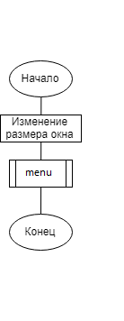

Рисунок 1 – Общая схема алгоритма главной функции

## 3.2. Разработка схемы алгоритма меню

Для перехода между задачами требуется меню. Оно нам необходимо чтобы любой пользователь мог выбрать одну из пяти задач из пункта меню. Изначально будет выделена одна из подзадач другим цветом, слева и справа стрелочками «=> подзадача<=». В зависимости от нажатой стрелочки («вверх» или «вниз») будет изменяться, выделения подзадач. При нажатии кнопки «Enter» будет запущена одна из подзадач, которая была выделена перед нажатием. В меню будет 5 подзадач:

* База Данных;
* Покер;
* Анимация;
* Об авторе;
* Выход;

Меню будет реализовано с помощью отдельной подпрограммы, схема алгоритма которой показана на рисунке 2.

main.cpp

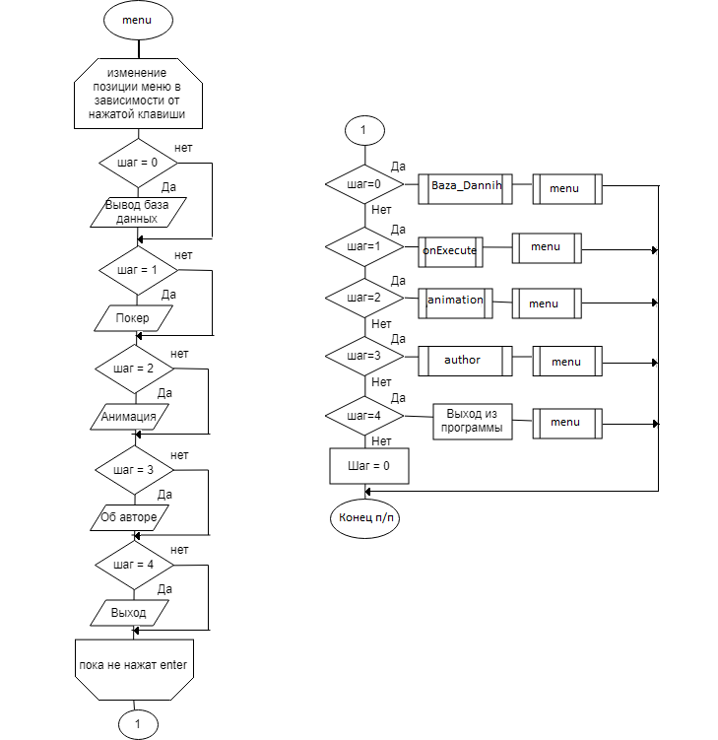

Рисунок 2 - Схема алгоритма меню

## 3.3. Разработка схемы алгоритма база данных «Записная книжка»

В подпрограмме база данных, будет предложение пользователю ввести файл, с которого будет считываться информация. Потом из введенного файла считается информация и запишется в 1-ую структуру. Файл закроется и вся информация из 1-ой структуры перезапишется во 2-ую. После будет вызвано меню базы данных. При возвращении будет вызываться подпрограмма сохранения, в которой вся измененная информация будет записана. Схема алгоритма подпрограммы, которой представлена на рисунке 3.

Baza_Dannih.h

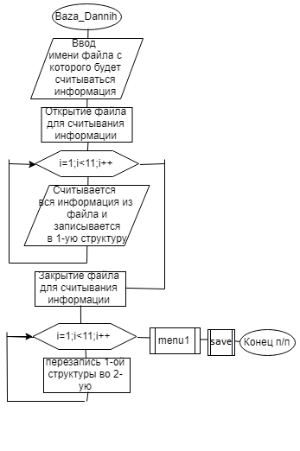

Рисунок 3 - Схема алгоритма базы данных

## 3.3.1. Разработка схемы алгоритма меню базы данных

Подпрограмма меню базы данных с возможностью выбора других функций, (работает так же, как и основное меню) содержащее:

* удаление людей из базы данных;
* добавление в неё;
* поиск по одному из девяти предложенных пунктов;
* возвращение в прошлое меню;

Схема алгоритма подпрограммы, которой представлена на рисунке 4. Baza_Dannih.h

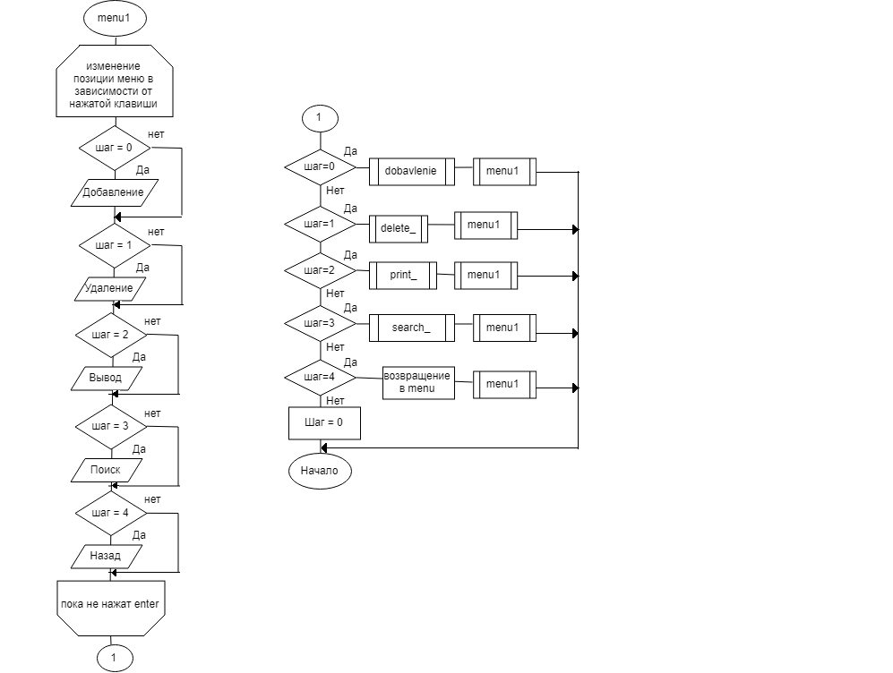

Рисунок 4-Схема алгоритма меню базы данных

## 3.3.2. Разработка схемы алгоритма удаления из базы данных

В подпрограмме удаления изначально будет выводиться таблица всех людей, которые есть в базе данных. И по номеру можно будет удалить человека из неё, схема алгоритма подпрограммы, которой представлена на рисунке 5.

Baza_Dannih.h

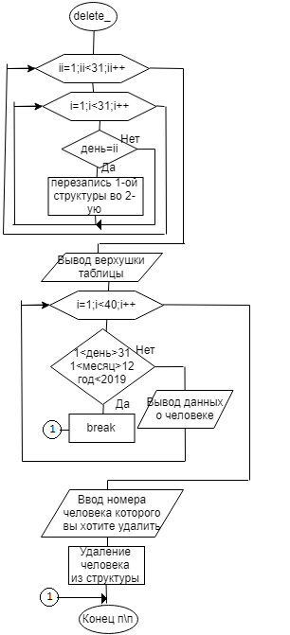

Рисунок 5 – Схема алгоритма удаления человека из базы данных

## 3.3.3. Разработка схемы алгоритма вывода всей информации

Для вывода всей информации о людях, которые есть в базе данных, используется таблица, в которую запишутся все люди из 2-ой структуры и выведется на экран. Схема алгоритма подпрограммы представлена на рисунке 6

Baza_Dannih.h

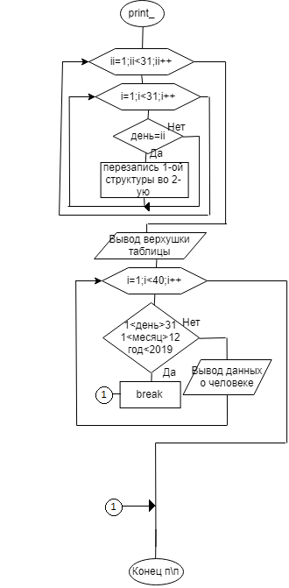

Рисунок 6 – Схема алгоритма подпрограммы, выводящей всю информацию справочника на экран

## 3.3.4. Разработка схемы алгоритма для поиска человека

Подпрограмма базы данных поиска будет искать людей по одному из критериев:

* Имени;
* Фамилии;
* Отчеству;
* Адресу;
* Номеру дома;
* Номеру телефона;
* Дню рождения;
* Месяцу рождения;
* Году рождения;

Среди элементов справочника и выводить искомую информацию о человеке, схема алгоритма подпрограммы представлена на рисунке 7.

Baza_Dannih.h

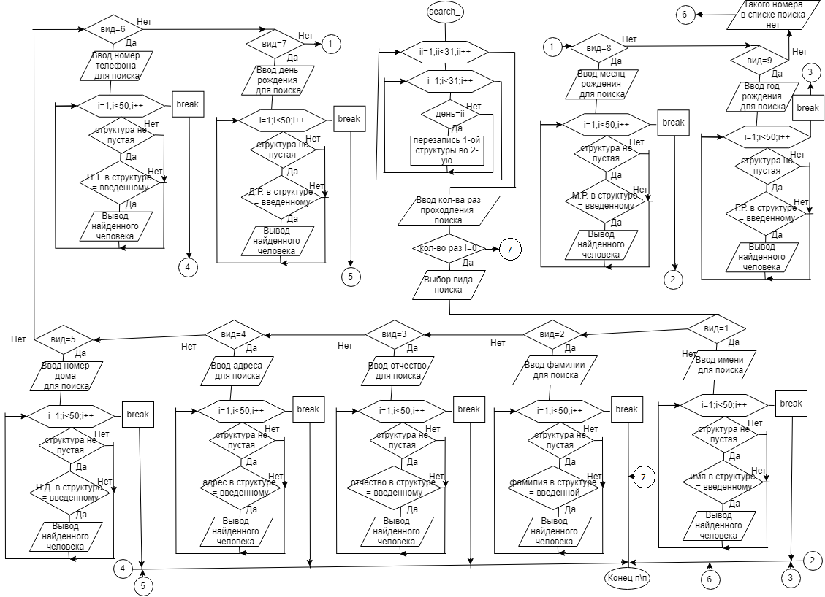

Рисунок. 7 – Схема алгоритма подпрограммы поиск

## 3.3.5. Разработка схемы алгоритма добавления в базу данных

Подпрограмма добавления человека в базу данных, заполнив пункты информации о человеке:

* фамилия;
* имя;
* отчество;
* улицу;
* номер дома;
* номер телефона;
* день рождения;
* месяц рождения;
* год рождения;

Будет записана во 2-ую структуру. Схема алгоритма подпрограммы представлена на рисунке 8.

Baza_Dannih.h

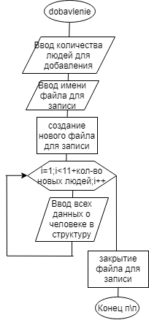

Рисунок 8 – Схема алгоритма подпрограммы добавления

## 3.3.6. Разработка схемы алгоритма сохранения информации

Функция сохранения всей информации, которую мы изменяли в течение всей работы с базой данной, будет записана в некоторый файл, который пользователь назовет. Схема алгоритма подпрограммы, которой представлена на рисунке 9.

Baza_Dannih.h

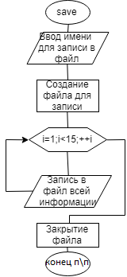

Рисунок 9 – Схема алгоритма подпрограммы сохранения

## 3.4. Разработка схемы алгоритма об авторе

При выборе подпрограммы «Об авторе» в пунктах главного меню, на экран выведется информация о нем. Схема алгоритма подпрограммы об авторе представлена на рисунке 10.

main.cpp

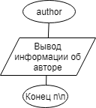

Рисунок 10 – Схема алгоритма вывода информации об авторе

## 3.5. Разработка схемы алгоритма анимация

Подпрограмма анимация представляет собой рисование пиксельного кота, его движений, который летит по звёздному небу, оставляя за собой след радуги. Схема алгоритма подпрограммы показана на рисунке 11.

main.cpp

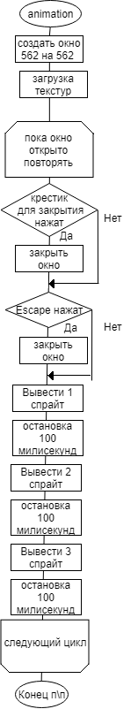

Рисунок 11 – Схема алгоритма подпрограммы анимация

## 3.6. Разработка схемы алгоритма главной функции покера

Подпрограмма главная функция покера включает в себя инициализацию и её проверку, вызов подпрограммы событий с окном, подпрограммы событий игры, подпрограмму перерисовки игрового процесса и подпрограмму выхода. Схема алгоритма подпрограммы представлена на рисунке 12.

CApp.cpp

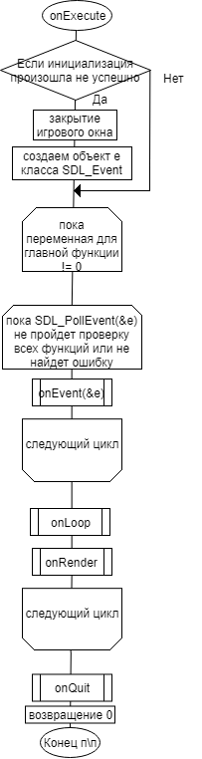

Рисунок 12 – Схема алгоритма подпрограммы главной функции для покера

## 3.6.1. Разработка схемы алгоритма событий окна

Подпрограмма всех возможных событий, которые можно отправить в создаваемое окно для покера. Схема алгоритма подпрограммы, которой представлена на рисунке 13.

CEvent.cpp

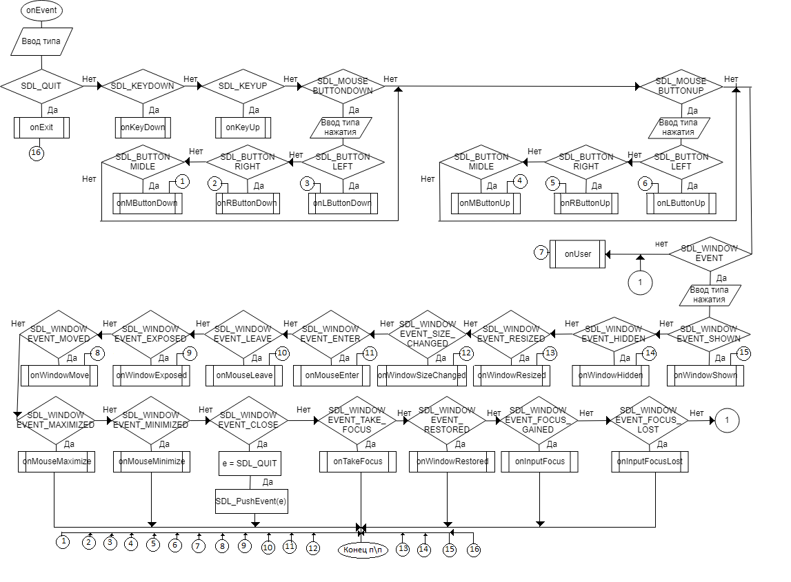

Рисунок 13 – Схема алгоритма событий для покера

## 3.6.2. Разработка схемы алгоритма события нажатия левой кнопкой мыши по окну

Схема алгоритма подпрограммы события нажатия левой кнопкой мыши по создаваемому окну для покера, для считывания какой-либо кнопки, если в такую попадает курсор мыши, представлена на рисунке 14.

CApp_OnEvent.cpp

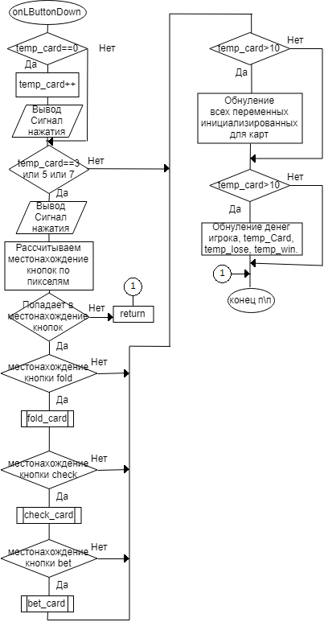

Рисунок 14 – схема алгоритма подпрограммы события нажатия левой

## 3.6.3. Разработка схемы алгоритма события нажатие крестика

Подпрограмма события – нажатие крестика для закрытия у создаваемого окна для покера, которая возвращает нулевое значение для главной переменной функции, чтобы началось обнуление всех переменных для выхода из главной функции покера. Схема алгоритма подпрограммы, которой представлена на рисунке 15.

CApp_OnEvent.cpp

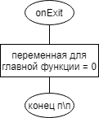

Рисунок 15 – схема алгоритма подпрограммы события – нажатие крестика

## 3.6.4. Разработка схемы алгоритма событий во время игры

Подпрограммы происходящих событий во время игры «Покер», включает в себя постепенную раздачу случайных карт всем игрокам. Схема алгоритма подпрограммы, которой представлена на рисунке 16.

CApp_onLoop.cpp

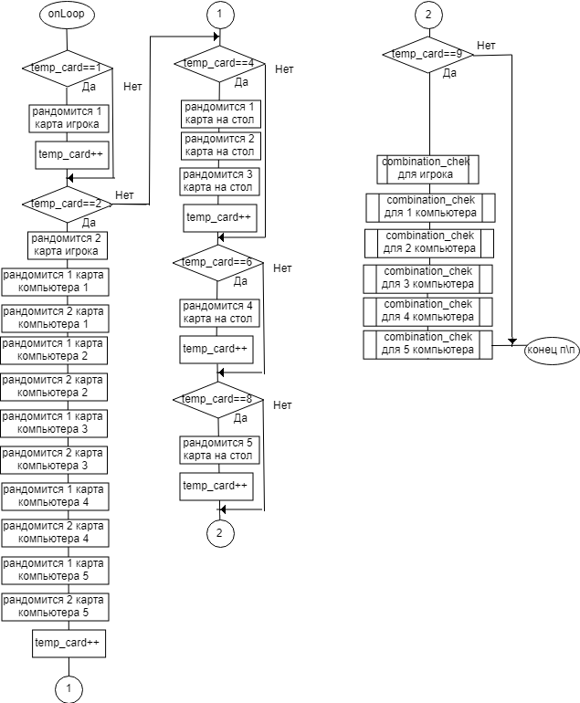

Рисунок 16 – схема алгоритма подпрограммы происходящих событий

## 3.6.5. Разработка схемы алгоритма событий во время игры

Подпрограммы проверка всех комбинаций, включает в себя проверку всех возможных комбинаций, которые могут быть в игре «Покер» у игроков. Схема алгоритмов подпрограммы, которой представлена на рисунке 17.

CApp.cpp

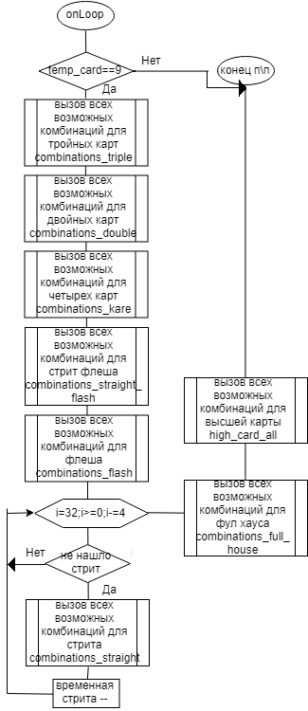

Рисунок 17 – схема алгоритма подпрограммы проверка комбинаций

## 3.6.6. Разработка схемы алгоритма проверка тройной комбинации

Подпрограмма проверка тройной комбинации игроков во время игры. Схема алгоритма подпрограммы, которой представлена на рисунке 18.

CApp.cpp

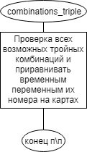

Рисунок 18 – схема алгоритма подпрограммы проверка тройной комбинации

## 3.6.7. Разработка схемы алгоритма проверка двойной комбинации

Схема алгоритма подпрограммы проверка двойной комбинации у игроков во время игры «Покер» представлена на рисунке 19.

CApp.cpp

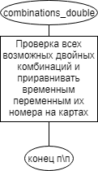

Рисунок 19 – схема алгоритма подпрограммы проверка двойной комбинации

## 3.6.8. Разработка схемы алгоритма проверка комбинации Каре

Схема алгоритма подпрограммы проверка комбинации Каре у игроков во время игры «Покер» представлена на рисунке 20.

CApp.cpp

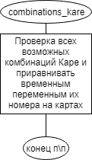

Рисунок 20 – схема алгоритма подпрограммы проверка комбинации Каре

## 3.6.9. Разработка схемы алгоритма проверка комбинации Стрит Флеш

Схема алгоритма подпрограммы проверка комбинации Стрит Флеш у игроков во время игры «Покер» представлена на рисунке 21.

CApp.cpp

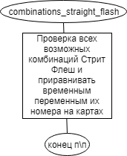

Рисунок 21 – схема алгоритма подпрограммы проверка комбинации Стрит Флеш

## 3.6.10. Разработка схемы алгоритма проверка комбинации Стрит

Подпрограмма проверка комбинации Стрит у игроков во время игры. Схема алгоритма подпрограммы, которой представлена на рисунке 22.

CApp.cpp

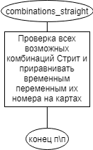

Рисунок 22 – схема алгоритма подпрограммы проверка комбинации Стрит

## 3.6.11. Разработка схемы алгоритма проверка комбинации Флеш

Подпрограмма проверка комбинации Флеш у игроков во время игры Схема алгоритма подпрограммы, которой представлена на рисунке 23.

CApp.cpp

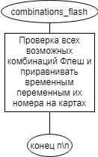

Рисунок 23 – схема алгоритма подпрограммы проверка комбинации Флеш

## 3.6.12. Разработка схемы алгоритма проверка комбинации Высшая карта

Подпрограмма проверка комбинации Высшая карта у игроков во время игры. Схема алгоритма подпрограммы, которой представлена на рисунке 24.

CApp.cpp

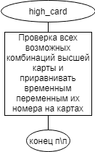

Рисунок 24 – схема алгоритма подпрограммы проверка комбинации Высшая карта

## 3.6.13. Разработка схемы алгоритма проверка комбинации Фул Хаус

Подпрограммы проверка комбинации Фул Хаус у игроков во время игры. Схема алгоритма подпрограммы, которой представлена на рисунке 25.

CApp.cpp

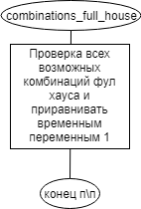

Рисунок 25 – схема алгоритма подпрограммы проверка комбинации

Фул Хаус

## 3.6.14. Разработка схемы алгоритма сброса карт

Подпрограмма сброс – сброса карт у игроков во время игры, по нажатию на кнопку «Flod» в правой нижней части экрана. Схема алгоритма подпрограммы, которой представлена на рисунке 26.

CApp.cpp

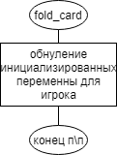

Рисунок 26 – схема алгоритма подпрограммы сброс

## 3.6.15. Разработка схемы алгоритма удержать

Подпрограмма удержать – удержать ставку, поставив 100 игровых единиц во время игры, по нажатию кнопки «Check» в правой нижней части окна. Схема алгоритма подпрограммы, которой представлена на рисунке 27.

CApp.cpp

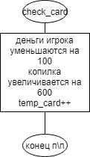

Рисунок 27 – схема алгоритма подпрограммы удержать

## 3.6.16. Разработка схемы алгоритма ставка

Подпрограмма ставка – поднять ставку, поставив 200 игровых единиц во время игры, по нажатию кнопки «Bet» в правой нижней части окна. Схема алгоритма подпрограммы, которой представлена на рисунке 28.

CApp.cpp

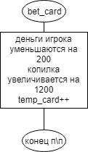

Рисунок 28 – схема алгоритма подпрограммы ставка

## 3.6.17. Разработка схемы алгоритма перерисовка

Подпрограмма перерисовка – отрисовка всех изображений выведенных на окно «Покер», в течение всей игры. Схема алгоритма подпрограммы, которой представлена на рисунке 29.

Capp_onRender.cpp

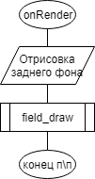

Рисунок 29 – схема алгоритма подпрограммы перерисовка

## 3.6.18. Разработка схемы алгоритма рисование полей

Подпрограмма рисование полей – отрисовка всех изображений выведенных на окно «Покер», в течение всей игры. Схема алгоритма подпрограммы, которой представлена на рисунке 30.

Capp_onRender.cpp

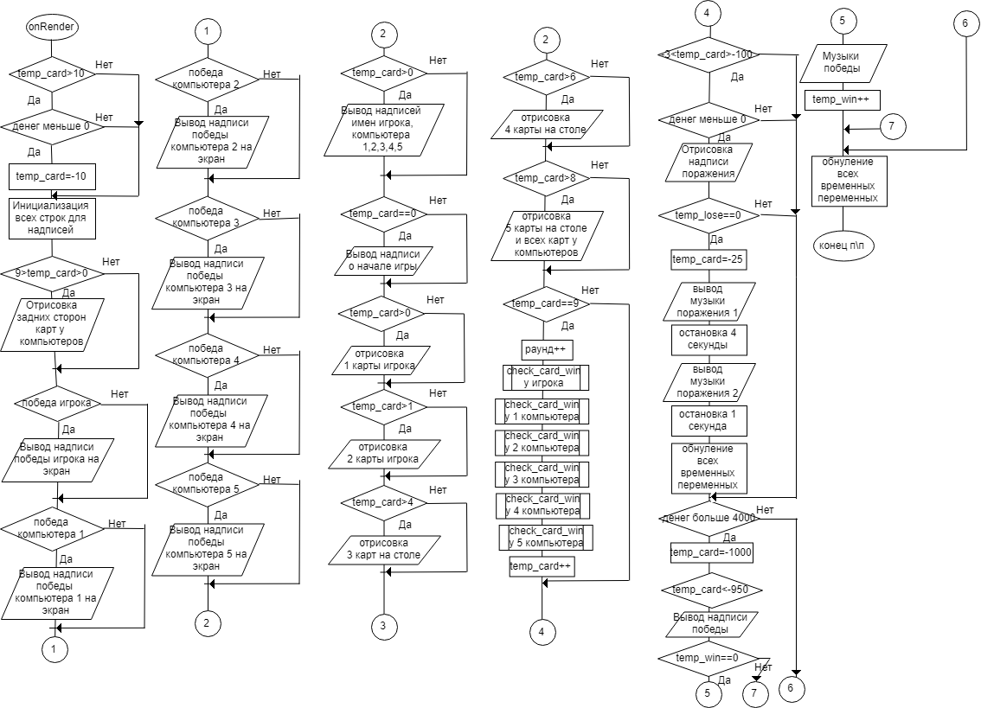

Рисунок 30 – схема алгоритма подпрограммы рисование полей

## 3.6.19. Разработка схемы алгоритма проверка победы

Подпрограмма проверка победы – сравнивание всех комбинаций игроков друг с другом, и по правилам покера, произойдет выбор победителя. Схема алгоритма подпрограммы, которой представлена на рисунке 31.

CApp.cpp

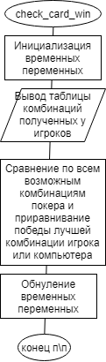

Рисунок 31 – схема алгоритма подпрограммы проверка победы

## 3.6.20. Разработка схемы алгоритма проверка победы

Подпрограмма выхода – обнуление всех загруженных текстур, музыки, форматов текста и тд. Схема алгоритма подпрограммы, которой представлена на рисунке 32.

Capp_onQuit.cpp

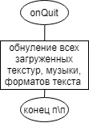

Рисунок 32 – схема алгоритма подпрограммы выхода

## **Особенности разработки программы**

Для реализации всех алгоритмов был использован язык C++, среда разработки CodeBlocks и библиотека SDL_2. Программа разработана в строгом соответствии со схемами алгоритмов. В программе был использован выбор пунктов в меню с клавиатуры, и запись всей информации базы данных в файлы. Вся информация программы находится в 14-ти разных файлах. Программа состоит из 8 276‬ строк кода.

## **Инструкция пользователю**

Для запуска программы необходимо запустить файл kursachproject.exe.

В открывшемся окне выбрать стрелками на клавиатуре один из пунктов меню, чтобы выбрать нужный пункт нажмите Enter.

Для работы с базой данных «Записная книжка» необходимо выбрать соответствующий пункт меню и нажать Enter. Как представлено на рисунке 33.

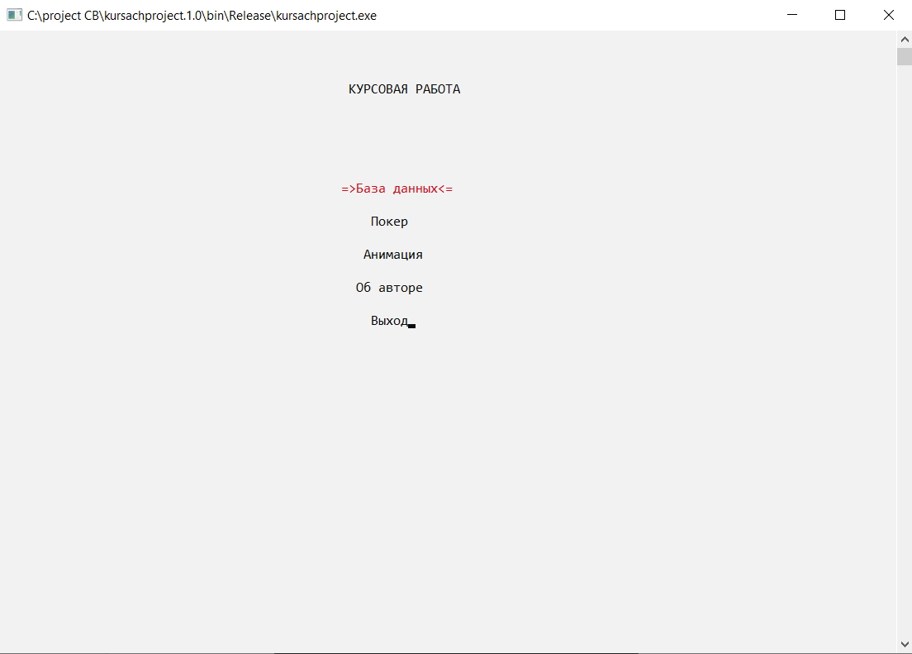

Рисунок 33 – основное меню

Далее необходимо ввести имя файла, с которого будет считываться информация о людях, как показано на рисунке 34.

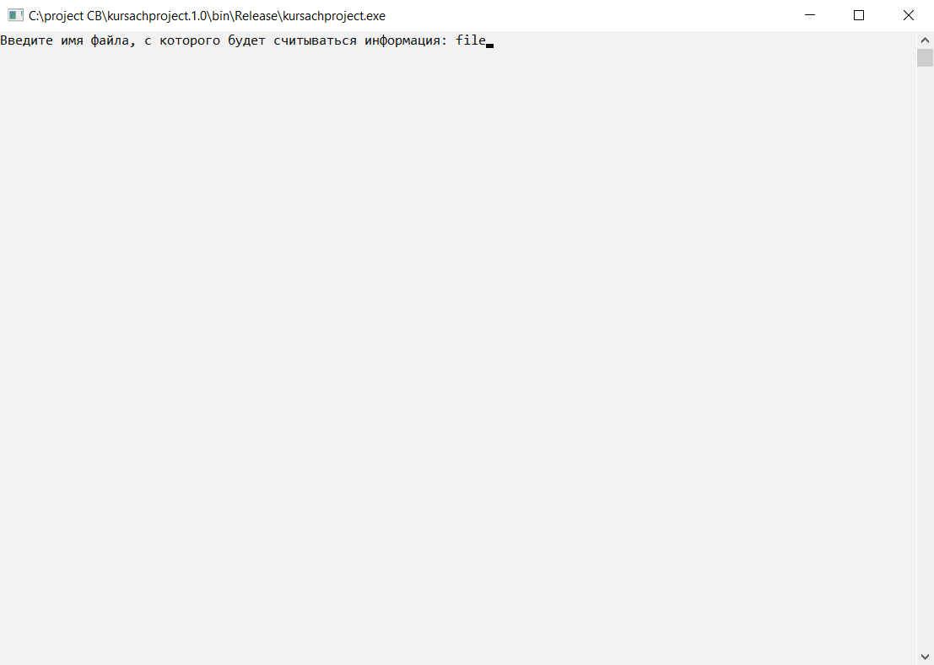

Рисунок 34 – ввод названия файла

В подменю базы данных нужно навестись стрелочками на нужный вам пункт и нажать Enter. Как на рисунке 35.

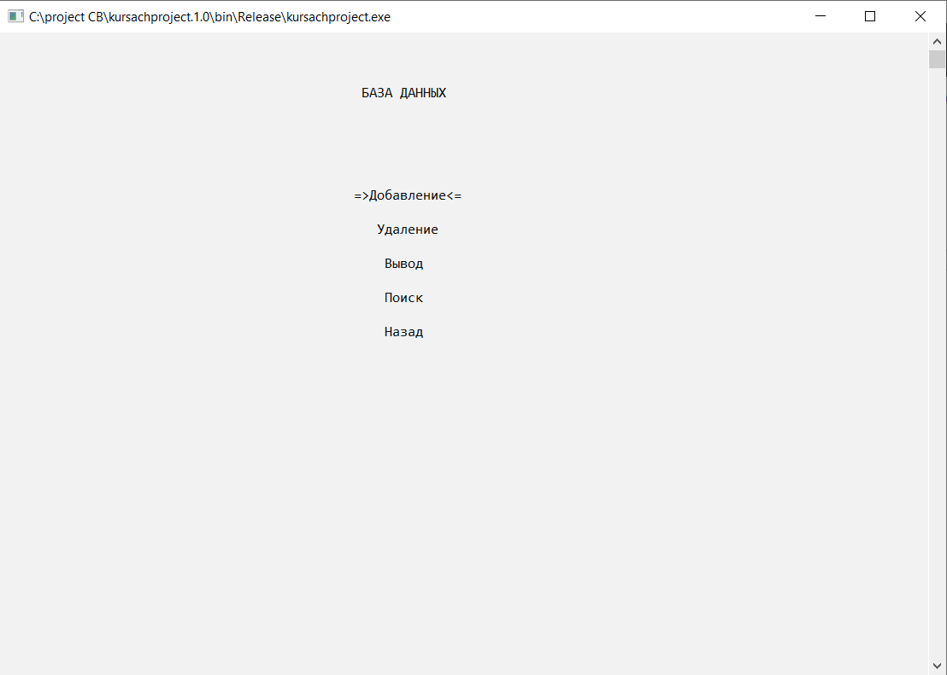

Рисунок 35 – подменю базы данных

В подменю добавление по базе данных необходимо ввести количество людей, которых хотите внести в базу данных, ввести имя файла в который они будут записаны, и написать подробную информацию о них. Как представлено на рисунке 36.

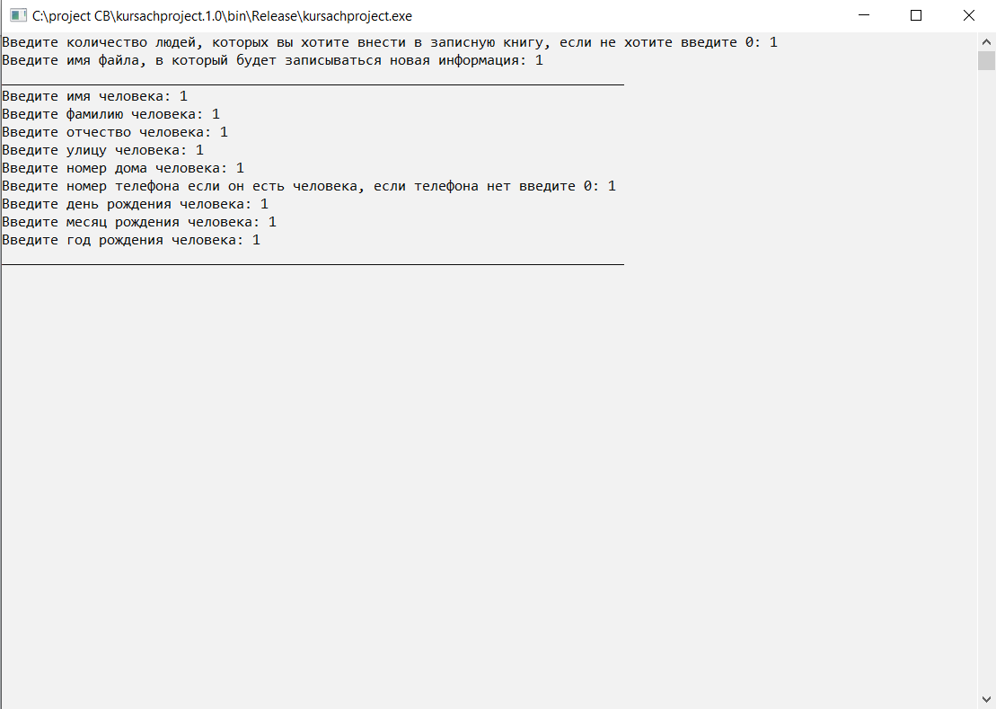

Рисунок 36 – пример работы добавления в базу данных

В подменю удаления по базе данных необходимо вписать номер человека из выведенной таблицы. Как представлено на рисунке 37.

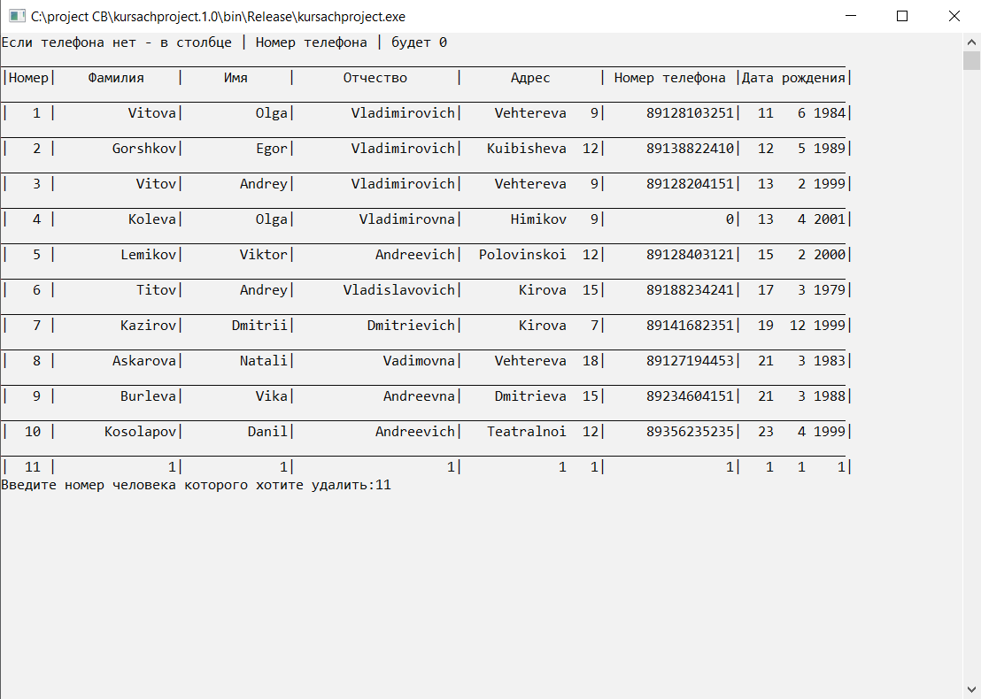

Рисунок 37 – пример работы удаления из базы данных

В подменю вывода всей информации о людях, будут выведены все, кто есть в базе данных. Как представлено на рисунке 38.

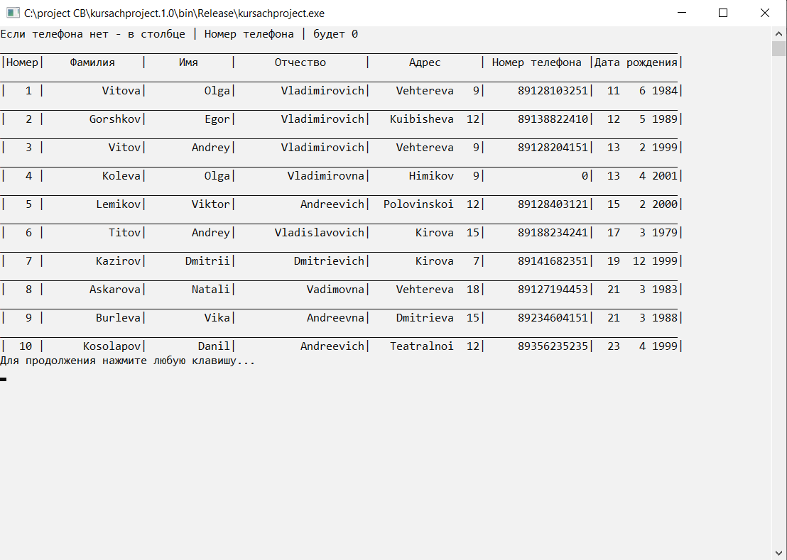

Рисунок 38 – пример работы вывода базы данных

В подменю поиска по базе данных необходимо ввести количество раз прохождения поиска и нажать Enter, выбрать ключевое слово для поиска, ввести его номер также и нажать Enter. Как представлено на рисунке 39.

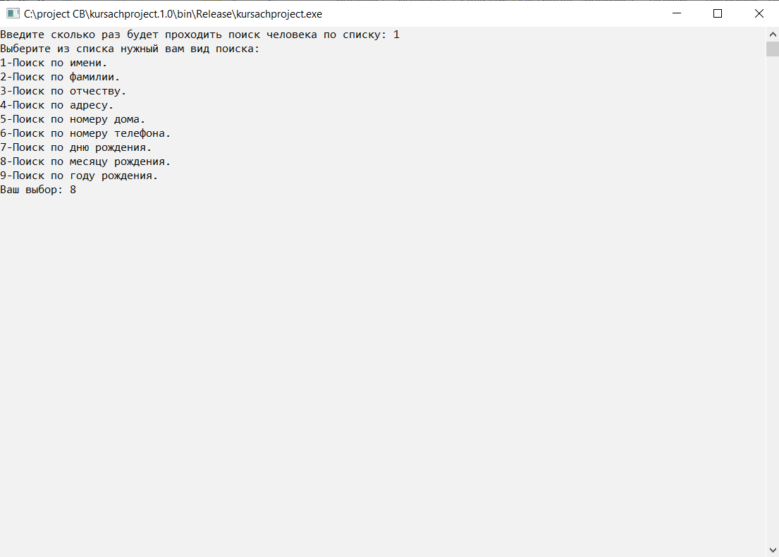

Рисунок 39 – пример работы поиска по базе данных

После этого нужно ввести поисковый запрос и нажать Enter, как представлено на рисунке 40.

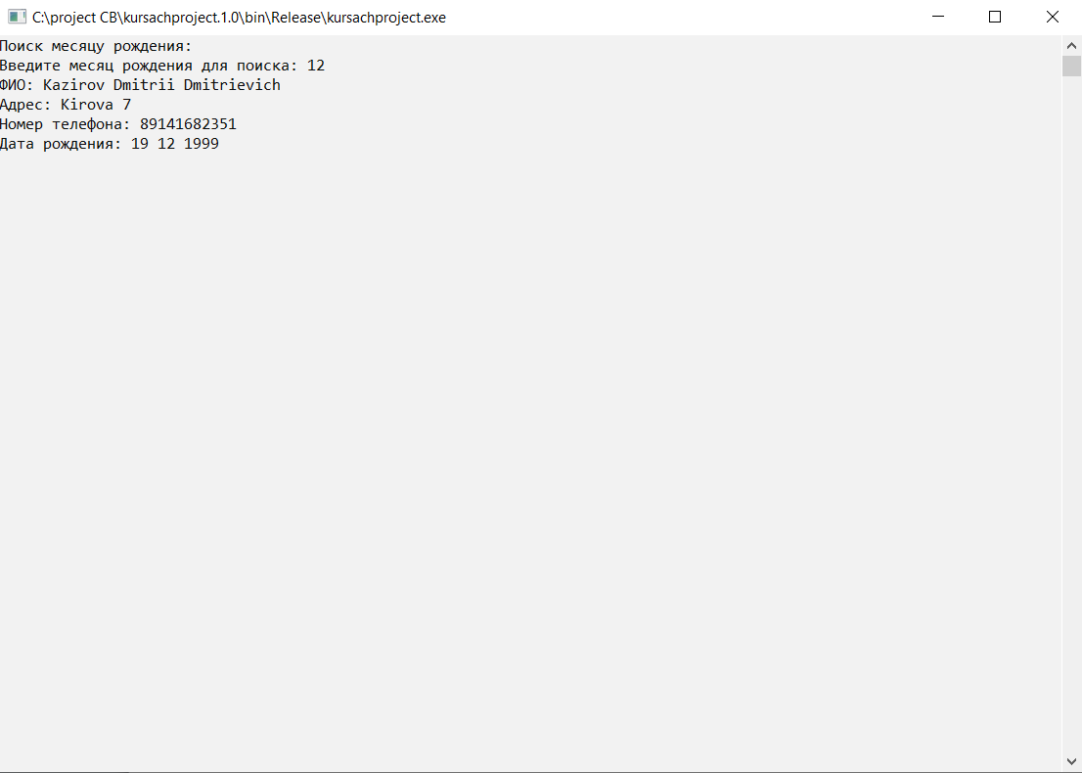

Рисунок 40 – пример работы поиска по базе данных

После окончания работы с базой данных наведитесь в подменю клавишу «Назад» и нажмите Enter, потом введите имя файла для сохранения и также нажмите Enter. Как представлено на рисунке 41.

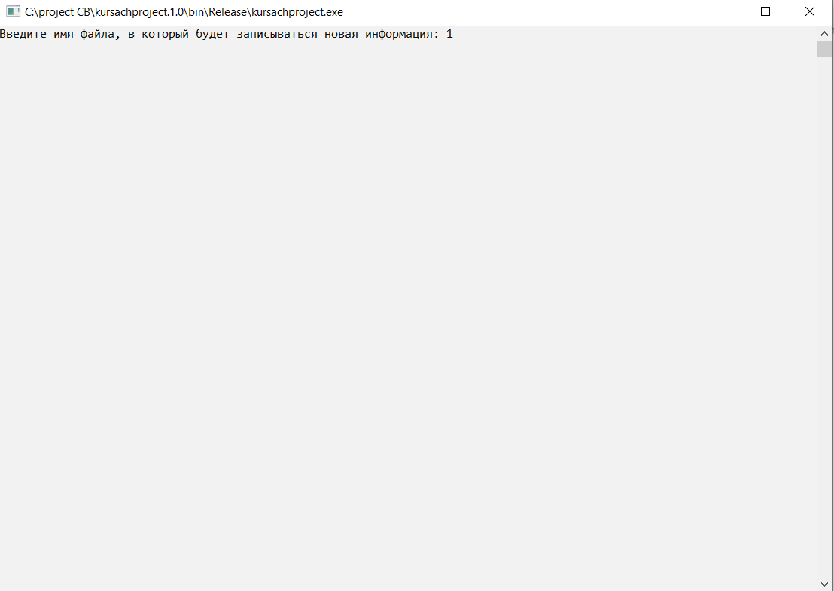

Рисунок 41 – пример работы сохранения базы данных

Чтобы открыть игру, выберите в основном меню подзадачу «Покер». После этого выведется отдельное окно с игрой. Управление осуществляется нажатиями левой кнопки мыши. Чтобы выйти нажмите Esc или нажмите на крестик для закрытия окна. Как это представлено на рисунке 42.

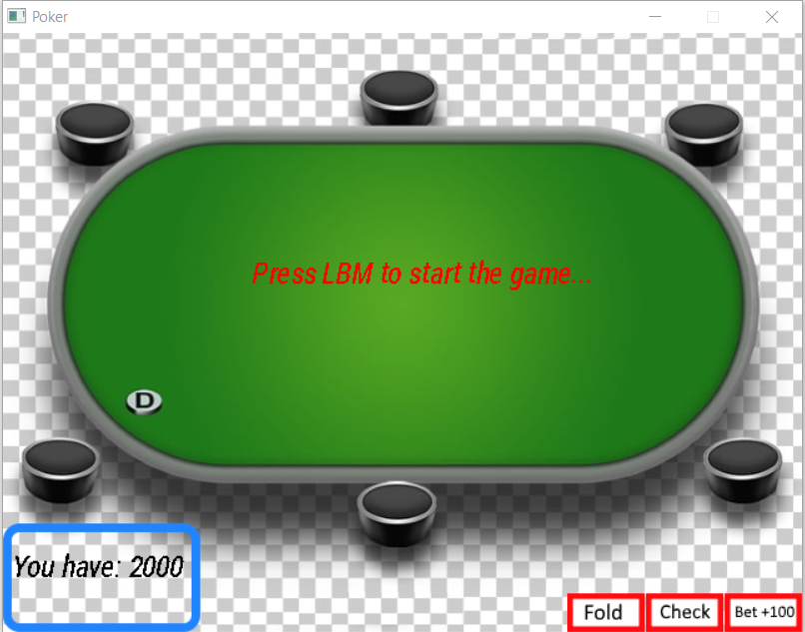

Рисунок 42 – пример работы игры «Покер»

Нажмите левой кнопкой мыши по окну, для начала игры, как это представлено на рисунке 43.

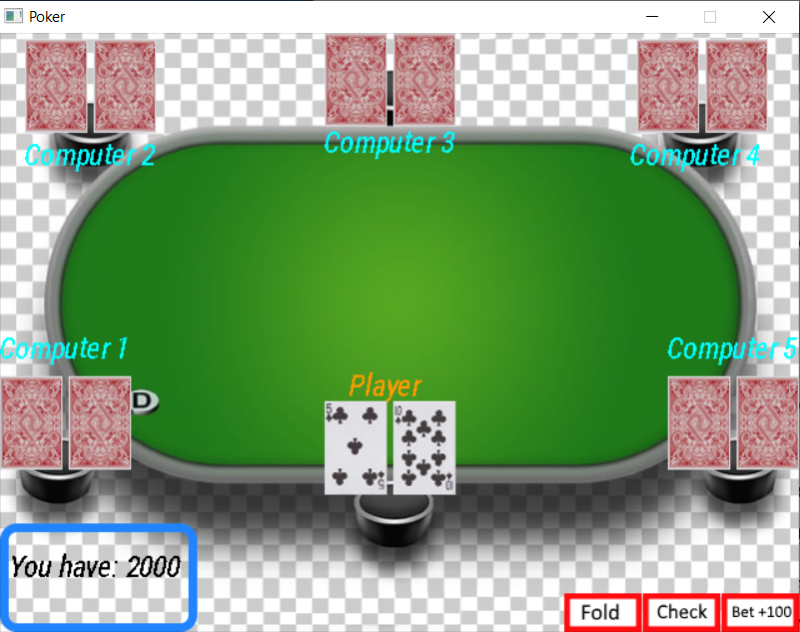

Рисунок 43 – пример работы игры «Покер»

Всем игрокам раздали карты. У нас есть выбор сбросить, удержать ставку (100) или поднять ставку (200). На примере удержали ставку и на столе открыли 3 карты. Как представлено на рисунке 44.

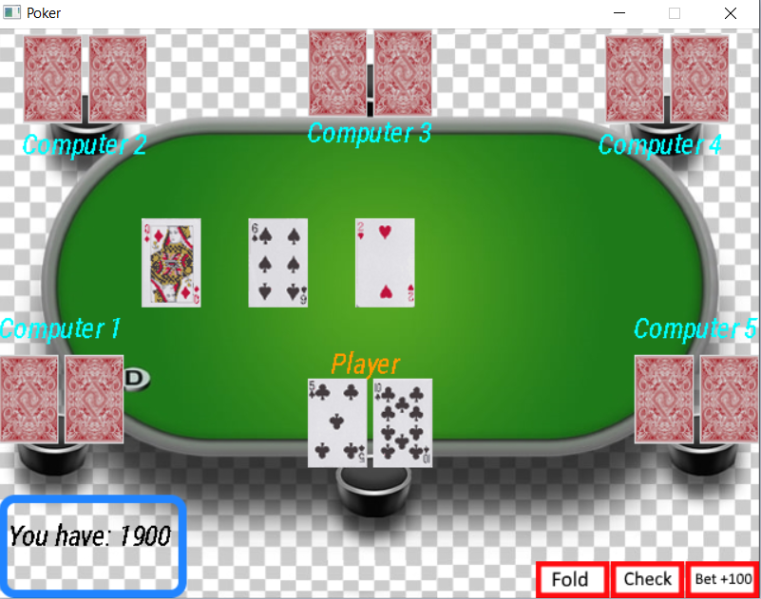

Рисунок 44 – пример работы игры «Покер»

Далее на примере удерживают ставку еще 2 раза, и открываются последние 2 карты, и определяется победитель по лучшей комбинации. Как представлено на рисунке 45.

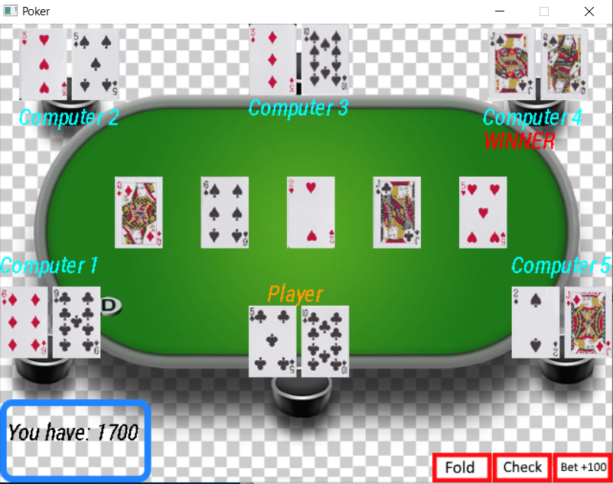

Рисунок 45 – пример работы игры «Покер»

Победителем на примере стал 4 компьютер. У него сложилась двойная пара из 2 вольтов и 2 дам. Данные обо всех комбинациях игроков выводятся в консоль, как представлено на рисунке 46.

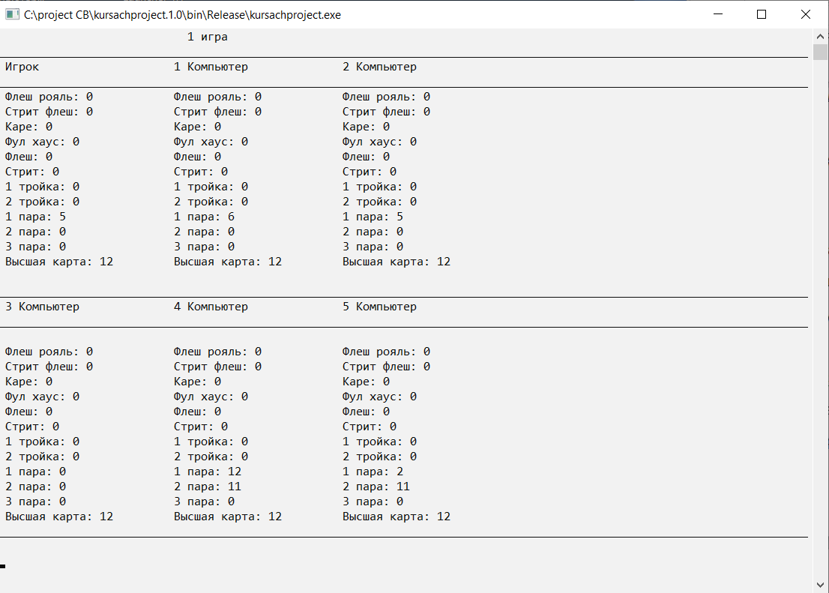

Рисунок 46 – пример работы вывода всех комбинаций в консоль игры

Выбрав пункт «Анимация» из основного меню, пользователь увидит анимацию движения пиксельного кота, который летит по звездному небу и оставляет за собой след радуги. Для закрытия анимации, нажмите «Esc» или закройте окно с анимацей. Пример работы анимации представлен на рисунке 47.

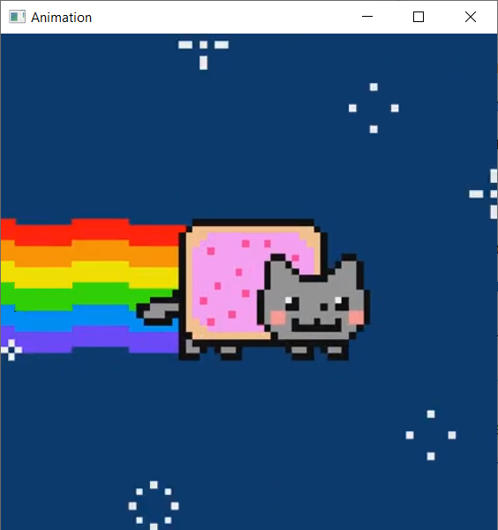

Рисунок 47 – пример работы анимации

Выбрав пункт «Об авторе» из основного меню, пользователь увидит информацию о разработчике данного курсового проекта, как представлено на рисунке 48.

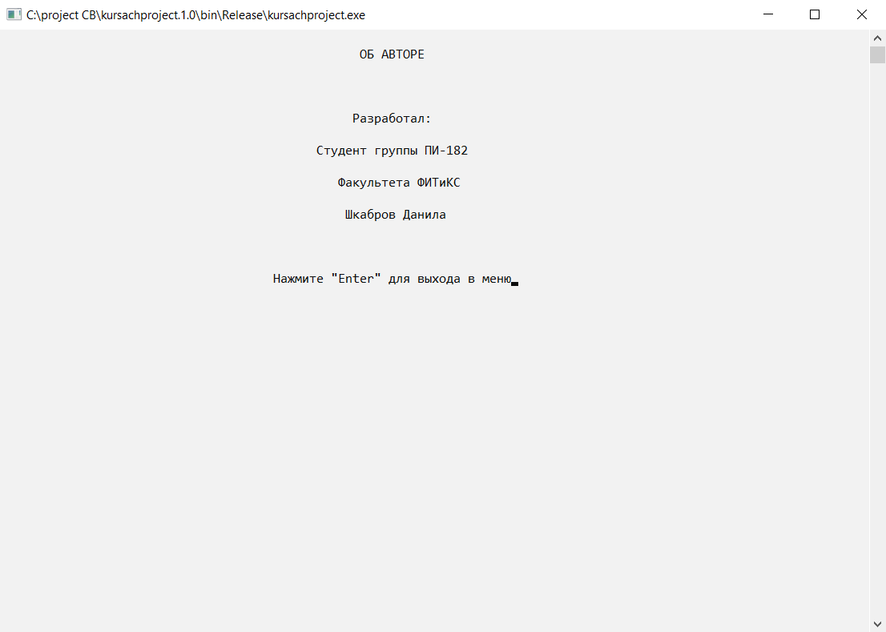

Рисунок 48 – информация об авторе

Последний пункт – это «Выход», при нажатии на который происходит выход из программы.

## **Результаты тестирования**

Программа была протестирована во всех режимах и результаты тестирования были сведены в таблице 1.

|  |  |  |  |
| --- | --- | --- | --- |
| Режим | Вводимые  данные | Ожидаемый  результат | Результат |
| Ввод данных в БД | 10 людей их его данные | 10 людей их его данные | 10 людей их его данные |
| Поиск данных в БД | Человек 1 | Человек 1 найден | Человек 1 найден |
| Добавление данных в БД | Человек 11 и его данные | Человек 11 и его данные | Человек 11 и его данные |
| Удаление данных из БД | 1 человек | 1 человек удален | 1 человек удален |

Таблица 1 – Результаты тестирования программы

Результат тестирования основного меню представлен на рисунке 49.



Рисунок 49 – тестирование основного меню

Результат тестирования ввода имени файла, с которого будет считываться информация, представлен на рисунке 50.



Рисунок 50 – тестирование ввода имени файла

Результат тестирования подменю, который представлен на рисунке 51.



Рисунок 51 – тестирование подменю базы данных

Результат тестирования добавления человека в базу данных, представлен на рисунке 52.



Рисунок 52 – тестирование работы добавления в базу данных

Результат тестирования удаления человека из базы данных, представлен на рисунке 53.



Рисунок 53 – тестирование работы удаления из базы данных

Результат тестирования вывода всей информации о людях, представлен на рисунке 54.



Рисунок 54 – тестирование работы вывода базы данных

Результат тестирования поиска информации о людях, представлен на рисунке 55 и рисунке 56.



Рисунок 55 – тестирование работы поиска по базе данных



Рисунок 56 – тестирование работы поиска по базе данных

Результат тестирования сохранения в файл всей информации из базы данных, представлен на рисунке 57.



Рисунок 57 – тестирование работы сохранения базы данных

Результат тестирования игры «Покер», представлен с рисунка 58 по рисунок 61.



Рисунок 58 – тестирование работы игры «Покер»



Рисунок 59 – тестирование работы игры «Покер»



Рисунок 60 – тестирование работы игры «Покер»



Рисунок 61 – тестирование работы игры «Покер»

Результат тестирования вывода всех комбинаций у игроков, представлен на рисунке 62.



Рисунок 62 – тестирование работы вывода всех комбинаций в консоль игры

Результат тестирования анимации, представлен на рисунке 63.



Рисунок 63 – тестирование работы анимации

Результат тестирования подзадачи «Об авторе», представлен на рисунке 64.



Рисунок 64 – тестирование информации об авторе

**Заключение**

В результате выполнения курсового проекта, были разработаны алгоритмы и отлажены программы:

* Электронная «Записная книжка»
* Программа-игра;
* Анимация;
* Сведения об авторе;
* Выход.

Достоинства программы:

* При поиске в базе данных информация о людях отсортирована по дню, месяцу и году рождения по возрастанию;
* Красивая визуализация игры «Покер»;
* Продуманная до мелочей игра «Покер».

Недостатки:

* База данных чувствительна к регистру.

Игровая программа «Покер» полностью проработана, и может быть использована людьми, для развлечения и улучшения стратегических и логических навыков. Разработанная база данных работает и может быть применена на практике.

Приложение

**main.cpp:**

#include "CApp.h"

#include "Baza_Dannih.h"

#include <math.h>

#include <locale.h>

#include <stdio.h>

#include <stdlib.h>

#include <iostream>

#include <conio.h>

#include <graphics.h>

#include <sstream>

#include <windows.h>

#include <winbgim.h>

#include <limits.h>

#include <SFML/Graphics.hpp>

char Colour[3];

using namespace std;

enum ConsoleColor

{

Black = 0,

Blue = 1,

Green = 2,

Cyan = 3,

Red = 4,

Magenta = 5,

Brown = 6,

LightGray = 7,

DarkGray = 8,

LightBlue = 9,

LightGreen = 10,

LightCyan = 11,

LightRed = 12,

LightMagenta = 13,

Yellow = 14,

White = 15

};

void XY(int x, int y)

{

COORD a = { x, y };

HANDLE form = GetStdHandle(STD_OUTPUT_HANDLE);

SetConsoleCursorPosition(form, a);

}

void Color(int text, int background)

{

HANDLE hStdOut = GetStdHandle(STD_OUTPUT_HANDLE);

SetConsoleTextAttribute(hStdOut, (WORD)((background << 4) | text));

}

void SetColour(char R, char G, char B)

{

Colour[0] = R;

Colour[1] = G;

Colour[2] = B;

}

void menu();

int main();

void animation()

{

srand( time( NULL ) );

sf::RenderWindow window(sf::VideoMode(562, 562), "Animation");

sf::Texture t1;

t1.loadFromFile("Animation/Animation1.bmp");

sf::Texture t2;

t2.loadFromFile("Animation/Animation2.bmp");

sf::Texture t3;

t3.loadFromFile("Animation/Animation3.bmp");

sf::Sprite s;

sf::Sprite s1;

sf::Sprite s2;

s.setTexture(t1);

s1.setTexture(t2);

s2.setTexture(t3);

while (window.isOpen())

{

sf::Event event;

while (window.pollEvent(event))

{

if (event.type == sf::Event::Closed)

window.close();

if (event.key.code == sf::Keyboard::Escape)

window.close();

}

window.draw(s);

window.display();

Sleep(100);

window.draw(s1);

window.display();

Sleep(100);

window.draw(s2);

window.display();

Sleep(100);

}

menu();

}

void author()

{

system("cls");

XY(50, 1);

Color(0, 15);//цвет букв, задний фон

printf("ОБ АВТОРЕ");

XY(49, 5);

printf("Разработал:");

XY(44, 7);

printf("Студент группы ПИ-182");

XY(47, 9);

printf("Факультета ФИТиКС");

XY(48, 11);

printf("Шкабров Данила");

XY(38, 15);

printf("Нажмите \"Enter\" для выхода в меню");

}

void menu()

{

int n;

int key = 0;//начальное положение ключа

system("cls");

do

{

Color(0, 15);

system("cls");

key = (key + 5) % 5;

XY(47, 3);

printf("КУРСОВАЯ РАБОТА");

if (key == 0)

{

XY(46, 9);

Color(4, 15);

printf("=>База данных<=");

}

else

{

XY(48, 9);

Color(0, 15);

printf("База данных");

}

if (key == 1)

{

XY(48, 11);

Color(4, 15);

printf("=>Покер<=");

}

else

{

XY(50, 11);

Color(0, 15);

printf("Покер");

}

if (key == 3)

{

XY(46, 15);

Color(4, 15);

printf("=>Об авторе<=");

}

else

{

XY(48, 15);

Color(0, 15);

printf("Об авторе");

}

if (key == 2)

{

XY(47, 13);

Color(4, 15);

printf("=>Анимация<=");

}

else

{

XY(49, 13);

Color(0, 15);

printf("Анимация");

}

if (key == 4)

{

XY(48, 17);

Color(4, 15);

printf("=>Выход<=");

}

else

{

XY(50, 17);

Color(0, 15);

printf("Выход");

}

{

n = _getch();

if (n == 80) key++;

if (n == 72) key--;

}

}

while (n != 13);

switch (key)

{

case 0:

{

system("cls");

Baza_Dannih();

_getch();

menu();

break;

}

case 1:

{

system("cls");

CApp game;

game.onExecute();

menu();

break;

}

case 2:

{

system("cls");

animation();

menu();

break;

}

case 3:

{

system("cls");

author();

_getch();

menu();

break;

}

{

}

case 4:

{

system("cls");

exit(1);

menu();

break;

}

}

key = 0;

}

int main(int argc,char** argv)

{

srand( time( NULL ) );

setlocale(LC_ALL, "Russian");

HWND window_header = GetConsoleWindow();

SetWindowPos(window_header, HWND_TOP, 250, 100, 900, 640, NULL);

menu();

return 0;

}

**CApp.cpp:**

#include "CApp.h"

//Конструктор

CApp::CApp()

{

running = true;

window = NULL;

screen = NULL;

background = NULL;

//--------------CARDS--------------------

cart_2_spades = NULL;

cart_2_clubs = NULL;

cart_2_hearts = NULL;

cart_2_diamonds = NULL;

cart_3_spades = NULL;

cart_3_clubs = NULL;

cart_3_hearts = NULL;

cart_3_diamonds = NULL;

cart_4_spades = NULL;

cart_4_clubs = NULL;

cart_4_hearts = NULL;

cart_4_diamonds = NULL;

cart_5_spades = NULL;

cart_5_clubs = NULL;

cart_5_hearts = NULL;

cart_5_diamonds = NULL;

cart_6_spades = NULL;

cart_6_clubs = NULL;

cart_6_hearts = NULL;

cart_6_diamonds = NULL;

cart_7_spades = NULL;

cart_7_clubs = NULL;

cart_7_hearts = NULL;

cart_7_diamonds = NULL;

cart_8_spades = NULL;

cart_8_clubs = NULL;

cart_8_hearts = NULL;

cart_8_diamonds = NULL;

cart_9_spades = NULL;

cart_9_clubs = NULL;

cart_9_hearts = NULL;

cart_9_diamonds = NULL;

cart_10_spades = NULL;

cart_10_clubs = NULL;

cart_10_hearts = NULL;

cart_10_diamonds = NULL;

cart_J_spades = NULL;

cart_J_clubs = NULL;

cart_J_hearts = NULL;

cart_J_diamonds = NULL;

cart_Q_spades = NULL;

cart_Q_clubs = NULL;

cart_Q_hearts = NULL;

cart_Q_diamonds = NULL;

cart_K_spades = NULL;

cart_K_clubs = NULL;

cart_K_hearts = NULL;

cart_K_diamonds = NULL;

cart_A_spades = NULL;

cart_A_clubs = NULL;

cart_A_hearts = NULL;

cart_A_diamonds = NULL;

Back_Card = NULL;

//--------------CARDS--------------------

snd_draw = NULL;

snd_lose = NULL;

snd_place = NULL;

snd_win = NULL;

}

//*************************

//Диструктор

CApp::~CApp()

{

}

//************************

//Главная функция

int CApp::onExecute()

{

if(!onInit())

return -1;

SDL_Event e;

while(running)

{

while(SDL_PollEvent(&e))

{

onEvent(&e);

}

onLoop();

onRender();

}

onQuit();

return 0;

}

//--------------CARDS--------------------

void CApp::fold_card()

{

check_temp_card_straight=0;

check_temp_high_card=0;

temp_card=0;

//--------------player--------------------

check_flush_royalP=0;

check_straight_flushP=0;

check_kareP=0;

check_tripleP=0;

check_triple2P=0;

check_doubleP=0;

check_double2P=0;

check_double3P=0;

check_straighP=0;

check_flushP=0;

check_full_houseP=0;

check_highP=0;

straight_tempP=11;

//--------------player(END)--------------

}

//--------------CARDS--------------------

void CApp::check_card()

{

money-=100;

moneybox+=600;

temp_card++;

}

//--------------CARDS--------------------

void CApp::bet_card()

{

money-=200;

moneybox+=1200;

temp_card++;

}

//--------------CARDS--------------------

void CApp::combinations_double(int card1, int card2, int *check_double, int *check_double2, int *check_double3)

{

if(*check_double==0)

{

if((queue_cards[card1] == queue_cards[0] || queue_cards[card1] == queue_cards[1] || queue_cards[card1] == queue_cards[2] || queue_cards[card1] == queue_cards[3]) && (queue_cards[card2] == queue_cards[0] || queue_cards[card2] == queue_cards[1] || queue_cards[card2] == queue_cards[2] || queue_cards[card2] == queue_cards[3]))

{

*check_double=2;

}

if((queue_cards[card1] == queue_cards[4] || queue_cards[card1] == queue_cards[5] || queue_cards[card1] == queue_cards[6] || queue_cards[card1] == queue_cards[7]) && (queue_cards[card2] == queue_cards[4] || queue_cards[card2] == queue_cards[5] || queue_cards[card2] == queue_cards[6] || queue_cards[card2] == queue_cards[7]))

{

*check_double=3;

}

if((queue_cards[card1] == queue_cards[8] || queue_cards[card1] == queue_cards[9] || queue_cards[card1] == queue_cards[10] || queue_cards[card1] == queue_cards[11]) && (queue_cards[card2] == queue_cards[8] || queue_cards[card2] == queue_cards[9] || queue_cards[card2] == queue_cards[10] || queue_cards[card2] == queue_cards[11]))

{

*check_double=4;

}

if((queue_cards[card1] == queue_cards[12] || queue_cards[card1] == queue_cards[13] || queue_cards[card1] == queue_cards[14] || queue_cards[card1] == queue_cards[15]) && (queue_cards[card2] == queue_cards[12] || queue_cards[card2] == queue_cards[13] || queue_cards[card2] == queue_cards[14] || queue_cards[card2] == queue_cards[15]))

{

*check_double=5;

}

if((queue_cards[card1] == queue_cards[16] || queue_cards[card1] == queue_cards[17] || queue_cards[card1] == queue_cards[18] || queue_cards[card1] == queue_cards[19]) && (queue_cards[card2] == queue_cards[16] || queue_cards[card2] == queue_cards[17] || queue_cards[card2] == queue_cards[18] || queue_cards[card2] == queue_cards[19]))

{

*check_double=6;

}

if((queue_cards[card1] == queue_cards[20] || queue_cards[card1] == queue_cards[21] || queue_cards[card1] == queue_cards[22] || queue_cards[card1] == queue_cards[23]) && (queue_cards[card2] == queue_cards[20] || queue_cards[card2] == queue_cards[21] || queue_cards[card2] == queue_cards[22] || queue_cards[card2] == queue_cards[23]))

{

*check_double=7;

}

if((queue_cards[card1] == queue_cards[24] || queue_cards[card1] == queue_cards[25] || queue_cards[card1] == queue_cards[26] || queue_cards[card1] == queue_cards[27]) && (queue_cards[card2] == queue_cards[24] || queue_cards[card2] == queue_cards[25] || queue_cards[card2] == queue_cards[26] || queue_cards[card2] == queue_cards[27]))

{

*check_double=8;

}

if((queue_cards[card1] == queue_cards[28] || queue_cards[card1] == queue_cards[29] || queue_cards[card1] == queue_cards[30] || queue_cards[card1] == queue_cards[31]) && (queue_cards[card2] == queue_cards[28] || queue_cards[card2] == queue_cards[29] || queue_cards[card2] == queue_cards[30] || queue_cards[card2] == queue_cards[31]))

{

*check_double=9;

}

if((queue_cards[card1] == queue_cards[32] || queue_cards[card1] == queue_cards[33] || queue_cards[card1] == queue_cards[34] || queue_cards[card1] == queue_cards[35]) && (queue_cards[card2] == queue_cards[32] || queue_cards[card2] == queue_cards[33] || queue_cards[card2] == queue_cards[34] || queue_cards[card2] == queue_cards[35]))

{

*check_double=10;

}

if((queue_cards[card1] == queue_cards[36] || queue_cards[card1] == queue_cards[37] || queue_cards[card1] == queue_cards[38] || queue_cards[card1] == queue_cards[39]) && (queue_cards[card2] == queue_cards[36] || queue_cards[card2] == queue_cards[37] || queue_cards[card2] == queue_cards[38] || queue_cards[card2] == queue_cards[39]))

{

*check_double=11;

}

if((queue_cards[card1] == queue_cards[40] || queue_cards[card1] == queue_cards[41] || queue_cards[card1] == queue_cards[42] || queue_cards[card1] == queue_cards[43]) && (queue_cards[card2] == queue_cards[40] || queue_cards[card2] == queue_cards[41] || queue_cards[card2] == queue_cards[42] || queue_cards[card2] == queue_cards[43]))

{

*check_double=12;

}

if((queue_cards[card1] == queue_cards[44] || queue_cards[card1] == queue_cards[45] || queue_cards[card1] == queue_cards[46] || queue_cards[card1] == queue_cards[47]) && (queue_cards[card2] == queue_cards[44] || queue_cards[card2] == queue_cards[45] || queue_cards[card2] == queue_cards[46] || queue_cards[card2] == queue_cards[47]))

{

*check_double=13;

}

if((queue_cards[card1] == queue_cards[48] || queue_cards[card1] == queue_cards[49] || queue_cards[card1] == queue_cards[50] || queue_cards[card1] == queue_cards[51]) && (queue_cards[card2] == queue_cards[48] || queue_cards[card2] == queue_cards[49] || queue_cards[card2] == queue_cards[50] || queue_cards[card2] == queue_cards[51]))

{

*check_double=14;

}

}

else

{

if(*check_double2==0&&*check_double!=0)

{

if((queue_cards[card1] == queue_cards[0] || queue_cards[card1] == queue_cards[1] || queue_cards[card1] == queue_cards[2] || queue_cards[card1] == queue_cards[3]) && (queue_cards[card2] == queue_cards[0] || queue_cards[card2] == queue_cards[1] || queue_cards[card2] == queue_cards[2] || queue_cards[card2] == queue_cards[3]))

{

*check_double2=2;

}

if((queue_cards[card1] == queue_cards[4] || queue_cards[card1] == queue_cards[5] || queue_cards[card1] == queue_cards[6] || queue_cards[card1] == queue_cards[7]) && (queue_cards[card2] == queue_cards[4] || queue_cards[card2] == queue_cards[5] || queue_cards[card2] == queue_cards[6] || queue_cards[card2] == queue_cards[7]))

{

*check_double2=3;

}

if((queue_cards[card1] == queue_cards[8] || queue_cards[card1] == queue_cards[9] || queue_cards[card1] == queue_cards[10] || queue_cards[card1] == queue_cards[11]) && (queue_cards[card2] == queue_cards[8] || queue_cards[card2] == queue_cards[9] || queue_cards[card2] == queue_cards[10] || queue_cards[card2] == queue_cards[11]))

{

*check_double2=4;

}

if((queue_cards[card1] == queue_cards[12] || queue_cards[card1] == queue_cards[13] || queue_cards[card1] == queue_cards[14] || queue_cards[card1] == queue_cards[15]) && (queue_cards[card2] == queue_cards[12] || queue_cards[card2] == queue_cards[13] || queue_cards[card2] == queue_cards[14] || queue_cards[card2] == queue_cards[15]))

{

*check_double2=5;

}

if((queue_cards[card1] == queue_cards[16] || queue_cards[card1] == queue_cards[17] || queue_cards[card1] == queue_cards[18] || queue_cards[card1] == queue_cards[19]) && (queue_cards[card2] == queue_cards[16] || queue_cards[card2] == queue_cards[17] || queue_cards[card2] == queue_cards[18] || queue_cards[card2] == queue_cards[19]))

{

*check_double2=6;

}

if((queue_cards[card1] == queue_cards[20] || queue_cards[card1] == queue_cards[21] || queue_cards[card1] == queue_cards[22] || queue_cards[card1] == queue_cards[23]) && (queue_cards[card2] == queue_cards[20] || queue_cards[card2] == queue_cards[21] || queue_cards[card2] == queue_cards[22] || queue_cards[card2] == queue_cards[23]))

{

*check_double2=7;

}

if((queue_cards[card1] == queue_cards[24] || queue_cards[card1] == queue_cards[25] || queue_cards[card1] == queue_cards[26] || queue_cards[card1] == queue_cards[27]) && (queue_cards[card2] == queue_cards[24] || queue_cards[card2] == queue_cards[25] || queue_cards[card2] == queue_cards[26] || queue_cards[card2] == queue_cards[27]))

{

*check_double2=8;

}

if((queue_cards[card1] == queue_cards[28] || queue_cards[card1] == queue_cards[29] || queue_cards[card1] == queue_cards[30] || queue_cards[card1] == queue_cards[31]) && (queue_cards[card2] == queue_cards[28] || queue_cards[card2] == queue_cards[29] || queue_cards[card2] == queue_cards[30] || queue_cards[card2] == queue_cards[31]))

{

*check_double2=9;

}

if((queue_cards[card1] == queue_cards[32] || queue_cards[card1] == queue_cards[33] || queue_cards[card1] == queue_cards[34] || queue_cards[card1] == queue_cards[35]) && (queue_cards[card2] == queue_cards[32] || queue_cards[card2] == queue_cards[33] || queue_cards[card2] == queue_cards[34] || queue_cards[card2] == queue_cards[35]))

{

*check_double2=10;

}

if((queue_cards[card1] == queue_cards[36] || queue_cards[card1] == queue_cards[37] || queue_cards[card1] == queue_cards[38] || queue_cards[card1] == queue_cards[39]) && (queue_cards[card2] == queue_cards[36] || queue_cards[card2] == queue_cards[37] || queue_cards[card2] == queue_cards[38] || queue_cards[card2] == queue_cards[39]))

{

*check_double2=11;

}

if((queue_cards[card1] == queue_cards[40] || queue_cards[card1] == queue_cards[41] || queue_cards[card1] == queue_cards[42] || queue_cards[card1] == queue_cards[43]) && (queue_cards[card2] == queue_cards[40] || queue_cards[card2] == queue_cards[41] || queue_cards[card2] == queue_cards[42] || queue_cards[card2] == queue_cards[43]))

{

*check_double2=12;

}

if((queue_cards[card1] == queue_cards[44] || queue_cards[card1] == queue_cards[45] || queue_cards[card1] == queue_cards[46] || queue_cards[card1] == queue_cards[47]) && (queue_cards[card2] == queue_cards[44] || queue_cards[card2] == queue_cards[45] || queue_cards[card2] == queue_cards[46] || queue_cards[card2] == queue_cards[47]))

{

*check_double2=13;

}

if((queue_cards[card1] == queue_cards[48] || queue_cards[card1] == queue_cards[49] || queue_cards[card1] == queue_cards[50] || queue_cards[card1] == queue_cards[51]) && (queue_cards[card2] == queue_cards[48] || queue_cards[card2] == queue_cards[49] || queue_cards[card2] == queue_cards[50] || queue_cards[card2] == queue_cards[51]))

{

*check_double2=14;

}

}

else

{

if(*check_double3==0&&*check_double2!=0&&*check_double!=0)

{

if((queue_cards[card1] == queue_cards[0] || queue_cards[card1] == queue_cards[1] || queue_cards[card1] == queue_cards[2] || queue_cards[card1] == queue_cards[3]) && (queue_cards[card2] == queue_cards[0] || queue_cards[card2] == queue_cards[1] || queue_cards[card2] == queue_cards[2] || queue_cards[card2] == queue_cards[3]))

{

*check_double3=2;

}

if((queue_cards[card1] == queue_cards[4] || queue_cards[card1] == queue_cards[5] || queue_cards[card1] == queue_cards[6] || queue_cards[card1] == queue_cards[7]) && (queue_cards[card2] == queue_cards[4] || queue_cards[card2] == queue_cards[5] || queue_cards[card2] == queue_cards[6] || queue_cards[card2] == queue_cards[7]))

{

*check_double3=3;

}

if((queue_cards[card1] == queue_cards[8] || queue_cards[card1] == queue_cards[9] || queue_cards[card1] == queue_cards[10] || queue_cards[card1] == queue_cards[11]) && (queue_cards[card2] == queue_cards[8] || queue_cards[card2] == queue_cards[9] || queue_cards[card2] == queue_cards[10] || queue_cards[card2] == queue_cards[11]))

{

*check_double3=4;

}

if((queue_cards[card1] == queue_cards[12] || queue_cards[card1] == queue_cards[13] || queue_cards[card1] == queue_cards[14] || queue_cards[card1] == queue_cards[15]) && (queue_cards[card2] == queue_cards[12] || queue_cards[card2] == queue_cards[13] || queue_cards[card2] == queue_cards[14] || queue_cards[card2] == queue_cards[15]))

{

*check_double3=5;

}

if((queue_cards[card1] == queue_cards[16] || queue_cards[card1] == queue_cards[17] || queue_cards[card1] == queue_cards[18] || queue_cards[card1] == queue_cards[19]) && (queue_cards[card2] == queue_cards[16] || queue_cards[card2] == queue_cards[17] || queue_cards[card2] == queue_cards[18] || queue_cards[card2] == queue_cards[19]))

{

*check_double3=6;

}

if((queue_cards[card1] == queue_cards[20] || queue_cards[card1] == queue_cards[21] || queue_cards[card1] == queue_cards[22] || queue_cards[card1] == queue_cards[23]) && (queue_cards[card2] == queue_cards[20] || queue_cards[card2] == queue_cards[21] || queue_cards[card2] == queue_cards[22] || queue_cards[card2] == queue_cards[23]))

{

*check_double3=7;

}

if((queue_cards[card1] == queue_cards[24] || queue_cards[card1] == queue_cards[25] || queue_cards[card1] == queue_cards[26] || queue_cards[card1] == queue_cards[27]) && (queue_cards[card2] == queue_cards[24] || queue_cards[card2] == queue_cards[25] || queue_cards[card2] == queue_cards[26] || queue_cards[card2] == queue_cards[27]))

{

*check_double3=8;

}

if((queue_cards[card1] == queue_cards[28] || queue_cards[card1] == queue_cards[29] || queue_cards[card1] == queue_cards[30] || queue_cards[card1] == queue_cards[31]) && (queue_cards[card2] == queue_cards[28] || queue_cards[card2] == queue_cards[29] || queue_cards[card2] == queue_cards[30] || queue_cards[card2] == queue_cards[31]))

{

*check_double3=9;

}

if((queue_cards[card1] == queue_cards[32] || queue_cards[card1] == queue_cards[33] || queue_cards[card1] == queue_cards[34] || queue_cards[card1] == queue_cards[35]) && (queue_cards[card2] == queue_cards[32] || queue_cards[card2] == queue_cards[33] || queue_cards[card2] == queue_cards[34] || queue_cards[card2] == queue_cards[35]))

{

*check_double3=10;

}

if((queue_cards[card1] == queue_cards[36] || queue_cards[card1] == queue_cards[37] || queue_cards[card1] == queue_cards[38] || queue_cards[card1] == queue_cards[39]) && (queue_cards[card2] == queue_cards[36] || queue_cards[card2] == queue_cards[37] || queue_cards[card2] == queue_cards[38] || queue_cards[card2] == queue_cards[39]))

{

*check_double3=11;

}

if((queue_cards[card1] == queue_cards[40] || queue_cards[card1] == queue_cards[41] || queue_cards[card1] == queue_cards[42] || queue_cards[card1] == queue_cards[43]) && (queue_cards[card2] == queue_cards[40] || queue_cards[card2] == queue_cards[41] || queue_cards[card2] == queue_cards[42] || queue_cards[card2] == queue_cards[43]))

{

*check_double3=12;

}

if((queue_cards[card1] == queue_cards[44] || queue_cards[card1] == queue_cards[45] || queue_cards[card1] == queue_cards[46] || queue_cards[card1] == queue_cards[47]) && (queue_cards[card2] == queue_cards[44] || queue_cards[card2] == queue_cards[45] || queue_cards[card2] == queue_cards[46] || queue_cards[card2] == queue_cards[47]))

{

*check_double3=13;

}

if((queue_cards[card1] == queue_cards[48] || queue_cards[card1] == queue_cards[49] || queue_cards[card1] == queue_cards[50] || queue_cards[card1] == queue_cards[51]) && (queue_cards[card2] == queue_cards[48] || queue_cards[card2] == queue_cards[49] || queue_cards[card2] == queue_cards[50] || queue_cards[card2] == queue_cards[51]))

{

*check_double3=14;

}

}

}

}

if(*check_double==*check_double2)

*check_double2=0;

if(*check_double==*check_double3)

*check_double3=0;

if(*check_double2==*check_double3)

*check_double3=0;

}

//--------------CARDS--------------------

void CApp::combinations_triple(int card1, int card2, int card3, int *check_triple, int *check_triple2)

{

if(*check_triple==0)

{

if((queue_cards[card1] == queue_cards[0] || queue_cards[card1] == queue_cards[1] || queue_cards[card1] == queue_cards[2] || queue_cards[card1] == queue_cards[3]) && (queue_cards[card2] == queue_cards[0] || queue_cards[card2] == queue_cards[1] || queue_cards[card2] == queue_cards[2] || queue_cards[card2] == queue_cards[3]) && (queue_cards[card3] == queue_cards[0] || queue_cards[card3] == queue_cards[1] || queue_cards[card3] == queue_cards[2] || queue_cards[card3] == queue_cards[3]))

{

*check_triple=2;

}

if((queue_cards[card1] == queue_cards[4] || queue_cards[card1] == queue_cards[5] || queue_cards[card1] == queue_cards[6] || queue_cards[card1] == queue_cards[7]) && (queue_cards[card2] == queue_cards[4] || queue_cards[card2] == queue_cards[5] || queue_cards[card2] == queue_cards[6] || queue_cards[card2] == queue_cards[7]) && (queue_cards[card3] == queue_cards[4] || queue_cards[card3] == queue_cards[5] || queue_cards[card3] == queue_cards[6] || queue_cards[card3] == queue_cards[7]))

{

*check_triple=3;

}

if((queue_cards[card1] == queue_cards[8] || queue_cards[card1] == queue_cards[9] || queue_cards[card1] == queue_cards[10] || queue_cards[card1] == queue_cards[11]) && (queue_cards[card2] == queue_cards[8] || queue_cards[card2] == queue_cards[9] || queue_cards[card2] == queue_cards[10] || queue_cards[card2] == queue_cards[11]) && (queue_cards[card3] == queue_cards[8] || queue_cards[card3] == queue_cards[9] || queue_cards[card3] == queue_cards[10] || queue_cards[card3] == queue_cards[11]))

{

*check_triple=4;

}

if((queue_cards[card1] == queue_cards[12] || queue_cards[card1] == queue_cards[13] || queue_cards[card1] == queue_cards[14] || queue_cards[card1] == queue_cards[15]) && (queue_cards[card2] == queue_cards[12] || queue_cards[card2] == queue_cards[13] || queue_cards[card2] == queue_cards[14] || queue_cards[card2] == queue_cards[15]) && (queue_cards[card3] == queue_cards[12] || queue_cards[card3] == queue_cards[13] || queue_cards[card3] == queue_cards[14] || queue_cards[card3] == queue_cards[15]))

{

*check_triple=5;

}

if((queue_cards[card1] == queue_cards[16] || queue_cards[card1] == queue_cards[17] || queue_cards[card1] == queue_cards[18] || queue_cards[card1] == queue_cards[19]) && (queue_cards[card2] == queue_cards[16] || queue_cards[card2] == queue_cards[17] || queue_cards[card2] == queue_cards[18] || queue_cards[card2] == queue_cards[19]) && (queue_cards[card3] == queue_cards[16] || queue_cards[card3] == queue_cards[17] || queue_cards[card3] == queue_cards[18] || queue_cards[card3] == queue_cards[19]))

{

*check_triple=6;

}

if((queue_cards[card1] == queue_cards[20] || queue_cards[card1] == queue_cards[21] || queue_cards[card1] == queue_cards[22] || queue_cards[card1] == queue_cards[23]) && (queue_cards[card2] == queue_cards[20] || queue_cards[card2] == queue_cards[21] || queue_cards[card2] == queue_cards[22] || queue_cards[card2] == queue_cards[23]) && (queue_cards[card3] == queue_cards[20] || queue_cards[card3] == queue_cards[21] || queue_cards[card3] == queue_cards[22] || queue_cards[card3] == queue_cards[23]))

{

*check_triple=7;

}

if((queue_cards[card1] == queue_cards[24] || queue_cards[card1] == queue_cards[25] || queue_cards[card1] == queue_cards[26] || queue_cards[card1] == queue_cards[27]) && (queue_cards[card2] == queue_cards[24] || queue_cards[card2] == queue_cards[25] || queue_cards[card2] == queue_cards[26] || queue_cards[card2] == queue_cards[27]) && (queue_cards[card3] == queue_cards[24] || queue_cards[card3] == queue_cards[25] || queue_cards[card3] == queue_cards[26] || queue_cards[card3] == queue_cards[27]))

{

*check_triple=8;

}

if((queue_cards[card1] == queue_cards[28] || queue_cards[card1] == queue_cards[29] || queue_cards[card1] == queue_cards[30] || queue_cards[card1] == queue_cards[31]) && (queue_cards[card2] == queue_cards[28] || queue_cards[card2] == queue_cards[29] || queue_cards[card2] == queue_cards[30] || queue_cards[card2] == queue_cards[31]) && (queue_cards[card3] == queue_cards[28] || queue_cards[card3] == queue_cards[29] || queue_cards[card3] == queue_cards[30] || queue_cards[card3] == queue_cards[31]))

{

*check_triple=9;

}

if((queue_cards[card1] == queue_cards[32] || queue_cards[card1] == queue_cards[33] || queue_cards[card1] == queue_cards[34] || queue_cards[card1] == queue_cards[35]) && (queue_cards[card2] == queue_cards[32] || queue_cards[card2] == queue_cards[33] || queue_cards[card2] == queue_cards[34] || queue_cards[card2] == queue_cards[35]) && (queue_cards[card3] == queue_cards[32] || queue_cards[card3] == queue_cards[33] || queue_cards[card3] == queue_cards[34] || queue_cards[card3] == queue_cards[35]))

{

*check_triple=10;

}

if((queue_cards[card1] == queue_cards[36] || queue_cards[card1] == queue_cards[37] || queue_cards[card1] == queue_cards[38] || queue_cards[card1] == queue_cards[39]) && (queue_cards[card2] == queue_cards[36] || queue_cards[card2] == queue_cards[37] || queue_cards[card2] == queue_cards[38] || queue_cards[card2] == queue_cards[39]) && (queue_cards[card3] == queue_cards[36] || queue_cards[card3] == queue_cards[37] || queue_cards[card3] == queue_cards[38] || queue_cards[card3] == queue_cards[39]))

{

*check_triple=11;

}

if((queue_cards[card1] == queue_cards[40] || queue_cards[card1] == queue_cards[41] || queue_cards[card1] == queue_cards[42] || queue_cards[card1] == queue_cards[43]) && (queue_cards[card2] == queue_cards[40] || queue_cards[card2] == queue_cards[41] || queue_cards[card2] == queue_cards[42] || queue_cards[card2] == queue_cards[43]) && (queue_cards[card3] == queue_cards[40] || queue_cards[card3] == queue_cards[41] || queue_cards[card3] == queue_cards[42] || queue_cards[card3] == queue_cards[43]))

{

*check_triple=12;

}

if((queue_cards[card1] == queue_cards[44] || queue_cards[card1] == queue_cards[45] || queue_cards[card1] == queue_cards[46] || queue_cards[card1] == queue_cards[47]) && (queue_cards[card2] == queue_cards[44] || queue_cards[card2] == queue_cards[45] || queue_cards[card2] == queue_cards[46] || queue_cards[card2] == queue_cards[47]) && (queue_cards[card3] == queue_cards[44] || queue_cards[card3] == queue_cards[45] || queue_cards[card3] == queue_cards[46] || queue_cards[card3] == queue_cards[47]))

{

*check_triple=13;

}

if((queue_cards[card1] == queue_cards[48] || queue_cards[card1] == queue_cards[49] || queue_cards[card1] == queue_cards[50] || queue_cards[card1] == queue_cards[51]) && (queue_cards[card2] == queue_cards[48] || queue_cards[card2] == queue_cards[49] || queue_cards[card2] == queue_cards[50] || queue_cards[card2] == queue_cards[51]) && (queue_cards[card3] == queue_cards[48] || queue_cards[card3] == queue_cards[49] || queue_cards[card3] == queue_cards[50] || queue_cards[card3] == queue_cards[51]))

{

*check_triple=14;

}

}

else

{

if(*check_triple2==0)

{

if((queue_cards[card1] == queue_cards[0] || queue_cards[card1] == queue_cards[1] || queue_cards[card1] == queue_cards[2] || queue_cards[card1] == queue_cards[3]) && (queue_cards[card2] == queue_cards[0] || queue_cards[card2] == queue_cards[1] || queue_cards[card2] == queue_cards[2] || queue_cards[card2] == queue_cards[3]) && (queue_cards[card3] == queue_cards[0] || queue_cards[card3] == queue_cards[1] || queue_cards[card3] == queue_cards[2] || queue_cards[card3] == queue_cards[3]))

{

*check_triple2=2;

}

if((queue_cards[card1] == queue_cards[4] || queue_cards[card1] == queue_cards[5] || queue_cards[card1] == queue_cards[6] || queue_cards[card1] == queue_cards[7]) && (queue_cards[card2] == queue_cards[4] || queue_cards[card2] == queue_cards[5] || queue_cards[card2] == queue_cards[6] || queue_cards[card2] == queue_cards[7]) && (queue_cards[card3] == queue_cards[4] || queue_cards[card3] == queue_cards[5] || queue_cards[card3] == queue_cards[6] || queue_cards[card3] == queue_cards[7]))

{

*check_triple2=3;

}

if((queue_cards[card1] == queue_cards[8] || queue_cards[card1] == queue_cards[9] || queue_cards[card1] == queue_cards[10] || queue_cards[card1] == queue_cards[11]) && (queue_cards[card2] == queue_cards[8] || queue_cards[card2] == queue_cards[9] || queue_cards[card2] == queue_cards[10] || queue_cards[card2] == queue_cards[11]) && (queue_cards[card3] == queue_cards[8] || queue_cards[card3] == queue_cards[9] || queue_cards[card3] == queue_cards[10] || queue_cards[card3] == queue_cards[11]))

{

*check_triple2=4;

}

if((queue_cards[card1] == queue_cards[12] || queue_cards[card1] == queue_cards[13] || queue_cards[card1] == queue_cards[14] || queue_cards[card1] == queue_cards[15]) && (queue_cards[card2] == queue_cards[12] || queue_cards[card2] == queue_cards[13] || queue_cards[card2] == queue_cards[14] || queue_cards[card2] == queue_cards[15]) && (queue_cards[card3] == queue_cards[12] || queue_cards[card3] == queue_cards[13] || queue_cards[card3] == queue_cards[14] || queue_cards[card3] == queue_cards[15]))

{

*check_triple2=5;

}

if((queue_cards[card1] == queue_cards[16] || queue_cards[card1] == queue_cards[17] || queue_cards[card1] == queue_cards[18] || queue_cards[card1] == queue_cards[19]) && (queue_cards[card2] == queue_cards[16] || queue_cards[card2] == queue_cards[17] || queue_cards[card2] == queue_cards[18] || queue_cards[card2] == queue_cards[19]) && (queue_cards[card3] == queue_cards[16] || queue_cards[card3] == queue_cards[17] || queue_cards[card3] == queue_cards[18] || queue_cards[card3] == queue_cards[19]))

{

*check_triple2=6;

}

if((queue_cards[card1] == queue_cards[20] || queue_cards[card1] == queue_cards[21] || queue_cards[card1] == queue_cards[22] || queue_cards[card1] == queue_cards[23]) && (queue_cards[card2] == queue_cards[20] || queue_cards[card2] == queue_cards[21] || queue_cards[card2] == queue_cards[22] || queue_cards[card2] == queue_cards[23]) && (queue_cards[card3] == queue_cards[20] || queue_cards[card3] == queue_cards[21] || queue_cards[card3] == queue_cards[22] || queue_cards[card3] == queue_cards[23]))

{

*check_triple=7;

}

if((queue_cards[card1] == queue_cards[24] || queue_cards[card1] == queue_cards[25] || queue_cards[card1] == queue_cards[26] || queue_cards[card1] == queue_cards[27]) && (queue_cards[card2] == queue_cards[24] || queue_cards[card2] == queue_cards[25] || queue_cards[card2] == queue_cards[26] || queue_cards[card2] == queue_cards[27]) && (queue_cards[card3] == queue_cards[24] || queue_cards[card3] == queue_cards[25] || queue_cards[card3] == queue_cards[26] || queue_cards[card3] == queue_cards[27]))

{

*check_triple2=8;

}

if((queue_cards[card1] == queue_cards[28] || queue_cards[card1] == queue_cards[29] || queue_cards[card1] == queue_cards[30] || queue_cards[card1] == queue_cards[31]) && (queue_cards[card2] == queue_cards[28] || queue_cards[card2] == queue_cards[29] || queue_cards[card2] == queue_cards[30] || queue_cards[card2] == queue_cards[31]) && (queue_cards[card3] == queue_cards[28] || queue_cards[card3] == queue_cards[29] || queue_cards[card3] == queue_cards[30] || queue_cards[card3] == queue_cards[31]))

{

*check_triple2=9;

}

if((queue_cards[card1] == queue_cards[32] || queue_cards[card1] == queue_cards[33] || queue_cards[card1] == queue_cards[34] || queue_cards[card1] == queue_cards[35]) && (queue_cards[card2] == queue_cards[32] || queue_cards[card2] == queue_cards[33] || queue_cards[card2] == queue_cards[34] || queue_cards[card2] == queue_cards[35]) && (queue_cards[card3] == queue_cards[32] || queue_cards[card3] == queue_cards[33] || queue_cards[card3] == queue_cards[34] || queue_cards[card3] == queue_cards[35]))

{

*check_triple2=10;

}

if((queue_cards[card1] == queue_cards[36] || queue_cards[card1] == queue_cards[37] || queue_cards[card1] == queue_cards[38] || queue_cards[card1] == queue_cards[39]) && (queue_cards[card2] == queue_cards[36] || queue_cards[card2] == queue_cards[37] || queue_cards[card2] == queue_cards[38] || queue_cards[card2] == queue_cards[39]) && (queue_cards[card3] == queue_cards[36] || queue_cards[card3] == queue_cards[37] || queue_cards[card3] == queue_cards[38] || queue_cards[card3] == queue_cards[39]))

{

*check_triple2=11;

}

if((queue_cards[card1] == queue_cards[40] || queue_cards[card1] == queue_cards[41] || queue_cards[card1] == queue_cards[42] || queue_cards[card1] == queue_cards[43]) && (queue_cards[card2] == queue_cards[40] || queue_cards[card2] == queue_cards[41] || queue_cards[card2] == queue_cards[42] || queue_cards[card2] == queue_cards[43]) && (queue_cards[card3] == queue_cards[40] || queue_cards[card3] == queue_cards[41] || queue_cards[card3] == queue_cards[42] || queue_cards[card3] == queue_cards[43]))

{

*check_triple2=12;

}

if((queue_cards[card1] == queue_cards[44] || queue_cards[card1] == queue_cards[45] || queue_cards[card1] == queue_cards[46] || queue_cards[card1] == queue_cards[47]) && (queue_cards[card2] == queue_cards[44] || queue_cards[card2] == queue_cards[45] || queue_cards[card2] == queue_cards[46] || queue_cards[card2] == queue_cards[47]) && (queue_cards[card3] == queue_cards[44] || queue_cards[card3] == queue_cards[45] || queue_cards[card3] == queue_cards[46] || queue_cards[card3] == queue_cards[47]))

{

*check_triple2=13;

}

if((queue_cards[card1] == queue_cards[48] || queue_cards[card1] == queue_cards[49] || queue_cards[card1] == queue_cards[50] || queue_cards[card1] == queue_cards[51]) && (queue_cards[card2] == queue_cards[48] || queue_cards[card2] == queue_cards[49] || queue_cards[card2] == queue_cards[50] || queue_cards[card2] == queue_cards[51]) && (queue_cards[card3] == queue_cards[48] || queue_cards[card3] == queue_cards[49] || queue_cards[card3] == queue_cards[50] || queue_cards[card3] == queue_cards[51]))

{

*check_triple2=14;

}

}

}

if(*check_triple==*check_triple2)

*check_triple2=0;

}

//--------------CARDS--------------------

void CApp::combinations_kare(int card1, int card2, int card3, int card4, int *check_kare)

{

if((queue_cards[card1] == queue_cards[0] || queue_cards[card1] == queue_cards[1] || queue_cards[card1] == queue_cards[2] || queue_cards[card1] == queue_cards[3]) && (queue_cards[card2] == queue_cards[0] || queue_cards[card2] == queue_cards[1] || queue_cards[card2] == queue_cards[2] || queue_cards[card2] == queue_cards[3]) && (queue_cards[card3] == queue_cards[0] || queue_cards[card3] == queue_cards[1] || queue_cards[card3] == queue_cards[2] || queue_cards[card3] == queue_cards[3]) && (queue_cards[card4] == queue_cards[0] || queue_cards[card4] == queue_cards[1] || queue_cards[card4] == queue_cards[2] || queue_cards[card4] == queue_cards[3]))

{

*check_kare=2;

}

if((queue_cards[card1] == queue_cards[4] || queue_cards[card1] == queue_cards[5] || queue_cards[card1] == queue_cards[6] || queue_cards[card1] == queue_cards[7]) && (queue_cards[card2] == queue_cards[4] || queue_cards[card2] == queue_cards[5] || queue_cards[card2] == queue_cards[6] || queue_cards[card2] == queue_cards[7]) && (queue_cards[card3] == queue_cards[4] || queue_cards[card3] == queue_cards[5] || queue_cards[card3] == queue_cards[6] || queue_cards[card3] == queue_cards[7]) && (queue_cards[card4] == queue_cards[4] || queue_cards[card4] == queue_cards[5] || queue_cards[card4] == queue_cards[6] || queue_cards[card4] == queue_cards[7]))

{

*check_kare=3;

}

if((queue_cards[card1] == queue_cards[8] || queue_cards[card1] == queue_cards[9] || queue_cards[card1] == queue_cards[10] || queue_cards[card1] == queue_cards[11]) && (queue_cards[card2] == queue_cards[8] || queue_cards[card2] == queue_cards[9] || queue_cards[card2] == queue_cards[10] || queue_cards[card2] == queue_cards[11]) && (queue_cards[card3] == queue_cards[8] || queue_cards[card3] == queue_cards[9] || queue_cards[card3] == queue_cards[10] || queue_cards[card3] == queue_cards[11]) && (queue_cards[card4] == queue_cards[8] || queue_cards[card4] == queue_cards[9] || queue_cards[card4] == queue_cards[10] || queue_cards[card4] == queue_cards[11]))

{

*check_kare=4;

}

if((queue_cards[card1] == queue_cards[12] || queue_cards[card1] == queue_cards[13] || queue_cards[card1] == queue_cards[14] || queue_cards[card1] == queue_cards[15]) && (queue_cards[card2] == queue_cards[12] || queue_cards[card2] == queue_cards[13] || queue_cards[card2] == queue_cards[14] || queue_cards[card2] == queue_cards[15]) && (queue_cards[card3] == queue_cards[12] || queue_cards[card3] == queue_cards[13] || queue_cards[card3] == queue_cards[14] || queue_cards[card3] == queue_cards[15]) && (queue_cards[card4] == queue_cards[12] || queue_cards[card4] == queue_cards[13] || queue_cards[card4] == queue_cards[14] || queue_cards[card4] == queue_cards[15]))

{

*check_kare=5;

}

if((queue_cards[card1] == queue_cards[16] || queue_cards[card1] == queue_cards[17] || queue_cards[card1] == queue_cards[18] || queue_cards[card1] == queue_cards[19]) && (queue_cards[card2] == queue_cards[16] || queue_cards[card2] == queue_cards[17] || queue_cards[card2] == queue_cards[18] || queue_cards[card2] == queue_cards[19]) && (queue_cards[card3] == queue_cards[16] || queue_cards[card3] == queue_cards[17] || queue_cards[card3] == queue_cards[18] || queue_cards[card3] == queue_cards[19]) && (queue_cards[card4] == queue_cards[16] || queue_cards[card4] == queue_cards[17] || queue_cards[card4] == queue_cards[18] || queue_cards[card4] == queue_cards[19]))

{

*check_kare=6;

}

if((queue_cards[card1] == queue_cards[20] || queue_cards[card1] == queue_cards[21] || queue_cards[card1] == queue_cards[22] || queue_cards[card1] == queue_cards[23]) && (queue_cards[card2] == queue_cards[20] || queue_cards[card2] == queue_cards[21] || queue_cards[card2] == queue_cards[22] || queue_cards[card2] == queue_cards[23]) && (queue_cards[card3] == queue_cards[20] || queue_cards[card3] == queue_cards[21] || queue_cards[card3] == queue_cards[22] || queue_cards[card3] == queue_cards[23]) && (queue_cards[card4] == queue_cards[20] || queue_cards[card4] == queue_cards[21] || queue_cards[card4] == queue_cards[22] || queue_cards[card4] == queue_cards[23]))

{

*check_kare=7;

}

if((queue_cards[card1] == queue_cards[24] || queue_cards[card1] == queue_cards[25] || queue_cards[card1] == queue_cards[26] || queue_cards[card1] == queue_cards[27]) && (queue_cards[card2] == queue_cards[24] || queue_cards[card2] == queue_cards[25] || queue_cards[card2] == queue_cards[26] || queue_cards[card2] == queue_cards[27]) && (queue_cards[card3] == queue_cards[24] || queue_cards[card3] == queue_cards[25] || queue_cards[card3] == queue_cards[26] || queue_cards[card3] == queue_cards[27]) && (queue_cards[card4] == queue_cards[24] || queue_cards[card4] == queue_cards[25] || queue_cards[card4] == queue_cards[26] || queue_cards[card4] == queue_cards[27]))

{

*check_kare=8;

}

if((queue_cards[card1] == queue_cards[28] || queue_cards[card1] == queue_cards[29] || queue_cards[card1] == queue_cards[30] || queue_cards[card1] == queue_cards[31]) && (queue_cards[card2] == queue_cards[28] || queue_cards[card2] == queue_cards[29] || queue_cards[card2] == queue_cards[30] || queue_cards[card2] == queue_cards[31]) && (queue_cards[card3] == queue_cards[28] || queue_cards[card3] == queue_cards[29] || queue_cards[card3] == queue_cards[30] || queue_cards[card3] == queue_cards[31]) && (queue_cards[card4] == queue_cards[28] || queue_cards[card4] == queue_cards[29] || queue_cards[card4] == queue_cards[30] || queue_cards[card4] == queue_cards[31]))

{

*check_kare=9;

}

if((queue_cards[card1] == queue_cards[32] || queue_cards[card1] == queue_cards[33] || queue_cards[card1] == queue_cards[34] || queue_cards[card1] == queue_cards[35]) && (queue_cards[card2] == queue_cards[32] || queue_cards[card2] == queue_cards[33] || queue_cards[card2] == queue_cards[34] || queue_cards[card2] == queue_cards[35]) && (queue_cards[card3] == queue_cards[32] || queue_cards[card3] == queue_cards[33] || queue_cards[card3] == queue_cards[34] || queue_cards[card3] == queue_cards[35]) && (queue_cards[card4] == queue_cards[32] || queue_cards[card4] == queue_cards[33] || queue_cards[card4] == queue_cards[34] || queue_cards[card4] == queue_cards[35]))

{

*check_kare=10;

}

if((queue_cards[card1] == queue_cards[36] || queue_cards[card1] == queue_cards[37] || queue_cards[card1] == queue_cards[38] || queue_cards[card1] == queue_cards[39]) && (queue_cards[card2] == queue_cards[36] || queue_cards[card2] == queue_cards[37] || queue_cards[card2] == queue_cards[38] || queue_cards[card2] == queue_cards[39]) && (queue_cards[card3] == queue_cards[36] || queue_cards[card3] == queue_cards[37] || queue_cards[card3] == queue_cards[38] || queue_cards[card3] == queue_cards[39]) && (queue_cards[card4] == queue_cards[36] || queue_cards[card4] == queue_cards[37] || queue_cards[card4] == queue_cards[38] || queue_cards[card4] == queue_cards[39]))

{

*check_kare=11;

}

if((queue_cards[card1] == queue_cards[40] || queue_cards[card1] == queue_cards[41] || queue_cards[card1] == queue_cards[42] || queue_cards[card1] == queue_cards[43]) && (queue_cards[card2] == queue_cards[40] || queue_cards[card2] == queue_cards[41] || queue_cards[card2] == queue_cards[42] || queue_cards[card2] == queue_cards[43]) && (queue_cards[card3] == queue_cards[40] || queue_cards[card3] == queue_cards[41] || queue_cards[card3] == queue_cards[42] || queue_cards[card3] == queue_cards[43]) && (queue_cards[card4] == queue_cards[40] || queue_cards[card4] == queue_cards[41] || queue_cards[card4] == queue_cards[42] || queue_cards[card4] == queue_cards[43]))

{

*check_kare=12;

}

if((queue_cards[card1] == queue_cards[44] || queue_cards[card1] == queue_cards[45] || queue_cards[card1] == queue_cards[46] || queue_cards[card1] == queue_cards[47]) && (queue_cards[card2] == queue_cards[44] || queue_cards[card2] == queue_cards[45] || queue_cards[card2] == queue_cards[46] || queue_cards[card2] == queue_cards[47]) && (queue_cards[card3] == queue_cards[44] || queue_cards[card3] == queue_cards[45] || queue_cards[card3] == queue_cards[46] || queue_cards[card3] == queue_cards[47]) && (queue_cards[card4] == queue_cards[44] || queue_cards[card4] == queue_cards[45] || queue_cards[card4] == queue_cards[46] || queue_cards[card4] == queue_cards[47]))

{

*check_kare=13;

}

if((queue_cards[card1] == queue_cards[48] || queue_cards[card1] == queue_cards[49] || queue_cards[card1] == queue_cards[50] || queue_cards[card1] == queue_cards[51]) && (queue_cards[card2] == queue_cards[48] || queue_cards[card2] == queue_cards[49] || queue_cards[card2] == queue_cards[50] || queue_cards[card2] == queue_cards[51]) && (queue_cards[card3] == queue_cards[48] || queue_cards[card3] == queue_cards[49] || queue_cards[card3] == queue_cards[50] || queue_cards[card3] == queue_cards[51]) && (queue_cards[card4] == queue_cards[48] || queue_cards[card4] == queue_cards[49] || queue_cards[card4] == queue_cards[50] || queue_cards[card4] == queue_cards[51]))

{

*check_kare=14;

}

}

//--------------CARDS--------------------

void CApp::combinations_straight_flash(int card1, int card2, int card3, int card4, int card5, int *check_flush_royal, int *check_straight_flush)

{

if((queue_cards[card1] == queue_cards[0]||queue_cards[card1] == queue_cards[4]||queue_cards[card1] == queue_cards[8]||queue_cards[card1] == queue_cards[12]||queue_cards[card1] == queue_cards[16]) && (queue_cards[card2] == queue_cards[0]||queue_cards[card2] == queue_cards[4]||queue_cards[card2] == queue_cards[8]||queue_cards[card2] == queue_cards[12]||queue_cards[card2] == queue_cards[16]) && (queue_cards[card3] == queue_cards[0]||queue_cards[card3] == queue_cards[4]||queue_cards[card3] == queue_cards[8]||queue_cards[card3] == queue_cards[12]||queue_cards[card3] == queue_cards[16]) && (queue_cards[card4] == queue_cards[0]||queue_cards[card4] == queue_cards[4]||queue_cards[card4] == queue_cards[8]||queue_cards[card4] == queue_cards[12]||queue_cards[card4] == queue_cards[16]) && (queue_cards[card5] == queue_cards[0]||queue_cards[card5] == queue_cards[4]||queue_cards[card5] == queue_cards[8]||queue_cards[card5] == queue_cards[12]||queue_cards[card5] == queue_cards[16]))

{

*check_straight_flush=1;

}

if((queue_cards[card1] == queue_cards[1]||queue_cards[card1] == queue_cards[5]||queue_cards[card1] == queue_cards[9]||queue_cards[card1] == queue_cards[13]||queue_cards[card1] == queue_cards[17]) && (queue_cards[card2] == queue_cards[1]||queue_cards[card2] == queue_cards[5]||queue_cards[card2] == queue_cards[9]||queue_cards[card2] == queue_cards[13]||queue_cards[card2] == queue_cards[17]) && (queue_cards[card3] == queue_cards[1]||queue_cards[card3] == queue_cards[5]||queue_cards[card3] == queue_cards[9]||queue_cards[card3] == queue_cards[13]||queue_cards[card3] == queue_cards[17]) && (queue_cards[card4] == queue_cards[1]||queue_cards[card4] == queue_cards[5]||queue_cards[card4] == queue_cards[9]||queue_cards[card4] == queue_cards[13]||queue_cards[card4] == queue_cards[17]) && (queue_cards[card5] == queue_cards[1]||queue_cards[card5] == queue_cards[5]||queue_cards[card5] == queue_cards[9]||queue_cards[card5] == queue_cards[13]||queue_cards[card5] == queue_cards[17]))

{

*check_straight_flush=1;

}

if((queue_cards[card1] == queue_cards[2]||queue_cards[card1] == queue_cards[6]||queue_cards[card1] == queue_cards[10]||queue_cards[card1] == queue_cards[14]||queue_cards[card1] == queue_cards[18]) && (queue_cards[card2] == queue_cards[2]||queue_cards[card2] == queue_cards[6]||queue_cards[card2] == queue_cards[10]||queue_cards[card2] == queue_cards[14]||queue_cards[card2] == queue_cards[18]) && (queue_cards[card3] == queue_cards[2]||queue_cards[card3] == queue_cards[6]||queue_cards[card3] == queue_cards[10]||queue_cards[card3] == queue_cards[14]||queue_cards[card3] == queue_cards[18]) && (queue_cards[card4] == queue_cards[2]||queue_cards[card4] == queue_cards[6]||queue_cards[card4] == queue_cards[10]||queue_cards[card4] == queue_cards[14]||queue_cards[card4] == queue_cards[18]) && (queue_cards[card5] == queue_cards[2]||queue_cards[card5] == queue_cards[6]||queue_cards[card5] == queue_cards[10]||queue_cards[card5] == queue_cards[14]||queue_cards[card5] == queue_cards[18]))

{

*check_straight_flush=1;

}

if((queue_cards[card1] == queue_cards[3]||queue_cards[card1] == queue_cards[7]||queue_cards[card1] == queue_cards[11]||queue_cards[card1] == queue_cards[15]||queue_cards[card1] == queue_cards[19]) && (queue_cards[card2] == queue_cards[3]||queue_cards[card2] == queue_cards[7]||queue_cards[card2] == queue_cards[11]||queue_cards[card2] == queue_cards[15]||queue_cards[card2] == queue_cards[19]) && (queue_cards[card3] == queue_cards[3]||queue_cards[card3] == queue_cards[7]||queue_cards[card3] == queue_cards[11]||queue_cards[card3] == queue_cards[15]||queue_cards[card3] == queue_cards[19]) && (queue_cards[card4] == queue_cards[3]||queue_cards[card4] == queue_cards[7]||queue_cards[card4] == queue_cards[11]||queue_cards[card4] == queue_cards[15]||queue_cards[card4] == queue_cards[19]) && (queue_cards[card5] == queue_cards[3]||queue_cards[card5] == queue_cards[7]||queue_cards[card5] == queue_cards[11]||queue_cards[card5] == queue_cards[15]||queue_cards[card5] == queue_cards[19]))

{

*check_straight_flush=1;

}

if((queue_cards[card1] == queue_cards[4]||queue_cards[card1] == queue_cards[8]||queue_cards[card1] == queue_cards[12]||queue_cards[card1] == queue_cards[16]||queue_cards[card1] == queue_cards[20]) && (queue_cards[card2] == queue_cards[4]||queue_cards[card2] == queue_cards[8]||queue_cards[card2] == queue_cards[12]||queue_cards[card2] == queue_cards[16]||queue_cards[card2] == queue_cards[20]) && (queue_cards[card3] == queue_cards[4]||queue_cards[card3] == queue_cards[8]||queue_cards[card3] == queue_cards[12]||queue_cards[card3] == queue_cards[16]||queue_cards[card3] == queue_cards[20]) && (queue_cards[card4] == queue_cards[4]||queue_cards[card4] == queue_cards[8]||queue_cards[card4] == queue_cards[12]||queue_cards[card4] == queue_cards[16]||queue_cards[card4] == queue_cards[20]) && (queue_cards[card5] == queue_cards[4]||queue_cards[card5] == queue_cards[8]||queue_cards[card5] == queue_cards[12]||queue_cards[card5] == queue_cards[16]||queue_cards[card5] == queue_cards[20]))

{

*check_straight_flush=2;

}

if((queue_cards[card1] == queue_cards[5]||queue_cards[card1] == queue_cards[9]||queue_cards[card1] == queue_cards[13]||queue_cards[card1] == queue_cards[17]||queue_cards[card1] == queue_cards[21]) && (queue_cards[card2] == queue_cards[5]||queue_cards[card2] == queue_cards[9]||queue_cards[card2] == queue_cards[13]||queue_cards[card2] == queue_cards[17]||queue_cards[card2] == queue_cards[21]) && (queue_cards[card3] == queue_cards[5]||queue_cards[card3] == queue_cards[9]||queue_cards[card3] == queue_cards[13]||queue_cards[card3] == queue_cards[17]||queue_cards[card3] == queue_cards[21]) && (queue_cards[card4] == queue_cards[5]||queue_cards[card4] == queue_cards[9]||queue_cards[card4] == queue_cards[13]||queue_cards[card4] == queue_cards[17]||queue_cards[card4] == queue_cards[21]) && (queue_cards[card5] == queue_cards[5]||queue_cards[card5] == queue_cards[9]||queue_cards[card5] == queue_cards[13]||queue_cards[card5] == queue_cards[17]||queue_cards[card5] == queue_cards[21]))

{

*check_straight_flush=2;

}

if((queue_cards[card1] == queue_cards[6]||queue_cards[card1] == queue_cards[10]||queue_cards[card1] == queue_cards[14]||queue_cards[card1] == queue_cards[18]||queue_cards[card1] == queue_cards[22]) && (queue_cards[card2] == queue_cards[6]||queue_cards[card2] == queue_cards[10]||queue_cards[card2] == queue_cards[14]||queue_cards[card2] == queue_cards[18]||queue_cards[card2] == queue_cards[22]) && (queue_cards[card3] == queue_cards[6]||queue_cards[card3] == queue_cards[10]||queue_cards[card3] == queue_cards[14]||queue_cards[card3] == queue_cards[18]||queue_cards[card3] == queue_cards[22]) && (queue_cards[card4] == queue_cards[6]||queue_cards[card4] == queue_cards[10]||queue_cards[card4] == queue_cards[14]||queue_cards[card4] == queue_cards[18]||queue_cards[card4] == queue_cards[22]) && (queue_cards[card5] == queue_cards[6]||queue_cards[card5] == queue_cards[10]||queue_cards[card5] == queue_cards[14]||queue_cards[card5] == queue_cards[18]||queue_cards[card5] == queue_cards[22]))

{

*check_straight_flush=2;

}

if((queue_cards[card1] == queue_cards[7]||queue_cards[card1] == queue_cards[11]||queue_cards[card1] == queue_cards[15]||queue_cards[card1] == queue_cards[19]||queue_cards[card1] == queue_cards[23]) && (queue_cards[card2] == queue_cards[7]||queue_cards[card2] == queue_cards[11]||queue_cards[card2] == queue_cards[15]||queue_cards[card2] == queue_cards[19]||queue_cards[card2] == queue_cards[23]) && (queue_cards[card3] == queue_cards[7]||queue_cards[card3] == queue_cards[11]||queue_cards[card3] == queue_cards[15]||queue_cards[card3] == queue_cards[19]||queue_cards[card3] == queue_cards[23]) && (queue_cards[card4] == queue_cards[7]||queue_cards[card4] == queue_cards[11]||queue_cards[card4] == queue_cards[15]||queue_cards[card4] == queue_cards[19]||queue_cards[card4] == queue_cards[23]) && (queue_cards[card5] == queue_cards[7]||queue_cards[card5] == queue_cards[11]||queue_cards[card5] == queue_cards[15]||queue_cards[card5] == queue_cards[19]||queue_cards[card5] == queue_cards[23]))

{

*check_straight_flush=2;

}

if((queue_cards[card1] == queue_cards[8]||queue_cards[card1] == queue_cards[12]||queue_cards[card1] == queue_cards[16]||queue_cards[card1] == queue_cards[20]||queue_cards[card1] == queue_cards[24]) && (queue_cards[card2] == queue_cards[8]||queue_cards[card2] == queue_cards[12]||queue_cards[card2] == queue_cards[16]||queue_cards[card2] == queue_cards[20]||queue_cards[card2] == queue_cards[24]) && (queue_cards[card3] == queue_cards[8]||queue_cards[card3] == queue_cards[12]||queue_cards[card3] == queue_cards[16]||queue_cards[card3] == queue_cards[20]||queue_cards[card3] == queue_cards[24]) && (queue_cards[card4] == queue_cards[8]||queue_cards[card4] == queue_cards[12]||queue_cards[card4] == queue_cards[16]||queue_cards[card4] == queue_cards[20]||queue_cards[card4] == queue_cards[24]) && (queue_cards[card5] == queue_cards[8]||queue_cards[card5] == queue_cards[12]||queue_cards[card5] == queue_cards[16]||queue_cards[card5] == queue_cards[20]||queue_cards[card5] == queue_cards[24]))

{

*check_straight_flush=3;

}

if((queue_cards[card1] == queue_cards[9]||queue_cards[card1] == queue_cards[13]||queue_cards[card1] == queue_cards[17]||queue_cards[card1] == queue_cards[21]||queue_cards[card1] == queue_cards[25]) && (queue_cards[card2] == queue_cards[9]||queue_cards[card2] == queue_cards[13]||queue_cards[card2] == queue_cards[17]||queue_cards[card2] == queue_cards[21]||queue_cards[card2] == queue_cards[25]) && (queue_cards[card3] == queue_cards[9]||queue_cards[card3] == queue_cards[13]||queue_cards[card3] == queue_cards[17]||queue_cards[card3] == queue_cards[21]||queue_cards[card3] == queue_cards[25]) && (queue_cards[card4] == queue_cards[9]||queue_cards[card4] == queue_cards[13]||queue_cards[card4] == queue_cards[17]||queue_cards[card4] == queue_cards[21]||queue_cards[card4] == queue_cards[25]) && (queue_cards[card5] == queue_cards[9]||queue_cards[card5] == queue_cards[13]||queue_cards[card5] == queue_cards[17]||queue_cards[card5] == queue_cards[21]||queue_cards[card5] == queue_cards[25]))

{

*check_straight_flush=3;

}

if((queue_cards[card1] == queue_cards[10]||queue_cards[card1] == queue_cards[14]||queue_cards[card1] == queue_cards[18]||queue_cards[card1] == queue_cards[22]||queue_cards[card1] == queue_cards[26]) && (queue_cards[card2] == queue_cards[10]||queue_cards[card2] == queue_cards[14]||queue_cards[card2] == queue_cards[18]||queue_cards[card2] == queue_cards[22]||queue_cards[card2] == queue_cards[26]) && (queue_cards[card3] == queue_cards[10]||queue_cards[card3] == queue_cards[14]||queue_cards[card3] == queue_cards[18]||queue_cards[card3] == queue_cards[22]||queue_cards[card3] == queue_cards[26]) && (queue_cards[card4] == queue_cards[10]||queue_cards[card4] == queue_cards[14]||queue_cards[card4] == queue_cards[18]||queue_cards[card4] == queue_cards[22]||queue_cards[card4] == queue_cards[26]) && (queue_cards[card5] == queue_cards[10]||queue_cards[card5] == queue_cards[14]||queue_cards[card5] == queue_cards[18]||queue_cards[card5] == queue_cards[22]||queue_cards[card5] == queue_cards[26]))

{

*check_straight_flush=3;

}

if((queue_cards[card1] == queue_cards[11]||queue_cards[card1] == queue_cards[15]||queue_cards[card1] == queue_cards[19]||queue_cards[card1] == queue_cards[23]||queue_cards[card1] == queue_cards[27]) && (queue_cards[card2] == queue_cards[11]||queue_cards[card2] == queue_cards[15]||queue_cards[card2] == queue_cards[19]||queue_cards[card2] == queue_cards[23]||queue_cards[card2] == queue_cards[27]) && (queue_cards[card3] == queue_cards[11]||queue_cards[card3] == queue_cards[15]||queue_cards[card3] == queue_cards[19]||queue_cards[card3] == queue_cards[23]||queue_cards[card3] == queue_cards[27]) && (queue_cards[card4] == queue_cards[11]||queue_cards[card4] == queue_cards[15]||queue_cards[card4] == queue_cards[19]||queue_cards[card4] == queue_cards[23]||queue_cards[card4] == queue_cards[27]) && (queue_cards[card5] == queue_cards[11]||queue_cards[card5] == queue_cards[15]||queue_cards[card5] == queue_cards[19]||queue_cards[card5] == queue_cards[23]||queue_cards[card5] == queue_cards[27]))

{

*check_straight_flush=3;

}

if((queue_cards[card1] == queue_cards[12]||queue_cards[card1] == queue_cards[16]||queue_cards[card1] == queue_cards[20]||queue_cards[card1] == queue_cards[24]||queue_cards[card1] == queue_cards[28]) && (queue_cards[card2] == queue_cards[12]||queue_cards[card2] == queue_cards[16]||queue_cards[card2] == queue_cards[20]||queue_cards[card2] == queue_cards[24]||queue_cards[card2] == queue_cards[28]) && (queue_cards[card3] == queue_cards[12]||queue_cards[card3] == queue_cards[16]||queue_cards[card3] == queue_cards[20]||queue_cards[card3] == queue_cards[24]||queue_cards[card3] == queue_cards[28]) && (queue_cards[card4] == queue_cards[12]||queue_cards[card4] == queue_cards[16]||queue_cards[card4] == queue_cards[20]||queue_cards[card4] == queue_cards[24]||queue_cards[card4] == queue_cards[28]) && (queue_cards[card5] == queue_cards[12]||queue_cards[card5] == queue_cards[16]||queue_cards[card5] == queue_cards[20]||queue_cards[card5] == queue_cards[24]||queue_cards[card5] == queue_cards[28]))

{

*check_straight_flush=4;

}

if((queue_cards[card1] == queue_cards[13]||queue_cards[card1] == queue_cards[17]||queue_cards[card1] == queue_cards[21]||queue_cards[card1] == queue_cards[25]||queue_cards[card1] == queue_cards[29]) && (queue_cards[card2] == queue_cards[13]||queue_cards[card2] == queue_cards[17]||queue_cards[card2] == queue_cards[21]||queue_cards[card2] == queue_cards[25]||queue_cards[card2] == queue_cards[29]) && (queue_cards[card3] == queue_cards[13]||queue_cards[card3] == queue_cards[17]||queue_cards[card3] == queue_cards[21]||queue_cards[card3] == queue_cards[25]||queue_cards[card3] == queue_cards[29]) && (queue_cards[card4] == queue_cards[13]||queue_cards[card4] == queue_cards[17]||queue_cards[card4] == queue_cards[21]||queue_cards[card4] == queue_cards[25]||queue_cards[card4] == queue_cards[29]) && (queue_cards[card5] == queue_cards[13]||queue_cards[card5] == queue_cards[17]||queue_cards[card5] == queue_cards[21]||queue_cards[card5] == queue_cards[25]||queue_cards[card5] == queue_cards[29]))

{

*check_straight_flush=4;

}

if((queue_cards[card1] == queue_cards[14]||queue_cards[card1] == queue_cards[18]||queue_cards[card1] == queue_cards[22]||queue_cards[card1] == queue_cards[26]||queue_cards[card1] == queue_cards[30]) && (queue_cards[card2] == queue_cards[14]||queue_cards[card2] == queue_cards[18]||queue_cards[card2] == queue_cards[22]||queue_cards[card2] == queue_cards[26]||queue_cards[card2] == queue_cards[30]) && (queue_cards[card3] == queue_cards[14]||queue_cards[card3] == queue_cards[18]||queue_cards[card3] == queue_cards[22]||queue_cards[card3] == queue_cards[26]||queue_cards[card3] == queue_cards[30]) && (queue_cards[card4] == queue_cards[14]||queue_cards[card4] == queue_cards[18]||queue_cards[card4] == queue_cards[22]||queue_cards[card4] == queue_cards[26]||queue_cards[card4] == queue_cards[30]) && (queue_cards[card5] == queue_cards[14]||queue_cards[card5] == queue_cards[18]||queue_cards[card5] == queue_cards[22]||queue_cards[card5] == queue_cards[26]||queue_cards[card5] == queue_cards[30]))

{

*check_straight_flush=4;

}

if((queue_cards[card1] == queue_cards[15]||queue_cards[card1] == queue_cards[19]||queue_cards[card1] == queue_cards[23]||queue_cards[card1] == queue_cards[27]||queue_cards[card1] == queue_cards[31]) && (queue_cards[card2] == queue_cards[15]||queue_cards[card2] == queue_cards[19]||queue_cards[card2] == queue_cards[23]||queue_cards[card2] == queue_cards[27]||queue_cards[card2] == queue_cards[31]) && (queue_cards[card3] == queue_cards[15]||queue_cards[card3] == queue_cards[19]||queue_cards[card3] == queue_cards[23]||queue_cards[card3] == queue_cards[27]||queue_cards[card3] == queue_cards[31]) && (queue_cards[card4] == queue_cards[15]||queue_cards[card4] == queue_cards[19]||queue_cards[card4] == queue_cards[23]||queue_cards[card4] == queue_cards[27]||queue_cards[card4] == queue_cards[31]) && (queue_cards[card5] == queue_cards[15]||queue_cards[card5] == queue_cards[19]||queue_cards[card5] == queue_cards[23]||queue_cards[card5] == queue_cards[27]||queue_cards[card5] == queue_cards[31]))

{

*check_straight_flush=4;

}

if((queue_cards[card1] == queue_cards[16]||queue_cards[card1] == queue_cards[20]||queue_cards[card1] == queue_cards[24]||queue_cards[card1] == queue_cards[28]||queue_cards[card1] == queue_cards[32]) && (queue_cards[card2] == queue_cards[16]||queue_cards[card2] == queue_cards[20]||queue_cards[card2] == queue_cards[24]||queue_cards[card2] == queue_cards[28]||queue_cards[card2] == queue_cards[32]) && (queue_cards[card3] == queue_cards[16]||queue_cards[card3] == queue_cards[20]||queue_cards[card3] == queue_cards[24]||queue_cards[card3] == queue_cards[28]||queue_cards[card3] == queue_cards[32]) && (queue_cards[card4] == queue_cards[16]||queue_cards[card4] == queue_cards[20]||queue_cards[card4] == queue_cards[24]||queue_cards[card4] == queue_cards[28]||queue_cards[card4] == queue_cards[32]) && (queue_cards[card5] == queue_cards[16]||queue_cards[card5] == queue_cards[20]||queue_cards[card5] == queue_cards[24]||queue_cards[card5] == queue_cards[28]||queue_cards[card5] == queue_cards[32]))

{

*check_straight_flush=5;

}

if((queue_cards[card1] == queue_cards[17]||queue_cards[card1] == queue_cards[21]||queue_cards[card1] == queue_cards[25]||queue_cards[card1] == queue_cards[29]||queue_cards[card1] == queue_cards[33]) && (queue_cards[card2] == queue_cards[17]||queue_cards[card2] == queue_cards[21]||queue_cards[card2] == queue_cards[25]||queue_cards[card2] == queue_cards[29]||queue_cards[card2] == queue_cards[33]) && (queue_cards[card3] == queue_cards[17]||queue_cards[card3] == queue_cards[21]||queue_cards[card3] == queue_cards[25]||queue_cards[card3] == queue_cards[29]||queue_cards[card3] == queue_cards[33]) && (queue_cards[card4] == queue_cards[17]||queue_cards[card4] == queue_cards[21]||queue_cards[card4] == queue_cards[25]||queue_cards[card4] == queue_cards[29]||queue_cards[card4] == queue_cards[33]) && (queue_cards[card5] == queue_cards[17]||queue_cards[card5] == queue_cards[21]||queue_cards[card5] == queue_cards[25]||queue_cards[card5] == queue_cards[29]||queue_cards[card5] == queue_cards[33]))

{

*check_straight_flush=5;

}

if((queue_cards[card1] == queue_cards[18]||queue_cards[card1] == queue_cards[22]||queue_cards[card1] == queue_cards[26]||queue_cards[card1] == queue_cards[30]||queue_cards[card1] == queue_cards[34]) && (queue_cards[card2] == queue_cards[18]||queue_cards[card2] == queue_cards[22]||queue_cards[card2] == queue_cards[26]||queue_cards[card2] == queue_cards[30]||queue_cards[card2] == queue_cards[34]) && (queue_cards[card3] == queue_cards[18]||queue_cards[card3] == queue_cards[22]||queue_cards[card3] == queue_cards[26]||queue_cards[card3] == queue_cards[30]||queue_cards[card3] == queue_cards[34]) && (queue_cards[card4] == queue_cards[18]||queue_cards[card4] == queue_cards[22]||queue_cards[card4] == queue_cards[26]||queue_cards[card4] == queue_cards[30]||queue_cards[card4] == queue_cards[34]) && (queue_cards[card5] == queue_cards[18]||queue_cards[card5] == queue_cards[22]||queue_cards[card5] == queue_cards[26]||queue_cards[card5] == queue_cards[30]||queue_cards[card5] == queue_cards[34]))

{

*check_straight_flush=5;

}

if((queue_cards[card1] == queue_cards[19]||queue_cards[card1] == queue_cards[23]||queue_cards[card1] == queue_cards[27]||queue_cards[card1] == queue_cards[31]||queue_cards[card1] == queue_cards[35]) && (queue_cards[card2] == queue_cards[19]||queue_cards[card2] == queue_cards[23]||queue_cards[card2] == queue_cards[27]||queue_cards[card2] == queue_cards[31]||queue_cards[card2] == queue_cards[35]) && (queue_cards[card3] == queue_cards[19]||queue_cards[card3] == queue_cards[23]||queue_cards[card3] == queue_cards[27]||queue_cards[card3] == queue_cards[31]||queue_cards[card3] == queue_cards[35]) && (queue_cards[card4] == queue_cards[19]||queue_cards[card4] == queue_cards[23]||queue_cards[card4] == queue_cards[27]||queue_cards[card4] == queue_cards[31]||queue_cards[card4] == queue_cards[35]) && (queue_cards[card5] == queue_cards[19]||queue_cards[card5] == queue_cards[23]||queue_cards[card5] == queue_cards[27]||queue_cards[card5] == queue_cards[31]||queue_cards[card5] == queue_cards[35]))

{

*check_straight_flush=5;

}

if((queue_cards[card1] == queue_cards[20]||queue_cards[card1] == queue_cards[24]||queue_cards[card1] == queue_cards[28]||queue_cards[card1] == queue_cards[32]||queue_cards[card1] == queue_cards[36]) && (queue_cards[card2] == queue_cards[20]||queue_cards[card2] == queue_cards[24]||queue_cards[card2] == queue_cards[28]||queue_cards[card2] == queue_cards[32]||queue_cards[card2] == queue_cards[36]) && (queue_cards[card3] == queue_cards[20]||queue_cards[card3] == queue_cards[24]||queue_cards[card3] == queue_cards[28]||queue_cards[card3] == queue_cards[32]||queue_cards[card3] == queue_cards[36]) && (queue_cards[card4] == queue_cards[20]||queue_cards[card4] == queue_cards[24]||queue_cards[card4] == queue_cards[28]||queue_cards[card4] == queue_cards[32]||queue_cards[card4] == queue_cards[36]) && (queue_cards[card5] == queue_cards[20]||queue_cards[card5] == queue_cards[24]||queue_cards[card5] == queue_cards[28]||queue_cards[card5] == queue_cards[32]||queue_cards[card5] == queue_cards[36]))

{

*check_straight_flush=6;

}

if((queue_cards[card1] == queue_cards[21]||queue_cards[card1] == queue_cards[25]||queue_cards[card1] == queue_cards[29]||queue_cards[card1] == queue_cards[33]||queue_cards[card1] == queue_cards[37]) && (queue_cards[card2] == queue_cards[21]||queue_cards[card2] == queue_cards[25]||queue_cards[card2] == queue_cards[29]||queue_cards[card2] == queue_cards[33]||queue_cards[card2] == queue_cards[37]) && (queue_cards[card3] == queue_cards[21]||queue_cards[card3] == queue_cards[25]||queue_cards[card3] == queue_cards[29]||queue_cards[card3] == queue_cards[33]||queue_cards[card3] == queue_cards[37]) && (queue_cards[card4] == queue_cards[21]||queue_cards[card4] == queue_cards[25]||queue_cards[card4] == queue_cards[29]||queue_cards[card4] == queue_cards[33]||queue_cards[card4] == queue_cards[37]) && (queue_cards[card5] == queue_cards[21]||queue_cards[card5] == queue_cards[25]||queue_cards[card5] == queue_cards[29]||queue_cards[card5] == queue_cards[33]||queue_cards[card5] == queue_cards[37]))

{

*check_straight_flush=6;

}

if((queue_cards[card1] == queue_cards[22]||queue_cards[card1] == queue_cards[26]||queue_cards[card1] == queue_cards[30]||queue_cards[card1] == queue_cards[34]||queue_cards[card1] == queue_cards[38]) && (queue_cards[card2] == queue_cards[22]||queue_cards[card2] == queue_cards[26]||queue_cards[card2] == queue_cards[30]||queue_cards[card2] == queue_cards[34]||queue_cards[card2] == queue_cards[38]) && (queue_cards[card3] == queue_cards[22]||queue_cards[card3] == queue_cards[26]||queue_cards[card3] == queue_cards[30]||queue_cards[card3] == queue_cards[34]||queue_cards[card3] == queue_cards[38]) && (queue_cards[card4] == queue_cards[22]||queue_cards[card4] == queue_cards[26]||queue_cards[card4] == queue_cards[30]||queue_cards[card4] == queue_cards[34]||queue_cards[card4] == queue_cards[38]) && (queue_cards[card5] == queue_cards[22]||queue_cards[card5] == queue_cards[26]||queue_cards[card5] == queue_cards[30]||queue_cards[card5] == queue_cards[34]||queue_cards[card5] == queue_cards[38]))

{

*check_straight_flush=6;

}

if((queue_cards[card1] == queue_cards[23]||queue_cards[card1] == queue_cards[27]||queue_cards[card1] == queue_cards[31]||queue_cards[card1] == queue_cards[35]||queue_cards[card1] == queue_cards[39]) && (queue_cards[card2] == queue_cards[23]||queue_cards[card2] == queue_cards[27]||queue_cards[card2] == queue_cards[31]||queue_cards[card2] == queue_cards[35]||queue_cards[card2] == queue_cards[39]) && (queue_cards[card3] == queue_cards[23]||queue_cards[card3] == queue_cards[27]||queue_cards[card3] == queue_cards[31]||queue_cards[card3] == queue_cards[35]||queue_cards[card3] == queue_cards[39]) && (queue_cards[card4] == queue_cards[23]||queue_cards[card4] == queue_cards[27]||queue_cards[card4] == queue_cards[31]||queue_cards[card4] == queue_cards[35]||queue_cards[card4] == queue_cards[39]) && (queue_cards[card5] == queue_cards[23]||queue_cards[card5] == queue_cards[27]||queue_cards[card5] == queue_cards[31]||queue_cards[card5] == queue_cards[35]||queue_cards[card5] == queue_cards[39]))

{

*check_straight_flush=6;

}

if((queue_cards[card1] == queue_cards[24]||queue_cards[card1] == queue_cards[28]||queue_cards[card1] == queue_cards[32]||queue_cards[card1] == queue_cards[36]||queue_cards[card1] == queue_cards[40]) && (queue_cards[card2] == queue_cards[24]||queue_cards[card2] == queue_cards[28]||queue_cards[card2] == queue_cards[32]||queue_cards[card2] == queue_cards[36]||queue_cards[card2] == queue_cards[40]) && (queue_cards[card3] == queue_cards[24]||queue_cards[card3] == queue_cards[28]||queue_cards[card3] == queue_cards[32]||queue_cards[card3] == queue_cards[36]||queue_cards[card3] == queue_cards[40]) && (queue_cards[card4] == queue_cards[24]||queue_cards[card4] == queue_cards[28]||queue_cards[card4] == queue_cards[32]||queue_cards[card4] == queue_cards[36]||queue_cards[card4] == queue_cards[40]) && (queue_cards[card5] == queue_cards[24]||queue_cards[card5] == queue_cards[28]||queue_cards[card5] == queue_cards[32]||queue_cards[card5] == queue_cards[36]||queue_cards[card5] == queue_cards[40]))

{

*check_straight_flush=7;

}

if((queue_cards[card1] == queue_cards[25]||queue_cards[card1] == queue_cards[29]||queue_cards[card1] == queue_cards[33]||queue_cards[card1] == queue_cards[37]||queue_cards[card1] == queue_cards[41]) && (queue_cards[card2] == queue_cards[25]||queue_cards[card2] == queue_cards[29]||queue_cards[card2] == queue_cards[33]||queue_cards[card2] == queue_cards[37]||queue_cards[card2] == queue_cards[41]) && (queue_cards[card3] == queue_cards[25]||queue_cards[card3] == queue_cards[29]||queue_cards[card3] == queue_cards[33]||queue_cards[card3] == queue_cards[37]||queue_cards[card3] == queue_cards[41]) && (queue_cards[card4] == queue_cards[25]||queue_cards[card4] == queue_cards[29]||queue_cards[card4] == queue_cards[33]||queue_cards[card4] == queue_cards[37]||queue_cards[card4] == queue_cards[41]) && (queue_cards[card5] == queue_cards[25]||queue_cards[card5] == queue_cards[29]||queue_cards[card5] == queue_cards[33]||queue_cards[card5] == queue_cards[37]||queue_cards[card5] == queue_cards[41]))

{

*check_straight_flush=7;

}

if((queue_cards[card1] == queue_cards[26]||queue_cards[card1] == queue_cards[30]||queue_cards[card1] == queue_cards[34]||queue_cards[card1] == queue_cards[38]||queue_cards[card1] == queue_cards[42]) && (queue_cards[card2] == queue_cards[26]||queue_cards[card2] == queue_cards[30]||queue_cards[card2] == queue_cards[34]||queue_cards[card2] == queue_cards[38]||queue_cards[card2] == queue_cards[42]) && (queue_cards[card3] == queue_cards[26]||queue_cards[card3] == queue_cards[30]||queue_cards[card3] == queue_cards[34]||queue_cards[card3] == queue_cards[38]||queue_cards[card3] == queue_cards[42]) && (queue_cards[card4] == queue_cards[26]||queue_cards[card4] == queue_cards[30]||queue_cards[card4] == queue_cards[34]||queue_cards[card4] == queue_cards[38]||queue_cards[card4] == queue_cards[42]) && (queue_cards[card5] == queue_cards[26]||queue_cards[card5] == queue_cards[30]||queue_cards[card5] == queue_cards[34]||queue_cards[card5] == queue_cards[38]||queue_cards[card5] == queue_cards[42]))

{

*check_straight_flush=7;

}

if((queue_cards[card1] == queue_cards[27]||queue_cards[card1] == queue_cards[31]||queue_cards[card1] == queue_cards[35]||queue_cards[card1] == queue_cards[39]||queue_cards[card1] == queue_cards[43]) && (queue_cards[card2] == queue_cards[27]||queue_cards[card2] == queue_cards[31]||queue_cards[card2] == queue_cards[35]||queue_cards[card2] == queue_cards[39]||queue_cards[card2] == queue_cards[43]) && (queue_cards[card3] == queue_cards[27]||queue_cards[card3] == queue_cards[31]||queue_cards[card3] == queue_cards[35]||queue_cards[card3] == queue_cards[39]||queue_cards[card3] == queue_cards[43]) && (queue_cards[card4] == queue_cards[27]||queue_cards[card4] == queue_cards[31]||queue_cards[card4] == queue_cards[35]||queue_cards[card4] == queue_cards[39]||queue_cards[card4] == queue_cards[43]) && (queue_cards[card5] == queue_cards[27]||queue_cards[card5] == queue_cards[31]||queue_cards[card5] == queue_cards[35]||queue_cards[card5] == queue_cards[39]||queue_cards[card5] == queue_cards[43]))

{

*check_straight_flush=7;

}

if((queue_cards[card1] == queue_cards[28]||queue_cards[card1] == queue_cards[32]||queue_cards[card1] == queue_cards[36]||queue_cards[card1] == queue_cards[40]||queue_cards[card1] == queue_cards[44]) && (queue_cards[card2] == queue_cards[28]||queue_cards[card2] == queue_cards[32]||queue_cards[card2] == queue_cards[36]||queue_cards[card2] == queue_cards[40]||queue_cards[card2] == queue_cards[44]) && (queue_cards[card3] == queue_cards[28]||queue_cards[card3] == queue_cards[32]||queue_cards[card3] == queue_cards[36]||queue_cards[card3] == queue_cards[40]||queue_cards[card3] == queue_cards[44]) && (queue_cards[card4] == queue_cards[28]||queue_cards[card4] == queue_cards[32]||queue_cards[card4] == queue_cards[36]||queue_cards[card4] == queue_cards[40]||queue_cards[card4] == queue_cards[44]) && (queue_cards[card5] == queue_cards[28]||queue_cards[card5] == queue_cards[32]||queue_cards[card5] == queue_cards[36]||queue_cards[card5] == queue_cards[40]||queue_cards[card5] == queue_cards[44]))

{

*check_straight_flush=8;

}

if((queue_cards[card1] == queue_cards[29]||queue_cards[card1] == queue_cards[33]||queue_cards[card1] == queue_cards[37]||queue_cards[card1] == queue_cards[41]||queue_cards[card1] == queue_cards[45]) && (queue_cards[card2] == queue_cards[29]||queue_cards[card2] == queue_cards[33]||queue_cards[card2] == queue_cards[37]||queue_cards[card2] == queue_cards[41]||queue_cards[card2] == queue_cards[45]) && (queue_cards[card3] == queue_cards[29]||queue_cards[card3] == queue_cards[33]||queue_cards[card3] == queue_cards[37]||queue_cards[card3] == queue_cards[41]||queue_cards[card3] == queue_cards[45]) && (queue_cards[card4] == queue_cards[29]||queue_cards[card4] == queue_cards[33]||queue_cards[card4] == queue_cards[37]||queue_cards[card4] == queue_cards[41]||queue_cards[card4] == queue_cards[45]) && (queue_cards[card5] == queue_cards[29]||queue_cards[card5] == queue_cards[33]||queue_cards[card5] == queue_cards[37]||queue_cards[card5] == queue_cards[41]||queue_cards[card5] == queue_cards[45]))

{

*check_straight_flush=8;

}

if((queue_cards[card1] == queue_cards[30]||queue_cards[card1] == queue_cards[34]||queue_cards[card1] == queue_cards[38]||queue_cards[card1] == queue_cards[42]||queue_cards[card1] == queue_cards[46]) && (queue_cards[card2] == queue_cards[30]||queue_cards[card2] == queue_cards[34]||queue_cards[card2] == queue_cards[38]||queue_cards[card2] == queue_cards[42]||queue_cards[card2] == queue_cards[46]) && (queue_cards[card3] == queue_cards[30]||queue_cards[card3] == queue_cards[34]||queue_cards[card3] == queue_cards[38]||queue_cards[card3] == queue_cards[42]||queue_cards[card3] == queue_cards[46]) && (queue_cards[card4] == queue_cards[30]||queue_cards[card4] == queue_cards[34]||queue_cards[card4] == queue_cards[38]||queue_cards[card4] == queue_cards[42]||queue_cards[card4] == queue_cards[46]) && (queue_cards[card5] == queue_cards[30]||queue_cards[card5] == queue_cards[34]||queue_cards[card5] == queue_cards[38]||queue_cards[card5] == queue_cards[42]||queue_cards[card5] == queue_cards[46]))

{

*check_straight_flush=8;

}

if((queue_cards[card1] == queue_cards[31]||queue_cards[card1] == queue_cards[35]||queue_cards[card1] == queue_cards[39]||queue_cards[card1] == queue_cards[43]||queue_cards[card1] == queue_cards[47]) && (queue_cards[card2] == queue_cards[31]||queue_cards[card2] == queue_cards[35]||queue_cards[card2] == queue_cards[39]||queue_cards[card2] == queue_cards[43]||queue_cards[card2] == queue_cards[47]) && (queue_cards[card3] == queue_cards[31]||queue_cards[card3] == queue_cards[35]||queue_cards[card3] == queue_cards[39]||queue_cards[card3] == queue_cards[43]||queue_cards[card3] == queue_cards[47]) && (queue_cards[card4] == queue_cards[31]||queue_cards[card4] == queue_cards[35]||queue_cards[card4] == queue_cards[39]||queue_cards[card4] == queue_cards[43]||queue_cards[card4] == queue_cards[47]) && (queue_cards[card5] == queue_cards[31]||queue_cards[card5] == queue_cards[35]||queue_cards[card5] == queue_cards[39]||queue_cards[card5] == queue_cards[43]||queue_cards[card5] == queue_cards[47]))

{

*check_straight_flush=8;

}

if((queue_cards[card1] == queue_cards[32]||queue_cards[card1] == queue_cards[36]||queue_cards[card1] == queue_cards[40]||queue_cards[card1] == queue_cards[44]||queue_cards[card1] == queue_cards[48]) && (queue_cards[card2] == queue_cards[32]||queue_cards[card2] == queue_cards[36]||queue_cards[card2] == queue_cards[40]||queue_cards[card2] == queue_cards[44]||queue_cards[card2] == queue_cards[48]) && (queue_cards[card3] == queue_cards[32]||queue_cards[card3] == queue_cards[36]||queue_cards[card3] == queue_cards[40]||queue_cards[card3] == queue_cards[44]||queue_cards[card3] == queue_cards[48]) && (queue_cards[card4] == queue_cards[32]||queue_cards[card4] == queue_cards[36]||queue_cards[card4] == queue_cards[40]||queue_cards[card4] == queue_cards[44]||queue_cards[card4] == queue_cards[48]) && (queue_cards[card5] == queue_cards[32]||queue_cards[card5] == queue_cards[36]||queue_cards[card5] == queue_cards[40]||queue_cards[card5] == queue_cards[44]||queue_cards[card5] == queue_cards[48]))

{

*check_flush_royal=1;

}

if((queue_cards[card1] == queue_cards[33]||queue_cards[card1] == queue_cards[37]||queue_cards[card1] == queue_cards[41]||queue_cards[card1] == queue_cards[45]||queue_cards[card1] == queue_cards[49]) && (queue_cards[card2] == queue_cards[33]||queue_cards[card2] == queue_cards[37]||queue_cards[card2] == queue_cards[41]||queue_cards[card2] == queue_cards[45]||queue_cards[card2] == queue_cards[49]) && (queue_cards[card3] == queue_cards[33]||queue_cards[card3] == queue_cards[37]||queue_cards[card3] == queue_cards[41]||queue_cards[card3] == queue_cards[45]||queue_cards[card3] == queue_cards[49]) && (queue_cards[card4] == queue_cards[33]||queue_cards[card4] == queue_cards[37]||queue_cards[card4] == queue_cards[41]||queue_cards[card4] == queue_cards[45]||queue_cards[card4] == queue_cards[49]) && (queue_cards[card5] == queue_cards[33]||queue_cards[card5] == queue_cards[37]||queue_cards[card5] == queue_cards[41]||queue_cards[card5] == queue_cards[45]||queue_cards[card5] == queue_cards[49]))

{

*check_flush_royal=1;

}

if((queue_cards[card1] == queue_cards[34]||queue_cards[card1] == queue_cards[38]||queue_cards[card1] == queue_cards[42]||queue_cards[card1] == queue_cards[46]||queue_cards[card1] == queue_cards[50]) && (queue_cards[card2] == queue_cards[34]||queue_cards[card2] == queue_cards[38]||queue_cards[card2] == queue_cards[42]||queue_cards[card2] == queue_cards[46]||queue_cards[card2] == queue_cards[50]) && (queue_cards[card3] == queue_cards[34]||queue_cards[card3] == queue_cards[38]||queue_cards[card3] == queue_cards[42]||queue_cards[card3] == queue_cards[46]||queue_cards[card3] == queue_cards[50]) && (queue_cards[card4] == queue_cards[34]||queue_cards[card4] == queue_cards[38]||queue_cards[card4] == queue_cards[42]||queue_cards[card4] == queue_cards[46]||queue_cards[card4] == queue_cards[50]) && (queue_cards[card5] == queue_cards[34]||queue_cards[card5] == queue_cards[38]||queue_cards[card5] == queue_cards[42]||queue_cards[card5] == queue_cards[46]||queue_cards[card5] == queue_cards[50]))

{

*check_flush_royal=1;

}

if((queue_cards[card1] == queue_cards[35]||queue_cards[card1] == queue_cards[39]||queue_cards[card1] == queue_cards[43]||queue_cards[card1] == queue_cards[47]||queue_cards[card1] == queue_cards[51]) && (queue_cards[card2] == queue_cards[35]||queue_cards[card2] == queue_cards[39]||queue_cards[card2] == queue_cards[43]||queue_cards[card2] == queue_cards[47]||queue_cards[card2] == queue_cards[51]) && (queue_cards[card3] == queue_cards[35]||queue_cards[card3] == queue_cards[39]||queue_cards[card3] == queue_cards[43]||queue_cards[card3] == queue_cards[47]||queue_cards[card3] == queue_cards[51]) && (queue_cards[card4] == queue_cards[35]||queue_cards[card4] == queue_cards[39]||queue_cards[card4] == queue_cards[43]||queue_cards[card4] == queue_cards[47]||queue_cards[card4] == queue_cards[51]) && (queue_cards[card5] == queue_cards[35]||queue_cards[card5] == queue_cards[39]||queue_cards[card5] == queue_cards[43]||queue_cards[card5] == queue_cards[47]||queue_cards[card5] == queue_cards[51]))

{

*check_flush_royal=1;

}

}

//--------------CARDS--------------------

void CApp::combinations_straight(int card1, int card2, int card3, int card4, int card5, int NS, int NS1, int temp, int *check_straigh)

{

//----------------STRAIGHT-2-------------

if(queue_cards[card1] == queue_cards[NS+0]||queue_cards[card1] == queue_cards[NS+1]||queue_cards[card1] == queue_cards[NS+2]||queue_cards[card1] == queue_cards[NS+3])

{

if(queue_cards[card2] == queue_cards[NS+4]||queue_cards[card2] == queue_cards[NS+5]||queue_cards[card2] == queue_cards[NS+6]||queue_cards[card2] == queue_cards[NS+7])

{

if(queue_cards[card3] == queue_cards[NS+8]||queue_cards[card3] == queue_cards[NS+9]||queue_cards[card3] == queue_cards[NS+10]||queue_cards[card3] == queue_cards[NS+11])

{

if(queue_cards[card4] == queue_cards[NS+12]||queue_cards[card4] == queue_cards[NS+13]||queue_cards[card4] == queue_cards[NS+14]||queue_cards[card4] == queue_cards[NS+15])

{

if(queue_cards[card5] == queue_cards[NS1+NS+16]||queue_cards[card5] == queue_cards[NS1+NS+17]||queue_cards[card5] == queue_cards[NS1+NS+18]||queue_cards[card5] == queue_cards[NS1+NS+19])

{

*check_straigh=1+temp;

check_temp_card_straight=1;

return;

}

}

if(queue_cards[card4] == queue_cards[NS1+NS+16]||queue_cards[card4] == queue_cards[NS1+NS+17]||queue_cards[card4] == queue_cards[NS1+NS+18]||queue_cards[card4] == queue_cards[NS1+NS+19])

{

if(queue_cards[card5] == queue_cards[NS+12]||queue_cards[card5] == queue_cards[NS+13]||queue_cards[card5] == queue_cards[NS+14]||queue_cards[card5] == queue_cards[NS+15])

{

*check_straigh=1+temp;

check_temp_card_straight=1;

return;

}

}

}

if(queue_cards[card3] == queue_cards[NS+12]||queue_cards[card3] == queue_cards[NS+13]||queue_cards[card3] == queue_cards[NS+14]||queue_cards[card3] == queue_cards[NS+15])

{

if(queue_cards[card4] == queue_cards[NS+8]||queue_cards[card4] == queue_cards[NS+9]||queue_cards[card4] == queue_cards[NS+10]||queue_cards[card4] == queue_cards[NS+11])

{

if(queue_cards[card5] == queue_cards[NS1+NS+16]||queue_cards[card5] == queue_cards[NS1+NS+17]||queue_cards[card5] == queue_cards[NS1+NS+18]||queue_cards[card5] == queue_cards[NS1+NS+19])

{

*check_straigh=1+temp;

check_temp_card_straight=1;

return;

}

}

if(queue_cards[card4] == queue_cards[NS1+NS+16]||queue_cards[card4] == queue_cards[NS1+NS+17]||queue_cards[card4] == queue_cards[NS1+NS+18]||queue_cards[card4] == queue_cards[NS1+NS+19])

{

if(queue_cards[card5] == queue_cards[NS+8]||queue_cards[card5] == queue_cards[NS+9]||queue_cards[card5] == queue_cards[NS+10]||queue_cards[card5] == queue_cards[NS+11])

{

*check_straigh=1+temp;

check_temp_card_straight=1;

return;

}

}

}

if(queue_cards[card3] == queue_cards[NS1+NS+16]||queue_cards[card3] == queue_cards[NS1+NS+17]||queue_cards[card3] == queue_cards[NS1+NS+18]||queue_cards[card3] == queue_cards[NS1+NS+19])

{

if(queue_cards[card4] == queue_cards[NS+12]||queue_cards[card4] == queue_cards[NS+13]||queue_cards[card4] == queue_cards[NS+14]||queue_cards[card4] == queue_cards[NS+15])

{

if(queue_cards[card5] == queue_cards[NS+8]||queue_cards[card5] == queue_cards[NS+9]||queue_cards[card5] == queue_cards[NS+10]||queue_cards[card5] == queue_cards[NS+11])

{

*check_straigh=1+temp;

check_temp_card_straight=1;

return;

}

}

if(queue_cards[card4] == queue_cards[NS+8]||queue_cards[card4] == queue_cards[NS+9]||queue_cards[card4] == queue_cards[NS+10]||queue_cards[card4] == queue_cards[NS+11])

{

if(queue_cards[card5] == queue_cards[NS+12]||queue_cards[card5] == queue_cards[NS+13]||queue_cards[card5] == queue_cards[NS+14]||queue_cards[card5] == queue_cards[NS+15])

{

*check_straigh=1+temp;

check_temp_card_straight=1;

return;

}

}

}

}

if(queue_cards[card2] == queue_cards[NS+8]||queue_cards[card2] == queue_cards[NS+9]||queue_cards[card2] == queue_cards[NS+10]||queue_cards[card2] == queue_cards[NS+11])

{

if(queue_cards[card3] == queue_cards[NS+4]||queue_cards[card3] == queue_cards[NS+5]||queue_cards[card3] == queue_cards[NS+6]||queue_cards[card3] == queue_cards[NS+7])

{

if(queue_cards[card4] == queue_cards[NS+12]||queue_cards[card4] == queue_cards[NS+13]||queue_cards[card4] == queue_cards[NS+14]||queue_cards[card4] == queue_cards[NS+15])

{

if(queue_cards[card5] == queue_cards[NS1+NS+16]||queue_cards[card5] == queue_cards[NS1+NS+17]||queue_cards[card5] == queue_cards[NS1+NS+18]||queue_cards[card5] == queue_cards[NS1+NS+19])

{

*check_straigh=1+temp;

check_temp_card_straight=1;

return;

}

}

if(queue_cards[card4] == queue_cards[NS1+NS+16]||queue_cards[card4] == queue_cards[NS1+NS+17]||queue_cards[card4] == queue_cards[NS1+NS+18]||queue_cards[card4] == queue_cards[NS1+NS+19])

{

if(queue_cards[card5] == queue_cards[NS+12]||queue_cards[card5] == queue_cards[NS+13]||queue_cards[card5] == queue_cards[NS+14]||queue_cards[card5] == queue_cards[NS+15])

{

*check_straigh=1+temp;

check_temp_card_straight=1;

return;

}

}

}

if(queue_cards[card3] == queue_cards[NS+12]||queue_cards[card3] == queue_cards[NS+13]||queue_cards[card3] == queue_cards[NS+14]||queue_cards[card3] == queue_cards[NS+15])

{

if(queue_cards[card4] == queue_cards[NS+4]||queue_cards[card4] == queue_cards[NS+5]||queue_cards[card4] == queue_cards[NS+6]||queue_cards[card4] == queue_cards[NS+7])

{

if(queue_cards[card5] == queue_cards[NS1+NS+16]||queue_cards[card5] == queue_cards[NS1+NS+17]||queue_cards[card5] == queue_cards[NS1+NS+18]||queue_cards[card5] == queue_cards[NS1+NS+19])

{

*check_straigh=1+temp;

check_temp_card_straight=1;

return;

}

}

if(queue_cards[card4] == queue_cards[NS1+NS+16]||queue_cards[card4] == queue_cards[NS1+NS+17]||queue_cards[card4] == queue_cards[NS1+NS+18]||queue_cards[card4] == queue_cards[NS1+NS+19])

{

if(queue_cards[card5] == queue_cards[NS+4]||queue_cards[card5] == queue_cards[NS+5]||queue_cards[card5] == queue_cards[NS+6]||queue_cards[card5] == queue_cards[NS+7])

{

*check_straigh=1+temp;

check_temp_card_straight=1;

return;

}

}

}

if(queue_cards[card3] == queue_cards[NS1+NS+16]||queue_cards[card3] == queue_cards[NS1+NS+17]||queue_cards[card3] == queue_cards[NS1+NS+18]||queue_cards[card3] == queue_cards[NS1+NS+19])

{

if(queue_cards[card4] == queue_cards[NS+12]||queue_cards[card4] == queue_cards[NS+13]||queue_cards[card4] == queue_cards[NS+14]||queue_cards[card4] == queue_cards[NS+15])

{

if(queue_cards[card5] == queue_cards[NS+4]||queue_cards[card5] == queue_cards[NS+5]||queue_cards[card5] == queue_cards[NS+6]||queue_cards[card5] == queue_cards[NS+7])

{

*check_straigh=1+temp;

check_temp_card_straight=1;

return;

}

}

if(queue_cards[card4] == queue_cards[NS+4]||queue_cards[card4] == queue_cards[NS+5]||queue_cards[card4] == queue_cards[NS+6]||queue_cards[card4] == queue_cards[NS+7])

{

if(queue_cards[card5] == queue_cards[NS+12]||queue_cards[card5] == queue_cards[NS+13]||queue_cards[card5] == queue_cards[NS+14]||queue_cards[card5] == queue_cards[NS+15])

{

*check_straigh=1+temp;

check_temp_card_straight=1;

return;

}

}

}

}

if(queue_cards[card2] == queue_cards[NS+12]||queue_cards[card2] == queue_cards[NS+13]||queue_cards[card2] == queue_cards[NS+14]||queue_cards[card2] == queue_cards[NS+15])

{

if(queue_cards[card3] == queue_cards[NS+8]||queue_cards[card3] == queue_cards[NS+9]||queue_cards[card3] == queue_cards[NS+10]||queue_cards[card3] == queue_cards[NS+11])

{

if(queue_cards[card4] == queue_cards[NS+4]||queue_cards[card4] == queue_cards[NS+5]||queue_cards[card4] == queue_cards[NS+6]||queue_cards[card4] == queue_cards[NS+7])

{

if(queue_cards[card5] == queue_cards[NS1+NS+16]||queue_cards[card5] == queue_cards[NS1+NS+17]||queue_cards[card5] == queue_cards[NS1+NS+18]||queue_cards[card5] == queue_cards[NS1+NS+19])

{

*check_straigh=1+temp;

check_temp_card_straight=1;

return;

}

}

if(queue_cards[card4] == queue_cards[NS1+NS+16]||queue_cards[card4] == queue_cards[NS1+NS+17]||queue_cards[card4] == queue_cards[NS1+NS+18]||queue_cards[card4] == queue_cards[NS1+NS+19])

{

if(queue_cards[card5] == queue_cards[NS+4]||queue_cards[card5] == queue_cards[NS+5]||queue_cards[card5] == queue_cards[NS+6]||queue_cards[card5] == queue_cards[NS+7])

{

*check_straigh=1+temp;

check_temp_card_straight=1;

return;

}

}

}

if(queue_cards[card3] == queue_cards[NS+4]||queue_cards[card3] == queue_cards[NS+5]||queue_cards[card3] == queue_cards[NS+6]||queue_cards[card3] == queue_cards[NS+7])

{

if(queue_cards[card4] == queue_cards[NS+8]||queue_cards[card4] == queue_cards[NS+9]||queue_cards[card4] == queue_cards[NS+10]||queue_cards[card4] == queue_cards[NS+11])

{

if(queue_cards[card5] == queue_cards[NS1+NS+16]||queue_cards[card5] == queue_cards[NS1+NS+17]||queue_cards[card5] == queue_cards[NS1+NS+18]||queue_cards[card5] == queue_cards[NS1+NS+19])

{

*check_straigh=1+temp;

check_temp_card_straight=1;

return;

}

}

if(queue_cards[card4] == queue_cards[NS1+NS+16]||queue_cards[card4] == queue_cards[NS1+NS+17]||queue_cards[card4] == queue_cards[NS1+NS+18]||queue_cards[card4] == queue_cards[NS1+NS+19])

{

if(queue_cards[card5] == queue_cards[NS+8]||queue_cards[card5] == queue_cards[NS+9]||queue_cards[card5] == queue_cards[NS+10]||queue_cards[card5] == queue_cards[NS+11])

{

*check_straigh=1+temp;

check_temp_card_straight=1;

return;

}

}

}

if(queue_cards[card3] == queue_cards[NS1+NS+16]||queue_cards[card3] == queue_cards[NS1+NS+17]||queue_cards[card3] == queue_cards[NS1+NS+18]||queue_cards[card3] == queue_cards[NS1+NS+19])

{

if(queue_cards[card4] == queue_cards[NS+4]||queue_cards[card4] == queue_cards[NS+5]||queue_cards[card4] == queue_cards[NS+6]||queue_cards[card4] == queue_cards[NS+7])

{

if(queue_cards[card5] == queue_cards[NS+8]||queue_cards[card5] == queue_cards[NS+9]||queue_cards[card5] == queue_cards[NS+10]||queue_cards[card5] == queue_cards[NS+11])

{

*check_straigh=1+temp;

check_temp_card_straight=1;

return;

}

}

if(queue_cards[card4] == queue_cards[NS+8]||queue_cards[card4] == queue_cards[NS+9]||queue_cards[card4] == queue_cards[NS+10]||queue_cards[card4] == queue_cards[NS+11])

{

if(queue_cards[card5] == queue_cards[NS+4]||queue_cards[card5] == queue_cards[NS+5]||queue_cards[card5] == queue_cards[NS+6]||queue_cards[card5] == queue_cards[NS+7])

{

*check_straigh=1+temp;

check_temp_card_straight=1;

return;

}

}

}

}

if(queue_cards[card2] == queue_cards[NS1+NS+16]||queue_cards[card2] == queue_cards[NS1+NS+17]||queue_cards[card2] == queue_cards[NS1+NS+18]||queue_cards[card2] == queue_cards[NS1+NS+19])

{

if(queue_cards[card3] == queue_cards[NS+8]||queue_cards[card3] == queue_cards[NS+9]||queue_cards[card3] == queue_cards[NS+10]||queue_cards[card3] == queue_cards[NS+11])

{

if(queue_cards[card4] == queue_cards[NS+12]||queue_cards[card4] == queue_cards[NS+13]||queue_cards[card4] == queue_cards[NS+14]||queue_cards[card4] == queue_cards[NS+15])

{

if(queue_cards[card5] == queue_cards[NS+4]||queue_cards[card5] == queue_cards[NS+5]||queue_cards[card5] == queue_cards[NS+6]||queue_cards[card5] == queue_cards[NS+7])

{

*check_straigh=1+temp;

check_temp_card_straight=1;

return;

}

}

if(queue_cards[card4] == queue_cards[NS+4]||queue_cards[card4] == queue_cards[NS+5]||queue_cards[card4] == queue_cards[NS+6]||queue_cards[card4] == queue_cards[NS+7])

{

if(queue_cards[card5] == queue_cards[NS+12]||queue_cards[card5] == queue_cards[NS+13]||queue_cards[card5] == queue_cards[NS+14]||queue_cards[card5] == queue_cards[NS+15])

{

*check_straigh=1+temp;

check_temp_card_straight=1;

return;

}

}

}

if(queue_cards[card3] == queue_cards[NS+12]||queue_cards[card3] == queue_cards[NS+13]||queue_cards[card3] == queue_cards[NS+14]||queue_cards[card3] == queue_cards[NS+15])

{

if(queue_cards[card4] == queue_cards[NS+8]||queue_cards[card4] == queue_cards[NS+9]||queue_cards[card4] == queue_cards[NS+10]||queue_cards[card4] == queue_cards[NS+11])

{

if(queue_cards[card5] == queue_cards[NS+4]||queue_cards[card5] == queue_cards[NS+5]||queue_cards[card5] == queue_cards[NS+6]||queue_cards[card5] == queue_cards[NS+7])

{

*check_straigh=1+temp;

check_temp_card_straight=1;

return;

}

}

if(queue_cards[card4] == queue_cards[NS+4]||queue_cards[card4] == queue_cards[NS+5]||queue_cards[card4] == queue_cards[NS+6]||queue_cards[card4] == queue_cards[NS+7])

{

if(queue_cards[card5] == queue_cards[NS+8]||queue_cards[card5] == queue_cards[NS+9]||queue_cards[card5] == queue_cards[NS+10]||queue_cards[card5] == queue_cards[NS+11])

{

*check_straigh=1+temp;

check_temp_card_straight=1;

return;

}

}

}

if(queue_cards[card3] == queue_cards[NS+4]||queue_cards[card3] == queue_cards[NS+5]||queue_cards[card3] == queue_cards[NS+6]||queue_cards[card3] == queue_cards[NS+7])

{

if(queue_cards[card4] == queue_cards[NS+12]||queue_cards[card4] == queue_cards[NS+13]||queue_cards[card4] == queue_cards[NS+14]||queue_cards[card4] == queue_cards[NS+15])

{

if(queue_cards[card5] == queue_cards[NS+8]||queue_cards[card5] == queue_cards[NS+9]||queue_cards[card5] == queue_cards[NS+10]||queue_cards[card5] == queue_cards[NS+11])

{

*check_straigh=1+temp;

check_temp_card_straight=1;

return;

}

}

if(queue_cards[card4] == queue_cards[NS+8]||queue_cards[card4] == queue_cards[NS+9]||queue_cards[card4] == queue_cards[NS+10]||queue_cards[card4] == queue_cards[NS+11])

{

if(queue_cards[card5] == queue_cards[NS+12]||queue_cards[card5] == queue_cards[NS+13]||queue_cards[card5] == queue_cards[NS+14]||queue_cards[card5] == queue_cards[NS+15])

{

*check_straigh=1+temp;

check_temp_card_straight=1;

return;

}

}

}

}

}

if(queue_cards[card1] == queue_cards[NS+4]||queue_cards[card1] == queue_cards[NS+5]||queue_cards[card1] == queue_cards[NS+6]||queue_cards[card1] == queue_cards[NS+7])

{

if(queue_cards[card2] == queue_cards[NS+0]||queue_cards[card2] == queue_cards[NS+1]||queue_cards[card2] == queue_cards[NS+2]||queue_cards[card2] == queue_cards[NS+3])

{

if(queue_cards[card3] == queue_cards[NS+8]||queue_cards[card3] == queue_cards[NS+9]||queue_cards[card3] == queue_cards[NS+10]||queue_cards[card3] == queue_cards[NS+11])

{

if(queue_cards[card4] == queue_cards[NS+12]||queue_cards[card4] == queue_cards[NS+13]||queue_cards[card4] == queue_cards[NS+14]||queue_cards[card4] == queue_cards[NS+15])

{

if(queue_cards[card5] == queue_cards[NS1+NS+16]||queue_cards[card5] == queue_cards[NS1+NS+17]||queue_cards[card5] == queue_cards[NS1+NS+18]||queue_cards[card5] == queue_cards[NS1+NS+19])

{

*check_straigh=1+temp;

check_temp_card_straight=1;

return;

}

}

if(queue_cards[card4] == queue_cards[NS1+NS+16]||queue_cards[card4] == queue_cards[NS1+NS+17]||queue_cards[card4] == queue_cards[NS1+NS+18]||queue_cards[card4] == queue_cards[NS1+NS+19])

{

if(queue_cards[card5] == queue_cards[NS+12]||queue_cards[card5] == queue_cards[NS+13]||queue_cards[card5] == queue_cards[NS+14]||queue_cards[card5] == queue_cards[NS+15])

{

*check_straigh=1+temp;

check_temp_card_straight=1;

return;

}

}

}

if(queue_cards[card3] == queue_cards[NS+12]||queue_cards[card3] == queue_cards[NS+13]||queue_cards[card3] == queue_cards[NS+14]||queue_cards[card3] == queue_cards[NS+15])

{

if(queue_cards[card4] == queue_cards[NS+8]||queue_cards[card4] == queue_cards[NS+9]||queue_cards[card4] == queue_cards[NS+10]||queue_cards[card4] == queue_cards[NS+11])

{

if(queue_cards[card5] == queue_cards[NS1+NS+16]||queue_cards[card5] == queue_cards[NS1+NS+17]||queue_cards[card5] == queue_cards[NS1+NS+18]||queue_cards[card5] == queue_cards[NS1+NS+19])

{

*check_straigh=1+temp;

check_temp_card_straight=1;

return;

}

}

if(queue_cards[card4] == queue_cards[NS1+NS+16]||queue_cards[card4] == queue_cards[NS1+NS+17]||queue_cards[card4] == queue_cards[NS1+NS+18]||queue_cards[card4] == queue_cards[NS1+NS+19])

{

if(queue_cards[card5] == queue_cards[NS+8]||queue_cards[card5] == queue_cards[NS+9]||queue_cards[card5] == queue_cards[NS+10]||queue_cards[card5] == queue_cards[NS+11])

{

*check_straigh=1+temp;

check_temp_card_straight=1;

return;

}

}

}

if(queue_cards[card3] == queue_cards[NS1+NS+16]||queue_cards[card3] == queue_cards[NS1+NS+17]||queue_cards[card3] == queue_cards[NS1+NS+18]||queue_cards[card3] == queue_cards[NS1+NS+19])

{

if(queue_cards[card4] == queue_cards[NS+12]||queue_cards[card4] == queue_cards[NS+13]||queue_cards[card4] == queue_cards[NS+14]||queue_cards[card4] == queue_cards[NS+15])

{

if(queue_cards[card5] == queue_cards[NS+8]||queue_cards[card5] == queue_cards[NS+9]||queue_cards[card5] == queue_cards[NS+10]||queue_cards[card5] == queue_cards[NS+11])

{

*check_straigh=1+temp;

check_temp_card_straight=1;

return;

}

}

if(queue_cards[card4] == queue_cards[NS+8]||queue_cards[card4] == queue_cards[NS+9]||queue_cards[card4] == queue_cards[NS+10]||queue_cards[card4] == queue_cards[NS+11])

{

if(queue_cards[card5] == queue_cards[NS+12]||queue_cards[card5] == queue_cards[NS+13]||queue_cards[card5] == queue_cards[NS+14]||queue_cards[card5] == queue_cards[NS+15])

{

*check_straigh=1+temp;

check_temp_card_straight=1;

return;

}

}

}

}

if(queue_cards[card2] == queue_cards[NS+8]||queue_cards[card2] == queue_cards[NS+9]||queue_cards[card2] == queue_cards[NS+10]||queue_cards[card2] == queue_cards[NS+11])

{

if(queue_cards[card3] == queue_cards[NS+0]||queue_cards[card3] == queue_cards[NS+1]||queue_cards[card3] == queue_cards[NS+2]||queue_cards[card3] == queue_cards[NS+3])

{

if(queue_cards[card4] == queue_cards[NS+12]||queue_cards[card4] == queue_cards[NS+13]||queue_cards[card4] == queue_cards[NS+14]||queue_cards[card4] == queue_cards[NS+15])

{

if(queue_cards[card5] == queue_cards[NS1+NS+16]||queue_cards[card5] == queue_cards[NS1+NS+17]||queue_cards[card5] == queue_cards[NS1+NS+18]||queue_cards[card5] == queue_cards[NS1+NS+19])

{

*check_straigh=1+temp;

check_temp_card_straight=1;

return;

}

}

if(queue_cards[card4] == queue_cards[NS1+NS+16]||queue_cards[card4] == queue_cards[NS1+NS+17]||queue_cards[card4] == queue_cards[NS1+NS+18]||queue_cards[card4] == queue_cards[NS1+NS+19])

{

if(queue_cards[card5] == queue_cards[NS+12]||queue_cards[card5] == queue_cards[NS+13]||queue_cards[card5] == queue_cards[NS+14]||queue_cards[card5] == queue_cards[NS+15])

{

*check_straigh=1+temp;

check_temp_card_straight=1;

return;

}

}

}

if(queue_cards[card3] == queue_cards[NS+12]||queue_cards[card3] == queue_cards[NS+13]||queue_cards[card3] == queue_cards[NS+14]||queue_cards[card3] == queue_cards[NS+15])

{

if(queue_cards[card4] == queue_cards[NS+0]||queue_cards[card4] == queue_cards[NS+1]||queue_cards[card4] == queue_cards[NS+2]||queue_cards[card4] == queue_cards[NS+3])

{

if(queue_cards[card5] == queue_cards[NS1+NS+16]||queue_cards[card5] == queue_cards[NS1+NS+17]||queue_cards[card5] == queue_cards[NS1+NS+18]||queue_cards[card5] == queue_cards[NS1+NS+19])

{

*check_straigh=1+temp;

check_temp_card_straight=1;

return;

}

}

if(queue_cards[card4] == queue_cards[NS1+NS+16]||queue_cards[card4] == queue_cards[NS1+NS+17]||queue_cards[card4] == queue_cards[NS1+NS+18]||queue_cards[card4] == queue_cards[NS1+NS+19])

{

if(queue_cards[card5] == queue_cards[NS+0]||queue_cards[card5] == queue_cards[NS+1]||queue_cards[card5] == queue_cards[NS+2]||queue_cards[card5] == queue_cards[NS+3])

{

*check_straigh=1+temp;

check_temp_card_straight=1;

return;

}

}

}

if(queue_cards[card3] == queue_cards[NS1+NS+16]||queue_cards[card3] == queue_cards[NS1+NS+17]||queue_cards[card3] == queue_cards[NS1+NS+18]||queue_cards[card3] == queue_cards[NS1+NS+19])

{

if(queue_cards[card4] == queue_cards[NS+12]||queue_cards[card4] == queue_cards[NS+13]||queue_cards[card4] == queue_cards[NS+14]||queue_cards[card4] == queue_cards[NS+15])

{

if(queue_cards[card5] == queue_cards[NS+0]||queue_cards[card5] == queue_cards[NS+1]||queue_cards[card5] == queue_cards[NS+2]||queue_cards[card5] == queue_cards[NS+3])

{

*check_straigh=1+temp;

check_temp_card_straight=1;

return;

}

}

if(queue_cards[card4] == queue_cards[NS+0]||queue_cards[card4] == queue_cards[NS+1]||queue_cards[card4] == queue_cards[NS+2]||queue_cards[card4] == queue_cards[NS+3])

{

if(queue_cards[card5] == queue_cards[NS+12]||queue_cards[card5] == queue_cards[NS+13]||queue_cards[card5] == queue_cards[NS+14]||queue_cards[card5] == queue_cards[NS+15])

{

*check_straigh=1+temp;

check_temp_card_straight=1;

return;

}

}

}

}

if(queue_cards[card2] == queue_cards[NS+12]||queue_cards[card2] == queue_cards[NS+13]||queue_cards[card2] == queue_cards[NS+14]||queue_cards[card2] == queue_cards[NS+15])

{

if(queue_cards[card3] == queue_cards[NS+8]||queue_cards[card3] == queue_cards[NS+9]||queue_cards[card3] == queue_cards[NS+10]||queue_cards[card3] == queue_cards[NS+11])

{

if(queue_cards[card4] == queue_cards[NS+0]||queue_cards[card4] == queue_cards[NS+1]||queue_cards[card4] == queue_cards[NS+2]||queue_cards[card4] == queue_cards[NS+3])

{

if(queue_cards[card5] == queue_cards[NS1+NS+16]||queue_cards[card5] == queue_cards[NS1+NS+17]||queue_cards[card5] == queue_cards[NS1+NS+18]||queue_cards[card5] == queue_cards[NS1+NS+19])

{

*check_straigh=1+temp;

check_temp_card_straight=1;

return;

}

}

if(queue_cards[card4] == queue_cards[NS1+NS+16]||queue_cards[card4] == queue_cards[NS1+NS+17]||queue_cards[card4] == queue_cards[NS1+NS+18]||queue_cards[card4] == queue_cards[NS1+NS+19])

{

if(queue_cards[card5] == queue_cards[NS+0]||queue_cards[card5] == queue_cards[NS+1]||queue_cards[card5] == queue_cards[NS+2]||queue_cards[card5] == queue_cards[NS+3])

{

*check_straigh=1+temp;

check_temp_card_straight=1;

return;

}

}

}

if(queue_cards[card3] == queue_cards[NS+0]||queue_cards[card3] == queue_cards[NS+1]||queue_cards[card3] == queue_cards[NS+2]||queue_cards[card3] == queue_cards[NS+3])

{

if(queue_cards[card4] == queue_cards[NS+8]||queue_cards[card4] == queue_cards[NS+9]||queue_cards[card4] == queue_cards[NS+10]||queue_cards[card4] == queue_cards[NS+11])

{

if(queue_cards[card5] == queue_cards[NS1+NS+16]||queue_cards[card5] == queue_cards[NS1+NS+17]||queue_cards[card5] == queue_cards[NS1+NS+18]||queue_cards[card5] == queue_cards[NS1+NS+19])

{

*check_straigh=1+temp;

check_temp_card_straight=1;

return;

}

}

if(queue_cards[card4] == queue_cards[NS1+NS+16]||queue_cards[card4] == queue_cards[NS1+NS+17]||queue_cards[card4] == queue_cards[NS1+NS+18]||queue_cards[card4] == queue_cards[NS1+NS+19])

{

if(queue_cards[card5] == queue_cards[NS+8]||queue_cards[card5] == queue_cards[NS+9]||queue_cards[card5] == queue_cards[NS+10]||queue_cards[card5] == queue_cards[NS+11])

{

*check_straigh=1+temp;

check_temp_card_straight=1;

return;

}

}

}

if(queue_cards[card3] == queue_cards[NS1+NS+16]||queue_cards[card3] == queue_cards[NS1+NS+17]||queue_cards[card3] == queue_cards[NS1+NS+18]||queue_cards[card3] == queue_cards[NS1+NS+19])

{

if(queue_cards[card4] == queue_cards[NS+0]||queue_cards[card4] == queue_cards[NS+1]||queue_cards[card4] == queue_cards[NS+2]||queue_cards[card4] == queue_cards[NS+3])

{

if(queue_cards[card5] == queue_cards[NS+8]||queue_cards[card5] == queue_cards[NS+9]||queue_cards[card5] == queue_cards[NS+10]||queue_cards[card5] == queue_cards[NS+11])

{

*check_straigh=1+temp;

check_temp_card_straight=1;

return;

}

}

if(queue_cards[card4] == queue_cards[NS+8]||queue_cards[card4] == queue_cards[NS+9]||queue_cards[card4] == queue_cards[NS+10]||queue_cards[card4] == queue_cards[NS+11])

{

if(queue_cards[card5] == queue_cards[NS+0]||queue_cards[card5] == queue_cards[NS+1]||queue_cards[card5] == queue_cards[NS+2]||queue_cards[card5] == queue_cards[NS+3])

{

*check_straigh=1+temp;

check_temp_card_straight=1;

return;

}

}

}

}

if(queue_cards[card2] == queue_cards[NS1+NS+16]||queue_cards[card2] == queue_cards[NS1+NS+17]||queue_cards[card2] == queue_cards[NS1+NS+18]||queue_cards[card2] == queue_cards[NS1+NS+19])

{

if(queue_cards[card3] == queue_cards[NS+8]||queue_cards[card3] == queue_cards[NS+9]||queue_cards[card3] == queue_cards[NS+10]||queue_cards[card3] == queue_cards[NS+11])

{

if(queue_cards[card4] == queue_cards[NS+12]||queue_cards[card4] == queue_cards[NS+13]||queue_cards[card4] == queue_cards[NS+14]||queue_cards[card4] == queue_cards[NS+15])

{

if(queue_cards[card5] == queue_cards[NS+0]||queue_cards[card5] == queue_cards[NS+1]||queue_cards[card5] == queue_cards[NS+2]||queue_cards[card5] == queue_cards[NS+3])

{

*check_straigh=1+temp;

check_temp_card_straight=1;

return;

}

}

if(queue_cards[card4] == queue_cards[NS+0]||queue_cards[card4] == queue_cards[NS+1]||queue_cards[card4] == queue_cards[NS+2]||queue_cards[card4] == queue_cards[NS+3])

{

if(queue_cards[card5] == queue_cards[NS+12]||queue_cards[card5] == queue_cards[NS+13]||queue_cards[card5] == queue_cards[NS+14]||queue_cards[card5] == queue_cards[NS+15])

{

*check_straigh=1+temp;

check_temp_card_straight=1;

return;

}

}

}

if(queue_cards[card3] == queue_cards[NS+12]||queue_cards[card3] == queue_cards[NS+13]||queue_cards[card3] == queue_cards[NS+14]||queue_cards[card3] == queue_cards[NS+15])

{

if(queue_cards[card4] == queue_cards[NS+8]||queue_cards[card4] == queue_cards[NS+9]||queue_cards[card4] == queue_cards[NS+10]||queue_cards[card4] == queue_cards[NS+11])

{

if(queue_cards[card5] == queue_cards[NS+0]||queue_cards[card5] == queue_cards[NS+1]||queue_cards[card5] == queue_cards[NS+2]||queue_cards[card5] == queue_cards[NS+3])

{

*check_straigh=1+temp;

check_temp_card_straight=1;

return;

}

}

if(queue_cards[card4] == queue_cards[NS+0]||queue_cards[card4] == queue_cards[NS+1]||queue_cards[card4] == queue_cards[NS+2]||queue_cards[card4] == queue_cards[NS+3])

{

if(queue_cards[card5] == queue_cards[NS+8]||queue_cards[card5] == queue_cards[NS+9]||queue_cards[card5] == queue_cards[NS+10]||queue_cards[card5] == queue_cards[NS+11])

{

*check_straigh=1+temp;

check_temp_card_straight=1;

return;

}

}

}

if(queue_cards[card3] == queue_cards[NS+0]||queue_cards[card3] == queue_cards[NS+1]||queue_cards[card3] == queue_cards[NS+2]||queue_cards[card3] == queue_cards[NS+3])

{

if(queue_cards[card4] == queue_cards[NS+12]||queue_cards[card4] == queue_cards[NS+13]||queue_cards[card4] == queue_cards[NS+14]||queue_cards[card4] == queue_cards[NS+15])

{

if(queue_cards[card5] == queue_cards[NS+8]||queue_cards[card5] == queue_cards[NS+9]||queue_cards[card5] == queue_cards[NS+10]||queue_cards[card5] == queue_cards[NS+11])

{

*check_straigh=1+temp;

check_temp_card_straight=1;

return;

}

}

if(queue_cards[card4] == queue_cards[NS+8]||queue_cards[card4] == queue_cards[NS+9]||queue_cards[card4] == queue_cards[NS+10]||queue_cards[card4] == queue_cards[NS+11])

{

if(queue_cards[card5] == queue_cards[NS+12]||queue_cards[card5] == queue_cards[NS+13]||queue_cards[card5] == queue_cards[NS+14]||queue_cards[card5] == queue_cards[NS+15])

{

*check_straigh=1+temp;

check_temp_card_straight=1;

return;

}

}

}

}

}

if(queue_cards[card1] == queue_cards[NS+8]||queue_cards[card1] == queue_cards[NS+9]||queue_cards[card1] == queue_cards[NS+10]||queue_cards[card1] == queue_cards[NS+11])

{

if(queue_cards[card2] == queue_cards[NS+4]||queue_cards[card2] == queue_cards[NS+5]||queue_cards[card2] == queue_cards[NS+6]||queue_cards[card2] == queue_cards[NS+7])

{

if(queue_cards[card3] == queue_cards[NS+0]||queue_cards[card3] == queue_cards[NS+1]||queue_cards[card3] == queue_cards[NS+2]||queue_cards[card3] == queue_cards[NS+3])

{

if(queue_cards[card4] == queue_cards[NS+12]||queue_cards[card4] == queue_cards[NS+13]||queue_cards[card4] == queue_cards[NS+14]||queue_cards[card4] == queue_cards[NS+15])

{

if(queue_cards[card5] == queue_cards[NS1+NS+16]||queue_cards[card5] == queue_cards[NS1+NS+17]||queue_cards[card5] == queue_cards[NS1+NS+18]||queue_cards[card5] == queue_cards[NS1+NS+19])

{

*check_straigh=1+temp;

check_temp_card_straight=1;

return;

}

}

if(queue_cards[card4] == queue_cards[NS1+NS+16]||queue_cards[card4] == queue_cards[NS1+NS+17]||queue_cards[card4] == queue_cards[NS1+NS+18]||queue_cards[card4] == queue_cards[NS1+NS+19])

{

if(queue_cards[card5] == queue_cards[NS+12]||queue_cards[card5] == queue_cards[NS+13]||queue_cards[card5] == queue_cards[NS+14]||queue_cards[card5] == queue_cards[NS+15])

{

*check_straigh=1+temp;

check_temp_card_straight=1;

return;

}

}

}

if(queue_cards[card3] == queue_cards[NS+12]||queue_cards[card3] == queue_cards[NS+13]||queue_cards[card3] == queue_cards[NS+14]||queue_cards[card3] == queue_cards[NS+15])

{

if(queue_cards[card4] == queue_cards[NS+0]||queue_cards[card4] == queue_cards[NS+1]||queue_cards[card4] == queue_cards[NS+2]||queue_cards[card4] == queue_cards[NS+3])

{

if(queue_cards[card5] == queue_cards[NS1+NS+16]||queue_cards[card5] == queue_cards[NS1+NS+17]||queue_cards[card5] == queue_cards[NS1+NS+18]||queue_cards[card5] == queue_cards[NS1+NS+19])

{

*check_straigh=1+temp;

check_temp_card_straight=1;

return;

}

}

if(queue_cards[card4] == queue_cards[NS1+NS+16]||queue_cards[card4] == queue_cards[NS1+NS+17]||queue_cards[card4] == queue_cards[NS1+NS+18]||queue_cards[card4] == queue_cards[NS1+NS+19])

{

if(queue_cards[card5] == queue_cards[NS+0]||queue_cards[card5] == queue_cards[NS+1]||queue_cards[card5] == queue_cards[NS+2]||queue_cards[card5] == queue_cards[NS+3])

{

*check_straigh=1+temp;

check_temp_card_straight=1;

return;

}

}

}

if(queue_cards[card3] == queue_cards[NS1+NS+16]||queue_cards[card3] == queue_cards[NS1+NS+17]||queue_cards[card3] == queue_cards[NS1+NS+18]||queue_cards[card3] == queue_cards[NS1+NS+19])

{

if(queue_cards[card4] == queue_cards[NS+12]||queue_cards[card4] == queue_cards[NS+13]||queue_cards[card4] == queue_cards[NS+14]||queue_cards[card4] == queue_cards[NS+15])

{

if(queue_cards[card5] == queue_cards[NS+0]||queue_cards[card5] == queue_cards[NS+1]||queue_cards[card5] == queue_cards[NS+2]||queue_cards[card5] == queue_cards[NS+3])

{

*check_straigh=1+temp;

check_temp_card_straight=1;

return;

}

}

if(queue_cards[card4] == queue_cards[NS+0]||queue_cards[card4] == queue_cards[NS+1]||queue_cards[card4] == queue_cards[NS+2]||queue_cards[card4] == queue_cards[NS+3])

{

if(queue_cards[card5] == queue_cards[NS+12]||queue_cards[card5] == queue_cards[NS+13]||queue_cards[card5] == queue_cards[NS+14]||queue_cards[card5] == queue_cards[NS+15])

{

*check_straigh=1+temp;

check_temp_card_straight=1;

return;

}

}

}

}

if(queue_cards[card2] == queue_cards[NS+0]||queue_cards[card2] == queue_cards[NS+1]||queue_cards[card2] == queue_cards[NS+2]||queue_cards[card2] == queue_cards[NS+3])

{

if(queue_cards[card3] == queue_cards[NS+4]||queue_cards[card3] == queue_cards[NS+5]||queue_cards[card3] == queue_cards[NS+6]||queue_cards[card3] == queue_cards[NS+7])

{

if(queue_cards[card4] == queue_cards[NS+12]||queue_cards[card4] == queue_cards[NS+13]||queue_cards[card4] == queue_cards[NS+14]||queue_cards[card4] == queue_cards[NS+15])

{

if(queue_cards[card5] == queue_cards[NS1+NS+16]||queue_cards[card5] == queue_cards[NS1+NS+17]||queue_cards[card5] == queue_cards[NS1+NS+18]||queue_cards[card5] == queue_cards[NS1+NS+19])

{

*check_straigh=1+temp;

check_temp_card_straight=1;

return;

}

}

if(queue_cards[card4] == queue_cards[NS1+NS+16]||queue_cards[card4] == queue_cards[NS1+NS+17]||queue_cards[card4] == queue_cards[NS1+NS+18]||queue_cards[card4] == queue_cards[NS1+NS+19])

{

if(queue_cards[card5] == queue_cards[NS+12]||queue_cards[card5] == queue_cards[NS+13]||queue_cards[card5] == queue_cards[NS+14]||queue_cards[card5] == queue_cards[NS+15])

{

*check_straigh=1+temp;

check_temp_card_straight=1;

return;

}

}

}

if(queue_cards[card3] == queue_cards[NS+12]||queue_cards[card3] == queue_cards[NS+13]||queue_cards[card3] == queue_cards[NS+14]||queue_cards[card3] == queue_cards[NS+15])

{

if(queue_cards[card4] == queue_cards[NS+4]||queue_cards[card4] == queue_cards[NS+5]||queue_cards[card4] == queue_cards[NS+6]||queue_cards[card4] == queue_cards[NS+7])

{

if(queue_cards[card5] == queue_cards[NS1+NS+16]||queue_cards[card5] == queue_cards[NS1+NS+17]||queue_cards[card5] == queue_cards[NS1+NS+18]||queue_cards[card5] == queue_cards[NS1+NS+19])

{

*check_straigh=1+temp;

check_temp_card_straight=1;

return;

}

}

if(queue_cards[card4] == queue_cards[NS1+NS+16]||queue_cards[card4] == queue_cards[NS1+NS+17]||queue_cards[card4] == queue_cards[NS1+NS+18]||queue_cards[card4] == queue_cards[NS1+NS+19])

{

if(queue_cards[card5] == queue_cards[NS+4]||queue_cards[card5] == queue_cards[NS+5]||queue_cards[card5] == queue_cards[NS+6]||queue_cards[card5] == queue_cards[NS+7])

{

*check_straigh=1+temp;

check_temp_card_straight=1;

return;

}

}

}

if(queue_cards[card3] == queue_cards[NS1+NS+16]||queue_cards[card3] == queue_cards[NS1+NS+17]||queue_cards[card3] == queue_cards[NS1+NS+18]||queue_cards[card3] == queue_cards[NS1+NS+19])

{

if(queue_cards[card4] == queue_cards[NS+12]||queue_cards[card4] == queue_cards[NS+13]||queue_cards[card4] == queue_cards[NS+14]||queue_cards[card4] == queue_cards[NS+15])

{

if(queue_cards[card5] == queue_cards[NS+4]||queue_cards[card5] == queue_cards[NS+5]||queue_cards[card5] == queue_cards[NS+6]||queue_cards[card5] == queue_cards[NS+7])

{

*check_straigh=1+temp;

check_temp_card_straight=1;

return;

}

}

if(queue_cards[card4] == queue_cards[NS+4]||queue_cards[card4] == queue_cards[NS+5]||queue_cards[card4] == queue_cards[NS+6]||queue_cards[card4] == queue_cards[NS+7])

{

if(queue_cards[card5] == queue_cards[NS+12]||queue_cards[card5] == queue_cards[NS+13]||queue_cards[card5] == queue_cards[NS+14]||queue_cards[card5] == queue_cards[NS+15])

{

*check_straigh=1+temp;

check_temp_card_straight=1;

return;

}

}

}

}

if(queue_cards[card2] == queue_cards[NS+12]||queue_cards[card2] == queue_cards[NS+13]||queue_cards[card2] == queue_cards[NS+14]||queue_cards[card2] == queue_cards[NS+15])

{

if(queue_cards[card3] == queue_cards[NS+0]||queue_cards[card3] == queue_cards[NS+1]||queue_cards[card3] == queue_cards[NS+2]||queue_cards[card3] == queue_cards[NS+3])

{

if(queue_cards[card4] == queue_cards[NS+4]||queue_cards[card4] == queue_cards[NS+5]||queue_cards[card4] == queue_cards[NS+6]||queue_cards[card4] == queue_cards[NS+7])

{

if(queue_cards[card5] == queue_cards[NS1+NS+16]||queue_cards[card5] == queue_cards[NS1+NS+17]||queue_cards[card5] == queue_cards[NS1+NS+18]||queue_cards[card5] == queue_cards[NS1+NS+19])

{

*check_straigh=1+temp;

check_temp_card_straight=1;

return;

}

}

if(queue_cards[card4] == queue_cards[NS1+NS+16]||queue_cards[card4] == queue_cards[NS1+NS+17]||queue_cards[card4] == queue_cards[NS1+NS+18]||queue_cards[card4] == queue_cards[NS1+NS+19])

{

if(queue_cards[card5] == queue_cards[NS+4]||queue_cards[card5] == queue_cards[NS+5]||queue_cards[card5] == queue_cards[NS+6]||queue_cards[card5] == queue_cards[NS+7])

{

*check_straigh=1+temp;

check_temp_card_straight=1;

return;

}

}

}

if(queue_cards[card3] == queue_cards[NS+4]||queue_cards[card3] == queue_cards[NS+5]||queue_cards[card3] == queue_cards[NS+6]||queue_cards[card3] == queue_cards[NS+7])

{

if(queue_cards[card4] == queue_cards[NS+0]||queue_cards[card4] == queue_cards[NS+1]||queue_cards[card4] == queue_cards[NS+2]||queue_cards[card4] == queue_cards[NS+3])

{

if(queue_cards[card5] == queue_cards[NS1+NS+16]||queue_cards[card5] == queue_cards[NS1+NS+17]||queue_cards[card5] == queue_cards[NS1+NS+18]||queue_cards[card5] == queue_cards[NS1+NS+19])

{

*check_straigh=1+temp;

check_temp_card_straight=1;

return;

}

}

if(queue_cards[card4] == queue_cards[NS1+NS+16]||queue_cards[card4] == queue_cards[NS1+NS+17]||queue_cards[card4] == queue_cards[NS1+NS+18]||queue_cards[card4] == queue_cards[NS1+NS+19])

{

if(queue_cards[card5] == queue_cards[NS+0]||queue_cards[card5] == queue_cards[NS+1]||queue_cards[card5] == queue_cards[NS+2]||queue_cards[card5] == queue_cards[NS+3])

{

*check_straigh=1+temp;

check_temp_card_straight=1;

return;

}

}

}

if(queue_cards[card3] == queue_cards[NS1+NS+16]||queue_cards[card3] == queue_cards[NS1+NS+17]||queue_cards[card3] == queue_cards[NS1+NS+18]||queue_cards[card3] == queue_cards[NS1+NS+19])

{

if(queue_cards[card4] == queue_cards[NS+4]||queue_cards[card4] == queue_cards[NS+5]||queue_cards[card4] == queue_cards[NS+6]||queue_cards[card4] == queue_cards[NS+7])

{

if(queue_cards[card5] == queue_cards[NS+0]||queue_cards[card5] == queue_cards[NS+1]||queue_cards[card5] == queue_cards[NS+2]||queue_cards[card5] == queue_cards[NS+3])

{

*check_straigh=1+temp;

check_temp_card_straight=1;

return;

}

}

if(queue_cards[card4] == queue_cards[NS+0]||queue_cards[card4] == queue_cards[NS+1]||queue_cards[card4] == queue_cards[NS+2]||queue_cards[card4] == queue_cards[NS+3])

{

if(queue_cards[card5] == queue_cards[NS+4]||queue_cards[card5] == queue_cards[NS+5]||queue_cards[card5] == queue_cards[NS+6]||queue_cards[card5] == queue_cards[NS+7])

{

*check_straigh=1+temp;

check_temp_card_straight=1;

return;

}

}

}

}

if(queue_cards[card2] == queue_cards[NS1+NS+16]||queue_cards[card2] == queue_cards[NS1+NS+17]||queue_cards[card2] == queue_cards[NS1+NS+18]||queue_cards[card2] == queue_cards[NS1+NS+19])

{

if(queue_cards[card3] == queue_cards[NS+0]||queue_cards[card3] == queue_cards[NS+1]||queue_cards[card3] == queue_cards[NS+2]||queue_cards[card3] == queue_cards[NS+3])

{

if(queue_cards[card4] == queue_cards[NS+12]||queue_cards[card4] == queue_cards[NS+13]||queue_cards[card4] == queue_cards[NS+14]||queue_cards[card4] == queue_cards[NS+15])

{

if(queue_cards[card5] == queue_cards[NS+4]||queue_cards[card5] == queue_cards[NS+5]||queue_cards[card5] == queue_cards[NS+6]||queue_cards[card5] == queue_cards[NS+7])

{

*check_straigh=1+temp;

check_temp_card_straight=1;

return;

}

}

if(queue_cards[card4] == queue_cards[NS+4]||queue_cards[card4] == queue_cards[NS+5]||queue_cards[card4] == queue_cards[NS+6]||queue_cards[card4] == queue_cards[NS+7])

{

if(queue_cards[card5] == queue_cards[NS+12]||queue_cards[card5] == queue_cards[NS+13]||queue_cards[card5] == queue_cards[NS+14]||queue_cards[card5] == queue_cards[NS+15])

{

*check_straigh=1+temp;

check_temp_card_straight=1;

return;

}

}

}

if(queue_cards[card3] == queue_cards[NS+12]||queue_cards[card3] == queue_cards[NS+13]||queue_cards[card3] == queue_cards[NS+14]||queue_cards[card3] == queue_cards[NS+15])

{

if(queue_cards[card4] == queue_cards[NS+0]||queue_cards[card4] == queue_cards[NS+1]||queue_cards[card4] == queue_cards[NS+2]||queue_cards[card4] == queue_cards[NS+3])

{

if(queue_cards[card5] == queue_cards[NS+4]||queue_cards[card5] == queue_cards[NS+5]||queue_cards[card5] == queue_cards[NS+6]||queue_cards[card5] == queue_cards[NS+7])

{

*check_straigh=1+temp;

check_temp_card_straight=1;

return;

}

}

if(queue_cards[card4] == queue_cards[NS+4]||queue_cards[card4] == queue_cards[NS+5]||queue_cards[card4] == queue_cards[NS+6]||queue_cards[card4] == queue_cards[NS+7])

{

if(queue_cards[card5] == queue_cards[NS+0]||queue_cards[card5] == queue_cards[NS+1]||queue_cards[card5] == queue_cards[NS+2]||queue_cards[card5] == queue_cards[NS+3])

{

*check_straigh=1+temp;

check_temp_card_straight=1;

return;

}

}

}

if(queue_cards[card3] == queue_cards[NS+4]||queue_cards[card3] == queue_cards[NS+5]||queue_cards[card3] == queue_cards[NS+6]||queue_cards[card3] == queue_cards[NS+7])

{

if(queue_cards[card4] == queue_cards[NS+12]||queue_cards[card4] == queue_cards[NS+13]||queue_cards[card4] == queue_cards[NS+14]||queue_cards[card4] == queue_cards[NS+15])

{

if(queue_cards[card5] == queue_cards[NS+0]||queue_cards[card5] == queue_cards[NS+1]||queue_cards[card5] == queue_cards[NS+2]||queue_cards[card5] == queue_cards[NS+3])

{

*check_straigh=1+temp;

check_temp_card_straight=1;

return;

}

}

if(queue_cards[card4] == queue_cards[NS+0]||queue_cards[card4] == queue_cards[NS+1]||queue_cards[card4] == queue_cards[NS+2]||queue_cards[card4] == queue_cards[NS+3])

{

if(queue_cards[card5] == queue_cards[NS+12]||queue_cards[card5] == queue_cards[NS+13]||queue_cards[card5] == queue_cards[NS+14]||queue_cards[card5] == queue_cards[NS+15])

{

*check_straigh=1+temp;

check_temp_card_straight=1;

return;

}

}

}

}

}

if(queue_cards[card1] == queue_cards[NS+12]||queue_cards[card1] == queue_cards[NS+13]||queue_cards[card1] == queue_cards[NS+14]||queue_cards[card1] == queue_cards[NS+15])

{

if(queue_cards[card2] == queue_cards[NS+4]||queue_cards[card2] == queue_cards[NS+5]||queue_cards[card2] == queue_cards[NS+6]||queue_cards[card2] == queue_cards[NS+7])

{

if(queue_cards[card3] == queue_cards[NS+8]||queue_cards[card3] == queue_cards[NS+9]||queue_cards[card3] == queue_cards[NS+10]||queue_cards[card3] == queue_cards[NS+11])

{

if(queue_cards[card4] == queue_cards[NS+0]||queue_cards[card4] == queue_cards[NS+1]||queue_cards[card4] == queue_cards[NS+2]||queue_cards[card4] == queue_cards[NS+3])

{

if(queue_cards[card5] == queue_cards[NS1+NS+16]||queue_cards[card5] == queue_cards[NS1+NS+17]||queue_cards[card5] == queue_cards[NS1+NS+18]||queue_cards[card5] == queue_cards[NS1+NS+19])

{

*check_straigh=1+temp;

check_temp_card_straight=1;

return;

}

}

if(queue_cards[card4] == queue_cards[NS1+NS+16]||queue_cards[card4] == queue_cards[NS1+NS+17]||queue_cards[card4] == queue_cards[NS1+NS+18]||queue_cards[card4] == queue_cards[NS1+NS+19])

{

if(queue_cards[card5] == queue_cards[NS+0]||queue_cards[card5] == queue_cards[NS+1]||queue_cards[card5] == queue_cards[NS+2]||queue_cards[card5] == queue_cards[NS+3])

{

*check_straigh=1+temp;

check_temp_card_straight=1;

return;

}

}

}

if(queue_cards[card3] == queue_cards[NS+0]||queue_cards[card3] == queue_cards[NS+1]||queue_cards[card3] == queue_cards[NS+2]||queue_cards[card3] == queue_cards[NS+3])

{

if(queue_cards[card4] == queue_cards[NS+8]||queue_cards[card4] == queue_cards[NS+9]||queue_cards[card4] == queue_cards[NS+10]||queue_cards[card4] == queue_cards[NS+11])

{

if(queue_cards[card5] == queue_cards[NS1+NS+16]||queue_cards[card5] == queue_cards[NS1+NS+17]||queue_cards[card5] == queue_cards[NS1+NS+18]||queue_cards[card5] == queue_cards[NS1+NS+19])

{

*check_straigh=1+temp;

check_temp_card_straight=1;

return;

}

}

if(queue_cards[card4] == queue_cards[NS1+NS+16]||queue_cards[card4] == queue_cards[NS1+NS+17]||queue_cards[card4] == queue_cards[NS1+NS+18]||queue_cards[card4] == queue_cards[NS1+NS+19])

{

if(queue_cards[card5] == queue_cards[NS+8]||queue_cards[card5] == queue_cards[NS+9]||queue_cards[card5] == queue_cards[NS+10]||queue_cards[card5] == queue_cards[NS+11])

{

*check_straigh=1+temp;

check_temp_card_straight=1;

return;

}

}

}

if(queue_cards[card3] == queue_cards[NS1+NS+16]||queue_cards[card3] == queue_cards[NS1+NS+17]||queue_cards[card3] == queue_cards[NS1+NS+18]||queue_cards[card3] == queue_cards[NS1+NS+19])

{

if(queue_cards[card4] == queue_cards[NS+0]||queue_cards[card4] == queue_cards[NS+1]||queue_cards[card4] == queue_cards[NS+2]||queue_cards[card4] == queue_cards[NS+3])

{

if(queue_cards[card5] == queue_cards[NS+8]||queue_cards[card5] == queue_cards[NS+9]||queue_cards[card5] == queue_cards[NS+10]||queue_cards[card5] == queue_cards[NS+11])

{

*check_straigh=1+temp;

check_temp_card_straight=1;

return;

}

}

if(queue_cards[card4] == queue_cards[NS+8]||queue_cards[card4] == queue_cards[NS+9]||queue_cards[card4] == queue_cards[NS+10]||queue_cards[card4] == queue_cards[NS+11])

{

if(queue_cards[card5] == queue_cards[NS+0]||queue_cards[card5] == queue_cards[NS+1]||queue_cards[card5] == queue_cards[NS+2]||queue_cards[card5] == queue_cards[NS+3])

{

*check_straigh=1+temp;

check_temp_card_straight=1;

return;

}

}

}

}

if(queue_cards[card2] == queue_cards[NS+8]||queue_cards[card2] == queue_cards[NS+9]||queue_cards[card2] == queue_cards[NS+10]||queue_cards[card2] == queue_cards[NS+11])

{

if(queue_cards[card3] == queue_cards[NS+4]||queue_cards[card3] == queue_cards[NS+5]||queue_cards[card3] == queue_cards[NS+6]||queue_cards[card3] == queue_cards[NS+7])

{

if(queue_cards[card4] == queue_cards[NS+0]||queue_cards[card4] == queue_cards[NS+1]||queue_cards[card4] == queue_cards[NS+2]||queue_cards[card4] == queue_cards[NS+3])

{

if(queue_cards[card5] == queue_cards[NS1+NS+16]||queue_cards[card5] == queue_cards[NS1+NS+17]||queue_cards[card5] == queue_cards[NS1+NS+18]||queue_cards[card5] == queue_cards[NS1+NS+19])

{

*check_straigh=1+temp;

check_temp_card_straight=1;

return;

}

}

if(queue_cards[card4] == queue_cards[NS1+NS+16]||queue_cards[card4] == queue_cards[NS1+NS+17]||queue_cards[card4] == queue_cards[NS1+NS+18]||queue_cards[card4] == queue_cards[NS1+NS+19])

{

if(queue_cards[card5] == queue_cards[NS+0]||queue_cards[card5] == queue_cards[NS+1]||queue_cards[card5] == queue_cards[NS+2]||queue_cards[card5] == queue_cards[NS+3])

{

*check_straigh=1+temp;

check_temp_card_straight=1;

return;

}

}

}

if(queue_cards[card3] == queue_cards[NS+0]||queue_cards[card3] == queue_cards[NS+1]||queue_cards[card3] == queue_cards[NS+2]||queue_cards[card3] == queue_cards[NS+3])

{

if(queue_cards[card4] == queue_cards[NS+4]||queue_cards[card4] == queue_cards[NS+5]||queue_cards[card4] == queue_cards[NS+6]||queue_cards[card4] == queue_cards[NS+7])

{

if(queue_cards[card5] == queue_cards[NS1+NS+16]||queue_cards[card5] == queue_cards[NS1+NS+17]||queue_cards[card5] == queue_cards[NS1+NS+18]||queue_cards[card5] == queue_cards[NS1+NS+19])

{

*check_straigh=1+temp;

check_temp_card_straight=1;

return;

}

}

if(queue_cards[card4] == queue_cards[NS1+NS+16]||queue_cards[card4] == queue_cards[NS1+NS+17]||queue_cards[card4] == queue_cards[NS1+NS+18]||queue_cards[card4] == queue_cards[NS1+NS+19])

{

if(queue_cards[card5] == queue_cards[NS+4]||queue_cards[card5] == queue_cards[NS+5]||queue_cards[card5] == queue_cards[NS+6]||queue_cards[card5] == queue_cards[NS+7])

{

*check_straigh=1+temp;

check_temp_card_straight=1;

return;

}

}

}

if(queue_cards[card3] == queue_cards[NS1+NS+16]||queue_cards[card3] == queue_cards[NS1+NS+17]||queue_cards[card3] == queue_cards[NS1+NS+18]||queue_cards[card3] == queue_cards[NS1+NS+19])

{

if(queue_cards[card4] == queue_cards[NS+0]||queue_cards[card4] == queue_cards[NS+1]||queue_cards[card4] == queue_cards[NS+2]||queue_cards[card4] == queue_cards[NS+3])

{

if(queue_cards[card5] == queue_cards[NS+4]||queue_cards[card5] == queue_cards[NS+5]||queue_cards[card5] == queue_cards[NS+6]||queue_cards[card5] == queue_cards[NS+7])

{

*check_straigh=1+temp;

check_temp_card_straight=1;

return;

}

}

if(queue_cards[card4] == queue_cards[NS+4]||queue_cards[card4] == queue_cards[NS+5]||queue_cards[card4] == queue_cards[NS+6]||queue_cards[card4] == queue_cards[NS+7])

{

if(queue_cards[card5] == queue_cards[NS+0]||queue_cards[card5] == queue_cards[NS+1]||queue_cards[card5] == queue_cards[NS+2]||queue_cards[card5] == queue_cards[NS+3])

{

*check_straigh=1+temp;

check_temp_card_straight=1;

return;

}

}

}

}

if(queue_cards[card2] == queue_cards[NS+0]||queue_cards[card2] == queue_cards[NS+1]||queue_cards[card2] == queue_cards[NS+2]||queue_cards[card2] == queue_cards[NS+3])

{

if(queue_cards[card3] == queue_cards[NS+8]||queue_cards[card3] == queue_cards[NS+9]||queue_cards[card3] == queue_cards[NS+10]||queue_cards[card3] == queue_cards[NS+11])

{

if(queue_cards[card4] == queue_cards[NS+4]||queue_cards[card4] == queue_cards[NS+5]||queue_cards[card4] == queue_cards[NS+6]||queue_cards[card4] == queue_cards[NS+7])

{

if(queue_cards[card5] == queue_cards[NS1+NS+16]||queue_cards[card5] == queue_cards[NS1+NS+17]||queue_cards[card5] == queue_cards[NS1+NS+18]||queue_cards[card5] == queue_cards[NS1+NS+19])

{

*check_straigh=1+temp;

check_temp_card_straight=1;

return;

}

}

if(queue_cards[card4] == queue_cards[NS1+NS+16]||queue_cards[card4] == queue_cards[NS1+NS+17]||queue_cards[card4] == queue_cards[NS1+NS+18]||queue_cards[card4] == queue_cards[NS1+NS+19])

{

if(queue_cards[card5] == queue_cards[NS+4]||queue_cards[card5] == queue_cards[NS+5]||queue_cards[card5] == queue_cards[NS+6]||queue_cards[card5] == queue_cards[NS+7])

{

*check_straigh=1+temp;

check_temp_card_straight=1;

return;

}

}

}

if(queue_cards[card3] == queue_cards[NS+4]||queue_cards[card3] == queue_cards[NS+5]||queue_cards[card3] == queue_cards[NS+6]||queue_cards[card3] == queue_cards[NS+7])

{

if(queue_cards[card4] == queue_cards[NS+8]||queue_cards[card4] == queue_cards[NS+9]||queue_cards[card4] == queue_cards[NS+10]||queue_cards[card4] == queue_cards[NS+11])

{

if(queue_cards[card5] == queue_cards[NS1+NS+16]||queue_cards[card5] == queue_cards[NS1+NS+17]||queue_cards[card5] == queue_cards[NS1+NS+18]||queue_cards[card5] == queue_cards[NS1+NS+19])

{

*check_straigh=1+temp;

check_temp_card_straight=1;

return;

}

}

if(queue_cards[card4] == queue_cards[NS1+NS+16]||queue_cards[card4] == queue_cards[NS1+NS+17]||queue_cards[card4] == queue_cards[NS1+NS+18]||queue_cards[card4] == queue_cards[NS1+NS+19])

{

if(queue_cards[card5] == queue_cards[NS+8]||queue_cards[card5] == queue_cards[NS+9]||queue_cards[card5] == queue_cards[NS+10]||queue_cards[card5] == queue_cards[NS+11])

{

*check_straigh=1+temp;

check_temp_card_straight=1;

return;

}

}

}

if(queue_cards[card3] == queue_cards[NS1+NS+16]||queue_cards[card3] == queue_cards[NS1+NS+17]||queue_cards[card3] == queue_cards[NS1+NS+18]||queue_cards[card3] == queue_cards[NS1+NS+19])

{

if(queue_cards[card4] == queue_cards[NS+4]||queue_cards[card4] == queue_cards[NS+5]||queue_cards[card4] == queue_cards[NS+6]||queue_cards[card4] == queue_cards[NS+7])

{

if(queue_cards[card5] == queue_cards[NS+8]||queue_cards[card5] == queue_cards[NS+9]||queue_cards[card5] == queue_cards[NS+10]||queue_cards[card5] == queue_cards[NS+11])

{

*check_straigh=1+temp;

check_temp_card_straight=1;

return;

}

}

if(queue_cards[card4] == queue_cards[NS+8]||queue_cards[card4] == queue_cards[NS+9]||queue_cards[card4] == queue_cards[NS+10]||queue_cards[card4] == queue_cards[NS+11])

{

if(queue_cards[card5] == queue_cards[NS+4]||queue_cards[card5] == queue_cards[NS+5]||queue_cards[card5] == queue_cards[NS+6]||queue_cards[card5] == queue_cards[NS+7])

{

*check_straigh=1+temp;

check_temp_card_straight=1;

return;

}

}

}

}

if(queue_cards[card2] == queue_cards[NS1+NS+16]||queue_cards[card2] == queue_cards[NS1+NS+17]||queue_cards[card2] == queue_cards[NS1+NS+18]||queue_cards[card2] == queue_cards[NS1+NS+19])

{

if(queue_cards[card3] == queue_cards[NS+8]||queue_cards[card3] == queue_cards[NS+9]||queue_cards[card3] == queue_cards[NS+10]||queue_cards[card3] == queue_cards[NS+11])

{

if(queue_cards[card4] == queue_cards[NS+0]||queue_cards[card4] == queue_cards[NS+1]||queue_cards[card4] == queue_cards[NS+2]||queue_cards[card4] == queue_cards[NS+3])

{

if(queue_cards[card5] == queue_cards[NS+4]||queue_cards[card5] == queue_cards[NS+5]||queue_cards[card5] == queue_cards[NS+6]||queue_cards[card5] == queue_cards[NS+7])

{

*check_straigh=1+temp;

check_temp_card_straight=1;

return;

}

}

if(queue_cards[card4] == queue_cards[NS+4]||queue_cards[card4] == queue_cards[NS+5]||queue_cards[card4] == queue_cards[NS+6]||queue_cards[card4] == queue_cards[NS+7])

{

if(queue_cards[card5] == queue_cards[NS+0]||queue_cards[card5] == queue_cards[NS+1]||queue_cards[card5] == queue_cards[NS+2]||queue_cards[card5] == queue_cards[NS+3])

{

*check_straigh=1+temp;

check_temp_card_straight=1;

return;

}

}

}

if(queue_cards[card3] == queue_cards[NS+0]||queue_cards[card3] == queue_cards[NS+1]||queue_cards[card3] == queue_cards[NS+2]||queue_cards[card3] == queue_cards[NS+3])

{

if(queue_cards[card4] == queue_cards[NS+8]||queue_cards[card4] == queue_cards[NS+9]||queue_cards[card4] == queue_cards[NS+10]||queue_cards[card4] == queue_cards[NS+11])

{

if(queue_cards[card5] == queue_cards[NS+4]||queue_cards[card5] == queue_cards[NS+5]||queue_cards[card5] == queue_cards[NS+6]||queue_cards[card5] == queue_cards[NS+7])

{

*check_straigh=1+temp;

check_temp_card_straight=1;

return;

}

}

if(queue_cards[card4] == queue_cards[NS+4]||queue_cards[card4] == queue_cards[NS+5]||queue_cards[card4] == queue_cards[NS+6]||queue_cards[card4] == queue_cards[NS+7])

{

if(queue_cards[card5] == queue_cards[NS+8]||queue_cards[card5] == queue_cards[NS+9]||queue_cards[card5] == queue_cards[NS+10]||queue_cards[card5] == queue_cards[NS+11])

{

*check_straigh=1+temp;

check_temp_card_straight=1;

return;

}

}

}

if(queue_cards[card3] == queue_cards[NS+4]||queue_cards[card3] == queue_cards[NS+5]||queue_cards[card3] == queue_cards[NS+6]||queue_cards[card3] == queue_cards[NS+7])

{

if(queue_cards[card4] == queue_cards[NS+0]||queue_cards[card4] == queue_cards[NS+1]||queue_cards[card4] == queue_cards[NS+2]||queue_cards[card4] == queue_cards[NS+3])

{

if(queue_cards[card5] == queue_cards[NS+8]||queue_cards[card5] == queue_cards[NS+9]||queue_cards[card5] == queue_cards[NS+10]||queue_cards[card5] == queue_cards[NS+11])

{

*check_straigh=1+temp;

check_temp_card_straight=1;

return;

}

}

if(queue_cards[card4] == queue_cards[NS+8]||queue_cards[card4] == queue_cards[NS+9]||queue_cards[card4] == queue_cards[NS+10]||queue_cards[card4] == queue_cards[NS+11])

{

if(queue_cards[card5] == queue_cards[NS+0]||queue_cards[card5] == queue_cards[NS+1]||queue_cards[card5] == queue_cards[NS+2]||queue_cards[card5] == queue_cards[NS+3])

{

*check_straigh=1+temp;

check_temp_card_straight=1;

return;

}

}

}

}

}

if(queue_cards[card1] == queue_cards[NS1+NS+16]||queue_cards[card1] == queue_cards[NS1+NS+17]||queue_cards[card1] == queue_cards[NS1+NS+18]||queue_cards[card1] == queue_cards[NS1+NS+19])

{

if(queue_cards[card2] == queue_cards[NS+4]||queue_cards[card2] == queue_cards[NS+5]||queue_cards[card2] == queue_cards[NS+6]||queue_cards[card2] == queue_cards[NS+7])

{

if(queue_cards[card3] == queue_cards[NS+8]||queue_cards[card3] == queue_cards[NS+9]||queue_cards[card3] == queue_cards[NS+10]||queue_cards[card3] == queue_cards[NS+11])

{

if(queue_cards[card4] == queue_cards[NS+12]||queue_cards[card4] == queue_cards[NS+13]||queue_cards[card4] == queue_cards[NS+14]||queue_cards[card4] == queue_cards[NS+15])

{

if(queue_cards[card5] == queue_cards[NS+0]||queue_cards[card5] == queue_cards[NS+1]||queue_cards[card5] == queue_cards[NS+2]||queue_cards[card5] == queue_cards[NS+3])

{

*check_straigh=1+temp;

check_temp_card_straight=1;

return;

}

}

if(queue_cards[card4] == queue_cards[NS+0]||queue_cards[card4] == queue_cards[NS+1]||queue_cards[card4] == queue_cards[NS+2]||queue_cards[card4] == queue_cards[NS+3])

{

if(queue_cards[card5] == queue_cards[NS+12]||queue_cards[card5] == queue_cards[NS+13]||queue_cards[card5] == queue_cards[NS+14]||queue_cards[card5] == queue_cards[NS+15])

{

*check_straigh=1+temp;

check_temp_card_straight=1;

return;

}

}

}

if(queue_cards[card3] == queue_cards[NS+12]||queue_cards[card3] == queue_cards[NS+13]||queue_cards[card3] == queue_cards[NS+14]||queue_cards[card3] == queue_cards[NS+15])

{

if(queue_cards[card4] == queue_cards[NS+8]||queue_cards[card4] == queue_cards[NS+9]||queue_cards[card4] == queue_cards[NS+10]||queue_cards[card4] == queue_cards[NS+11])

{

if(queue_cards[card5] == queue_cards[NS+0]||queue_cards[card5] == queue_cards[NS+1]||queue_cards[card5] == queue_cards[NS+2]||queue_cards[card5] == queue_cards[NS+3])

{

*check_straigh=1+temp;

check_temp_card_straight=1;

return;

}

}

if(queue_cards[card4] == queue_cards[NS+0]||queue_cards[card4] == queue_cards[NS+1]||queue_cards[card4] == queue_cards[NS+2]||queue_cards[card4] == queue_cards[NS+3])

{

if(queue_cards[card5] == queue_cards[NS+8]||queue_cards[card5] == queue_cards[NS+9]||queue_cards[card5] == queue_cards[NS+10]||queue_cards[card5] == queue_cards[NS+11])

{

*check_straigh=1+temp;

check_temp_card_straight=1;

return;

}

}

}

if(queue_cards[card3] == queue_cards[NS+0]||queue_cards[card3] == queue_cards[NS+1]||queue_cards[card3] == queue_cards[NS+2]||queue_cards[card3] == queue_cards[NS+3])

{

if(queue_cards[card4] == queue_cards[NS+12]||queue_cards[card4] == queue_cards[NS+13]||queue_cards[card4] == queue_cards[NS+14]||queue_cards[card4] == queue_cards[NS+15])

{

if(queue_cards[card5] == queue_cards[NS+8]||queue_cards[card5] == queue_cards[NS+9]||queue_cards[card5] == queue_cards[NS+10]||queue_cards[card5] == queue_cards[NS+11])

{

*check_straigh=1+temp;

check_temp_card_straight=1;

return;

}

}

if(queue_cards[card4] == queue_cards[NS+8]||queue_cards[card4] == queue_cards[NS+9]||queue_cards[card4] == queue_cards[NS+10]||queue_cards[card4] == queue_cards[NS+11])

{

if(queue_cards[card5] == queue_cards[NS+12]||queue_cards[card5] == queue_cards[NS+13]||queue_cards[card5] == queue_cards[NS+14]||queue_cards[card5] == queue_cards[NS+15])

{

*check_straigh=1+temp;

check_temp_card_straight=1;

return;

}

}

}

}

if(queue_cards[card2] == queue_cards[NS+8]||queue_cards[card2] == queue_cards[NS+9]||queue_cards[card2] == queue_cards[NS+10]||queue_cards[card2] == queue_cards[NS+11])

{

if(queue_cards[card3] == queue_cards[NS+4]||queue_cards[card3] == queue_cards[NS+5]||queue_cards[card3] == queue_cards[NS+6]||queue_cards[card3] == queue_cards[NS+7])

{

if(queue_cards[card4] == queue_cards[NS+12]||queue_cards[card4] == queue_cards[NS+13]||queue_cards[card4] == queue_cards[NS+14]||queue_cards[card4] == queue_cards[NS+15])

{

if(queue_cards[card5] == queue_cards[NS+0]||queue_cards[card5] == queue_cards[NS+1]||queue_cards[card5] == queue_cards[NS+2]||queue_cards[card5] == queue_cards[NS+3])

{

*check_straigh=1+temp;

check_temp_card_straight=1;

return;

}

}

if(queue_cards[card4] == queue_cards[NS+0]||queue_cards[card4] == queue_cards[NS+1]||queue_cards[card4] == queue_cards[NS+2]||queue_cards[card4] == queue_cards[NS+3])

{

if(queue_cards[card5] == queue_cards[NS+12]||queue_cards[card5] == queue_cards[NS+13]||queue_cards[card5] == queue_cards[NS+14]||queue_cards[card5] == queue_cards[NS+15])

{

*check_straigh=1+temp;

check_temp_card_straight=1;

return;

}

}

}

if(queue_cards[card3] == queue_cards[NS+12]||queue_cards[card3] == queue_cards[NS+13]||queue_cards[card3] == queue_cards[NS+14]||queue_cards[card3] == queue_cards[NS+15])

{

if(queue_cards[card4] == queue_cards[NS+4]||queue_cards[card4] == queue_cards[NS+5]||queue_cards[card4] == queue_cards[NS+6]||queue_cards[card4] == queue_cards[NS+7])

{

if(queue_cards[card5] == queue_cards[NS+0]||queue_cards[card5] == queue_cards[NS+1]||queue_cards[card5] == queue_cards[NS+2]||queue_cards[card5] == queue_cards[NS+3])

{

*check_straigh=1+temp;

check_temp_card_straight=1;

return;

}

}

if(queue_cards[card4] == queue_cards[NS+0]||queue_cards[card4] == queue_cards[NS+1]||queue_cards[card4] == queue_cards[NS+2]||queue_cards[card4] == queue_cards[NS+3])

{

if(queue_cards[card5] == queue_cards[NS+4]||queue_cards[card5] == queue_cards[NS+5]||queue_cards[card5] == queue_cards[NS+6]||queue_cards[card5] == queue_cards[NS+7])

{

*check_straigh=1+temp;

check_temp_card_straight=1;

return;

}

}

}

if(queue_cards[card3] == queue_cards[NS+0]||queue_cards[card3] == queue_cards[NS+1]||queue_cards[card3] == queue_cards[NS+2]||queue_cards[card3] == queue_cards[NS+3])

{

if(queue_cards[card4] == queue_cards[NS+12]||queue_cards[card4] == queue_cards[NS+13]||queue_cards[card4] == queue_cards[NS+14]||queue_cards[card4] == queue_cards[NS+15])

{

if(queue_cards[card5] == queue_cards[NS+4]||queue_cards[card5] == queue_cards[NS+5]||queue_cards[card5] == queue_cards[NS+6]||queue_cards[card5] == queue_cards[NS+7])

{

*check_straigh=1+temp;

check_temp_card_straight=1;

return;

}

}

if(queue_cards[card4] == queue_cards[NS+4]||queue_cards[card4] == queue_cards[NS+5]||queue_cards[card4] == queue_cards[NS+6]||queue_cards[card4] == queue_cards[NS+7])

{

if(queue_cards[card5] == queue_cards[NS+12]||queue_cards[card5] == queue_cards[NS+13]||queue_cards[card5] == queue_cards[NS+14]||queue_cards[card5] == queue_cards[NS+15])

{

*check_straigh=1+temp;

check_temp_card_straight=1;

return;

}

}

}

}

if(queue_cards[card2] == queue_cards[NS+12]||queue_cards[card2] == queue_cards[NS+13]||queue_cards[card2] == queue_cards[NS+14]||queue_cards[card2] == queue_cards[NS+15])

{

if(queue_cards[card3] == queue_cards[NS+8]||queue_cards[card3] == queue_cards[NS+9]||queue_cards[card3] == queue_cards[NS+10]||queue_cards[card3] == queue_cards[NS+11])

{

if(queue_cards[card4] == queue_cards[NS+4]||queue_cards[card4] == queue_cards[NS+5]||queue_cards[card4] == queue_cards[NS+6]||queue_cards[card4] == queue_cards[NS+7])

{

if(queue_cards[card5] == queue_cards[NS+0]||queue_cards[card5] == queue_cards[NS+1]||queue_cards[card5] == queue_cards[NS+2]||queue_cards[card5] == queue_cards[NS+3])

{

*check_straigh=1+temp;

check_temp_card_straight=1;

return;

}

}

if(queue_cards[card4] == queue_cards[NS+0]||queue_cards[card4] == queue_cards[NS+1]||queue_cards[card4] == queue_cards[NS+2]||queue_cards[card4] == queue_cards[NS+3])

{

if(queue_cards[card5] == queue_cards[NS+4]||queue_cards[card5] == queue_cards[NS+5]||queue_cards[card5] == queue_cards[NS+6]||queue_cards[card5] == queue_cards[NS+7])

{

*check_straigh=1+temp;

check_temp_card_straight=1;

return;

}

}

}

if(queue_cards[card3] == queue_cards[NS+4]||queue_cards[card3] == queue_cards[NS+5]||queue_cards[card3] == queue_cards[NS+6]||queue_cards[card3] == queue_cards[NS+7])

{

if(queue_cards[card4] == queue_cards[NS+8]||queue_cards[card4] == queue_cards[NS+9]||queue_cards[card4] == queue_cards[NS+10]||queue_cards[card4] == queue_cards[NS+11])

{

if(queue_cards[card5] == queue_cards[NS+0]||queue_cards[card5] == queue_cards[NS+1]||queue_cards[card5] == queue_cards[NS+2]||queue_cards[card5] == queue_cards[NS+3])

{

*check_straigh=1+temp;

check_temp_card_straight=1;

return;

}

}

if(queue_cards[card4] == queue_cards[NS+0]||queue_cards[card4] == queue_cards[NS+1]||queue_cards[card4] == queue_cards[NS+2]||queue_cards[card4] == queue_cards[NS+3])

{

if(queue_cards[card5] == queue_cards[NS+8]||queue_cards[card5] == queue_cards[NS+9]||queue_cards[card5] == queue_cards[NS+10]||queue_cards[card5] == queue_cards[NS+11])

{

*check_straigh=1+temp;

check_temp_card_straight=1;

return;

}

}

}

if(queue_cards[card3] == queue_cards[NS+0]||queue_cards[card3] == queue_cards[NS+1]||queue_cards[card3] == queue_cards[NS+2]||queue_cards[card3] == queue_cards[NS+3])

{

if(queue_cards[card4] == queue_cards[NS+4]||queue_cards[card4] == queue_cards[NS+5]||queue_cards[card4] == queue_cards[NS+6]||queue_cards[card4] == queue_cards[NS+7])

{

if(queue_cards[card5] == queue_cards[NS+8]||queue_cards[card5] == queue_cards[NS+9]||queue_cards[card5] == queue_cards[NS+10]||queue_cards[card5] == queue_cards[NS+11])

{

*check_straigh=1+temp;

check_temp_card_straight=1;

return;

}

}

if(queue_cards[card4] == queue_cards[NS+8]||queue_cards[card4] == queue_cards[NS+9]||queue_cards[card4] == queue_cards[NS+10]||queue_cards[card4] == queue_cards[NS+11])

{

if(queue_cards[card5] == queue_cards[NS+4]||queue_cards[card5] == queue_cards[NS+5]||queue_cards[card5] == queue_cards[NS+6]||queue_cards[card5] == queue_cards[NS+7])

{

*check_straigh=1+temp;

check_temp_card_straight=1;

return;

}

}

}

}

if(queue_cards[card2] == queue_cards[NS+0]||queue_cards[card2] == queue_cards[NS+1]||queue_cards[card2] == queue_cards[NS+2]||queue_cards[card2] == queue_cards[NS+3])

{

if(queue_cards[card3] == queue_cards[NS+8]||queue_cards[card3] == queue_cards[NS+9]||queue_cards[card3] == queue_cards[NS+10]||queue_cards[card3] == queue_cards[NS+11])

{

if(queue_cards[card4] == queue_cards[NS+12]||queue_cards[card4] == queue_cards[NS+13]||queue_cards[card4] == queue_cards[NS+14]||queue_cards[card4] == queue_cards[NS+15])

{

if(queue_cards[card5] == queue_cards[NS+4]||queue_cards[card5] == queue_cards[NS+5]||queue_cards[card5] == queue_cards[NS+6]||queue_cards[card5] == queue_cards[NS+7])

{

*check_straigh=1+temp;

check_temp_card_straight=1;

return;

}

}

if(queue_cards[card4] == queue_cards[NS+4]||queue_cards[card4] == queue_cards[NS+5]||queue_cards[card4] == queue_cards[NS+6]||queue_cards[card4] == queue_cards[NS+7])

{

if(queue_cards[card5] == queue_cards[NS+12]||queue_cards[card5] == queue_cards[NS+13]||queue_cards[card5] == queue_cards[NS+14]||queue_cards[card5] == queue_cards[NS+15])

{

*check_straigh=1+temp;

check_temp_card_straight=1;

return;

}

}

}

if(queue_cards[card3] == queue_cards[NS+12]||queue_cards[card3] == queue_cards[NS+13]||queue_cards[card3] == queue_cards[NS+14]||queue_cards[card3] == queue_cards[NS+15])

{

if(queue_cards[card4] == queue_cards[NS+8]||queue_cards[card4] == queue_cards[NS+9]||queue_cards[card4] == queue_cards[NS+10]||queue_cards[card4] == queue_cards[NS+11])

{

if(queue_cards[card5] == queue_cards[NS+4]||queue_cards[card5] == queue_cards[NS+5]||queue_cards[card5] == queue_cards[NS+6]||queue_cards[card5] == queue_cards[NS+7])

{

*check_straigh=1+temp;

check_temp_card_straight=1;

return;

}

}

if(queue_cards[card4] == queue_cards[NS+4]||queue_cards[card4] == queue_cards[NS+5]||queue_cards[card4] == queue_cards[NS+6]||queue_cards[card4] == queue_cards[NS+7])

{

if(queue_cards[card5] == queue_cards[NS+8]||queue_cards[card5] == queue_cards[NS+9]||queue_cards[card5] == queue_cards[NS+10]||queue_cards[card5] == queue_cards[NS+11])

{

*check_straigh=1+temp;

check_temp_card_straight=1;

return;

}

}

}

if(queue_cards[card3] == queue_cards[NS+4]||queue_cards[card3] == queue_cards[NS+5]||queue_cards[card3] == queue_cards[NS+6]||queue_cards[card3] == queue_cards[NS+7])

{

if(queue_cards[card4] == queue_cards[NS+12]||queue_cards[card4] == queue_cards[NS+13]||queue_cards[card4] == queue_cards[NS+14]||queue_cards[card4] == queue_cards[NS+15])

{

if(queue_cards[card5] == queue_cards[NS+8]||queue_cards[card5] == queue_cards[NS+9]||queue_cards[card5] == queue_cards[NS+10]||queue_cards[card5] == queue_cards[NS+11])

{

*check_straigh=1+temp;

check_temp_card_straight=1;

return;

}

}

if(queue_cards[card4] == queue_cards[NS+8]||queue_cards[card4] == queue_cards[NS+9]||queue_cards[card4] == queue_cards[NS+10]||queue_cards[card4] == queue_cards[NS+11])

{

if(queue_cards[card5] == queue_cards[NS+12]||queue_cards[card5] == queue_cards[NS+13]||queue_cards[card5] == queue_cards[NS+14]||queue_cards[card5] == queue_cards[NS+15])

{

*check_straigh=1+temp;

check_temp_card_straight=1;

return;

}

}

}

}

}

//----------------STRAIGHT-2(END)--------

}

//--------------CARDS--------------------

void CApp::combinations_flash(int card1, int card2, int card3, int card4, int card5, int *check_flush)

{

//--------------SPADES-------------------

if(queue_cards[card1] == queue_cards[0]||queue_cards[card1] == queue_cards[4]||queue_cards[card1] == queue_cards[8]||queue_cards[card1] == queue_cards[12]||queue_cards[card1] == queue_cards[16]||queue_cards[card1] == queue_cards[20]||queue_cards[card1] == queue_cards[24]||queue_cards[card1] == queue_cards[28]||queue_cards[card1] == queue_cards[32]||queue_cards[card1] == queue_cards[36]||queue_cards[card1] == queue_cards[40]||queue_cards[card1] == queue_cards[44]||queue_cards[card1] == queue_cards[48])

{

if(queue_cards[card2] == queue_cards[0]||queue_cards[card2] == queue_cards[4]||queue_cards[card2] == queue_cards[8]||queue_cards[card2] == queue_cards[12]||queue_cards[card2] == queue_cards[16]||queue_cards[card2] == queue_cards[20]||queue_cards[card2] == queue_cards[24]||queue_cards[card2] == queue_cards[28]||queue_cards[card2] == queue_cards[32]||queue_cards[card2] == queue_cards[36]||queue_cards[card2] == queue_cards[40]||queue_cards[card2] == queue_cards[44]||queue_cards[card2] == queue_cards[48])

{

if(queue_cards[card3] == queue_cards[0]||queue_cards[card3] == queue_cards[4]||queue_cards[card3] == queue_cards[8]||queue_cards[card3] == queue_cards[12]||queue_cards[card3] == queue_cards[16]||queue_cards[card3] == queue_cards[20]||queue_cards[card3] == queue_cards[24]||queue_cards[card3] == queue_cards[28]||queue_cards[card3] == queue_cards[32]||queue_cards[card3] == queue_cards[36]||queue_cards[card3] == queue_cards[40]||queue_cards[card3] == queue_cards[44]||queue_cards[card3] == queue_cards[48])

{

if(queue_cards[card4] == queue_cards[0]||queue_cards[card4] == queue_cards[4]||queue_cards[card4] == queue_cards[8]||queue_cards[card4] == queue_cards[12]||queue_cards[card4] == queue_cards[16]||queue_cards[card4] == queue_cards[20]||queue_cards[card4] == queue_cards[24]||queue_cards[card4] == queue_cards[28]||queue_cards[card4] == queue_cards[32]||queue_cards[card4] == queue_cards[36]||queue_cards[card4] == queue_cards[40]||queue_cards[card4] == queue_cards[44]||queue_cards[card4] == queue_cards[48])

{

if(queue_cards[card5] == queue_cards[0]||queue_cards[card5] == queue_cards[4]||queue_cards[card5] == queue_cards[8]||queue_cards[card5] == queue_cards[12]||queue_cards[card5] == queue_cards[16]||queue_cards[card5] == queue_cards[20]||queue_cards[card5] == queue_cards[24]||queue_cards[card5] == queue_cards[28]||queue_cards[card5] == queue_cards[32]||queue_cards[card5] == queue_cards[36]||queue_cards[card5] == queue_cards[40]||queue_cards[card5] == queue_cards[44]||queue_cards[card5] == queue_cards[48])

{

*check_flush=1;

}

}

}

}

}

//--------------SPADES(END)--------------

//--------------CLUBS--------------------

if(queue_cards[card1] == queue_cards[1]||queue_cards[card1] == queue_cards[5]||queue_cards[card1] == queue_cards[9]||queue_cards[card1] == queue_cards[13]||queue_cards[card1] == queue_cards[17]||queue_cards[card1] == queue_cards[21]||queue_cards[card1] == queue_cards[25]||queue_cards[card1] == queue_cards[29]||queue_cards[card1] == queue_cards[33]||queue_cards[card1] == queue_cards[37]||queue_cards[card1] == queue_cards[41]||queue_cards[card1] == queue_cards[45]||queue_cards[card1] == queue_cards[49])

{

if(queue_cards[card2] == queue_cards[1]||queue_cards[card2] == queue_cards[5]||queue_cards[card2] == queue_cards[9]||queue_cards[card2] == queue_cards[13]||queue_cards[card2] == queue_cards[17]||queue_cards[card2] == queue_cards[21]||queue_cards[card2] == queue_cards[25]||queue_cards[card2] == queue_cards[29]||queue_cards[card2] == queue_cards[33]||queue_cards[card2] == queue_cards[37]||queue_cards[card2] == queue_cards[41]||queue_cards[card2] == queue_cards[45]||queue_cards[card2] == queue_cards[49])

{

if(queue_cards[card3] == queue_cards[1]||queue_cards[card3] == queue_cards[5]||queue_cards[card3] == queue_cards[9]||queue_cards[card3] == queue_cards[13]||queue_cards[card3] == queue_cards[17]||queue_cards[card3] == queue_cards[21]||queue_cards[card3] == queue_cards[25]||queue_cards[card3] == queue_cards[29]||queue_cards[card3] == queue_cards[33]||queue_cards[card3] == queue_cards[37]||queue_cards[card3] == queue_cards[41]||queue_cards[card3] == queue_cards[45]||queue_cards[card3] == queue_cards[49])

{

if(queue_cards[card4] == queue_cards[1]||queue_cards[card4] == queue_cards[5]||queue_cards[card4] == queue_cards[9]||queue_cards[card4] == queue_cards[13]||queue_cards[card4] == queue_cards[17]||queue_cards[card4] == queue_cards[21]||queue_cards[card4] == queue_cards[25]||queue_cards[card4] == queue_cards[29]||queue_cards[card4] == queue_cards[33]||queue_cards[card4] == queue_cards[37]||queue_cards[card4] == queue_cards[41]||queue_cards[card4] == queue_cards[45]||queue_cards[card4] == queue_cards[49])

{

if(queue_cards[card5] == queue_cards[1]||queue_cards[card5] == queue_cards[5]||queue_cards[card5] == queue_cards[9]||queue_cards[card5] == queue_cards[13]||queue_cards[card5] == queue_cards[17]||queue_cards[card5] == queue_cards[21]||queue_cards[card5] == queue_cards[25]||queue_cards[card5] == queue_cards[29]||queue_cards[card5] == queue_cards[33]||queue_cards[card5] == queue_cards[37]||queue_cards[card5] == queue_cards[41]||queue_cards[card5] == queue_cards[45]||queue_cards[card5] == queue_cards[49])

{

*check_flush=1;

}

}

}

}

}

//--------------CLUBS(END)---------------

//--------------HEARTS-------------------

if(queue_cards[card1] == queue_cards[2]||queue_cards[card1] == queue_cards[6]||queue_cards[card1] == queue_cards[10]||queue_cards[card1] == queue_cards[14]||queue_cards[card1] == queue_cards[18]||queue_cards[card1] == queue_cards[22]||queue_cards[card1] == queue_cards[26]||queue_cards[card1] == queue_cards[30]||queue_cards[card1] == queue_cards[34]||queue_cards[card1] == queue_cards[38]||queue_cards[card1] == queue_cards[42]||queue_cards[card1] == queue_cards[46]||queue_cards[card1] == queue_cards[50])

{

if(queue_cards[card2] == queue_cards[2]||queue_cards[card2] == queue_cards[6]||queue_cards[card2] == queue_cards[10]||queue_cards[card2] == queue_cards[14]||queue_cards[card2] == queue_cards[18]||queue_cards[card2] == queue_cards[22]||queue_cards[card2] == queue_cards[26]||queue_cards[card2] == queue_cards[30]||queue_cards[card2] == queue_cards[34]||queue_cards[card2] == queue_cards[38]||queue_cards[card2] == queue_cards[42]||queue_cards[card2] == queue_cards[46]||queue_cards[card2] == queue_cards[50])

{

if(queue_cards[card3] == queue_cards[2]||queue_cards[card3] == queue_cards[6]||queue_cards[card3] == queue_cards[10]||queue_cards[card3] == queue_cards[14]||queue_cards[card3] == queue_cards[18]||queue_cards[card3] == queue_cards[22]||queue_cards[card3] == queue_cards[26]||queue_cards[card3] == queue_cards[30]||queue_cards[card3] == queue_cards[34]||queue_cards[card3] == queue_cards[38]||queue_cards[card3] == queue_cards[42]||queue_cards[card3] == queue_cards[46]||queue_cards[card3] == queue_cards[50])

{

if(queue_cards[card4] == queue_cards[2]||queue_cards[card4] == queue_cards[6]||queue_cards[card4] == queue_cards[10]||queue_cards[card4] == queue_cards[14]||queue_cards[card4] == queue_cards[18]||queue_cards[card4] == queue_cards[22]||queue_cards[card4] == queue_cards[26]||queue_cards[card4] == queue_cards[30]||queue_cards[card4] == queue_cards[34]||queue_cards[card4] == queue_cards[38]||queue_cards[card4] == queue_cards[42]||queue_cards[card4] == queue_cards[46]||queue_cards[card4] == queue_cards[50])

{

if(queue_cards[card5] == queue_cards[2]||queue_cards[card5] == queue_cards[6]||queue_cards[card5] == queue_cards[10]||queue_cards[card5] == queue_cards[14]||queue_cards[card5] == queue_cards[18]||queue_cards[card5] == queue_cards[22]||queue_cards[card5] == queue_cards[26]||queue_cards[card5] == queue_cards[30]||queue_cards[card5] == queue_cards[34]||queue_cards[card5] == queue_cards[38]||queue_cards[card5] == queue_cards[42]||queue_cards[card5] == queue_cards[46]||queue_cards[card5] == queue_cards[50])

{

*check_flush=1;

}

}

}

}

}

//--------------HEARTS(END)--------------

//--------------DIAMONDS-----------------

if(queue_cards[card1] == queue_cards[3]||queue_cards[card1] == queue_cards[7]||queue_cards[card1] == queue_cards[11]||queue_cards[card1] == queue_cards[15]||queue_cards[card1] == queue_cards[19]||queue_cards[card1] == queue_cards[23]||queue_cards[card1] == queue_cards[27]||queue_cards[card1] == queue_cards[31]||queue_cards[card1] == queue_cards[35]||queue_cards[card1] == queue_cards[39]||queue_cards[card1] == queue_cards[43]||queue_cards[card1] == queue_cards[47]||queue_cards[card1] == queue_cards[51])

{

if(queue_cards[card2] == queue_cards[3]||queue_cards[card2] == queue_cards[7]||queue_cards[card2] == queue_cards[11]||queue_cards[card2] == queue_cards[15]||queue_cards[card2] == queue_cards[19]||queue_cards[card2] == queue_cards[23]||queue_cards[card2] == queue_cards[27]||queue_cards[card2] == queue_cards[31]||queue_cards[card2] == queue_cards[35]||queue_cards[card2] == queue_cards[39]||queue_cards[card2] == queue_cards[43]||queue_cards[card2] == queue_cards[47]||queue_cards[card2] == queue_cards[51])

{

if(queue_cards[card3] == queue_cards[3]||queue_cards[card3] == queue_cards[7]||queue_cards[card3] == queue_cards[11]||queue_cards[card3] == queue_cards[15]||queue_cards[card3] == queue_cards[19]||queue_cards[card3] == queue_cards[23]||queue_cards[card3] == queue_cards[27]||queue_cards[card3] == queue_cards[31]||queue_cards[card3] == queue_cards[35]||queue_cards[card3] == queue_cards[39]||queue_cards[card3] == queue_cards[43]||queue_cards[card3] == queue_cards[47]||queue_cards[card3] == queue_cards[51])

{

if(queue_cards[card4] == queue_cards[3]||queue_cards[card4] == queue_cards[7]||queue_cards[card4] == queue_cards[11]||queue_cards[card4] == queue_cards[15]||queue_cards[card4] == queue_cards[19]||queue_cards[card4] == queue_cards[23]||queue_cards[card4] == queue_cards[27]||queue_cards[card4] == queue_cards[31]||queue_cards[card4] == queue_cards[35]||queue_cards[card4] == queue_cards[39]||queue_cards[card4] == queue_cards[43]||queue_cards[card4] == queue_cards[47]||queue_cards[card4] == queue_cards[51])

{

if(queue_cards[card5] == queue_cards[3]||queue_cards[card5] == queue_cards[7]||queue_cards[card5] == queue_cards[11]||queue_cards[card5] == queue_cards[15]||queue_cards[card5] == queue_cards[19]||queue_cards[card5] == queue_cards[23]||queue_cards[card5] == queue_cards[27]||queue_cards[card5] == queue_cards[31]||queue_cards[card5] == queue_cards[35]||queue_cards[card5] == queue_cards[39]||queue_cards[card5] == queue_cards[43]||queue_cards[card5] == queue_cards[47]||queue_cards[card5] == queue_cards[51])

{

*check_flush=1;

}

}

}

}

}

//--------------DIAMONDS(END)------------

}

//--------------CARDS--------------------

int CApp::high_card(int card1)

{

int check_temp_high_card=1;

if(card1==48||card1==49||card1==50||card1==51)

{

return check_temp_high_card=14;

}

if(card1==44||card1==45||card1==46||card1==47)

{

return check_temp_high_card=13;

}

if(card1==40||card1==41||card1==42||card1==43)

{

return check_temp_high_card=12;

}

if(card1==36||card1==37||card1==38||card1==39)

{

return check_temp_high_card=11;

}

if(card1==32||card1==33||card1==34||card1==35)

{

return check_temp_high_card=10;

}

if(card1==28||card1==29||card1==30||card1==31)

{

return check_temp_high_card=9;

}

if(card1==24||card1==25||card1==26||card1==27)

{

return check_temp_high_card=8;

}

if(card1==20||card1==21||card1==22||card1==23)

{

return check_temp_high_card=7;

}

if(card1==16||card1==17||card1==18||card1==19)

{

return check_temp_high_card=6;

}

if(card1==12||card1==13||card1==14||card1==15)

{

return check_temp_high_card=5;

}

if(card1==8||card1==9||card1==10||card1==11)

{

return check_temp_high_card=4;

}

if(card1==4||card1==5||card1==6||card1==7)

{

return check_temp_high_card=3;

}

if(card1==0||card1==1||card1==2||card1==3)

{

return check_temp_high_card=2;

}

}

//--------------CARDS--------------------

void CApp::combinations_full_house(int *check_full_house, int *check_double, int *check_double2, int *check_double3, int *check_triple, int *check_triple2)

{

if(*check_double!=*check_triple&&*check_double>0&&*check_triple>0)

{

*check_full_house=1;

}

if(*check_double2!=*check_triple&&*check_double2>0&&*check_triple>0)

{

*check_full_house=1;

}

if(*check_double3!=*check_triple&&*check_double3>0&&*check_triple>0)

{

*check_full_house=1;

}

}

//--------------CARDS--------------------

void CApp::high_card_all(int card1,int card2, int *check_high)

{

//---------------------------HIGH-CARD---------------------------

if(check_temp_high_card!=1)

{

int temp_hc1;

int temp_hc2;

int temp_hc3;

int temp_hc4;

int temp_hc5;

int temp_hc6;

int temp_hc7;

temp_hc1=high_card(card1);

temp_hc2=high_card(card2);

temp_hc3=high_card(card_1_all);

temp_hc4=high_card(card_2_all);

temp_hc5=high_card(card_3_all);

temp_hc6=high_card(card_4_all);

temp_hc7=high_card(card_5_all);

compare_temp( temp_hc1, temp_hc2, temp_hc3, temp_hc4, temp_hc5, temp_hc6, temp_hc7, check_high);

compare_temp( temp_hc2, temp_hc1, temp_hc3, temp_hc4, temp_hc5, temp_hc6, temp_hc7, check_high);

compare_temp( temp_hc3, temp_hc1, temp_hc2, temp_hc4, temp_hc5, temp_hc6, temp_hc7, check_high);

compare_temp( temp_hc4, temp_hc1, temp_hc2, temp_hc3, temp_hc5, temp_hc6, temp_hc7, check_high);

compare_temp( temp_hc5, temp_hc1, temp_hc2, temp_hc3, temp_hc4, temp_hc6, temp_hc7, check_high);

compare_temp( temp_hc6, temp_hc1, temp_hc2, temp_hc3, temp_hc4, temp_hc5, temp_hc7, check_high);

compare_temp( temp_hc7, temp_hc1, temp_hc2, temp_hc3, temp_hc4, temp_hc5, temp_hc6, check_high);

}

//---------------------------HIGH-CARD(END)----------------------

}

//--------------CARDS--------------------

void CApp::compare_temp(int temp1,int temp2,int temp3,int temp4,int temp5,int temp6,int temp7, int *check_high)

{

if(temp1>=temp2&&temp1>=temp3&&temp1>=temp4&&temp1>=temp5&&temp1>=temp6&&temp1>=temp7)

{

*check_high=temp1;

check_temp_high_card=1;

}

}

//--------------CARDS--------------------

void CApp::combinations_check(int card1, int card2, int *check_flush_royal, int *check_straight_flush, int *check_kare, int *check_triple, int *check_triple2, int *check_double, int *check_double2, int *check_double3, int *check_straigh, int *check_flush, int *check_full_house, int *check_high, int *straight_temp)

{

if(temp_card==9)

{

//---------------CHECK-COMBINATIONS-TRIPLE--------------------

//----------------check 2 hands card with 1 card table--------

combinations_triple(card1,card2,card_1_all, check_triple, check_triple2);

combinations_triple(card1,card2,card_2_all, check_triple, check_triple2);

combinations_triple(card1,card2,card_3_all, check_triple, check_triple2);

combinations_triple(card1,card2,card_4_all, check_triple, check_triple2);

combinations_triple(card1,card2,card_5_all, check_triple, check_triple2);

//----------------check 2 hands card with 1 card table(END)---

//----------------check 1 hands card with 2 card table--------

//---------------------------1 player-------------------------

combinations_triple(card1,card_1_all,card_2_all, check_triple, check_triple2);

combinations_triple(card1,card_1_all,card_3_all, check_triple, check_triple2);

combinations_triple(card1,card_1_all,card_4_all, check_triple, check_triple2);

combinations_triple(card1,card_1_all,card_5_all, check_triple, check_triple2);

combinations_triple(card1,card_2_all,card_3_all, check_triple, check_triple2);

combinations_triple(card1,card_2_all,card_4_all, check_triple, check_triple2);

combinations_triple(card1,card_2_all,card_5_all, check_triple, check_triple2);

combinations_triple(card1,card_3_all,card_4_all, check_triple, check_triple2);

combinations_triple(card1,card_3_all,card_5_all, check_triple, check_triple2);

combinations_triple(card1,card_4_all,card_5_all, check_triple, check_triple2);

//---------------------------2 player-------------------------

combinations_triple(card2,card_1_all,card_2_all, check_triple, check_triple2);

combinations_triple(card2,card_1_all,card_3_all, check_triple, check_triple2);

combinations_triple(card2,card_1_all,card_4_all, check_triple, check_triple2);

combinations_triple(card2,card_1_all,card_5_all, check_triple, check_triple2);

combinations_triple(card2,card_2_all,card_3_all, check_triple, check_triple2);

combinations_triple(card2,card_2_all,card_4_all, check_triple, check_triple2);

combinations_triple(card2,card_2_all,card_5_all, check_triple, check_triple2);

combinations_triple(card2,card_3_all,card_4_all, check_triple, check_triple2);

combinations_triple(card2,card_3_all,card_5_all, check_triple, check_triple2);

combinations_triple(card2,card_4_all,card_5_all, check_triple, check_triple2);

//----------------check 1 hands card with 2 card table(END)---

//--------------------------table-----------------------------

combinations_triple(card_1_all,card_2_all,card_3_all, check_triple, check_triple2);

combinations_triple(card_1_all,card_2_all,card_4_all, check_triple, check_triple2);

combinations_triple(card_1_all,card_2_all,card_5_all, check_triple, check_triple2);

combinations_triple(card_1_all,card_3_all,card_4_all, check_triple, check_triple2);

combinations_triple(card_1_all,card_3_all,card_5_all, check_triple, check_triple2);

combinations_triple(card_1_all,card_4_all,card_5_all, check_triple, check_triple2);

combinations_triple(card_2_all,card_3_all,card_4_all, check_triple, check_triple2);

combinations_triple(card_2_all,card_3_all,card_5_all, check_triple, check_triple2);

combinations_triple(card_2_all,card_4_all,card_5_all, check_triple, check_triple2);

combinations_triple(card_3_all,card_4_all,card_5_all, check_triple, check_triple2);

//--------------------------table(END)------------------------

//---------------CHECK-COMBINATIONS-TRIPLE(END)---------------

//---------------CHECK-COMBINATIONS-DOUBLE--------------------

//----------------check hands---------------------------------

combinations_double(card1,card2,check_double,check_double2,check_double3);

//------------------------------------------------------------

//----------------check table with hands----------------------

combinations_double(card1,card_1_all,check_double,check_double2,check_double3);

combinations_double(card2,card_1_all,check_double,check_double2,check_double3);

combinations_double(card1,card_2_all,check_double,check_double2,check_double3);

combinations_double(card2,card_2_all,check_double,check_double2,check_double3);

combinations_double(card1,card_3_all,check_double,check_double2,check_double3);

combinations_double(card2,card_3_all,check_double,check_double2,check_double3);

combinations_double(card1,card_4_all,check_double,check_double2,check_double3);

combinations_double(card2,card_4_all,check_double,check_double2,check_double3);

combinations_double(card1,card_5_all,check_double,check_double2,check_double3);

combinations_double(card2,card_5_all,check_double,check_double2,check_double3);

//------------------------------------------------------------

//-----------------------check table--------------------------

combinations_double(card_1_all,card_2_all,check_double,check_double2,check_double3);

combinations_double(card_1_all,card_3_all,check_double,check_double2,check_double3);

combinations_double(card_1_all,card_4_all,check_double,check_double2,check_double3);

combinations_double(card_1_all,card_5_all,check_double,check_double2,check_double3);

combinations_double(card_2_all,card_3_all,check_double,check_double2,check_double3);

combinations_double(card_2_all,card_4_all,check_double,check_double2,check_double3);

combinations_double(card_2_all,card_5_all,check_double,check_double2,check_double3);

combinations_double(card_3_all,card_4_all,check_double,check_double2,check_double3);

combinations_double(card_3_all,card_5_all,check_double,check_double2,check_double3);

combinations_double(card_4_all,card_5_all,check_double,check_double2,check_double3);

//------------------------------------------------------------

//---------------CHECK-COMBINATIONS-DOUBLE(END)---------------

//-----------------CHECK-COMBINATIONS-KARE--------------------

//----------------check 2 hands card with 2 card table--------

combinations_kare(card1, card2, card_1_all, card_2_all, check_kare);

combinations_kare(card1, card2, card_1_all, card_3_all, check_kare);

combinations_kare(card1, card2, card_1_all, card_4_all, check_kare);

combinations_kare(card1, card2, card_1_all, card_5_all, check_kare);

combinations_kare(card1, card2, card_2_all, card_3_all, check_kare);

combinations_kare(card1, card2, card_2_all, card_4_all, check_kare);

combinations_kare(card1, card2, card_2_all, card_5_all, check_kare);

combinations_kare(card1, card2, card_3_all, card_4_all, check_kare);

combinations_kare(card1, card2, card_3_all, card_5_all, check_kare);

combinations_kare(card1, card2, card_4_all, card_5_all, check_kare);

//----------------check 2 hands card with 2 card table(END)---

//----------------check 1 hands card with 3 card table--------

//---------------------------1 player-------------------------

combinations_kare(card1, card_1_all, card_2_all, card_3_all, check_kare);

combinations_kare(card1, card_1_all, card_2_all, card_4_all, check_kare);

combinations_kare(card1, card_1_all, card_2_all, card_5_all, check_kare);

combinations_kare(card1, card_1_all, card_3_all, card_4_all, check_kare);

combinations_kare(card1, card_1_all, card_3_all, card_5_all, check_kare);

combinations_kare(card1, card_1_all, card_4_all, card_5_all, check_kare);

combinations_kare(card1, card_2_all, card_3_all, card_4_all, check_kare);

combinations_kare(card1, card_2_all, card_4_all, card_5_all, check_kare);

combinations_kare(card1, card_3_all, card_4_all, card_5_all, check_kare);

//---------------------------2 player-------------------------

combinations_kare(card2, card_1_all, card_2_all, card_3_all, check_kare);

combinations_kare(card2, card_1_all, card_2_all, card_4_all, check_kare);

combinations_kare(card2, card_1_all, card_2_all, card_5_all, check_kare);

combinations_kare(card2, card_1_all, card_3_all, card_4_all, check_kare);

combinations_kare(card2, card_1_all, card_3_all, card_5_all, check_kare);

combinations_kare(card2, card_1_all, card_4_all, card_5_all, check_kare);

combinations_kare(card2, card_2_all, card_3_all, card_4_all, check_kare);

combinations_kare(card2, card_2_all, card_4_all, card_5_all, check_kare);

combinations_kare(card2, card_3_all, card_4_all, card_5_all, check_kare);

//----------------check 1 hands card with 3 card table(END)---

//-----------------------------table--------------------------

combinations_kare(card_1_all, card_2_all, card_3_all, card_4_all, check_kare);

combinations_kare(card_1_all, card_2_all, card_3_all, card_5_all, check_kare);

combinations_kare(card_1_all, card_2_all, card_4_all, card_5_all, check_kare);

combinations_kare(card_1_all, card_3_all, card_4_all, card_5_all, check_kare);

combinations_kare(card_2_all, card_3_all, card_4_all, card_5_all, check_kare);

//--------------------------table(END)------------------------

//---------------CHECK-COMBINATIONS-KARE(END)-----------------

//-------------CHECK-COMBINATIONS-STRAIGHT-FLASH--------------

//----------------check 2 hands card with 3 card table--------

combinations_straight_flash(card1, card2, card_1_all, card_2_all, card_3_all, check_flush_royal, check_straight_flush);

combinations_straight_flash(card1, card2, card_1_all, card_3_all, card_2_all, check_flush_royal, check_straight_flush);

combinations_straight_flash(card1, card2, card_3_all, card_2_all, card_1_all, check_flush_royal, check_straight_flush);

combinations_straight_flash(card1, card2, card_1_all, card_2_all, card_4_all, check_flush_royal, check_straight_flush);

combinations_straight_flash(card1, card2, card_1_all, card_2_all, card_5_all, check_flush_royal, check_straight_flush);

combinations_straight_flash(card1, card2, card_1_all, card_3_all, card_4_all, check_flush_royal, check_straight_flush);

combinations_straight_flash(card1, card2, card_1_all, card_3_all, card_5_all, check_flush_royal, check_straight_flush);

combinations_straight_flash(card1, card2, card_1_all, card_4_all, card_5_all, check_flush_royal, check_straight_flush);

combinations_straight_flash(card1, card2, card_2_all, card_3_all, card_4_all, check_flush_royal, check_straight_flush);

combinations_straight_flash(card1, card2, card_2_all, card_3_all, card_5_all, check_flush_royal, check_straight_flush);

combinations_straight_flash(card1, card2, card_2_all, card_4_all, card_5_all, check_flush_royal, check_straight_flush);

combinations_straight_flash(card1, card2, card_3_all, card_4_all, card_5_all, check_flush_royal, check_straight_flush);

//----------------check 2 hands card with 3 card table(END)---

//----------------check 1 hands card with 4 card table--------

//---------------------------1 player-------------------------

combinations_straight_flash(card1, card_1_all, card_2_all, card_3_all, card_4_all, check_flush_royal, check_straight_flush);

combinations_straight_flash(card1, card_1_all, card_2_all, card_3_all, card_5_all, check_flush_royal, check_straight_flush);

combinations_straight_flash(card1, card_1_all, card_2_all, card_4_all, card_5_all, check_flush_royal, check_straight_flush);

combinations_straight_flash(card1, card_1_all, card_3_all, card_4_all, card_5_all, check_flush_royal, check_straight_flush);

combinations_straight_flash(card1, card_2_all, card_3_all, card_4_all, card_5_all, check_flush_royal, check_straight_flush);

//---------------------------2 player-------------------------

combinations_straight_flash(card2, card_1_all, card_2_all, card_3_all, card_4_all, check_flush_royal, check_straight_flush);

combinations_straight_flash(card2, card_1_all, card_2_all, card_3_all, card_5_all, check_flush_royal, check_straight_flush);

combinations_straight_flash(card2, card_1_all, card_2_all, card_4_all, card_5_all, check_flush_royal, check_straight_flush);

combinations_straight_flash(card2, card_1_all, card_3_all, card_4_all, card_5_all, check_flush_royal, check_straight_flush);

combinations_straight_flash(card2, card_2_all, card_3_all, card_4_all, card_5_all, check_flush_royal, check_straight_flush);

//----------------check 1 hands card with 3 card table(END)---

//-----------------------------table--------------------------

combinations_straight_flash(card_1_all, card_2_all, card_3_all, card_4_all, card_5_all, check_flush_royal, check_straight_flush);

//--------------------------table(END)------------------------

//----------CHECK-COMBINATIONS-STRAIGHT-FLASH(END)------------

//-----------------CHECK-COMBINATIONS-FLASH-------------------

//----------------check 2 hands card with 3 card table--------

combinations_flash(card1, card2, card_1_all, card_2_all, card_3_all, check_flush);

combinations_flash(card1, card2, card_1_all, card_3_all, card_2_all, check_flush);

combinations_flash(card1, card2, card_3_all, card_2_all, card_1_all, check_flush);

combinations_flash(card1, card2, card_1_all, card_2_all, card_4_all, check_flush);

combinations_flash(card1, card2, card_1_all, card_2_all, card_5_all, check_flush);

combinations_flash(card1, card2, card_1_all, card_3_all, card_4_all, check_flush);

combinations_flash(card1, card2, card_1_all, card_3_all, card_5_all, check_flush);

combinations_flash(card1, card2, card_1_all, card_4_all, card_5_all, check_flush);

combinations_flash(card1, card2, card_2_all, card_3_all, card_4_all, check_flush);

combinations_flash(card1, card2, card_2_all, card_3_all, card_5_all, check_flush);

combinations_flash(card1, card2, card_2_all, card_4_all, card_5_all, check_flush);

combinations_flash(card1, card2, card_3_all, card_4_all, card_5_all, check_flush);

//----------------check 2 hands card with 3 card table(END)---

//----------------check 1 hands card with 4 card table--------

//---------------------------1 player-------------------------

combinations_flash(card1, card_1_all, card_2_all, card_3_all, card_4_all, check_flush);

combinations_flash(card1, card_1_all, card_2_all, card_3_all, card_5_all, check_flush);

combinations_flash(card1, card_1_all, card_2_all, card_4_all, card_5_all, check_flush);

combinations_flash(card1, card_1_all, card_3_all, card_4_all, card_5_all, check_flush);

combinations_flash(card1, card_2_all, card_3_all, card_4_all, card_5_all, check_flush);

//---------------------------2 player-------------------------

combinations_flash(card2, card_1_all, card_2_all, card_3_all, card_4_all, check_flush);

combinations_flash(card2, card_1_all, card_2_all, card_3_all, card_5_all, check_flush);

combinations_flash(card2, card_1_all, card_2_all, card_4_all, card_5_all, check_flush);

combinations_flash(card2, card_1_all, card_3_all, card_4_all, card_5_all, check_flush);

combinations_flash(card2, card_2_all, card_3_all, card_4_all, card_5_all, check_flush);

//----------------check 1 hands card with 3 card table(END)---

//-----------------------------table--------------------------

combinations_flash(card_1_all, card_2_all, card_3_all, card_4_all, card_5_all, check_flush);

//--------------------------table(END)------------------------

//-----------------CHECK-COMBINATIONS-FLASH(END)--------------

//-----------------CHECK-COMBINATIONS-STRAIGHT----------------

for(int i = 32;i >= 0; i-=4 )

{

if(check_temp_card_straight!=1)

{

//----------------check 2 hands card with 3 card table--------

combinations_straight(card1, card2, card_1_all, card_2_all, card_3_all, i, 0, *straight_temp, check_straigh);

combinations_straight(card1, card2, card_1_all, card_3_all, card_2_all, i, 0, *straight_temp, check_straigh);

combinations_straight(card1, card2, card_3_all, card_2_all, card_1_all, i, 0, *straight_temp, check_straigh);

combinations_straight(card1, card2, card_1_all, card_2_all, card_4_all, i, 0, *straight_temp, check_straigh);

combinations_straight(card1, card2, card_1_all, card_2_all, card_5_all, i, 0, *straight_temp, check_straigh);

combinations_straight(card1, card2, card_1_all, card_3_all, card_4_all, i, 0, *straight_temp, check_straigh);

combinations_straight(card1, card2, card_1_all, card_3_all, card_5_all, i, 0, *straight_temp, check_straigh);

combinations_straight(card1, card2, card_1_all, card_4_all, card_5_all, i, 0, *straight_temp, check_straigh);

combinations_straight(card1, card2, card_2_all, card_3_all, card_4_all, i, 0, *straight_temp, check_straigh);

combinations_straight(card1, card2, card_2_all, card_3_all, card_5_all, i, 0, *straight_temp, check_straigh);

combinations_straight(card1, card2, card_2_all, card_4_all, card_5_all, i, 0, *straight_temp, check_straigh);

combinations_straight(card1, card2, card_3_all, card_4_all, card_5_all, i, 0, *straight_temp, check_straigh);

//----------------check 2 hands card with 3 card table(END)---

//----------------check 1 hands card with 4 card table--------

//---------------------------1 player-------------------------

combinations_straight(card1, card_1_all, card_2_all, card_3_all, card_4_all, i, 0, *straight_temp, check_straigh);

combinations_straight(card1, card_1_all, card_2_all, card_3_all, card_5_all, i, 0, *straight_temp, check_straigh);

combinations_straight(card1, card_1_all, card_2_all, card_4_all, card_5_all, i, 0, *straight_temp, check_straigh);

combinations_straight(card1, card_1_all, card_3_all, card_4_all, card_5_all, i, 0, *straight_temp, check_straigh);

combinations_straight(card1, card_2_all, card_3_all, card_4_all, card_5_all, i, 0, *straight_temp, check_straigh);

//---------------------------2 player-------------------------

combinations_straight(card2, card_1_all, card_2_all, card_3_all, card_4_all, i, 0, *straight_temp, check_straigh);

combinations_straight(card2, card_1_all, card_2_all, card_3_all, card_5_all, i, 0, *straight_temp, check_straigh);

combinations_straight(card2, card_1_all, card_2_all, card_4_all, card_5_all, i, 0, *straight_temp, check_straigh);

combinations_straight(card2, card_1_all, card_3_all, card_4_all, card_5_all, i, 0, *straight_temp, check_straigh);

combinations_straight(card2, card_2_all, card_3_all, card_4_all, card_5_all, i, 0, *straight_temp, check_straigh);

//----------------check 1 hands card with 3 card table(END)---

//-----------------------------table--------------------------

combinations_straight(card_1_all, card_2_all, card_3_all, card_4_all, card_5_all, i, 0, *straight_temp, check_straigh);

//--------------------------table(END)------------------------

(*straight_temp)--;

}

}

//-----------------CHECK-COMBINATIONS-STRAIGHT(END)-----------

if(check_temp_card_straight!=1)

{

*straight_temp=1;

//----------------check 2 hands card with 3 card table--------

combinations_straight(card1, card2, card_1_all, card_2_all, card_3_all, 0, 32, *straight_temp, check_straigh);

combinations_straight(card1, card2, card_1_all, card_3_all, card_2_all, 0, 32, *straight_temp, check_straigh);

combinations_straight(card1, card2, card_3_all, card_2_all, card_1_all, 0, 32, *straight_temp, check_straigh);

combinations_straight(card1, card2, card_1_all, card_2_all, card_4_all, 0, 32, *straight_temp, check_straigh);

combinations_straight(card1, card2, card_1_all, card_2_all, card_5_all, 0, 32, *straight_temp, check_straigh);

combinations_straight(card1, card2, card_1_all, card_3_all, card_4_all, 0, 32, *straight_temp, check_straigh);

combinations_straight(card1, card2, card_1_all, card_3_all, card_5_all, 0, 32, *straight_temp, check_straigh);

combinations_straight(card1, card2, card_1_all, card_4_all, card_5_all, 0, 32, *straight_temp, check_straigh);

combinations_straight(card1, card2, card_2_all, card_3_all, card_4_all, 0, 32, *straight_temp, check_straigh);

combinations_straight(card1, card2, card_2_all, card_3_all, card_5_all, 0, 32, *straight_temp, check_straigh);

combinations_straight(card1, card2, card_2_all, card_4_all, card_5_all, 0, 32, *straight_temp, check_straigh);

combinations_straight(card1, card2, card_3_all, card_4_all, card_5_all, 0, 32, *straight_temp, check_straigh);

//----------------check 2 hands card with 3 card table(END)---

//----------------check 1 hands card with 4 card table--------

//---------------------------1 player-------------------------

combinations_straight(card1, card_1_all, card_2_all, card_3_all, card_4_all, 0, 32, *straight_temp, check_straigh);

combinations_straight(card1, card_1_all, card_2_all, card_3_all, card_5_all, 0, 32, *straight_temp, check_straigh);

combinations_straight(card1, card_1_all, card_2_all, card_4_all, card_5_all, 0, 32, *straight_temp, check_straigh);

combinations_straight(card1, card_1_all, card_3_all, card_4_all, card_5_all, 0, 32, *straight_temp, check_straigh);

combinations_straight(card1, card_2_all, card_3_all, card_4_all, card_5_all, 0, 32, *straight_temp, check_straigh);

//---------------------------2 player-------------------------

combinations_straight(card2, card_1_all, card_2_all, card_3_all, card_4_all, 0, 32, *straight_temp, check_straigh);

combinations_straight(card2, card_1_all, card_2_all, card_3_all, card_5_all, 0, 32, *straight_temp, check_straigh);

combinations_straight(card2, card_1_all, card_2_all, card_4_all, card_5_all, 0, 32, *straight_temp, check_straigh);

combinations_straight(card2, card_1_all, card_3_all, card_4_all, card_5_all, 0, 32, *straight_temp, check_straigh);

combinations_straight(card2, card_2_all, card_3_all, card_4_all, card_5_all, 0, 32, *straight_temp, check_straigh);

//----------------check 1 hands card with 3 card table(END)---

//-----------------------------table--------------------------

combinations_straight(card_1_all, card_2_all, card_3_all, card_4_all, card_5_all, 0, 32, *straight_temp, check_straigh);

//--------------------------table(END)------------------------

*straight_temp=1;

}

//-----------------CHECK-COMBINATIONS-STRAIGHT(END)-----------

combinations_full_house(check_full_house, check_double, check_double2, check_double3, check_triple, check_triple2);

high_card_all(card1,card2, check_high);

}

}

//--------------CARDS--------------------

void CApp::random_card_2_player()

{

card_2_player=(rand() % 52);

while(card_2_player==card_1_player)

{

card_2_player=(rand() % 52);

}

}

//--------------CARDS--------------------

void CApp::random_card_1_computer1()

{

card_1_computer1=(rand() % 52);

while(card_1_computer1==card_1_player||card_1_computer1==card_2_player)

{

card_1_computer1=(rand() % 52);

}

}

//--------------CARDS--------------------

void CApp::random_card_2_computer1()

{

card_2_computer1=(rand() % 52);

while(card_2_computer1==card_1_player||card_2_computer1==card_2_player||card_2_computer1==card_1_computer1)

{

card_2_computer1=(rand() % 52);

}

}

//--------------CARDS--------------------

void CApp::random_card_1_computer2()

{

card_1_computer2=(rand() % 52);

while(card_1_computer2==card_1_player||card_1_computer2==card_2_player||card_1_computer2==card_1_computer1||card_1_computer2==card_2_computer1)

{

card_1_computer2=(rand() % 52);

}

}

//--------------CARDS--------------------

void CApp::random_card_2_computer2()

{

card_2_computer2=(rand() % 52);

while(card_2_computer2==card_1_player||card_2_computer2==card_2_player||card_2_computer2==card_1_computer1||card_2_computer2==card_2_computer1||card_2_computer2==card_1_computer2)

{

card_2_computer2=(rand() % 52);

}

}

//--------------CARDS--------------------

void CApp::random_card_1_computer3()

{

card_1_computer3=(rand() % 52);

while(card_1_computer3==card_1_player||card_1_computer3==card_2_player||card_1_computer3==card_1_computer1||card_1_computer3==card_2_computer1||card_1_computer3==card_1_computer2||card_1_computer3==card_2_computer2)

{

card_1_computer3=(rand() % 52);

}

}

//--------------CARDS--------------------

void CApp::random_card_2_computer3()

{

card_2_computer3=(rand() % 52);

while(card_2_computer3==card_1_player||card_2_computer3==card_2_player||card_2_computer3==card_1_computer1||card_2_computer3==card_2_computer1||card_2_computer3==card_1_computer2||card_2_computer3==card_2_computer2||card_2_computer3==card_1_computer3)

{

card_2_computer3=(rand() % 52);

}

}

//--------------CARDS--------------------

void CApp::random_card_1_computer4()

{

card_1_computer4=(rand() % 52);

while(card_1_computer4==card_1_player||card_1_computer4==card_2_player||card_1_computer4==card_1_computer1||card_1_computer4==card_2_computer1||card_1_computer4==card_1_computer2||card_1_computer4==card_2_computer2||card_1_computer4==card_1_computer3||card_1_computer4==card_2_computer3)

{

card_1_computer4=(rand() % 52);

}

}

//--------------CARDS--------------------

void CApp::random_card_2_computer4()

{

card_2_computer4=(rand() % 52);

while(card_2_computer4==card_1_player||card_2_computer4==card_2_player||card_2_computer4==card_1_computer1||card_2_computer4==card_2_computer1||card_2_computer4==card_1_computer2||card_2_computer4==card_2_computer2||card_2_computer4==card_1_computer3||card_2_computer4==card_2_computer3||card_2_computer4==card_1_computer4)

{

card_2_computer4=(rand() % 52);

}

}

//--------------CARDS--------------------

void CApp::random_card_1_computer5()

{

card_1_computer5=(rand() % 52);

while(card_1_computer5==card_1_player||card_1_computer5==card_2_player||card_1_computer5==card_1_computer1||card_1_computer5==card_2_computer1||card_1_computer5==card_1_computer2||card_1_computer5==card_2_computer2||card_1_computer5==card_1_computer3||card_1_computer5==card_2_computer3||card_1_computer5==card_1_computer4||card_1_computer5==card_2_computer4)

{

card_1_computer5=(rand() % 52);

}

}

//--------------CARDS--------------------

void CApp::random_card_2_computer5()

{

card_2_computer5=(rand() % 52);

while(card_2_computer5==card_1_player||card_2_computer5==card_2_player||card_2_computer5==card_1_computer1||card_2_computer5==card_2_computer1||card_2_computer5==card_1_computer2||card_2_computer5==card_2_computer2||card_2_computer5==card_1_computer3||card_2_computer5==card_2_computer3||card_2_computer5==card_1_computer4||card_2_computer5==card_2_computer4||card_2_computer5==card_1_computer5)

{

card_2_computer5=(rand() % 52);

}

}

//--------------CARDS--------------------

void CApp::random_card_1_all()

{

card_1_all=(rand() % 52);

while(card_1_all==card_1_player||card_1_all==card_2_player||card_1_all==card_1_computer1||card_1_all==card_2_computer1||card_1_all==card_1_computer2||card_1_all==card_2_computer2||card_1_all==card_1_computer3||card_1_all==card_2_computer3||card_1_all==card_1_computer4||card_1_all==card_2_computer4||card_1_all==card_1_computer5||card_1_all==card_2_computer5)

{

card_1_all=(rand() % 52);

}

}

//--------------CARDS--------------------

void CApp::random_card_2_all()

{

card_2_all=(rand() % 52);

while(card_2_all==card_1_player||card_2_all==card_2_player||card_2_all==card_1_all||card_2_all==card_1_computer1||card_2_all==card_2_computer1||card_2_all==card_1_computer2||card_2_all==card_2_computer2||card_2_all==card_1_computer3||card_2_all==card_2_computer3||card_2_all==card_1_computer4||card_2_all==card_2_computer4||card_2_all==card_1_computer5||card_2_all==card_2_computer5)

{

card_2_all=(rand() % 52);

}

}

//--------------CARDS--------------------

void CApp::random_card_3_all()

{

card_3_all=(rand() % 52);

while(card_3_all==card_1_player||card_3_all==card_2_player||card_3_all==card_1_all||card_3_all==card_2_all||card_3_all==card_1_computer1||card_3_all==card_2_computer1||card_3_all==card_1_computer2||card_3_all==card_2_computer2||card_3_all==card_1_computer3||card_3_all==card_2_computer3||card_3_all==card_1_computer4||card_3_all==card_2_computer4||card_3_all==card_1_computer5||card_3_all==card_2_computer5)

{

card_3_all=(rand() % 52);

}

}

//--------------CARDS--------------------

void CApp::random_card_4_all()

{

card_4_all=(rand() % 52);

while(card_4_all==card_1_player||card_4_all==card_2_player||card_4_all==card_1_all||card_4_all==card_2_all||card_4_all==card_3_all||card_4_all==card_1_computer1||card_4_all==card_2_computer1||card_4_all==card_1_computer2||card_4_all==card_2_computer2||card_4_all==card_1_computer3||card_4_all==card_2_computer3||card_4_all==card_1_computer4||card_4_all==card_2_computer4||card_4_all==card_1_computer5||card_4_all==card_2_computer5)

{

card_4_all=(rand() % 52);

}

}

//--------------CARDS--------------------

void CApp::random_card_5_all()

{

card_5_all=(rand() % 52);

while(card_5_all==card_1_player||card_5_all==card_2_player||card_5_all==card_1_all||card_5_all==card_2_all||card_5_all==card_3_all||card_5_all==card_4_all||card_5_all==card_1_computer1||card_5_all==card_2_computer1||card_5_all==card_1_computer2||card_5_all==card_2_computer2||card_5_all==card_1_computer3||card_5_all==card_2_computer3||card_5_all==card_1_computer4||card_5_all==card_2_computer4||card_5_all==card_1_computer5||card_5_all==card_2_computer5)

{

card_5_all=(rand() % 52);

}

}

//--------------CARDS--------------------

void CApp::check_card_win()

{

int check_rfl=1;

int check_fl=1;

int check_tr=1;

int check_ful=1;

int checl_db=1;

int chek_hg=1;

int check_str=1;

int temp_flhs=0;

int str_tp=0;

int db_temp=0;

int db1_temp=0;

int db2_temp=0;

int db_max=0;

int db2_max=0;

int hg_temp=0;

int tp_fl=0;

if(proverkaP==0)

{

cout<<"\t\t\t "<<round_card<<" игра"<<endl;

cout<<"________________________________________________________________________________________________________________________"<<endl;

cout<<" Игрок"<<"\t\t\t "; cout<<"1 Компьютер"<<"\t\t "; cout<<"2 Компьютер"<<endl;

cout<<"________________________________________________________________________________________________________________________"<<endl;

cout<<" Флеш рояль: "<<check_flush_royalP<<"\t \t "; cout<<"Флеш рояль: "<<check_flush_royalC1<<"\t \t "; cout<<"Флеш рояль: "<<check_flush_royalC2<<endl;

cout<<" Стрит флеш: "<<check_straight_flushP<<"\t \t "; cout<<"Стрит флеш: "<<check_straight_flushC1<<"\t \t "; cout<<"Стрит флеш: "<<check_straight_flushC2<<endl;

cout<<" Каре: "<<check_kareP<<"\t \t "; cout<<"Каре: "<<check_kareC1<<"\t \t "; cout<<"Каре: "<<check_kareC2<<endl;

cout<<" Фул хаус: "<<check_full_houseP<<"\t \t "; cout<<"Фул хаус: "<<check_full_houseC1<<"\t \t "; cout<<"Фул хаус: "<<check_full_houseC2<<endl;

cout<<" Флеш: "<<check_flushP<<"\t \t "; cout<<"Флеш: "<<check_flushC1<<"\t \t "; cout<<"Флеш: "<<check_flushC2<<endl;

cout<<" Стрит: "<<check_straighP<<"\t \t "; cout<<"Стрит: "<<check_straighC1<<"\t \t "; cout<<"Стрит: "<<check_straighC2<<endl;

cout<<" 1 тройка: "<<check_tripleP<<"\t \t "; cout<<"1 тройка: "<<check_tripleC1<<"\t \t "; cout<<"1 тройка: "<<check_tripleC2<<endl;

cout<<" 2 тройка: "<<check_triple2P<<"\t \t "; cout<<"2 тройка: "<<check_triple2C1<<"\t \t "; cout<<"2 тройка: "<<check_triple2C2<<endl;

cout<<" 1 пара: "<<check_doubleP<<"\t \t "; cout<<"1 пара: "<<check_doubleC1<<"\t \t "; cout<<"1 пара: "<<check_doubleC2<<endl;

cout<<" 2 пара: "<<check_double2P<<"\t \t "; cout<<"2 пара: "<<check_double2C1<<"\t \t "; cout<<"2 пара: "<<check_double2C2<<endl;

cout<<" 3 пара: "<<check_double3P<<"\t \t "; cout<<"3 пара: "<<check_double3C1<<"\t \t "; cout<<"3 пара: "<<check_double3C2<<endl;

cout<<" Высшая карта: "<<check_highP<<"\t "; cout<<"Высшая карта: "<<check_highC1<<"\t "; cout<<"Высшая карта: "<<check_highC2<<endl;

cout<<endl;

cout<<"________________________________________________________________________________________________________________________"<<endl;

cout<<" 3 Компьютер"<<"\t\t "; cout<<"4 Компьютер"<<"\t\t "; cout<<"5 Компьютер"<<endl;

cout<<"________________________________________________________________________________________________________________________"<<endl;

cout<<endl<<" Флеш рояль: "<<check_flush_royalC3<<"\t \t "; cout<<"Флеш рояль: "<<check_flush_royalC4<<"\t \t "; cout<<"Флеш рояль: "<<check_flush_royalC5<<endl;

cout<<" Стрит флеш: "<<check_straight_flushC3<<"\t \t "; cout<<"Стрит флеш: "<<check_straight_flushC4<<"\t \t "; cout<<"Стрит флеш: "<<check_straight_flushC5<<endl;

cout<<" Каре: "<<check_kareC3<<"\t \t "; cout<<"Каре: "<<check_kareC4<<"\t \t "; cout<<"Каре: "<<check_kareC5<<endl;

cout<<" Фул хаус: "<<check_full_houseC3<<"\t \t "; cout<<"Фул хаус: "<<check_full_houseC4<<"\t \t "; cout<<"Фул хаус: "<<check_full_houseC5<<endl;

cout<<" Флеш: "<<check_flushC3<<"\t \t "; cout<<"Флеш: "<<check_flushC4<<"\t \t "; cout<<"Флеш: "<<check_flushC5<<endl;

cout<<" Стрит: "<<check_straighC3<<"\t \t "; cout<<"Стрит: "<<check_straighC4<<"\t \t "; cout<<"Стрит: "<<check_straighC5<<endl;

cout<<" 1 тройка: "<<check_tripleC3<<"\t \t "; cout<<"1 тройка: "<<check_tripleC4<<"\t \t "; cout<<"1 тройка: "<<check_tripleC5<<endl;

cout<<" 2 тройка: "<<check_triple2C3<<"\t \t "; cout<<"2 тройка: "<<check_triple2C4<<"\t \t "; cout<<"2 тройка: "<<check_triple2C5<<endl;

cout<<" 1 пара: "<<check_doubleC3<<"\t \t "; cout<<"1 пара: "<<check_doubleC4<<"\t \t "; cout<<"1 пара: "<<check_doubleC5<<endl;

cout<<" 2 пара: "<<check_double2C3<<"\t \t "; cout<<"2 пара: "<<check_double2C4<<"\t \t "; cout<<"2 пара: "<<check_double2C5<<endl;

cout<<" 3 пара: "<<check_double3C3<<"\t \t "; cout<<"3 пара: "<<check_double3C4<<"\t \t "; cout<<"3 пара: "<<check_double3C5<<endl;

cout<<" Высшая карта: "<<check_highC3<<"\t "; cout<<"Высшая карта: "<<check_highC4<<"\t "; cout<<"Высшая карта: "<<check_highC5<<endl;

cout<<"________________________________________________________________________________________________________________________"<<endl;

cout<<endl;

}

//--------------------FLUSH-ROYAL---------------------

if(check_flush_royalP==1||check_flush_royalC1==1||check_flush_royalC2==1||check_flush_royalC3==1||check_flush_royalC4==1||check_flush_royalC5==1)

{

if(check_flush_royalP>=check_flush_royalC1&&check_flush_royalP>=check_flush_royalC2&&check_flush_royalP>=check_flush_royalC3&&check_flush_royalP>=check_flush_royalC4&&check_flush_royalP>=check_flush_royalC5)

{

if(check_flush_royalC1==1)

{

check_rfl++;

win_cardC1=1;

}

if(check_flush_royalC2==1)

{

check_rfl++;

win_cardC2=1;

}

if(check_flush_royalC3==1)

{

check_rfl++;

win_cardC3=1;

}

if(check_flush_royalC4==1)

{

check_rfl++;

win_cardC4=1;

}

if(check_flush_royalC5==1)

{

check_rfl++;

win_cardC5=1;

}

money+=moneybox/check_rfl;

temp_flhs=1;

temp_card=10;

win_cardP=1;

}

if(check_flush_royalP<check_flush_royalC1||check_flush_royalP<check_flush_royalC2||check_flush_royalP<check_flush_royalC3||check_flush_royalP<check_flush_royalC4||check_flush_royalP<check_flush_royalC5)

{

temp_flhs=1;

temp_card=10;

}

}

//--------------------STRAIGHT-FLUSH---------------------

else

{

if(check_straight_flushP>0||check_straight_flushC1>0||check_straight_flushC2>0||check_straight_flushC3>0||check_straight_flushC4>0||check_straight_flushC5>0)

{

if(check_straight_flushP>=check_straight_flushC1&&check_straight_flushP>=check_straight_flushC2&&check_straight_flushP>=check_straight_flushC3&&check_straight_flushP>=check_straight_flushC4&&check_straight_flushP>=check_straight_flushC5)

{

if(check_straight_flushP==check_straight_flushC1&&check_straight_flushP==check_straight_flushC2&&check_straight_flushP==check_straight_flushC3&&check_straight_flushP==check_straight_flushC4&&check_straight_flushP==check_straight_flushC5)

{

temp_flhs=1;

money+=moneybox/6;

temp_card=10;

win_cardP=1;

win_cardC1=1;

win_cardC2=1;

win_cardC3=1;

win_cardC4=1;

win_cardC5=1;

}

if(check_straight_flushP>check_straight_flushC1&&check_straight_flushP>check_straight_flushC2&&check_straight_flushP>check_straight_flushC3&&check_straight_flushP>check_straight_flushC4&&check_straight_flushP>check_straight_flushC5)

{

temp_flhs=1;

money+=moneybox;

temp_card=10;

win_cardP=1;

}

}

if(check_straight_flushP<check_straight_flushC1||check_straight_flushP<check_straight_flushC2||check_straight_flushP<check_straight_flushC3||check_straight_flushP<check_straight_flushC4||check_straight_flushP<check_straight_flushC5)

{

temp_flhs=1;

temp_card=10;

}

}

//--------------------KARE-----------------------------

else

{

if(check_kareP>=1||check_kareC1>=1||check_kareC2>=1||check_kareC3>=1||check_kareC4>=1||check_kareC5>=1)

{

if(check_kareP>=check_kareC1&&check_kareP>=check_kareC2&&check_kareP>=check_kareC3&&check_kareP>=check_kareC4&&check_kareP>=check_kareC5)

{

if(check_kareP==check_kareC1&&check_kareP==check_kareC2&&check_kareP==check_kareC3&&check_kareP==check_kareC4&&check_kareP==check_kareC5)

{

if(check_highP>check_highC1&&check_highP>check_highC2&&check_highP>check_highC3&&check_highP>check_highC4&&check_highP>check_highC5)

{

temp_flhs=1;

money+=moneybox;

temp_card=10;

}

if(check_highP==check_highC1&&check_highP==check_highC2&&check_highP==check_highC3&&check_highP==check_highC4&&check_highP==check_highC5)

{

temp_flhs=1;

money+=moneybox/6;

temp_card=10;

win_cardP=1;

win_cardC1=1;

win_cardC2=1;

win_cardC3=1;

win_cardC4=1;

win_cardC5=1;

}

if(check_highP<check_highC1||check_highP<check_highC2||check_highP<check_highC3||check_highP<check_highC4||check_highP<check_highC5)

{

temp_flhs=1;

temp_card=10;

}

}

if(check_kareP>check_kareC1&&check_kareP>check_kareC2&&check_kareP>check_kareC3&&check_kareP>check_kareC4&&check_kareP>check_kareC5)

{

temp_flhs=1;

money+=moneybox;

temp_card=10;

win_cardP=1;

}

}

if(check_kareP<check_kareC1||check_kareP<check_kareC2||check_kareP<check_kareC3||check_kareP<check_kareC4||check_kareP<check_kareC5)

{

temp_flhs=1;

temp_card=10;

}

}

//--------------------FULL-HOUSE----------------------

else

{

if(check_full_houseP>=1||check_full_houseC1>=1||check_full_houseC2>=1||check_full_houseC3>=1||check_full_houseC4>=1||check_full_houseC5>=1)

{

//------------------------PLAYER--------------------

if(check_tripleP>check_triple2P)

{

check_fh_triple_P=check_tripleP;

}

if(check_triple2P>check_tripleP)

{

check_fh_triple_P=check_triple2P;

}

if(check_doubleP==check_fh_triple_P)

{

if(check_double2P>check_double3P)

{

check_fh_double_P=check_double2P;

}

if(check_double3P>check_double2P)

{

check_fh_double_P=check_double3P;

}

}

if(check_double2P==check_fh_triple_P)

{

if(check_doubleP>check_double3P)

{

check_fh_double_P=check_doubleP;

}

if(check_double3P>check_doubleP)

{

check_fh_double_P=check_double3P;

}

}

if(check_double3P==check_fh_triple_P)

{

if(check_doubleP>check_double2P)

{

check_fh_double_P=check_doubleP;

}

if(check_double2P>check_doubleP)

{

check_fh_double_P=check_double2P;

}

}

//------------------------COMPUTER1-----------------

if(check_tripleC1>check_triple2C1)

{

check_fh_triple_C1=check_tripleC1;

}

if(check_triple2C1>check_tripleC1)

{

check_fh_triple_C1=check_triple2C1;

}

if(check_doubleC1==check_fh_triple_C1)

{

if(check_double2C1>check_double3C1)

{

check_fh_double_C1=check_double2C1;

}

if(check_double3C1>check_double2C1)

{

check_fh_double_C1=check_double3C1;

}

}

if(check_double2C1==check_fh_triple_C1)

{

if(check_doubleC1>check_double3C1)

{

check_fh_double_C1=check_doubleC1;

}

if(check_double3C1>check_doubleC1)

{

check_fh_double_C1=check_double3C1;

}

}

if(check_double3C1==check_fh_triple_C1)

{

if(check_doubleC1>check_double2C1)

{

check_fh_double_C1=check_doubleC1;

}

if(check_double2C1>check_doubleC1)

{

check_fh_double_C1=check_double2C1;

}

}

//------------------------COMPUTER2-----------------

if(check_tripleC2>check_triple2C2)

{

check_fh_triple_C2=check_tripleC2;

}

if(check_triple2C2>check_tripleC2)

{

check_fh_triple_C2=check_triple2C2;

}

if(check_doubleC2==check_fh_triple_C2)

{

if(check_double2C2>check_double3C2)

{

check_fh_double_C2=check_double2C2;

}

if(check_double3C2>check_double2C2)

{

check_fh_double_C2=check_double3C2;

}

}

if(check_double2C2==check_fh_triple_C2)

{

if(check_doubleC2>check_double3C2)

{

check_fh_double_C2=check_doubleC2;

}

if(check_double3C2>check_doubleC2)

{

check_fh_double_C2=check_double3C2;

}

}

if(check_double3C2==check_fh_triple_C2)

{

if(check_doubleC2>check_double2C2)

{

check_fh_double_C2=check_doubleC2;

}

if(check_double2C2>check_doubleC2)

{

check_fh_double_C2=check_double2C2;

}

}

//------------------------COMPUTER3-----------------

if(check_tripleC3>check_triple2C3)

{

check_fh_triple_C3=check_tripleC3;

}

if(check_triple2C3>check_tripleC3)

{

check_fh_triple_C3=check_triple2C3;

}

if(check_doubleC3==check_fh_triple_C3)

{

if(check_double2C3>check_double3C3)

{

check_fh_double_C3=check_double2C3;

}

if(check_double3C3>check_double2C3)

{

check_fh_double_C3=check_double3C3;

}

}

if(check_double2C3==check_fh_triple_C3)

{

if(check_doubleC3>check_double3C3)

{

check_fh_double_C3=check_doubleC3;

}

if(check_double3C3>check_doubleC3)

{

check_fh_double_C3=check_double3C3;

}

}

if(check_double3C3==check_fh_triple_C3)

{

if(check_doubleC3>check_double2C3)

{

check_fh_double_C3=check_doubleC3;

}

if(check_double2C3>check_doubleC3)

{

check_fh_double_C3=check_double2C3;

}

}

//------------------------COMPUTER4-----------------

if(check_tripleC4>check_triple2C4)

{

check_fh_triple_C4=check_tripleC4;

}

if(check_triple2C4>check_tripleC4)

{

check_fh_triple_C4=check_triple2C4;

}

if(check_doubleC4==check_fh_triple_C4)

{

if(check_double2C4>check_double3C4)

{

check_fh_double_C4=check_double2C4;

}

if(check_double3C4>check_double2C4)

{

check_fh_double_C4=check_double3C4;

}

}

if(check_double2C4==check_fh_triple_C4)

{

if(check_doubleC4>check_double3C4)

{

check_fh_double_C4=check_doubleC4;

}

if(check_double3C4>check_doubleC4)

{

check_fh_double_C4=check_double3C4;

}

}

if(check_double3C4==check_fh_triple_C4)

{

if(check_doubleC4>check_double2C4)

{

check_fh_double_C4=check_doubleC4;

}

if(check_double2C4>check_doubleC4)

{

check_fh_double_C4=check_double2C4;

}

}

//------------------------COMPUTER5-----------------

if(check_tripleC5>check_triple2C5)

{

check_fh_triple_C5=check_tripleC5;

}

if(check_triple2C5>check_tripleC5)

{

check_fh_triple_C5=check_triple2C5;

}

if(check_doubleC5==check_fh_triple_C5)

{

if(check_double2C5>check_double3C5)

{

check_fh_double_C5=check_double2C5;

}

if(check_double3C5>check_double2C5)

{

check_fh_double_C5=check_double3C5;

}

}

if(check_double2C5==check_fh_triple_C5)

{

if(check_doubleC5>check_double3C5)

{

check_fh_double_C5=check_doubleC5;

}

if(check_double3C5>check_doubleC5)

{

check_fh_double_C5=check_double3C5;

}

}

if(check_double3C5==check_fh_triple_C5)

{

if(check_doubleC5>check_double2C5)

{

check_fh_double_C5=check_doubleC5;

}

if(check_double2C5>check_doubleC5)

{

check_fh_double_C5=check_double2C5;

}

}

//-------------------------------------------------

if(check_full_houseP>=check_full_houseC1&&check_full_houseP>=check_full_houseC2&&check_full_houseP>=check_full_houseC3&&check_full_houseP>=check_full_houseC4&&check_full_houseP>=check_full_houseC5)

{

if(check_fh_triple_P>check_fh_triple_C1&&check_fh_triple_P>check_fh_triple_C2&&check_fh_triple_P>check_fh_triple_C3&&check_fh_triple_P>check_fh_triple_C4&&check_fh_triple_P>check_fh_triple_C5)

{

money+=moneybox;

temp_flhs=1;

temp_card=10;

win_cardP=1;

tp_fl=1;

}

if(check_fh_triple_P==check_fh_triple_C1||check_fh_triple_P==check_fh_triple_C2||check_fh_triple_P==check_fh_triple_C3||check_fh_triple_P==check_fh_triple_C4||check_fh_triple_P==check_fh_triple_C5)

{

if(win_cardP==0)

{

if(check_fh_double_P>=check_fh_double_C1&&check_fh_double_P>=check_fh_double_C2&&check_fh_double_P>=check_fh_double_C3&&check_fh_double_P>=check_fh_double_C4&&check_fh_double_P>=check_fh_double_C5)

{

if(check_fh_double_P>check_fh_double_C1&&check_fh_double_P>check_fh_double_C2&&check_fh_double_P>check_fh_double_C3&&check_fh_double_P>check_fh_double_C4&&check_fh_double_P>check_fh_double_C5)

{

money+=moneybox;

temp_flhs=1;

temp_card=10;

win_cardP=1;

tp_fl=1;

}

if(check_fh_double_P>check_fh_double_C1&&check_fh_double_P>check_fh_double_C2&&check_fh_double_P>check_fh_double_C3&&check_fh_double_P>check_fh_double_C4&&check_fh_double_P>check_fh_double_C5)

{

money+=moneybox;

temp_flhs=1;

temp_card=10;

win_cardP=1;

tp_fl=1;

}

if(check_fh_double_P<check_fh_double_C1||check_fh_double_P<check_fh_double_C2||check_fh_double_P<check_fh_double_C3||check_fh_double_P<check_fh_double_C4||check_fh_double_P<check_fh_double_C5)

{

temp_flhs=1;

temp_card=10;

}

if(check_fh_double_P==check_fh_double_C1&&check_fh_triple_P==check_fh_triple_C1)

{

check_ful++;

}

if(check_fh_double_P==check_fh_double_C2&&check_fh_triple_P==check_fh_triple_C2)

{

check_ful++;

}

if(check_fh_double_P==check_fh_double_C2&&check_fh_triple_P==check_fh_triple_C2)

{

check_ful++;

}

if(check_fh_double_P==check_fh_double_C2&&check_fh_triple_P==check_fh_triple_C2)

{

check_ful++;

}

if(check_fh_double_P==check_fh_double_C2&&check_fh_triple_P==check_fh_triple_C2)

{

check_ful++;

}

money+=moneybox/check_ful;

temp_flhs=1;

temp_card=10;

win_cardP=1;

tp_fl=1;

}

}

if(check_fh_triple_P<check_fh_triple_C1||check_fh_triple_P<check_fh_triple_C2||check_fh_triple_P<check_fh_triple_C3||check_fh_triple_P<check_fh_triple_C4||check_fh_triple_P<check_fh_triple_C5)

{

temp_flhs=1;

temp_card=10;

}

}

if(check_full_houseP>check_full_houseC1&&check_full_houseP>check_full_houseC2&&check_full_houseP>check_full_houseC3&&check_full_houseP>check_full_houseC4&&check_full_houseP>check_full_houseC5)

{

money+=moneybox;

temp_flhs=1;

temp_card=10;

win_cardP=1;

tp_fl=1;

}

if(check_full_houseP<check_full_houseC1||check_full_houseP<check_full_houseC2||check_full_houseP<check_full_houseC3||check_full_houseP<check_full_houseC4||check_full_houseP<check_full_houseC5)

{

temp_flhs=1;

temp_card=10;

}

}

if(check_full_houseP<check_full_houseC1||check_full_houseP<check_full_houseC2||check_full_houseP<check_full_houseC3||check_full_houseP<check_full_houseC4||check_full_houseP<check_full_houseC5)

{

temp_flhs=1;

temp_card=10;

}

}

//--------------------FLUSH-------------------------

else

{

if(check_flushP>=1||check_flushC1>=1||check_flushC2>=1||check_flushC3>=1||check_flushC4>=1||check_flushC5>=1)

{

if(check_flushP>=check_flushC1&&check_flushP>=check_flushC2&&check_flushP>=check_flushC3&&check_flushP>=check_flushC4&&check_flushP>=check_flushC5)

{

if(check_flushC1==1)

{

check_fl++;

win_cardC1=1;

}

if(check_flushC2==1)

{

check_fl++;

win_cardC2=1;

}

if(check_flushC3==1)

{

check_fl++;

win_cardC3=1;

}

if(check_flushC4==1)

{

check_fl++;

win_cardC4=1;

}

if(check_flushC5==1)

{

check_fl++;

win_cardC5=1;

}

temp_flhs=1;

money+=moneybox/check_fl;

temp_card=10;

win_cardP=1;

}

if(check_flushP<check_flushC1||check_flushP<check_flushC2||check_flushP<check_flushC3||check_flushP<check_flushC4||check_flushP<check_flushC5)

{

temp_flhs=1;

temp_card=10;

}

}

//--------------------STRAIGHT-----------------------

else

{

if(check_straighP>=1||check_straighC1>=1||check_straighC2>=1||check_straighC3>=1||check_straighC4>=1||check_straighC5>=1)

{

if(check_straighP>=check_straighC1&&check_straighP>=check_straighC2&&check_straighP>=check_straighC3&&check_straighP>=check_straighC4&&check_straighP>=check_straighC5)

{

if(check_straighP==check_straighC1||check_straighP==check_straighC2||check_straighP==check_straighC3||check_straighP==check_straighC4||check_straighP||check_straighC5)

{

if(check_straighP==check_straighC1)

{

check_str++;

win_cardC1=1;

}

if(check_straighP==check_straighC2)

{

check_str++;

win_cardC2=1;

}

if(check_straighP==check_straighC3)

{

check_str++;

win_cardC3=1;

}

if(check_straighP==check_straighC4)

{

check_str++;

win_cardC4=1;

}

if(check_straighP==check_straighC5)

{

check_str++;

win_cardC5=1;

}

temp_flhs=1;

money+=moneybox/check_str;

str_tp=1;

temp_card=10;

win_cardP=1;

}

if(str_tp==0)

{

if(check_straighP>check_straighC1&&check_straighP>check_straighC2&&check_straighP>check_straighC3&&check_straighP>check_straighC4&&check_straighP>check_straighC5)

{

temp_flhs=1;

money+=moneybox;

temp_card=10;

win_cardP=1;

}

}

}

if(check_straighP<check_straighC1||check_straighP<check_straighC2||check_straighP<check_straighC3||check_straighP<check_straighC4||check_straighP<check_straighC5)

{

temp_flhs=1;

temp_card=10;

}

}

//--------------------TRIPLE-----------------------

else

{

if(check_tripleP>0||check_tripleC1>0||check_tripleC2>0||check_tripleC3>0||check_tripleC4>0||check_tripleC5>0)

{

if(temp_flhs==0)

{

//-------------------PLAYER------------------------

if(check_tripleP>check_triple2P)

{

check_tr_triple_P=check_tripleP;

}

if(check_triple2P>check_tripleP)

{

check_tr_triple_P=check_triple2P;

}

//-------------------COMPUTER1---------------------

if(check_tripleC1>check_triple2C1)

{

check_tr_triple_C1=check_tripleC1;

}

if(check_triple2C1>check_tripleC1)

{

check_tr_triple_C1=check_triple2C1;

}

//-------------------COMPUTER2---------------------

if(check_tripleC2>check_triple2C2)

{

check_tr_triple_C2=check_tripleC2;

}

if(check_triple2C2>check_tripleC2)

{

check_tr_triple_C2=check_triple2C2;

}

//-------------------COMPUTER3---------------------

if(check_tripleC3>check_triple2C3)

{

check_tr_triple_C3=check_tripleC3;

}

if(check_triple2C3>check_tripleC3)

{

check_tr_triple_C3=check_triple2C3;

}

//-------------------COMPUTER4---------------------

if(check_tripleC4>check_triple2C4)

{

check_tr_triple_C4=check_tripleC4;

}

if(check_triple2C4>check_tripleC4)

{

check_tr_triple_C4=check_triple2C4;

}

//-------------------COMPUTER5---------------------

if(check_tripleC5>check_triple2C5)

{

check_tr_triple_C5=check_tripleC5;

}

if(check_triple2C5>check_tripleC5)

{

check_tr_triple_C5=check_triple2C5;

}

//-------------------------------------------------

if(check_tr_triple_P>=check_tr_triple_C1&&check_tr_triple_P>=check_tr_triple_C2&&check_tr_triple_P>=check_tr_triple_C3&&check_tr_triple_P>=check_tr_triple_C4&&check_tr_triple_P>=check_tr_triple_C5)

{

if(check_tr_triple_P>check_tr_triple_C1&&check_tr_triple_P>check_tr_triple_C2&&check_tr_triple_P>check_tr_triple_C3&&check_tr_triple_P>check_tr_triple_C4&&check_tr_triple_P>check_tr_triple_C5)

{

money+=moneybox;

temp_flhs=1;

temp_card=10;

win_cardP=1;

}

if(check_tr_triple_P==check_tr_triple_C1||check_tr_triple_P==check_tr_triple_C2||check_tr_triple_P==check_tr_triple_C3||check_tr_triple_P==check_tr_triple_C4||check_tr_triple_P==check_tr_triple_C5)

{

if((check_highP>=check_highC1&&check_tr_triple_P==check_tr_triple_C1)||(check_highP>=check_highC2&&check_tr_triple_P==check_tr_triple_C2)||(check_highP>=check_highC3&&check_tr_triple_P==check_tr_triple_C3)||(check_highP>=check_highC4&&check_tr_triple_P==check_tr_triple_C4)||(check_highP>=check_highC5&&check_tr_triple_P==check_tr_triple_C5))

{

if(check_highP>check_highC1&&check_highP>check_highC2&&check_highP>check_highC3&&check_highP>check_highC4&&check_highP>check_highC5)

{

money+=moneybox;

temp_flhs=1;

temp_card=10;

win_cardP=1;

}

if(check_highP==check_highC1&&check_tr_triple_P==check_tr_triple_C1)

{

check_tr++;

win_cardC1=1;

}

if(check_highP==check_highC2&&check_tr_triple_P==check_tr_triple_C2)

{

check_tr++;

win_cardC2=1;

}

if(check_highP==check_highC3&&check_tr_triple_P==check_tr_triple_C3)

{

check_tr++;

win_cardC3=1;

}

if(check_highP==check_highC4&&check_tr_triple_P==check_tr_triple_C4)

{

check_tr++;

win_cardC4=1;

}

if(check_highP==check_highC5&&check_tr_triple_P==check_tr_triple_C5)

{

check_tr++;

win_cardC5=1;

}

temp_flhs=1;

money+=moneybox/check_tr;

temp_card=10;

win_cardP=1;

}

}

}

if(check_tr_triple_P<check_tr_triple_C1||check_tr_triple_P<check_tr_triple_C2||check_tr_triple_P<check_tr_triple_C3||check_tr_triple_P<check_tr_triple_C4||check_tr_triple_P<check_tr_triple_C5)

{

temp_flhs=1;

temp_card=10;

}

}

}

//--------------------DOUBLE-----------------------

else

{

if(check_doubleP>0||check_doubleC1>0||check_doubleC2>0||check_doubleC3>0||check_doubleC4>0||check_doubleC5>0)

{

if(tp_fl==0)

{

if(temp_flhs==0)

{

//-------------------PLAYER------------------------

if(check_doubleP>check_double2P&&check_doubleP>check_double3P)

{

check_db_double_P=check_doubleP;

if(check_double2P>check_double3P)

{

check_2db_double_P=check_double2P;

}

if(check_double3P>check_double2P)

{

check_2db_double_P=check_double3P;

}

}

if(check_double2P>check_doubleP&&check_double2P>check_double3P)

{

check_db_double_P=check_double2P;

if(check_doubleP>check_double3P)

{

check_2db_double_P=check_doubleP;

}

if(check_double3P>check_doubleP)

{

check_2db_double_P=check_double3P;

}

}

if(check_double3P>check_doubleP&&check_double3P>check_double2P)

{

check_db_double_P=check_double3P;

if(check_doubleP>check_double2P)

{

check_2db_double_P=check_doubleP;

}

if(check_double2P>check_doubleP)

{

check_2db_double_P=check_double2P;

}

}

//-------------------COMPUTER1---------------------

if(check_doubleC1>check_double2C1&&check_doubleC1>check_double3C1)

{

check_db_double_C1=check_doubleC1;

if(check_double2C1>check_double3C1)

{

check_2db_double_C1=check_double2C1;

}

if(check_double3C1>check_double2C1)

{

check_2db_double_C1=check_double3C1;

}

}

if(check_double2C1>check_doubleC1&&check_double2C1>check_double3C1)

{

check_db_double_C1=check_double2C1;

if(check_doubleC1>check_double3C1)

{

check_2db_double_C1=check_doubleC1;

}

if(check_double3C1>check_doubleC1)

{

check_2db_double_C1=check_double3C1;

}

}

if(check_double3C1>check_doubleC1&&check_double3C1>check_double2C1)

{

check_db_double_C1=check_double3C1;

if(check_doubleC1>check_double2C1)

{

check_2db_double_C1=check_doubleC1;

}

if(check_double2C1>check_doubleC1)

{

check_2db_double_C1=check_double2C1;

}

}

//-------------------COMPUTER2---------------------

if(check_doubleC2>check_double2C2&&check_doubleC2>check_double3C2)

{

check_db_double_C2=check_doubleC2;

if(check_double2C2>check_double3C2)

{

check_2db_double_C2=check_double2C2;

}

if(check_double3C2>check_double2C2)

{

check_2db_double_C2=check_double3C2;

}

}

if(check_double2C2>check_doubleC2&&check_double2C2>check_double3C2)

{

check_db_double_C2=check_double2C2;

if(check_doubleC2>check_double3C2)

{

check_2db_double_C2=check_doubleC2;

}

if(check_double3C2>check_doubleC2)

{

check_2db_double_C2=check_double3C2;

}

}

if(check_double3C2>check_doubleC2&&check_double3C2>check_double2C2)

{

check_db_double_C2=check_double3C2;

if(check_doubleC2>check_double2C2)

{

check_2db_double_C2=check_doubleC2;

}

if(check_double2C2>check_doubleC2)

{

check_2db_double_C2=check_double2C2;

}

}

//-------------------COMPUTER3---------------------

if(check_doubleC3>check_double2C3&&check_doubleC3>check_double3C3)

{

check_db_double_C3=check_doubleC3;

if(check_double2C3>check_double3C3)

{

check_2db_double_C3=check_double2C3;

}

if(check_double3C3>check_double2C3)

{

check_2db_double_C3=check_double3C3;

}

}

if(check_double2C3>check_doubleC3&&check_double2C3>check_double3C3)

{

check_db_double_C3=check_double2C3;

if(check_doubleC3>check_double3C3)

{

check_2db_double_C3=check_doubleC3;

}

if(check_double3C3>check_doubleC3)

{

check_2db_double_C3=check_double3C3;

}

}

if(check_double3C3>check_doubleC3&&check_double3C3>check_double2C3)

{

check_db_double_C3=check_double3C3;

if(check_doubleC3>check_double2C3)

{

check_2db_double_C3=check_doubleC3;

}

if(check_double2C3>check_doubleC3)

{

check_2db_double_C3=check_double2C3;

}

}

//-------------------COMPUTER4---------------------

if(check_doubleC4>check_double2C4&&check_doubleC4>check_double3C4)

{

check_db_double_C4=check_doubleC4;

if(check_double2C4>check_double3C4)

{

check_2db_double_C4=check_double2C4;

}

if(check_double3C4>check_double2C4)

{

check_2db_double_C4=check_double3C4;

}

}

if(check_double2C4>check_doubleC4&&check_double2C4>check_double3C4)

{

check_db_double_C4=check_double2C4;

if(check_doubleC4>check_double3C4)

{

check_2db_double_C4=check_doubleC4;

}

if(check_double3C4>check_doubleC4)

{

check_2db_double_C4=check_double3C4;

}

}

if(check_double3C4>check_doubleC4&&check_double3C4>check_double2C4)

{

check_db_double_C4=check_double3C4;

if(check_doubleC4>check_double2C4)

{

check_2db_double_C4=check_doubleC4;

}

if(check_double2C4>check_doubleC4)

{

check_2db_double_C4=check_double2C4;

}

}

//-------------------COMPUTER5---------------------

if(check_doubleC5>check_double2C5&&check_doubleC5>check_double3C5)

{

check_db_double_C5=check_doubleC5;

if(check_double2C5>check_double3C5)

{

check_2db_double_C5=check_double2C5;

}

if(check_double3C5>check_double2C5)

{

check_2db_double_C5=check_double3C5;

}

}

if(check_double2C5>check_doubleC5&&check_double2C5>check_double3C5)

{

check_db_double_C5=check_double2C5;

if(check_doubleC5>check_double3C5)

{

check_2db_double_C5=check_doubleC5;

}

if(check_double3C5>check_doubleC5)

{

check_2db_double_C5=check_double3C5;

}

}

if(check_double3C5>check_doubleC5&&check_double3C5>check_double2C5)

{

check_db_double_C5=check_double3C5;

if(check_doubleC5>check_double2C5)

{

check_2db_double_C5=check_doubleC5;

}

if(check_double2C5>check_doubleC5)

{

check_2db_double_C5=check_double2C5;

}

}

//-------------------------------------------------

if(check_db_double_P>check_db_double_C1)

{

if(db_max<check_db_double_P)db_max=check_db_double_P;

}

else if(db_max<check_db_double_C1)db_max=check_db_double_C1;

if(check_db_double_P>check_db_double_C2)

{

if(db_max<check_db_double_P)db_max=check_db_double_P;

}

else if(db_max<check_db_double_C2)db_max=check_db_double_C2;

if(check_db_double_P>check_db_double_C3)

{

if(db_max<check_db_double_P)db_max=check_db_double_P;

}

else if(db_max<check_db_double_C3)db_max=check_db_double_C3;

if(check_db_double_P>check_db_double_C4)

{

if(db_max<check_db_double_P)db_max=check_db_double_P;

}

else if(db_max<check_db_double_C4)db_max=check_db_double_C4;

if(check_db_double_P>check_db_double_C5)

{

if(db_max<check_db_double_P)db_max=check_db_double_P;

}

else if(db_max<check_db_double_C5)db_max=check_db_double_C5;

//-------------------------------------------------

if(check_2db_double_P>check_2db_double_C1)

{

if(db2_max<check_2db_double_P)db2_max=check_2db_double_P;

}

else if(db2_max<check_2db_double_C1)db2_max=check_2db_double_C1;

if(check_2db_double_P>check_2db_double_C2)

{

if(db2_max<check_2db_double_P)db2_max=check_2db_double_P;

}

else if(db2_max<check_2db_double_C2)db2_max=check_2db_double_C2;

if(check_2db_double_P>check_2db_double_C3)

{

if(db2_max<check_2db_double_P)db2_max=check_2db_double_P;

}

else if(db2_max<check_2db_double_C3)db2_max=check_2db_double_C3;

if(check_2db_double_P>check_2db_double_C4)

{

if(db2_max<check_2db_double_P)db2_max=check_2db_double_P;

}

else if(db2_max<check_2db_double_C4)db2_max=check_2db_double_C4;

if(check_2db_double_P>check_2db_double_C5)

{

if(db2_max<check_2db_double_P)db2_max=check_2db_double_P;

}

else if(db2_max<check_2db_double_C5)db2_max=check_2db_double_C5;

//-------------------------------------------------

if(win_cardP==0&&win_cardC1==0&&win_cardC2==0&&win_cardC3==0&&win_cardC4==0&&win_cardC5==0)

{

if((check_db_double_P>=check_db_double_C1&&check_db_double_P>=check_db_double_C2&&check_db_double_P>=check_db_double_C3&&check_db_double_P>=check_db_double_C4&&check_db_double_P>=check_db_double_C5)||(check_2db_double_P>=check_2db_double_C1&&check_2db_double_P>=check_2db_double_C2&&check_2db_double_P>=check_2db_double_C3&&check_2db_double_P>=check_2db_double_C4&&check_2db_double_P>=check_2db_double_C5))

{

if(check_2db_double_P>0&&check_2db_double_C1==0&&check_2db_double_C2==0&&check_2db_double_C3==0&&check_2db_double_C4==0&&check_2db_double_C5==0)

{

money+=moneybox;

temp_flhs=1;

temp_card=10;

win_cardP=1;

}

if(win_cardP==0&&win_cardC1==0&&win_cardC2==0&&win_cardC3==0&&win_cardC4==0&&win_cardC5==0)

{

if(check_db_double_P>check_db_double_C1&&check_2db_double_P>0&&check_db_double_P>check_db_double_C2&&check_2db_double_P>0&&check_db_double_P>check_db_double_C3&&check_2db_double_P>0&&check_db_double_P>check_db_double_C4&&check_2db_double_P>0&&check_db_double_P>check_db_double_C5&&check_2db_double_P>0)

{

money+=moneybox;

temp_flhs=1;

temp_card=10;

win_cardP=1;

}

}

if(check_2db_double_P==0&&check_2db_double_C1==0&&check_2db_double_C2==0&&check_2db_double_C3==0&&check_2db_double_C4==0&&check_2db_double_C5==0)

{

if(check_db_double_P==0&&check_2db_double_P==0)

{

db_temp=1;

}

if(win_cardP==0&&win_cardC1==0&&win_cardC2==0&&win_cardC3==0&&win_cardC4==0&&win_cardC5==0)

{

if(check_db_double_P>0)

{

if((check_db_double_P>=db2_max&&check_2db_double_P>=db_max)||(check_2db_double_P>=db2_max&&check_db_double_P>=db_max))

{

if(check_db_double_P>check_db_double_C1&&check_db_double_P>check_db_double_C2&&check_db_double_P>check_db_double_C3&&check_db_double_P>check_db_double_C4&&check_db_double_P>check_db_double_C5)

{

money+=moneybox;

temp_flhs=1;

temp_card=10;

win_cardP=1;

}

if((check_highP<check_highC1&&((check_db_double_C1>=db2_max&&check_2db_double_C1>=db_max)||(check_2db_double_C1>=db2_max&&check_db_double_C1>=db_max)))||(check_highP<check_highC2&&((check_db_double_C2>=db2_max&&check_2db_double_C2>=db_max)||(check_2db_double_C2>=db2_max&&check_db_double_C2>=db_max)))||(check_highP<check_highC3&&((check_db_double_C3>=db2_max&&check_2db_double_C3>=db_max)||(check_2db_double_C3>=db2_max&&check_db_double_C3>=db_max)))||(check_highP<check_highC4&&((check_db_double_C4>=db2_max&&check_2db_double_C4>=db_max)||(check_2db_double_C4>=db2_max&&check_db_double_C4>=db_max)))||(check_highP<check_highC5&&((check_db_double_C5>=db2_max&&check_2db_double_C5>=db_max)||(check_2db_double_C5>=db2_max&&check_db_double_C5>=db_max))))

{

db_temp=1;

temp_flhs=1;

temp_card=10;

}

if(check_highP>=check_highC1||check_highP>=check_highC2||check_highP>=check_highC3||check_highP>=check_highC4||check_highP>=check_highC5)

{

if(db_temp==0)

{

if(win_cardP==0&&win_cardC1==0&&win_cardC2==0&&win_cardC3==0&&win_cardC4==0&&win_cardC5==0)

{

if(check_highP>check_highC1&&check_highP>check_highC2&&check_highP>check_highC3&&check_highP>check_highC4&&check_highP>check_highC5)

{

money+=moneybox;

temp_flhs=1;

temp_card=10;

}

if(win_cardP==0&&win_cardC1==0&&win_cardC2==0&&win_cardC3==0&&win_cardC4==0&&win_cardC5==0)

{

if(check_highP==check_highC1&&check_db_double_P==check_db_double_C1)

{

checl_db++;

win_cardC1=1;

}

if(check_highP==check_highC2&&check_db_double_P==check_db_double_C2)

{

checl_db++;

win_cardC2=1;

}

if(check_highP==check_highC3&&check_db_double_P==check_db_double_C3)

{

checl_db++;

win_cardC3=1;

}

if(check_highP==check_highC4&&check_db_double_P==check_db_double_C4)

{

checl_db++;

win_cardC4=1;

}

if(check_highP==check_highC5&&check_db_double_P==check_db_double_C5)

{

checl_db++;

win_cardC5=1;

}

temp_flhs=1;

money+=moneybox/checl_db;

temp_card=10;

win_cardP=1;

}

}

}

}

}

}

}

}

if(check_db_double_P>0&&check_2db_double_P>=check_2db_double_C1&&check_2db_double_P>=check_2db_double_C2&&check_2db_double_P>=check_2db_double_C3&&check_2db_double_P>=check_2db_double_C4&&check_2db_double_P>=check_2db_double_C5)

{

if(win_cardP==0&&win_cardC1==0&&win_cardC2==0&&win_cardC3==0&&win_cardC4==0&&win_cardC5==0)

{

if(check_2db_double_P>check_2db_double_C1&&check_2db_double_P>check_2db_double_C2&&check_2db_double_P>check_2db_double_C3&&check_2db_double_P>check_2db_double_C4&&check_2db_double_P>check_2db_double_C5)

{

money+=moneybox;

temp_flhs=1;

db1_temp=1;

temp_card=10;

win_cardP=1;

}

}

if(win_cardP==0&&win_cardC1==0&&win_cardC2==0&&win_cardC3==0&&win_cardC4==0&&win_cardC5==0)

{

if(check_2db_double_P>0)

{

if((check_db_double_P>=db2_max&&check_2db_double_P>=db_max)||(check_2db_double_P>=db2_max&&check_db_double_P>=db_max))

{

if((check_highP<check_highC1&&((check_db_double_C1>=db2_max&&check_2db_double_C1>=db_max)||(check_2db_double_C1>=db2_max&&check_db_double_C1>=db_max)))||(check_highP<check_highC2&&((check_db_double_C2>=db2_max&&check_2db_double_C2>=db_max)||(check_2db_double_C2>=db2_max&&check_db_double_C2>=db_max)))||(check_highP<check_highC3&&((check_db_double_C3>=db2_max&&check_2db_double_C3>=db_max)||(check_2db_double_C3>=db2_max&&check_db_double_C3>=db_max)))||(check_highP<check_highC4&&((check_db_double_C4>=db2_max&&check_2db_double_C4>=db_max)||(check_2db_double_C4>=db2_max&&check_db_double_C4>=db_max)))||(check_highP<check_highC5&&((check_db_double_C5>=db2_max&&check_2db_double_C5>=db_max)||(check_2db_double_C5>=db2_max&&check_db_double_C5>=db_max))))

{

db2_temp=1;

temp_flhs=1;

temp_card=10;

}

if(check_highP>=check_highC1||check_highP>=check_highC2||check_highP>=check_highC3||check_highP>=check_highC4||check_highP>=check_highC5)

{

if(db2_temp==0)

{

if(check_highP>check_highC1&&check_highP>check_highC2&&check_highP>check_highC3&&check_highP>check_highC4&&check_highP>check_highC5)

{

money+=moneybox;

temp_flhs=1;

temp_card=10;

win_cardP=1;

}

if(check_highP==check_highC1&&check_2db_double_P==check_2db_double_C1&&check_db_double_P==check_db_double_C1)

{

checl_db++;

win_cardC1=1;

}

if(check_highP==check_highC2&&check_2db_double_P==check_2db_double_C2&&check_db_double_P==check_db_double_C1)

{

checl_db++;

win_cardC2=1;

}

if(check_highP==check_highC3&&check_2db_double_P==check_2db_double_C3&&check_db_double_P==check_db_double_C1)

{

checl_db++;

win_cardC3=1;

}

if(check_highP==check_highC4&&check_2db_double_P==check_2db_double_C4&&check_db_double_P==check_db_double_C1)

{

checl_db++;

win_cardC4=1;

}

if(check_highP==check_highC5&&check_2db_double_P==check_2db_double_C5&&check_db_double_P==check_db_double_C1)

{

checl_db++;

win_cardC5=1;

}

temp_flhs=1;

money+=moneybox/checl_db;

temp_card=10;

win_cardP=1;

}

}

}

}

}

}

if(check_2db_double_P<check_2db_double_C1||check_2db_double_P<check_2db_double_C2||check_2db_double_P<check_2db_double_C3||check_2db_double_P<check_2db_double_C4||check_2db_double_P<check_2db_double_C5)

{

temp_flhs=1;

temp_card=10;

}

if(check_db_double_P<check_db_double_C1||check_db_double_P<check_db_double_C2||check_db_double_P<check_db_double_C3||check_db_double_P<check_db_double_C4||check_db_double_P<check_db_double_C5)

{

temp_flhs=1;

temp_card=10;

}

}

if(check_db_double_P<check_db_double_C1||check_db_double_P<check_db_double_C2||check_db_double_P<check_db_double_C3||check_db_double_P<check_db_double_C4||check_db_double_P<check_db_double_C5)

{

temp_flhs=1;

temp_card=10;

}

}

}

}

}

//-------------------HIGH-CARD---------------------

else

{

if(check_db_double_P==0&&check_db_double_C1==0&&check_db_double_C2==0&&check_db_double_C3==0&&check_db_double_C4==0&&check_db_double_C5==0&&check_2db_double_P==0&&check_2db_double_C1==0&&check_2db_double_C2==0&&check_2db_double_C3==0&&check_2db_double_C4==0&&check_2db_double_C5==0&&check_tr_triple_P==0&&check_tr_triple_C1==0&&check_tr_triple_C2==0&&check_tr_triple_C3==0&&check_tr_triple_C4==0&&check_tr_triple_C5==0&&check_straighP==0&&check_straighC1==0&&check_straighC2==0&&check_straighC3==0&&check_straighC4==0&&check_straighC5==0&&check_flushP==0&&check_flushC1==0&&check_flushC2==0&&check_flushC3==0&&check_flushC4==0&&check_flushC5==0&&check_straight_flushP==0&&check_straight_flushC1==0&&check_straight_flushC2==0&&check_straight_flushC3==0&&check_straight_flushC4==0&&check_straight_flushC5==0&&check_flush_royalP==0&&check_flush_royalC1==0&&check_flush_royalC2==0&&check_flush_royalC3==0&&check_flush_royalC4==0&&check_flush_royalC5==0)

{

if(check_highP<check_highC1||check_highP<check_highC2||check_highP<check_highC3||check_highP<check_highC4||check_highP<check_highC5)

{

temp_flhs=1;

temp_card=10;

hg_temp=1;

}

if(check_highP>=check_highC1&&check_highP>=check_highC2&&check_highP>=check_highC3&&check_highP>=check_highC4&&check_highP>=check_highC5)

{

if(hg_temp==0)

{

if(check_highP>check_highC1&&check_highP>check_highC2&&check_highP>check_highC3&&check_highP>check_highC4&&check_highP>check_highC5)

{

temp_flhs=1;

money+=moneybox;

temp_card=10;

win_cardP=1;

}

if(check_highP==check_highC1)

{

chek_hg++;

win_cardC1=1;

}

if(check_highP==check_highC2)

{

chek_hg++;

win_cardC2=1;

}

if(check_highP==check_highC3)

{

chek_hg++;

win_cardC3=1;

}

if(check_highP==check_highC4)

{

chek_hg++;

win_cardC4=1;

}

if(check_highP==check_highC5)

{

chek_hg++;

win_cardC5=1;

}

temp_flhs=1;

money+=moneybox/chek_hg;

temp_card=10;

win_cardP=1;

}

}

}

}

}

}

}

}

}

}

}

temp_card=10;

//-------------------------------------------------

check_rfl=1;

check_fl=1;

check_tr=1;

checl_db=1;

chek_hg=1;

check_ful=1;

check_str=1;

temp_flhs=0;

str_tp=0;

db_temp=0;

db1_temp=0;

db2_temp=0;

hg_temp=0;

db_max=0;

db2_max=0;

check_fh_double_P=0;

check_fh_triple_P=0;

check_tr_triple_P=0;

check_db_double_P=0;

check_2db_double_P=0;

check_fh_double_C1=0;

check_fh_triple_C1=0;

check_tr_triple_C1=0;

check_db_double_C1=0;

check_2db_double_C1=0;

check_fh_double_C2=0;

check_fh_triple_C2=0;

check_tr_triple_C2=0;

check_db_double_C2=0;

check_2db_double_C2=0;

check_fh_double_C3=0;

check_fh_triple_C3=0;

check_tr_triple_C3=0;

check_db_double_C3=0;

check_2db_double_C3=0;

check_fh_double_C4=0;

check_fh_triple_C4=0;

check_tr_triple_C4=0;

check_db_double_C4=0;

check_2db_double_C4=0;

check_fh_double_C5=0;

check_fh_triple_C5=0;

check_tr_triple_C5=0;

check_db_double_C5=0;

check_2db_double_C5=0;

}

//--------------CARDS--------------------

void CApp::check_card_win(int *check_flush_royalP,int *check_straight_flushP,int *check_kareP,int *check_tripleP,int *check_triple2P,int *check_doubleP,int *check_double2P,

int *check_double3P,int *check_straighP,int *check_flushP,int *check_full_houseP,int *check_highP,int *straight_tempP,int *check_fh_double_P,int *check_fh_triple_P,

int *check_tr_triple_P,int *check_db_double_P,int *check_2db_double_P,int *win_cardP,

int *check_flush_royalC1,int *check_straight_flushC1,int *check_kareC1,int *check_tripleC1,int *check_triple2C1,int *check_doubleC1,

int *check_double2C1,int *check_double3C1,int *check_straighC1,int *check_flushC1,int *check_full_houseC1,int *check_highC1,int *straight_tempC1,int *check_fh_double_C1,

int *check_fh_triple_C1,int *check_tr_triple_C1,int *check_db_double_C1,int *check_2db_double_C1,int *win_cardC1,

int *check_flush_royalC2,int *check_straight_flushC2,int *check_kareC2,int *check_tripleC2,int *check_triple2C2,int *check_doubleC2,int *check_double2C2,int *check_double3C2,

int *check_straighC2,int *check_flushC2,int *check_full_houseC2,int *check_highC2,int *straight_tempC2,int *check_fh_double_C2,int *check_fh_triple_C2,int *check_tr_triple_C2,

int *check_db_double_C2,int *check_2db_double_C2,int *win_cardC2,

int *check_flush_royalC3,int *check_straight_flushC3,int *check_kareC3,int *check_tripleC3,int *check_triple2C3,int *check_doubleC3,int *check_double2C3,

int *check_double3C3,int *check_straighC3,int *check_flushC3,int *check_full_houseC3,int *check_highC3,int *straight_tempC3,int *check_fh_double_C3,int *check_fh_triple_C3,int *check_tr_triple_C3,

int *check_db_double_C3,int *check_2db_double_C3,int *win_cardC3,

int *check_flush_royalC4,int *check_straight_flushC4,int *check_kareC4,int *check_tripleC4,int *check_triple2C4,int *check_doubleC4,int *check_double2C4,int *check_double3C4,

int *check_straighC4,int *check_flushC4,int *check_full_houseC4,int *check_highC4,int *straight_tempC4,int *check_fh_double_C4,int *check_fh_triple_C4,int *check_tr_triple_C4,

int *check_db_double_C4,int *check_2db_double_C4,int *win_cardC4,

int *check_flush_royalC5,int *check_straight_flushC5,int *check_kareC5,int *check_tripleC5,int *check_triple2C5,int *check_doubleC5,int *check_double2C5,int *check_double3C5,int *check_straighC5,

int *check_flushC5,int *check_full_houseC5,int *check_highC5,int *straight_tempC5,int *check_fh_double_C5,int *check_fh_triple_C5,int *check_tr_triple_C5,

int *check_db_double_C5,int *check_2db_double_C5,int *win_cardC5)

{

int check_rfl=1;

int check_fl=1;

int check_tr=1;

int checl_db=1;

int chek_hg=1;

int check_str=1;

int temp_flhs=0;

int str_tp=0;

int db_temp=0;

int db1_temp=0;

int db2_temp=0;

int hg_temp=0;

int tp_fl=0;

int db_max=0;

int db2_max=0;

if(proverkaT==0)

{

//--------------------FLUSH-ROYAL---------------------

if(*check_flush_royalP==1||*check_flush_royalC1==1||*check_flush_royalC2==1||*check_flush_royalC3==1||*check_flush_royalC4==1||*check_flush_royalC5==1)

{

if(*check_flush_royalP>=*check_flush_royalC1&&*check_flush_royalP>=*check_flush_royalC2&&*check_flush_royalP>=*check_flush_royalC3&&*check_flush_royalP>=*check_flush_royalC4&&*check_flush_royalP>=*check_flush_royalC5)

{

if(*check_flush_royalC1==1)

{

check_rfl++;

*win_cardC1=1;

}

if(*check_flush_royalC2==1)

{

check_rfl++;

*win_cardC2=1;

}

if(*check_flush_royalC3==1)

{

check_rfl++;

*win_cardC3=1;

}

if(*check_flush_royalC4==1)

{

check_rfl++;

*win_cardC4=1;

}

if(*check_flush_royalC5==1)

{

check_rfl++;

*win_cardC5=1;

}

temp_flhs=1;

*win_cardP=1;

}

if(*check_flush_royalP<*check_flush_royalC1||*check_flush_royalP<*check_flush_royalC2||*check_flush_royalP<*check_flush_royalC3||*check_flush_royalP<*check_flush_royalC4||*check_flush_royalP<*check_flush_royalC5)

{

temp_flhs=1;

}

}

//--------------------STRAIGHT-FLUSH---------------------

else

{

if(*check_straight_flushP>0||*check_straight_flushC1>0||*check_straight_flushC2>0||*check_straight_flushC3>0||*check_straight_flushC4>0||*check_straight_flushC5>0)

{

if(*check_straight_flushP>=*check_straight_flushC1&&*check_straight_flushP>=*check_straight_flushC2&&*check_straight_flushP>=*check_straight_flushC3&&*check_straight_flushP>=*check_straight_flushC4&&*check_straight_flushP>=*check_straight_flushC5)

{

if(*check_straight_flushP==*check_straight_flushC1&&*check_straight_flushP==*check_straight_flushC2&&*check_straight_flushP==*check_straight_flushC3&&*check_straight_flushP==*check_straight_flushC4&&*check_straight_flushP==*check_straight_flushC5)

{

temp_flhs=1;

*win_cardP=1;

*win_cardC1=1;

*win_cardC2=1;

*win_cardC3=1;

*win_cardC4=1;

*win_cardC5=1;

}

if(*check_straight_flushP>*check_straight_flushC1&&*check_straight_flushP>*check_straight_flushC2&&*check_straight_flushP>*check_straight_flushC3&&*check_straight_flushP>*check_straight_flushC4&&*check_straight_flushP>*check_straight_flushC5)

{

temp_flhs=1;

*win_cardP=1;

}

}

if(*check_straight_flushP<*check_straight_flushC1||*check_straight_flushP<*check_straight_flushC2||*check_straight_flushP<*check_straight_flushC3||*check_straight_flushP<*check_straight_flushC4||*check_straight_flushP<*check_straight_flushC5)

{

temp_flhs=1;

}

}

//--------------------KARE-----------------------------

else

{

if(*check_kareP>=1||*check_kareC1>=1||*check_kareC2>=1||*check_kareC3>=1||*check_kareC4>=1||*check_kareC5>=1)

{

if(*check_kareP>=*check_kareC1&&*check_kareP>=*check_kareC2&&*check_kareP>=*check_kareC3&&*check_kareP>=*check_kareC4&&*check_kareP>=*check_kareC5)

{

if(*check_kareP==*check_kareC1&&*check_kareP==*check_kareC2&&*check_kareP==*check_kareC3&&*check_kareP==*check_kareC4&&*check_kareP==*check_kareC5)

{

if(*check_highP>*check_highC1&&*check_highP>*check_highC2&&*check_highP>*check_highC3&&*check_highP>*check_highC4&&*check_highP>*check_highC5)

{

temp_flhs=1;

}

if(*check_highP==*check_highC1&&*check_highP==*check_highC2&&*check_highP==*check_highC3&&*check_highP==*check_highC4&&*check_highP==*check_highC5)

{

temp_flhs=1;

*win_cardP=1;

*win_cardC1=1;

*win_cardC2=1;

*win_cardC3=1;

*win_cardC4=1;

*win_cardC5=1;

}

if(*check_highP<*check_highC1||*check_highP<*check_highC2||*check_highP<*check_highC3||*check_highP<*check_highC4||*check_highP<*check_highC5)

{

temp_flhs=1;

}

}

if(*check_kareP>*check_kareC1&&*check_kareP>*check_kareC2&&*check_kareP>*check_kareC3&&*check_kareP>*check_kareC4&&*check_kareP>*check_kareC5)

{

temp_flhs=1;

temp_card=10;

*win_cardP=1;

}

}

if(*check_kareP<*check_kareC1||*check_kareP<*check_kareC2||*check_kareP<*check_kareC3||*check_kareP<*check_kareC4||*check_kareP<*check_kareC5)

{

temp_flhs=1;

}

}

//--------------------FULL-HOUSE----------------------

else

{

if(*check_full_houseP>=1||*check_full_houseC1>=1||*check_full_houseC2>=1||*check_full_houseC3>=1||*check_full_houseC4>=1||*check_full_houseC5>=1)

{

//------------------------PLAYER--------------------

if(*check_tripleP>*check_triple2P)

{

*check_fh_triple_P=*check_tripleP;

}

if(*check_triple2P>*check_tripleP)

{

*check_fh_triple_P=*check_triple2P;

}

if(*check_doubleP==*check_fh_triple_P)

{

if(*check_double2P>*check_double3P)

{

*check_fh_double_P=*check_double2P;

}

if(*check_double3P>*check_double2P)

{

*check_fh_double_P=*check_double3P;

}

}

if(*check_double2P==*check_fh_triple_P)

{

if(*check_doubleP>*check_double3P)

{

*check_fh_double_P=*check_doubleP;

}

if(*check_double3P>*check_doubleP)

{

*check_fh_double_P=*check_double3P;

}

}

if(*check_double3P==*check_fh_triple_P)

{

if(*check_doubleP>*check_double2P)

{

*check_fh_double_P=*check_doubleP;

}

if(*check_double2P>*check_doubleP)

{

*check_fh_double_P=*check_double2P;

}

}

//------------------------COMPUTER1-----------------

if(*check_tripleC1>*check_triple2C1)

{

*check_fh_triple_C1=*check_tripleC1;

}

if(*check_triple2C1>*check_tripleC1)

{

*check_fh_triple_C1=*check_triple2C1;

}

if(*check_doubleC1==*check_fh_triple_C1)

{

if(*check_double2C1>*check_double3C1)

{

*check_fh_double_C1=*check_double2C1;

}

if(*check_double3C1>*check_double2C1)

{

*check_fh_double_C1=*check_double3C1;

}

}

if(*check_double2C1==*check_fh_triple_C1)

{

if(*check_doubleC1>*check_double3C1)

{

*check_fh_double_C1=*check_doubleC1;

}

if(*check_double3C1>*check_doubleC1)

{

*check_fh_double_C1=*check_double3C1;

}

}

if(*check_double3C1==*check_fh_triple_C1)

{

if(*check_doubleC1>*check_double2C1)

{

*check_fh_double_C1=*check_doubleC1;

}

if(*check_double2C1>*check_doubleC1)

{

*check_fh_double_C1=*check_double2C1;

}

}

//------------------------COMPUTER2-----------------

if(*check_tripleC2>*check_triple2C2)

{

*check_fh_triple_C2=*check_tripleC2;

}

if(*check_triple2C2>*check_tripleC2)

{

*check_fh_triple_C2=*check_triple2C2;

}

if(*check_doubleC2==*check_fh_triple_C2)

{

if(*check_double2C2>*check_double3C2)

{

*check_fh_double_C2=*check_double2C2;

}

if(*check_double3C2>*check_double2C2)

{

*check_fh_double_C2=*check_double3C2;

}

}

if(*check_double2C2==*check_fh_triple_C2)

{

if(*check_doubleC2>*check_double3C2)

{

*check_fh_double_C2=*check_doubleC2;

}

if(*check_double3C2>*check_doubleC2)

{

*check_fh_double_C2=*check_double3C2;

}

}

if(*check_double3C2==*check_fh_triple_C2)

{

if(*check_doubleC2>*check_double2C2)

{

*check_fh_double_C2=*check_doubleC2;

}

if(*check_double2C2>*check_doubleC2)

{

*check_fh_double_C2=*check_double2C2;

}

}

//------------------------COMPUTER3-----------------

if(*check_tripleC3>*check_triple2C3)

{

*check_fh_triple_C3=*check_tripleC3;

}

if(*check_triple2C3>*check_tripleC3)

{

*check_fh_triple_C3=*check_triple2C3;

}

if(*check_doubleC3==*check_fh_triple_C3)

{

if(*check_double2C3>*check_double3C3)

{

*check_fh_double_C3=*check_double2C3;

}

if(*check_double3C3>*check_double2C3)

{

*check_fh_double_C3=*check_double3C3;

}

}

if(*check_double2C3==*check_fh_triple_C3)

{

if(*check_doubleC3>*check_double3C3)

{

*check_fh_double_C3=*check_doubleC3;

}

if(*check_double3C3>*check_doubleC3)

{

*check_fh_double_C3=*check_double3C3;

}

}

if(*check_double3C3==*check_fh_triple_C3)

{

if(*check_doubleC3>*check_double2C3)

{

*check_fh_double_C3=*check_doubleC3;

}

if(*check_double2C3>*check_doubleC3)

{

*check_fh_double_C3=*check_double2C3;

}

}

//------------------------COMPUTER4-----------------

if(*check_tripleC4>*check_triple2C4)

{

*check_fh_triple_C4=*check_tripleC4;

}

if(*check_triple2C4>*check_tripleC4)

{

*check_fh_triple_C4=*check_triple2C4;

}

if(*check_doubleC4==*check_fh_triple_C4)

{

if(*check_double2C4>*check_double3C4)

{

*check_fh_double_C4=*check_double2C4;

}

if(*check_double3C4>*check_double2C4)

{

*check_fh_double_C4=*check_double3C4;

}

}

if(*check_double2C4==*check_fh_triple_C4)

{

if(*check_doubleC4>*check_double3C4)

{

*check_fh_double_C4=*check_doubleC4;

}

if(*check_double3C4>*check_doubleC4)

{

*check_fh_double_C4=*check_double3C4;

}

}

if(*check_double3C4==*check_fh_triple_C4)

{

if(*check_doubleC4>*check_double2C4)

{

*check_fh_double_C4=*check_doubleC4;

}

if(*check_double2C4>*check_doubleC4)

{

*check_fh_double_C4=*check_double2C4;

}

}

//------------------------COMPUTER5-----------------

if(*check_tripleC5>*check_triple2C5)

{

*check_fh_triple_C5=*check_tripleC5;

}

if(*check_triple2C5>*check_tripleC5)

{

*check_fh_triple_C5=*check_triple2C5;

}

if(*check_doubleC5==*check_fh_triple_C5)

{

if(*check_double2C5>*check_double3C5)

{

*check_fh_double_C5=*check_double2C5;

}

if(*check_double3C5>*check_double2C5)

{

*check_fh_double_C5=*check_double3C5;

}

}

if(*check_double2C5==*check_fh_triple_C5)

{

if(*check_doubleC5>*check_double3C5)

{

*check_fh_double_C5=*check_doubleC5;

}

if(*check_double3C5>*check_doubleC5)

{

*check_fh_double_C5=*check_double3C5;

}

}

if(*check_double3C5==*check_fh_triple_C5)

{

if(*check_doubleC5>*check_double2C5)

{

*check_fh_double_C5=*check_doubleC5;

}

if(*check_double2C5>*check_doubleC5)

{

*check_fh_double_C5=*check_double2C5;

}

}

//-------------------------------------------------

if(*check_full_houseP>=*check_full_houseC1&&*check_full_houseP>=*check_full_houseC2&&*check_full_houseP>=*check_full_houseC3&&*check_full_houseP>=*check_full_houseC4&&*check_full_houseP>=*check_full_houseC5)

{

if(*check_fh_triple_P>*check_fh_triple_C1&&*check_fh_triple_P>*check_fh_triple_C2&&*check_fh_triple_P>*check_fh_triple_C3&&*check_fh_triple_P>*check_fh_triple_C4&&*check_fh_triple_P>*check_fh_triple_C5)

{

temp_flhs=1;

*win_cardP=1;

tp_fl=1;

}

if(*check_fh_triple_P==*check_fh_triple_C1||*check_fh_triple_P==*check_fh_triple_C2||*check_fh_triple_P==*check_fh_triple_C3||*check_fh_triple_P||*check_fh_triple_C4||*check_fh_triple_P||*check_fh_triple_C5)

{

if(*check_fh_double_P>=*check_fh_double_C1&&*check_fh_double_P>=*check_fh_double_C2&&*check_fh_double_P>=*check_fh_double_C3&&*check_fh_double_P>=*check_fh_double_C4&&*check_fh_double_P>=*check_fh_double_C5)

{

if(*check_fh_double_P>*check_fh_double_C1&&*check_fh_double_P>*check_fh_double_C2&&*check_fh_double_P>*check_fh_double_C3&&*check_fh_double_P>*check_fh_double_C4&&*check_fh_double_P>*check_fh_double_C5)

{

temp_flhs=1;

*win_cardP=1;

tp_fl=1;

}

if(*win_cardP==0)

{

if(*check_fh_double_P<*check_fh_double_C1||*check_fh_double_P<*check_fh_double_C2||*check_fh_double_P<*check_fh_double_C3||*check_fh_double_P<*check_fh_double_C4||*check_fh_double_P<*check_fh_double_C5)

{

temp_flhs=1;

}

if(*check_fh_double_P==*check_fh_double_C1&&*check_fh_triple_P==*check_fh_triple_C1)

{

*win_cardC1=1;

}

if(*check_fh_double_P==*check_fh_double_C2&&*check_fh_triple_P==*check_fh_triple_C2)

{

*win_cardC2=1;

}

if(*check_fh_double_P==*check_fh_double_C3&&*check_fh_triple_P==*check_fh_triple_C3)

{

*win_cardC3=1;

}

if(*check_fh_double_P==*check_fh_double_C4&&*check_fh_triple_P==*check_fh_triple_C4)

{

*win_cardC4=1;

}

if(*check_fh_double_P==*check_fh_double_C5&&*check_fh_triple_P==*check_fh_triple_C5)

{

*win_cardC5=1;

}

temp_flhs=1;

*win_cardP=1;

tp_fl=1;

}

}

if(*check_fh_triple_P<*check_fh_triple_C1||*check_fh_triple_P<*check_fh_triple_C2||*check_fh_triple_P<*check_fh_triple_C3||*check_fh_triple_P<*check_fh_triple_C4||*check_fh_triple_P<*check_fh_triple_C5)

{

temp_flhs=1;

}

}

if(*check_full_houseP>*check_full_houseC1&&*check_full_houseP>*check_full_houseC2&&*check_full_houseP>*check_full_houseC3&&*check_full_houseP>*check_full_houseC4&&*check_full_houseP>*check_full_houseC5)

{

temp_flhs=1;

*win_cardP=1;

tp_fl=1;

}

if(*check_full_houseP<*check_full_houseC1||*check_full_houseP<*check_full_houseC2||*check_full_houseP<*check_full_houseC3||*check_full_houseP<*check_full_houseC4||*check_full_houseP<*check_full_houseC5)

{

temp_flhs=1;

}

}

if(*check_full_houseP<*check_full_houseC1||*check_full_houseP<*check_full_houseC2||*check_full_houseP<*check_full_houseC3||*check_full_houseP<*check_full_houseC4||*check_full_houseP<*check_full_houseC5)

{

temp_flhs=1;

}

}

//--------------------FLUSH-------------------------

else

{

if(*check_flushP>=1||*check_flushC1>=1||*check_flushC2>=1||*check_flushC3>=1||*check_flushC4>=1||*check_flushC5>=1)

{

if(*check_flushP>=*check_flushC1&&*check_flushP>=*check_flushC2&&*check_flushP>=*check_flushC3&&*check_flushP>=*check_flushC4&&*check_flushP>=*check_flushC5)

{

if(*check_flushC1==1)

{

check_fl++;

*win_cardC1=1;

}

if(*check_flushC2==1)

{

check_fl++;

*win_cardC2=1;

}

if(*check_flushC3==1)

{

check_fl++;

*win_cardC3=1;

}

if(*check_flushC4==1)

{

check_fl++;

*win_cardC4=1;

}

if(*check_flushC5==1)

{

check_fl++;

*win_cardC5=1;

}

temp_flhs=1;

*win_cardP=1;

}

if(*check_flushP<*check_flushC1||*check_flushP<*check_flushC2||*check_flushP<*check_flushC3||*check_flushP<*check_flushC4||*check_flushP<*check_flushC5)

{

temp_flhs=1;

}

}

//--------------------STRAIGHT-----------------------

else

{

if(*check_straighP>=1||*check_straighC1>=1||*check_straighC2>=1||*check_straighC3>=1||*check_straighC4>=1||*check_straighC5>=1)

{

if(*check_straighP>=*check_straighC1&&*check_straighP>=*check_straighC2&&*check_straighP>=*check_straighC3&&*check_straighP>=*check_straighC4&&*check_straighP>=*check_straighC5)

{

if(*check_straighP==*check_straighC1||*check_straighP==*check_straighC2||*check_straighP==*check_straighC3||*check_straighP==*check_straighC4||*check_straighP||*check_straighC5)

{

if(*check_straighP==*check_straighC1)

{

check_str++;

*win_cardC1=1;

}

if(*check_straighP==*check_straighC2)

{

check_str++;

*win_cardC2=1;

}

if(*check_straighP==*check_straighC3)

{

check_str++;

*win_cardC3=1;

}

if(*check_straighP==*check_straighC4)

{

check_str++;

*win_cardC4=1;

}

if(*check_straighP==*check_straighC5)

{

check_str++;

*win_cardC5=1;

}

temp_flhs=1;

str_tp=1;

*win_cardP=1;

}

if(str_tp==0)

{

if(*check_straighP>*check_straighC1&&*check_straighP>*check_straighC2&&*check_straighP>*check_straighC3&&*check_straighP>*check_straighC4&&*check_straighP>*check_straighC5)

{

temp_flhs=1;

*win_cardP=1;

}

}

}

if(*check_straighP<*check_straighC1||*check_straighP<*check_straighC2||*check_straighP<*check_straighC3||*check_straighP<*check_straighC4||*check_straighP<*check_straighC5)

{

temp_flhs=1;

}

}

//--------------------TRIPLE-----------------------

else

{

if(*check_tripleP>0||*check_tripleC1>0||*check_tripleC2>0||*check_tripleC3>0||*check_tripleC4>0||*check_tripleC5>0)

{

if(temp_flhs==0)

{

//-------------------PLAYER------------------------

if(*check_tripleP>*check_triple2P)

{

*check_tr_triple_P=*check_tripleP;

}

if(*check_triple2P>*check_tripleP)

{

*check_tr_triple_P=*check_triple2P;

}

//-------------------COMPUTER1---------------------

if(*check_tripleC1>*check_triple2C1)

{

*check_tr_triple_C1=*check_tripleC1;

}

if(*check_triple2C1>*check_tripleC1)

{

*check_tr_triple_C1=*check_triple2C1;

}

//-------------------COMPUTER2---------------------

if(*check_tripleC2>*check_triple2C2)

{

*check_tr_triple_C2=*check_tripleC2;

}

if(*check_triple2C2>*check_tripleC2)

{

*check_tr_triple_C2=*check_triple2C2;

}

//-------------------COMPUTER3---------------------

if(*check_tripleC3>*check_triple2C3)

{

*check_tr_triple_C3=*check_tripleC3;

}

if(*check_triple2C3>*check_tripleC3)

{

*check_tr_triple_C3=*check_triple2C3;

}

//-------------------COMPUTER4---------------------

if(*check_tripleC4>*check_triple2C4)

{

*check_tr_triple_C4=*check_tripleC4;

}

if(*check_triple2C4>*check_tripleC4)

{

*check_tr_triple_C4=*check_triple2C4;

}

//-------------------COMPUTER5---------------------

if(*check_tripleC5>*check_triple2C5)

{

*check_tr_triple_C5=*check_tripleC5;

}

if(*check_triple2C5>*check_tripleC5)

{

*check_tr_triple_C5=*check_triple2C5;

}

//-------------------------------------------------

if(*check_tr_triple_P>=*check_tr_triple_C1&&*check_tr_triple_P>=*check_tr_triple_C2&&*check_tr_triple_P>=*check_tr_triple_C3&&*check_tr_triple_P>=*check_tr_triple_C4&&*check_tr_triple_P>=*check_tr_triple_C5)

{

if(*check_tr_triple_P>*check_tr_triple_C1&&*check_tr_triple_P>*check_tr_triple_C2&&*check_tr_triple_P>*check_tr_triple_C3&&*check_tr_triple_P>*check_tr_triple_C4&&*check_tr_triple_P>*check_tr_triple_C5)

{

temp_flhs=1;

*win_cardP=1;

}

if(*check_tr_triple_P==*check_tr_triple_C1||*check_tr_triple_P==*check_tr_triple_C2||*check_tr_triple_P==*check_tr_triple_C3||*check_tr_triple_P==*check_tr_triple_C4||*check_tr_triple_P==*check_tr_triple_C5)

{

if((*check_highP>=*check_highC1&&*check_tr_triple_P==*check_tr_triple_C1)||(*check_highP>=*check_highC2&&*check_tr_triple_P==*check_tr_triple_C2)||(*check_highP>=*check_highC3&&*check_tr_triple_P==*check_tr_triple_C3)||(*check_highP>=*check_highC4&&*check_tr_triple_P==*check_tr_triple_C4)||(*check_highP>=*check_highC5&&*check_tr_triple_P==*check_tr_triple_C5))

{

if((*check_highP>*check_highC1&&*check_tr_triple_P==*check_tr_triple_C1)&&(*check_highP>*check_highC2&&*check_tr_triple_P==*check_tr_triple_C2)&&(*check_highP>*check_highC3&&*check_tr_triple_P==*check_tr_triple_C3)&&(*check_highP>*check_highC4&&*check_tr_triple_P==*check_tr_triple_C4)&&(*check_highP>*check_highC5&&*check_tr_triple_P==*check_tr_triple_C5))

{

temp_flhs=1;

*win_cardP=1;

}

if(*check_highP==*check_highC1&&*check_tr_triple_P==*check_tr_triple_C1)

{

check_tr++;

*win_cardC1=1;

}

if(*check_highP==*check_highC2&&*check_tr_triple_P==*check_tr_triple_C2)

{

check_tr++;

*win_cardC2=1;

}

if(*check_highP==*check_highC3&&*check_tr_triple_P==*check_tr_triple_C3)

{

check_tr++;

*win_cardC3=1;

}

if(*check_highP==*check_highC4&&*check_tr_triple_P==*check_tr_triple_C4)

{

check_tr++;

*win_cardC4=1;

}

if(*check_highP==*check_highC5&&*check_tr_triple_P==*check_tr_triple_C5)

{

check_tr++;

*win_cardC5=1;

}

temp_flhs=1;

*win_cardP=1;

}

}

}

if(*check_tr_triple_P<*check_tr_triple_C1||*check_tr_triple_P<*check_tr_triple_C2||*check_tr_triple_P<*check_tr_triple_C3||*check_tr_triple_P<*check_tr_triple_C4||*check_tr_triple_P<*check_tr_triple_C5)

{

temp_flhs=1;

}

}

}

//--------------------DOUBLE-----------------------

else

{

if(*check_doubleP>0||*check_doubleC1>0||*check_doubleC2>0||*check_doubleC3>0||*check_doubleC4>0||*check_doubleC5>0)

{

if(tp_fl==0)

{

if(temp_flhs==0)

{

//-------------------PLAYER------------------------

if(*check_doubleP>*check_double2P&&*check_doubleP>*check_double3P)

{

*check_db_double_P=*check_doubleP;

if(*check_double2P>*check_double3P)

{

*check_2db_double_P=*check_double2P;

}

if(*check_double3P>*check_double2P)

{

*check_2db_double_P=*check_double3P;

}

}

if(*check_double2P>*check_doubleP&&*check_double2P>*check_double3P)

{

*check_db_double_P=*check_double2P;

if(*check_doubleP>*check_double3P)

{

*check_2db_double_P=*check_doubleP;

}

if(*check_double3P>*check_doubleP)

{

*check_2db_double_P=*check_double3P;

}

}

if(*check_double3P>*check_doubleP&&*check_double3P>*check_double2P)

{

*check_db_double_P=*check_double3P;

if(*check_doubleP>*check_double2P)

{

*check_2db_double_P=*check_doubleP;

}

if(*check_double2P>*check_doubleP)

{

*check_2db_double_P=*check_double2P;

}

}

//-------------------COMPUTER1---------------------

if(*check_doubleC1>*check_double2C1&&*check_doubleC1>*check_double3C1)

{

*check_db_double_C1=*check_doubleC1;

if(*check_double2C1>*check_double3C1)

{

*check_2db_double_C1=*check_double2C1;

}

if(*check_double3C1>*check_double2C1)

{

*check_2db_double_C1=*check_double3C1;

}

}

if(*check_double2C1>*check_doubleC1&&*check_double2C1>*check_double3C1)

{

*check_db_double_C1=*check_double2C1;

if(*check_doubleC1>*check_double3C1)

{

*check_2db_double_C1=*check_doubleC1;

}

if(*check_double3C1>*check_doubleC1)

{

*check_2db_double_C1=*check_double3C1;

}

}

if(*check_double3C1>*check_doubleC1&&*check_double3C1>*check_double2C1)

{

*check_db_double_C1=*check_double3C1;

if(*check_doubleC1>*check_double2C1)

{

*check_2db_double_C1=*check_doubleC1;

}

if(*check_double2C1>*check_doubleC1)

{

*check_2db_double_C1=*check_double2C1;

}

}

//-------------------COMPUTER2---------------------

if(*check_doubleC2>*check_double2C2&&*check_doubleC2>*check_double3C2)

{

*check_db_double_C2=*check_doubleC2;

if(*check_double2C2>*check_double3C2)

{

*check_2db_double_C2=*check_double2C2;

}

if(*check_double3C2>*check_double2C2)

{

*check_2db_double_C2=*check_double3C2;

}

}

if(*check_double2C2>*check_doubleC2&&*check_double2C2>*check_double3C2)

{

*check_db_double_C2=*check_double2C2;

if(*check_doubleC2>*check_double3C2)

{

*check_2db_double_C2=*check_doubleC2;

}

if(*check_double3C2>*check_doubleC2)

{

*check_2db_double_C2=*check_double3C2;

}

}

if(*check_double3C2>*check_doubleC2&&*check_double3C2>*check_double2C2)

{

*check_db_double_C2=*check_double3C2;

if(*check_doubleC2>*check_double2C2)

{

*check_2db_double_C2=*check_doubleC2;

}

if(*check_double2C2>*check_doubleC2)

{

*check_2db_double_C2=*check_double2C2;

}

}

//-------------------COMPUTER3---------------------

if(*check_doubleC3>*check_double2C3&&*check_doubleC3>*check_double3C3)

{

*check_db_double_C3=*check_doubleC3;

if(*check_double2C3>*check_double3C3)

{

*check_2db_double_C3=*check_double2C3;

}

if(*check_double3C3>*check_double2C3)

{

*check_2db_double_C3=*check_double3C3;

}

}

if(*check_double2C3>*check_doubleC3&&*check_double2C3>*check_double3C3)

{

*check_db_double_C3=*check_double2C3;

if(*check_doubleC3>*check_double3C3)

{

*check_2db_double_C3=*check_doubleC3;

}

if(*check_double3C3>*check_doubleC3)

{

*check_2db_double_C3=*check_double3C3;

}

}

if(*check_double3C3>*check_doubleC3&&*check_double3C3>*check_double2C3)

{

*check_db_double_C3=*check_double3C3;

if(*check_doubleC3>*check_double2C3)

{

*check_2db_double_C3=*check_doubleC3;

}

if(*check_double2C3>*check_doubleC3)

{

*check_2db_double_C3=*check_double2C3;

}

}

//-------------------COMPUTER4---------------------

if(*check_doubleC4>*check_double2C4&&*check_doubleC4>*check_double3C4)

{

*check_db_double_C4=*check_doubleC4;

if(*check_double2C4>*check_double3C4)

{

*check_2db_double_C4=*check_double2C4;

}

if(*check_double3C4>*check_double2C4)

{

*check_2db_double_C4=*check_double3C4;

}

}

if(*check_double2C4>*check_doubleC4&&*check_double2C4>*check_double3C4)

{

*check_db_double_C4=*check_double2C4;

if(*check_doubleC4>*check_double3C4)

{

*check_2db_double_C4=*check_doubleC4;

}

if(*check_double3C4>*check_doubleC4)

{

*check_2db_double_C4=*check_double3C4;

}

}

if(*check_double3C4>*check_doubleC4&&*check_double3C4>*check_double2C4)

{

*check_db_double_C4=*check_double3C4;

if(*check_doubleC4>*check_double2C4)

{

*check_2db_double_C4=*check_doubleC4;

}

if(*check_double2C4>*check_doubleC4)

{

*check_2db_double_C4=*check_double2C4;

}

}

//-------------------COMPUTER5---------------------

if(*check_doubleC5>*check_double2C5&&*check_doubleC5>*check_double3C5)

{

*check_db_double_C5=*check_doubleC5;

if(*check_double2C5>*check_double3C5)

{

*check_2db_double_C5=*check_double2C5;

}

if(*check_double3C5>*check_double2C5)

{

*check_2db_double_C5=*check_double3C5;

}

}

if(*check_double2C5>*check_doubleC5&&*check_double2C5>*check_double3C5)

{

*check_db_double_C5=*check_double2C5;

if(*check_doubleC5>*check_double3C5)

{

*check_2db_double_C5=*check_doubleC5;

}

if(*check_double3C5>*check_doubleC5)

{

*check_2db_double_C5=*check_double3C5;

}

}

if(*check_double3C5>*check_doubleC5&&*check_double3C5>*check_double2C5)

{

*check_db_double_C5=*check_double3C5;

if(*check_doubleC5>*check_double2C5)

{

*check_2db_double_C5=*check_doubleC5;

}

if(*check_double2C5>*check_doubleC5)

{

*check_2db_double_C5=*check_double2C5;

}

}

//-------------------------------------------------

if(*check_db_double_P>*check_db_double_C1)

{

if(db_max<*check_db_double_P)db_max=*check_db_double_P;

}

else if(db_max<*check_db_double_C1)db_max=*check_db_double_C1;

if(*check_db_double_P>*check_db_double_C2)

{

if(db_max<*check_db_double_P)db_max=*check_db_double_P;

}

else if(db_max<*check_db_double_C2)db_max=*check_db_double_C2;

if(*check_db_double_P>*check_db_double_C3)

{

if(db_max<*check_db_double_P)db_max=*check_db_double_P;

}

else if(db_max<*check_db_double_C3)db_max=*check_db_double_C3;

if(*check_db_double_P>*check_db_double_C4)

{

if(db_max<*check_db_double_P)db_max=*check_db_double_P;

}

else if(db_max<*check_db_double_C4)db_max=*check_db_double_C4;

if(*check_db_double_P>*check_db_double_C5)

{

if(db_max<*check_db_double_P)db_max=*check_db_double_P;

}

else if(db_max<*check_db_double_C5)db_max=*check_db_double_C5;

//-------------------------------------------------

if(*check_2db_double_P>*check_2db_double_C1)

{

if(db2_max<*check_2db_double_P)db2_max=*check_2db_double_P;

}

else if(db2_max<*check_2db_double_C1)db2_max=*check_2db_double_C1;

if(*check_2db_double_P>*check_2db_double_C2)

{

if(db2_max<*check_2db_double_P)db2_max=*check_2db_double_P;

}

else if(db2_max<*check_2db_double_C2)db2_max=*check_2db_double_C2;

if(*check_2db_double_P>*check_2db_double_C3)

{

if(db2_max<*check_2db_double_P)db2_max=*check_2db_double_P;

}

else if(db2_max<*check_2db_double_C3)db2_max=*check_2db_double_C3;

if(*check_2db_double_P>*check_2db_double_C4)

{

if(db2_max<*check_2db_double_P)db2_max=*check_2db_double_P;

}

else if(db2_max<*check_2db_double_C4)db2_max=*check_2db_double_C4;

if(*check_2db_double_P>*check_2db_double_C5)

{

if(db2_max<*check_2db_double_P)db2_max=*check_2db_double_P;

}

else if(db2_max<*check_2db_double_C5)db2_max=*check_2db_double_C5;

//-------------------------------------------------

if((*check_db_double_P>=*check_db_double_C1&&*check_db_double_P>=*check_db_double_C2&&*check_db_double_P>=*check_db_double_C3&&*check_db_double_P>=*check_db_double_C4&&*check_db_double_P>=*check_db_double_C5)||(*check_2db_double_P>=*check_2db_double_C1&&*check_2db_double_P>=*check_2db_double_C2&&*check_2db_double_P>=*check_2db_double_C3&&*check_2db_double_P>=*check_2db_double_C4&&*check_2db_double_P>=*check_2db_double_C5))

{

if(*check_2db_double_P>0&&*check_2db_double_C1==0&&*check_2db_double_C2==0&&*check_2db_double_C3==0&&*check_2db_double_C4==0&&*check_2db_double_C5==0)

{

temp_flhs=1;

*win_cardP=1;

}

if(*check_db_double_P>*check_db_double_C1&&*check_2db_double_P>0&&*check_db_double_P>*check_db_double_C2&&*check_2db_double_P>0&&*check_db_double_P>*check_db_double_C3&&*check_2db_double_P>0&&*check_db_double_P>*check_db_double_C4&&*check_2db_double_P>0&&*check_db_double_P>*check_db_double_C5&&*check_2db_double_P>0)

{

temp_flhs=1;

*win_cardP=1;

}

if(*check_2db_double_P==0&&*check_2db_double_C1==0&&*check_2db_double_C2==0&&*check_2db_double_C3==0&&*check_2db_double_C4==0&&*check_2db_double_C5==0)

{

if(*check_db_double_P>*check_db_double_C1&&*check_db_double_P>*check_db_double_C2&&*check_db_double_P>*check_db_double_C3&&*check_db_double_P>*check_db_double_C4&&*check_db_double_P>*check_db_double_C5)

{

temp_flhs=1;

*win_cardP=1;

}

if(*check_highP>=*check_highC1||*check_highP>=*check_highC2||*check_highP>=*check_highC3||*check_highP>=*check_highC4||*check_highP>=*check_highC5)

{

if(*check_db_double_P==0&&*check_2db_double_P==0)

{

db_temp=1;

}

if((*check_highP<*check_highC1&&((*check_db_double_C1>=db2_max&&*check_2db_double_C1>=db_max)||(*check_2db_double_C1>=db2_max&&*check_db_double_C1>=db_max)))||(*check_highP<*check_highC2&&((*check_db_double_C2>=db2_max&&*check_2db_double_C2>=db_max)||(*check_2db_double_C2>=db2_max&&*check_db_double_C2>=db_max)))||(*check_highP<*check_highC3&&((*check_db_double_C3>=db2_max&&*check_2db_double_C3>=db_max)||(*check_2db_double_C3>=db2_max&&*check_db_double_C3>=db_max)))||(*check_highP<*check_highC4&&((*check_db_double_C4>=db2_max&&*check_2db_double_C4>=db_max)||(*check_2db_double_C4>=db2_max&&*check_db_double_C4>=db_max)))||(*check_highP<*check_highC5&&((*check_db_double_C5>=db2_max&&*check_2db_double_C5>=db_max)||(*check_2db_double_C5>=db2_max&&*check_db_double_C5>=db_max))))

{

db_temp=1;

temp_flhs=1;

}

if((*check_db_double_P>=db2_max&&*check_2db_double_P>=db_max)||(*check_2db_double_P>=db2_max&&*check_db_double_P>=db_max))

{

if(db_temp==0)

{

if(*check_highP>*check_highC1&&*check_highP>*check_highC2&&*check_highP>*check_highC3&&*check_highP>*check_highC4&&*check_highP>*check_highC5)

{

temp_flhs=1;

}

if(*check_highP==*check_highC1&&*check_db_double_P==*check_db_double_C1)

{

checl_db++;

*win_cardC1=1;

}

if(*check_highP==*check_highC2&&*check_db_double_P==*check_db_double_C2)

{

checl_db++;

*win_cardC2=1;

}

if(*check_highP==*check_highC3&&*check_db_double_P==*check_db_double_C3)

{

checl_db++;

*win_cardC3=1;

}

if(*check_highP==*check_highC4&&*check_db_double_P==*check_db_double_C4)

{

checl_db++;

*win_cardC4=1;

}

if(*check_highP==*check_highC5&&*check_db_double_P==*check_db_double_C5)

{

checl_db++;

*win_cardC5=1;

}

temp_flhs=1;

*win_cardP=1;

}

}

}

}

if(*check_db_double_P>0&&*check_2db_double_P>=*check_2db_double_C1&&*check_2db_double_P>=*check_2db_double_C2&&*check_2db_double_P>=*check_2db_double_C3&&*check_2db_double_P>=*check_2db_double_C4&&*check_2db_double_P>=*check_2db_double_C5)

{

if(*check_2db_double_P>0)

{

if((*check_db_double_P>=db2_max&&*check_2db_double_P>=db_max)||(*check_2db_double_P>=db2_max&&*check_db_double_P>=db_max))

{

if((*check_highP<*check_highC1&&((*check_db_double_C1>=db2_max&&*check_2db_double_C1>=db_max)||(*check_2db_double_C1>=db2_max&&*check_db_double_C1>=db_max)))||(*check_highP<*check_highC2&&((*check_db_double_C2>=db2_max&&*check_2db_double_C2>=db_max)||(*check_2db_double_C2>=db2_max&&*check_db_double_C2>=db_max)))||(*check_highP<*check_highC3&&((*check_db_double_C3>=db2_max&&*check_2db_double_C3>=db_max)||(*check_2db_double_C3>=db2_max&&*check_db_double_C3>=db_max)))||(*check_highP<*check_highC4&&((*check_db_double_C4>=db2_max&&*check_2db_double_C4>=db_max)||(*check_2db_double_C4>=db2_max&&*check_db_double_C4>=db_max)))||(*check_highP<*check_highC5&&((*check_db_double_C5>=db2_max&&*check_2db_double_C5>=db_max)||(*check_2db_double_C5>=db2_max&&*check_db_double_C5>=db_max))))

{

db2_temp=1;

temp_flhs=1;

}

if(*check_2db_double_P>*check_2db_double_C1&&*check_2db_double_P>*check_2db_double_C2&&*check_2db_double_P>*check_2db_double_C3&&*check_2db_double_P>*check_2db_double_C4&&*check_2db_double_P>*check_2db_double_C5)

{

temp_flhs=1;

db1_temp=1;

*win_cardP=1;

}

if(db2_temp==0)

{

if(*check_2db_double_P==*check_2db_double_C1||*check_2db_double_P==*check_2db_double_C2||*check_2db_double_P==*check_2db_double_C3||*check_2db_double_P==*check_2db_double_C4||*check_2db_double_P==*check_2db_double_C5)

{

if(*check_highP>=*check_highC1||*check_highP>=*check_highC2||*check_highP>=*check_highC3||*check_highP>=*check_highC4||*check_highP>=*check_highC5)

{

if(db2_temp==0)

{

if(*check_highP>*check_highC1&&*check_highP>*check_highC2&&*check_highP>*check_highC3&&*check_highP>*check_highC4&&*check_highP>*check_highC5)

{

temp_flhs=1;

*win_cardP=1;

}

if(db2_temp==0)

{

if(*check_highP==*check_highC1&&*check_2db_double_P==*check_2db_double_C1&&*check_db_double_P==*check_db_double_C1)

{

checl_db++;

*win_cardC1=1;

}

if(*check_highP==*check_highC2&&*check_2db_double_P==*check_2db_double_C2&&*check_db_double_P==*check_db_double_C1)

{

checl_db++;

*win_cardC2=1;

}

if(*check_highP==*check_highC3&&*check_2db_double_P==*check_2db_double_C3&&*check_db_double_P==*check_db_double_C1)

{

checl_db++;

*win_cardC3=1;

}

if(*check_highP==*check_highC4&&*check_2db_double_P==*check_2db_double_C4&&*check_db_double_P==*check_db_double_C1)

{

checl_db++;

*win_cardC4=1;

}

if(*check_highP==*check_highC5&&*check_2db_double_P==*check_2db_double_C5&&*check_db_double_P==*check_db_double_C1)

{

checl_db++;

*win_cardC5=1;

}

temp_flhs=1;

*win_cardP=1;

}

}

}

}

}

}

}

}

if(*check_2db_double_P<*check_2db_double_C1||*check_2db_double_P<*check_2db_double_C2||*check_2db_double_P<*check_2db_double_C3||*check_2db_double_P<*check_2db_double_C4||*check_2db_double_P<*check_2db_double_C5)

{

temp_flhs=1;

}

if(*check_db_double_P<*check_db_double_C1||*check_db_double_P<*check_db_double_C2||*check_db_double_P<*check_db_double_C3||*check_db_double_P<*check_db_double_C4||*check_db_double_P<*check_db_double_C5)

{

temp_flhs=1;

}

}

if(*check_db_double_P<*check_db_double_C1||*check_db_double_P<*check_db_double_C2||*check_db_double_P<*check_db_double_C3||*check_db_double_P<*check_db_double_C4||*check_db_double_P<*check_db_double_C5)

{

temp_flhs=1;

}

}

}

}

//-------------------HIGH-CARD---------------------

else

{

if(*check_db_double_P==0&&*check_db_double_C1==0&&*check_db_double_C2==0&&*check_db_double_C3==0&&*check_db_double_C4==0&&*check_db_double_C5==0&&*check_2db_double_P==0&&*check_2db_double_C1==0&&*check_2db_double_C2==0&&*check_2db_double_C3==0&&*check_2db_double_C4==0&&*check_2db_double_C5==0&&*check_tr_triple_P==0&&*check_tr_triple_C1==0&&*check_tr_triple_C2==0&&*check_tr_triple_C3==0&&*check_tr_triple_C4==0&&*check_tr_triple_C5==0&&*check_straighP==0&&*check_straighC1==0&&*check_straighC2==0&&*check_straighC3==0&&*check_straighC4==0&&*check_straighC5==0&&*check_flushP==0&&*check_flushC1==0&&*check_flushC2==0&&*check_flushC3==0&&*check_flushC4==0&&*check_flushC5==0&&*check_straight_flushP==0&&*check_straight_flushC1==0&&*check_straight_flushC2==0&&*check_straight_flushC3==0&&*check_straight_flushC4==0&&*check_straight_flushC5==0&&*check_flush_royalP==0&&*check_flush_royalC1==0&&*check_flush_royalC2==0&&*check_flush_royalC3==0&&*check_flush_royalC4==0&&*check_flush_royalC5==0)

{

if(*check_highP<*check_highC1||*check_highP<*check_highC2||*check_highP<*check_highC3||*check_highP<*check_highC4||*check_highP<*check_highC5)

{

temp_flhs=1;

hg_temp=1;

}

if(*check_highP>=*check_highC1&&*check_highP>=*check_highC2&&*check_highP>=*check_highC3&&*check_highP>=*check_highC4&&*check_highP>=*check_highC5)

{

if(hg_temp==0)

{

if(*check_highP>*check_highC1&&*check_highP>*check_highC2&&*check_highP>*check_highC3&&*check_highP>*check_highC4&&*check_highP>*check_highC5)

{

temp_flhs=1;

*win_cardP=1;

}

if(*check_highP==*check_highC1)

{

chek_hg++;

*win_cardC1=1;

}

if(*check_highP==*check_highC2)

{

chek_hg++;

*win_cardC2=1;

}

if(*check_highP==*check_highC3)

{

chek_hg++;

*win_cardC3=1;

}

if(*check_highP==*check_highC4)

{

chek_hg++;

*win_cardC4=1;

}

if(*check_highP==*check_highC5)

{

chek_hg++;

*win_cardC5=1;

}

temp_flhs=1;

*win_cardP=1;

}

}

}

}

}

}

}

}

}

}

}

//-------------------------------------------------

check_rfl=1;

check_fl=1;

check_tr=1;

checl_db=1;

chek_hg=1;

check_str=1;

temp_flhs=0;

str_tp=0;

db_temp=0;

db1_temp=0;

db2_temp=0;

hg_temp=0;

db_max=0;

db2_max=0;

*check_fh_double_P=0;

*check_fh_triple_P=0;

*check_tr_triple_P=0;

*check_db_double_P=0;

*check_2db_double_P=0;

*check_fh_double_C1=0;

*check_fh_triple_C1=0;

*check_tr_triple_C1=0;

*check_db_double_C1=0;

*check_2db_double_C1=0;

*check_fh_double_C2=0;

*check_fh_triple_C2=0;

*check_tr_triple_C2=0;

*check_db_double_C2=0;

*check_2db_double_C2=0;

*check_fh_double_C3=0;

*check_fh_triple_C3=0;

*check_tr_triple_C3=0;

*check_db_double_C3=0;

*check_2db_double_C3=0;

*check_fh_double_C4=0;

*check_fh_triple_C4=0;

*check_tr_triple_C4=0;

*check_db_double_C4=0;

*check_2db_double_C4=0;

*check_fh_double_C5=0;

*check_fh_triple_C5=0;

*check_tr_triple_C5=0;

*check_db_double_C5=0;

*check_2db_double_C5=0;

}

}

**CApp_onEvent.cpp:**

#include"CApp.h"

void CApp::onEvent(SDL_Event* e)

{

CEvent::onEvent(e);

}

//*******************************

void CApp::onExit()

{

running = false;

}

//*******************************

void CApp::onLButtonDown(int xm, int ym)

{

if(temp_card==0)

{

temp_card++;

Mix_PlayChannel(-1,snd_place,0);

}

if(temp_card==3||temp_card==5||temp_card==7)

{

Mix_PlayChannel(-1,snd_place,0);

int i1 = floor((xm - CARD_LEFT) / 63);

int j1 = floor((ym - CARD_TOP) / 31);

if(i1 < 0 || i1 > 2 || j1 < 0 || j1 > 1)

return;

if (i1 == 0)

{

fold_card();

}

if (i1 == 1)

{

check_card();

}

if (i1 == 2)

{

bet_card();

}

}

if(temp_card>10)

{

temp_card=0;

Mix_PlayChannel(-1,snd_place,0);

check_temp_card_straight=0;

check_temp_high_card=0;

moneybox=0;

//--------------player--------------------

check_flush_royalP=0;

check_straight_flushP=0;

check_kareP=0;

check_tripleP=0;

check_triple2P=0;

check_doubleP=0;

check_double2P=0;

check_double3P=0;

check_straighP=0;

check_flushP=0;

check_full_houseP=0;

check_highP=0;

straight_tempP=10;

proverkaP=0;

check_fh_double_P=0;

check_fh_triple_P=0;

check_tr_triple_P=0;

check_db_double_P=0;

check_2db_double_P=0;

win_cardP=0;

//--------------player(END)--------------

//--------------computer-1---------------

check_flush_royalC1=0;

check_straight_flushC1=0;

check_kareC1=0;

check_tripleC1=0;

check_triple2C1=0;

check_doubleC1=0;

check_double2C1=0;

check_double3C1=0;

check_straighC1=0;

check_flushC1=0;

check_full_houseC1=0;

check_highC1=0;

straight_tempC1=10;

check_fh_double_C1=0;

check_fh_triple_C1=0;

check_tr_triple_C1=0;

check_db_double_C1=0;

check_2db_double_C1=0;

win_cardC1=0;

//--------------computer-1(END)----------

//--------------computer-2---------------

check_flush_royalC2=0;

check_straight_flushC2=0;

check_kareC2=0;

check_tripleC2=0;

check_triple2C2=0;

check_doubleC2=0;

check_double2C2=0;

check_double3C2=0;

check_straighC2=0;

check_flushC2=0;

check_full_houseC2=0;

check_highC2=0;

straight_tempC2=10;

check_fh_double_C2=0;

check_fh_triple_C2=0;

check_tr_triple_C2=0;

check_db_double_C2=0;

check_2db_double_C2=0;

win_cardC2=0;

//--------------computer-2(END)----------

//--------------computer-3---------------

check_flush_royalC3=0;

check_straight_flushC3=0;

check_kareC3=0;

check_tripleC3=0;

check_triple2C3=0;

check_doubleC3=0;

check_double2C3=0;

check_double3C3=0;

check_straighC3=0;

check_flushC3=0;

check_full_houseC3=0;

check_highC3=0;

straight_tempC3=10;

check_fh_double_C3=0;

check_fh_triple_C3=0;

check_tr_triple_C3=0;

check_db_double_C3=0;

check_2db_double_C3=0;

win_cardC3=0;

//--------------computer-3(END)----------

//--------------computer-4---------------

check_flush_royalC4=0;

check_straight_flushC4=0;

check_kareC4=0;

check_tripleC4=0;

check_triple2C4=0;

check_doubleC4=0;

check_double2C4=0;

check_double3C4=0;

check_straighC4=0;

check_flushC4=0;

check_full_houseC4=0;

check_highC4=0;

straight_tempC4=10;

check_fh_double_C4=0;

check_fh_triple_C4=0;

check_tr_triple_C4=0;

check_db_double_C4=0;

check_2db_double_C4=0;

win_cardC4=0;

//--------------computer-4(END)----------

//--------------computer-5---------------

check_flush_royalC5=0;

check_straight_flushC5=0;

check_kareC5=0;

check_tripleC5=0;

check_triple2C5=0;

check_doubleC5=0;

check_double2C5=0;

check_double3C5=0;

check_straighC5=0;

check_flushC5=0;

check_full_houseC5=0;

check_highC5=0;

straight_tempC5=10;

check_fh_double_C5=0;

check_fh_triple_C5=0;

check_tr_triple_C5=0;

check_db_double_C5=0;

check_2db_double_C5=0;

win_cardC5=0;

//--------------computer-5(END)----------

}

if(temp_card<-15)

{

money=2000;

temp_card=0;

temp_lose=0;

temp_win=0;

}

}

**Capp_onInit.cpp:**

#include "CApp.h"

bool CApp::onInit()

{

if(SDL_Init(SDL_INIT_EVERYTHING) < 0)

{

return false;

}

//----------------------------------

window = SDL_CreateWindow(WINDOW_CAPTION, 450, 200, WINDOW_WIDTH, WINDOW_HEIGHT, SDL_WINDOW_SHOWN);

if(window == NULL)

{

return false;

}

//----------------------------------

screen = SDL_GetWindowSurface(window);

if(screen == NULL)

return false;

//----------------------------------

SDL_SetSurfaceRLE(screen,1);

//----------------------------------

background = CSurface::loadSursface("Backgrounds/Background.bmp",screen);

//--------------CARDS--------------------

queue_cards[0] = cart_2_spades = CSurface::loadSursface("Cards/2Spades.bmp",screen);

queue_cards[1] = cart_2_clubs = CSurface::loadSursface("Cards/2Clubs.bmp",screen);

queue_cards[2] = cart_2_hearts = CSurface::loadSursface("Cards/2Hearts.bmp",screen);

queue_cards[3] = cart_2_diamonds = CSurface::loadSursface("Cards/2Diamonds.bmp",screen);

queue_cards[4] = cart_3_spades = CSurface::loadSursface("Cards/3Spades.bmp",screen);

queue_cards[5] = cart_3_clubs = CSurface::loadSursface("Cards/3Clubs.bmp",screen);

queue_cards[6] = cart_3_hearts = CSurface::loadSursface("Cards/3Hearts.bmp",screen);

queue_cards[7] = cart_3_diamonds = CSurface::loadSursface("Cards/3Diamonds.bmp",screen);

queue_cards[8] = cart_4_spades = CSurface::loadSursface("Cards/4Spades.bmp",screen);

queue_cards[9] = cart_4_clubs = CSurface::loadSursface("Cards/4Clubs.bmp",screen);

queue_cards[10] = cart_4_hearts = CSurface::loadSursface("Cards/4Hearts.bmp",screen);

queue_cards[11] = cart_4_diamonds = CSurface::loadSursface("Cards/4Diamonds.bmp",screen);

queue_cards[12] = cart_5_spades = CSurface::loadSursface("Cards/5Spades.bmp",screen);

queue_cards[13] = cart_5_clubs = CSurface::loadSursface("Cards/5Clubs.bmp",screen);

queue_cards[14] = cart_5_hearts = CSurface::loadSursface("Cards/5Hearts.bmp",screen);

queue_cards[15] = cart_5_diamonds = CSurface::loadSursface("Cards/5Diamonds.bmp",screen);

queue_cards[16] = cart_6_spades = CSurface::loadSursface("Cards/6Spades.bmp",screen);

queue_cards[17] = cart_6_clubs = CSurface::loadSursface("Cards/6Clubs.bmp",screen);

queue_cards[18] = cart_6_hearts = CSurface::loadSursface("Cards/6Hearts.bmp",screen);

queue_cards[19] = cart_6_diamonds = CSurface::loadSursface("Cards/6Diamonds.bmp",screen);

queue_cards[20] = cart_7_spades = CSurface::loadSursface("Cards/7Spades.bmp",screen);

queue_cards[21] = cart_7_clubs = CSurface::loadSursface("Cards/7Clubs.bmp",screen);

queue_cards[22] = cart_7_hearts = CSurface::loadSursface("Cards/7Hearts.bmp",screen);

queue_cards[23] = cart_7_diamonds = CSurface::loadSursface("Cards/7Diamonds.bmp",screen);

queue_cards[24] = cart_8_spades = CSurface::loadSursface("Cards/8Spades.bmp",screen);

queue_cards[25] = cart_8_clubs = CSurface::loadSursface("Cards/8Clubs.bmp",screen);

queue_cards[26] = cart_8_hearts = CSurface::loadSursface("Cards/8Hearts.bmp",screen);

queue_cards[27] = cart_8_diamonds = CSurface::loadSursface("Cards/8Diamonds.bmp",screen);

queue_cards[28] = cart_9_spades = CSurface::loadSursface("Cards/9Spades.bmp",screen);

queue_cards[29] = cart_9_clubs = CSurface::loadSursface("Cards/9Clubs.bmp",screen);

queue_cards[30] = cart_9_hearts = CSurface::loadSursface("Cards/9Hearts.bmp",screen);

queue_cards[31] = cart_9_diamonds = CSurface::loadSursface("Cards/9Diamonds.bmp",screen);

queue_cards[32] = cart_10_spades = CSurface::loadSursface("Cards/10Spades.bmp",screen);

queue_cards[33] = cart_10_clubs = CSurface::loadSursface("Cards/10Clubs.bmp",screen);

queue_cards[34] = cart_10_hearts = CSurface::loadSursface("Cards/10Hearts.bmp",screen);

queue_cards[35] = cart_10_diamonds = CSurface::loadSursface("Cards/10Diamonds.bmp",screen);

queue_cards[36] = cart_J_spades = CSurface::loadSursface("Cards/JSpades.bmp",screen);

queue_cards[37] = cart_J_clubs = CSurface::loadSursface("Cards/JClubs.bmp",screen);

queue_cards[38] = cart_J_hearts = CSurface::loadSursface("Cards/JHearts.bmp",screen);

queue_cards[39] = cart_J_diamonds = CSurface::loadSursface("Cards/JDiamonds.bmp",screen);

queue_cards[40] = cart_Q_spades = CSurface::loadSursface("Cards/QSpades.bmp",screen);

queue_cards[41] = cart_Q_clubs = CSurface::loadSursface("Cards/QClubs.bmp",screen);

queue_cards[42] = cart_Q_hearts = CSurface::loadSursface("Cards/QHearts.bmp",screen);

queue_cards[43] = cart_Q_diamonds = CSurface::loadSursface("Cards/QDiamonds.bmp",screen);

queue_cards[44] = cart_K_spades = CSurface::loadSursface("Cards/KSpades.bmp",screen);

queue_cards[45] = cart_K_clubs = CSurface::loadSursface("Cards/KClubs.bmp",screen);

queue_cards[46] = cart_K_hearts = CSurface::loadSursface("Cards/KHearts.bmp",screen);

queue_cards[47] = cart_K_diamonds = CSurface::loadSursface("Cards/KDiamonds.bmp",screen);

queue_cards[48] = cart_A_spades = CSurface::loadSursface("Cards/ASpades.bmp",screen);

queue_cards[49] = cart_A_clubs = CSurface::loadSursface("Cards/AClubs.bmp",screen);

queue_cards[50] = cart_A_hearts = CSurface::loadSursface("Cards/AHearts.bmp",screen);

queue_cards[51] = cart_A_diamonds = CSurface::loadSursface("Cards/ADiamonds.bmp",screen);

Back_Card = CSurface::loadSursface("Cards/BackCard.bmp",screen);

//--------------CARDS--------------------

if(cart_2_spades == NULL || cart_2_clubs == NULL || cart_2_hearts == NULL || cart_2_diamonds == NULL)

{

return false;

}

if(cart_3_spades == NULL || cart_3_clubs == NULL || cart_3_hearts == NULL || cart_3_diamonds == NULL)

{

return false;

}

if(cart_4_spades == NULL || cart_4_clubs == NULL || cart_4_hearts == NULL || cart_4_diamonds == NULL)

{

return false;

}

if(cart_5_spades == NULL || cart_5_clubs == NULL || cart_5_hearts == NULL || cart_5_diamonds == NULL)

{

return false;

}

if(cart_6_spades == NULL || cart_6_clubs == NULL || cart_6_hearts == NULL || cart_6_diamonds == NULL)

{

return false;

}

if(cart_7_spades == NULL || cart_7_clubs == NULL || cart_7_hearts == NULL || cart_7_diamonds == NULL)

{

return false;

}

if(cart_8_spades == NULL || cart_8_clubs == NULL || cart_8_hearts == NULL || cart_8_diamonds == NULL)

{

return false;

}

if(cart_9_spades == NULL || cart_9_clubs == NULL || cart_9_hearts == NULL || cart_9_diamonds == NULL)

{

return false;

}

if(cart_10_spades == NULL || cart_10_clubs == NULL || cart_10_hearts == NULL || cart_10_diamonds == NULL)

{

return false;

}

if(cart_J_spades == NULL || cart_J_clubs == NULL || cart_J_hearts == NULL || cart_J_diamonds == NULL)

{

return false;

}

if(cart_Q_spades == NULL || cart_Q_clubs == NULL || cart_Q_hearts == NULL || cart_Q_diamonds == NULL)

{

return false;

}

if(cart_K_spades == NULL || cart_K_clubs == NULL || cart_K_hearts == NULL || cart_K_diamonds == NULL)

{

return false;

}

if(cart_A_spades == NULL || cart_A_clubs == NULL || cart_A_hearts == NULL || cart_A_diamonds == NULL)

{

return false;

}

if(Back_Card == NULL)

{

return false;

}

//--------------CARDS--------------------

if(background == NULL)

{

return false;

}

//-----------------------------

if(Mix_OpenAudio(44100, MIX_DEFAULT_FORMAT, 2, 2048)==-1)

{

return false;

}

//-----------------------------

if(!loadMedia())

return false;

return true;

}

bool CApp::loadMedia()

{

snd_draw = Mix_LoadWAV("Music/Draw.wav");

snd_lose = Mix_LoadWAV("Music/Lose.wav");

snd_place = Mix_LoadWAV("Music/Place.wav");

snd_win = Mix_LoadWAV("Music/Win.wav");

if(snd_draw == NULL || snd_lose == NULL || snd_place == NULL || snd_win == NULL)

return false;

//--------------------------------

if(TTF_Init()== -1)

return false;

font = TTF_OpenFont("Fonts/RobotoCondensed-Italic.ttf",24);

if(!font)

return false;

return true;

}

**CApp_onLoop.cpp:**

#include "CApp.h"

void CApp::onLoop()

{

if(temp_card==1)

{

queue_cards[card_1_player=(rand() % 52)];

temp_card++;

}

if(temp_card==2)

{

random_card_2_player();

queue_cards[card_2_player];

random_card_1_computer1();

queue_cards[card_1_computer1];

random_card_2_computer1();

queue_cards[card_2_computer1];

random_card_1_computer2();

queue_cards[card_1_computer2];

random_card_2_computer2();

queue_cards[card_2_computer2];

random_card_1_computer3();

queue_cards[card_1_computer3];

random_card_2_computer3();

queue_cards[card_2_computer3];

random_card_1_computer4();

queue_cards[card_1_computer4];

random_card_2_computer4();

queue_cards[card_2_computer4];

random_card_1_computer5();

queue_cards[card_1_computer5];

random_card_2_computer5();

queue_cards[card_2_computer5];

temp_card++;

}

if(temp_card==4)

{

random_card_1_all();

queue_cards[card_1_all];

random_card_2_all();

queue_cards[card_2_all];

random_card_3_all();

queue_cards[card_3_all];

temp_card++;

}

if(temp_card==6)

{

random_card_4_all();

queue_cards[card_4_all];

temp_card++;

}

if(temp_card==8)

{

random_card_5_all();

queue_cards[card_5_all];

temp_card++;

}

if(temp_card==9)

{

combinations_check(card_1_player, card_2_player, &check_flush_royalP, &check_straight_flushP, &check_kareP, &check_tripleP, &check_triple2P, &check_doubleP, &check_double2P, &check_double3P, &check_straighP, &check_flushP, &check_full_houseP, &check_highP, &straight_tempP);

check_temp_card_straight=0;

check_temp_high_card=0;

combinations_check(card_1_computer1, card_2_computer1, &check_flush_royalC1, &check_straight_flushC1, &check_kareC1, &check_tripleC1, &check_triple2C1, &check_doubleC1, &check_double2C1, &check_double3C1, &check_straighC1, &check_flushC1, &check_full_houseC1, &check_highC1, &straight_tempC1);

check_temp_card_straight=0;

check_temp_high_card=0;

combinations_check(card_1_computer2, card_2_computer2, &check_flush_royalC2, &check_straight_flushC2, &check_kareC2, &check_tripleC2, &check_triple2C2, &check_doubleC2, &check_double2C2, &check_double3C2, &check_straighC2, &check_flushC2, &check_full_houseC2, &check_highC2, &straight_tempC2);

check_temp_card_straight=0;

check_temp_high_card=0;

combinations_check(card_1_computer3, card_2_computer3, &check_flush_royalC3, &check_straight_flushC3, &check_kareC3, &check_tripleC3, &check_triple2C3, &check_doubleC3, &check_double2C3, &check_double3C3, &check_straighC3, &check_flushC3, &check_full_houseC3, &check_highC3, &straight_tempC3);

check_temp_card_straight=0;

check_temp_high_card=0;

combinations_check(card_1_computer4, card_2_computer4, &check_flush_royalC4, &check_straight_flushC4, &check_kareC4, &check_tripleC4, &check_triple2C4, &check_doubleC4, &check_double2C4, &check_double3C4, &check_straighC4, &check_flushC4, &check_full_houseC4, &check_highC4, &straight_tempC4);

check_temp_card_straight=0;

check_temp_high_card=0;

combinations_check(card_1_computer5, card_2_computer5, &check_flush_royalC5, &check_straight_flushC5, &check_kareC5, &check_tripleC5, &check_triple2C5, &check_doubleC5, &check_double2C5, &check_double3C5, &check_straighC5, &check_flushC5, &check_full_houseC5, &check_highC5, &straight_tempC5);

}

}

**CApp_onQuit.cpp:**

#include "CApp.h"

void CApp::onQuit()

{

TTF_CloseFont(font);

font = NULL;

Mix_FreeChunk(snd_draw);

snd_draw = NULL;

Mix_FreeChunk(snd_lose);

snd_lose = NULL;

Mix_FreeChunk(snd_place);

snd_place = NULL;

Mix_FreeChunk(snd_win);

snd_win = NULL;

SDL_FreeSurface(screen);

screen = NULL;

SDL_FreeSurface(background);

background = NULL;

SDL_DestroyWindow(window);

window = NULL;

//--------------CARDS--------------------

SDL_FreeSurface(cart_2_spades);

cart_2_spades = NULL;

SDL_FreeSurface(cart_2_clubs);

cart_2_clubs = NULL;

SDL_FreeSurface(cart_2_hearts);

cart_2_hearts = NULL;

SDL_FreeSurface(cart_2_diamonds);

cart_2_diamonds = NULL;

SDL_FreeSurface(cart_3_spades);

cart_3_spades = NULL;

SDL_FreeSurface(cart_3_clubs);

cart_3_clubs = NULL;

SDL_FreeSurface(cart_3_hearts);

cart_3_hearts = NULL;

SDL_FreeSurface(cart_3_diamonds);

cart_3_diamonds = NULL;

SDL_FreeSurface(cart_4_spades);

cart_4_spades = NULL;

SDL_FreeSurface(cart_4_clubs);

cart_4_clubs = NULL;

SDL_FreeSurface(cart_4_hearts);

cart_4_hearts = NULL;

SDL_FreeSurface(cart_4_diamonds);

cart_4_diamonds = NULL;

SDL_FreeSurface(cart_5_spades);

cart_5_spades = NULL;

SDL_FreeSurface(cart_5_clubs);

cart_5_clubs = NULL;

SDL_FreeSurface(cart_5_hearts);

cart_5_hearts = NULL;

SDL_FreeSurface(cart_5_diamonds);

cart_5_diamonds = NULL;

SDL_FreeSurface(cart_6_spades);

cart_6_spades = NULL;

SDL_FreeSurface(cart_6_clubs);

cart_6_clubs = NULL;

SDL_FreeSurface(cart_6_hearts);

cart_6_hearts = NULL;

SDL_FreeSurface(cart_6_diamonds);

cart_6_diamonds = NULL;

SDL_FreeSurface(cart_7_spades);

cart_7_spades = NULL;

SDL_FreeSurface(cart_7_clubs);

cart_7_clubs = NULL;

SDL_FreeSurface(cart_7_hearts);

cart_7_hearts = NULL;

SDL_FreeSurface(cart_7_diamonds);

cart_7_diamonds = NULL;

SDL_FreeSurface(cart_8_spades);

cart_8_spades = NULL;

SDL_FreeSurface(cart_8_clubs);

cart_8_clubs = NULL;

SDL_FreeSurface(cart_8_hearts);

cart_8_hearts = NULL;

SDL_FreeSurface(cart_8_diamonds);

cart_8_diamonds = NULL;

SDL_FreeSurface(cart_9_spades);

cart_9_spades = NULL;

SDL_FreeSurface(cart_9_clubs);

cart_9_clubs = NULL;

SDL_FreeSurface(cart_9_hearts);

cart_9_hearts = NULL;

SDL_FreeSurface(cart_9_diamonds);

cart_9_diamonds = NULL;

SDL_FreeSurface(cart_10_spades);

cart_10_spades = NULL;

SDL_FreeSurface(cart_10_clubs);

cart_10_clubs = NULL;

SDL_FreeSurface(cart_10_hearts);

cart_10_hearts = NULL;

SDL_FreeSurface(cart_10_diamonds);

cart_10_diamonds = NULL;

SDL_FreeSurface(cart_J_spades);

cart_J_spades = NULL;

SDL_FreeSurface(cart_J_clubs);

cart_J_clubs = NULL;

SDL_FreeSurface(cart_J_hearts);

cart_J_hearts = NULL;

SDL_FreeSurface(cart_J_diamonds);

cart_J_diamonds = NULL;

SDL_FreeSurface(cart_Q_spades);

cart_Q_spades = NULL;

SDL_FreeSurface(cart_Q_clubs);

cart_Q_clubs = NULL;

SDL_FreeSurface(cart_Q_hearts);

cart_Q_hearts = NULL;

SDL_FreeSurface(cart_Q_diamonds);

cart_Q_diamonds = NULL;

SDL_FreeSurface(cart_K_spades);

cart_K_spades = NULL;

SDL_FreeSurface(cart_K_clubs);

cart_K_clubs = NULL;

SDL_FreeSurface(cart_K_hearts);

cart_K_hearts = NULL;

SDL_FreeSurface(cart_K_diamonds);

cart_K_diamonds = NULL;

SDL_FreeSurface(cart_A_spades);

cart_A_spades = NULL;

SDL_FreeSurface(cart_A_clubs);

cart_A_clubs = NULL;

SDL_FreeSurface(cart_A_hearts);

cart_A_hearts = NULL;

SDL_FreeSurface(cart_A_diamonds);

cart_A_diamonds = NULL;

//--------------CARDS--------------------

Mix_Quit();

TTF_Quit();

SDL_Quit();

}

**CApp_onRender.cpp:**

#include "CApp.h"

void CApp::onRender()

{

CSurface::drawSurface(background,screen, 0,0);

field_draw();

SDL_UpdateWindowSurface(window);

}

//***********************************

void CApp::field_draw()

{

if(temp_card>10)

{if(money<0)temp_card=-10;}

std::string szPlayer = "Player";

std::string szComputer1 = "Computer 1";

std::string szComputer2 = "Computer 2";

std::string szComputer3 = "Computer 3";

std::string szComputer4 = "Computer 4";

std::string szComputer5 = "Computer 5";

std::string szWin1 = "WINNER";

std::string szLose = "GAME OVER";

std::string szWin = "CONGRATULATIONS";

std::string szComp = "Press LBM to start the game...";

std::string szDraw = "You have: " + std::to_string(money);

//-----------------------------

if(temp_card>0&&temp_card<9)

{

CSurface::drawSurface(Back_Card, screen, 0, 275);

CSurface::drawSurface(Back_Card, screen, 55, 275);

CSurface::drawSurface(Back_Card, screen, 20, 5);

CSurface::drawSurface(Back_Card, screen, 75, 5);

CSurface::drawSurface(Back_Card, screen, 260, 0);

CSurface::drawSurface(Back_Card, screen, 315, 0);

CSurface::drawSurface(Back_Card, screen, 510, 5);

CSurface::drawSurface(Back_Card, screen, 565, 5);

CSurface::drawSurface(Back_Card, screen, 535, 275);

CSurface::drawSurface(Back_Card, screen, 590, 275);

}

if(win_cardP==1)

{

CSurface::drawTextSurface(font,screen,szWin1.c_str(),280,245,255,0,0);

}

if(win_cardC1==1)

{

CSurface::drawTextSurface(font,screen,szWin1.c_str(),0,215,255,0,0);

}

if(win_cardC2==1)

{

CSurface::drawTextSurface(font,screen,szWin1.c_str(),20,105,255,0,0);

}

if(win_cardC3==1)

{

CSurface::drawTextSurface(font,screen,szWin1.c_str(),260,95,255,0,0);

}

if(win_cardC4==1)

{

CSurface::drawTextSurface(font,screen,szWin1.c_str(),505,105,255,0,0);

}

if(win_cardC5==1)

{

CSurface::drawTextSurface(font,screen,szWin1.c_str(),535,215,255,0,0);

}

if(temp_card>0)

{

CSurface::drawTextSurface(font,screen,szPlayer.c_str(),280,265,255,155,0);

CSurface::drawTextSurface(font,screen,szComputer1.c_str(),0,235,0,255,255);

CSurface::drawTextSurface(font,screen,szComputer2.c_str(),20,80,0,255,255);

CSurface::drawTextSurface(font,screen,szComputer3.c_str(),260,70,0,255,255);

CSurface::drawTextSurface(font,screen,szComputer4.c_str(),505,80,0,255,255);

CSurface::drawTextSurface(font,screen,szComputer5.c_str(),535,235,0,255,255);

}

if(temp_card==0)

{

CSurface::drawTextSurface(font,screen,szComp.c_str(),200,175,255,0,0);

}

CSurface::drawTextSurface(font,screen,szDraw.c_str(),8,410,0,0,0);

//-----------------------------

if(temp_card>0)

{

CSurface::drawSurface(queue_cards[card_1_player], screen, 260, 295);

}

if(temp_card>1)

{

CSurface::drawSurface(queue_cards[card_2_player], screen, 315, 295);

}

if(temp_card>4)

{

CSurface::drawSurface(queue_cards[card_1_all], screen, 120, 160);

CSurface::drawSurface(queue_cards[card_2_all], screen, 210, 160);

CSurface::drawSurface(queue_cards[card_3_all], screen, 300, 160);

}

if(temp_card>6)

{

CSurface::drawSurface(queue_cards[card_4_all], screen, 390, 160);

}

if(temp_card>8)

{

CSurface::drawSurface(queue_cards[card_5_all], screen, 480, 160);

}

if(temp_card>8)

{

CSurface::drawSurface(queue_cards[card_1_computer1], screen, 0, 275);

CSurface::drawSurface(queue_cards[card_2_computer1], screen, 55, 275);

CSurface::drawSurface(queue_cards[card_1_computer2], screen, 20, 5);

CSurface::drawSurface(queue_cards[card_2_computer2], screen, 75, 5);

CSurface::drawSurface(queue_cards[card_1_computer3], screen, 260, 0);

CSurface::drawSurface(queue_cards[card_2_computer3], screen, 315, 0);

CSurface::drawSurface(queue_cards[card_1_computer4], screen, 510, 5);

CSurface::drawSurface(queue_cards[card_2_computer4], screen, 565, 5);

CSurface::drawSurface(queue_cards[card_1_computer5], screen, 535, 275);

CSurface::drawSurface(queue_cards[card_2_computer5], screen, 590, 275);

}

if(temp_card==9)

{

round_card++;

check_card_win();

//====================================================================================================================================================================

check_card_win( &check_flush_royalC1, &check_straight_flushC1, &check_kareC1, &check_tripleC1, &check_triple2C1, &check_doubleC1,

&check_double2C1, &check_double3C1, &check_straighC1, &check_flushC1, &check_full_houseC1, &check_highC1, &straight_tempC1, &check_fh_double_C1,

&check_fh_triple_C1, &check_tr_triple_C1, &check_db_double_C1, &check_2db_double_C1, &win_cardC1,

&check_flush_royalP, &check_straight_flushP, &check_kareP, &check_tripleP, &check_triple2P, &check_doubleP, &check_double2P,

&check_double3P, &check_straighP, &check_flushP, &check_full_houseP, &check_highP, &straight_tempP, &check_fh_double_P, &check_fh_triple_P,

&check_tr_triple_P, &check_db_double_P, &check_2db_double_P, &win_cardP,

&check_flush_royalC2, &check_straight_flushC2, &check_kareC2, &check_tripleC2, &check_triple2C2, &check_doubleC2, &check_double2C2, &check_double3C2,

&check_straighC2, &check_flushC2, &check_full_houseC2, &check_highC2, &straight_tempC2, &check_fh_double_C2, &check_fh_triple_C2, &check_tr_triple_C2,

&check_db_double_C2, &check_2db_double_C2, &win_cardC2,

&check_flush_royalC3, &check_straight_flushC3, &check_kareC3, &check_tripleC3, &check_triple2C3, &check_doubleC3, &check_double2C3,

&check_double3C3, &check_straighC3, &check_flushC3, &check_full_houseC3, &check_highC3, &straight_tempC3, &check_fh_double_C3, &check_fh_triple_C3, &check_tr_triple_C3,

&check_db_double_C3, &check_2db_double_C3, &win_cardC3,

&check_flush_royalC4, &check_straight_flushC4, &check_kareC4, &check_tripleC4, &check_triple2C4, &check_doubleC4, &check_double2C4, &check_double3C4,

&check_straighC4, &check_flushC4, &check_full_houseC4, &check_highC4, &straight_tempC4, &check_fh_double_C4, &check_fh_triple_C4, &check_tr_triple_C4,

&check_db_double_C4, &check_2db_double_C4, &win_cardC4,

&check_flush_royalC5, &check_straight_flushC5, &check_kareC5, &check_tripleC5, &check_triple2C5, &check_doubleC5, &check_double2C5, &check_double3C5, &check_straighC5,

&check_flushC5, &check_full_houseC5, &check_highC5, &straight_tempC5, &check_fh_double_C5, &check_fh_triple_C5, &check_tr_triple_C5,

&check_db_double_C5, &check_2db_double_C5, &win_cardC5);

//====================================================================================================================================================================

check_card_win( &check_flush_royalC2, &check_straight_flushC2, &check_kareC2, &check_tripleC2, &check_triple2C2, &check_doubleC2, &check_double2C2, &check_double3C2,

&check_straighC2, &check_flushC2, &check_full_houseC2, &check_highC2, &straight_tempC2, &check_fh_double_C2, &check_fh_triple_C2, &check_tr_triple_C2,

&check_db_double_C2, &check_2db_double_C2, &win_cardC2,

&check_flush_royalC1, &check_straight_flushC1, &check_kareC1, &check_tripleC1, &check_triple2C1, &check_doubleC1,

&check_double2C1, &check_double3C1, &check_straighC1, &check_flushC1, &check_full_houseC1, &check_highC1, &straight_tempC1, &check_fh_double_C1,

&check_fh_triple_C1, &check_tr_triple_C1, &check_db_double_C1, &check_2db_double_C1, &win_cardC1,

&check_flush_royalP, &check_straight_flushP, &check_kareP, &check_tripleP, &check_triple2P, &check_doubleP, &check_double2P,

&check_double3P, &check_straighP, &check_flushP, &check_full_houseP, &check_highP, &straight_tempP, &check_fh_double_P, &check_fh_triple_P,

&check_tr_triple_P, &check_db_double_P, &check_2db_double_P, &win_cardP,

&check_flush_royalC3, &check_straight_flushC3, &check_kareC3, &check_tripleC3, &check_triple2C3, &check_doubleC3, &check_double2C3,

&check_double3C3, &check_straighC3, &check_flushC3, &check_full_houseC3, &check_highC3, &straight_tempC3, &check_fh_double_C3, &check_fh_triple_C3, &check_tr_triple_C3,

&check_db_double_C3, &check_2db_double_C3, &win_cardC3,

&check_flush_royalC4, &check_straight_flushC4, &check_kareC4, &check_tripleC4, &check_triple2C4, &check_doubleC4, &check_double2C4, &check_double3C4,

&check_straighC4, &check_flushC4, &check_full_houseC4, &check_highC4, &straight_tempC4, &check_fh_double_C4, &check_fh_triple_C4, &check_tr_triple_C4,

&check_db_double_C4, &check_2db_double_C4, &win_cardC4,

&check_flush_royalC5, &check_straight_flushC5, &check_kareC5, &check_tripleC5, &check_triple2C5, &check_doubleC5, &check_double2C5, &check_double3C5, &check_straighC5,

&check_flushC5, &check_full_houseC5, &check_highC5, &straight_tempC5, &check_fh_double_C5, &check_fh_triple_C5, &check_tr_triple_C5,

&check_db_double_C5, &check_2db_double_C5, &win_cardC5);

//====================================================================================================================================================================

check_card_win(&check_flush_royalC3, &check_straight_flushC3, &check_kareC3, &check_tripleC3, &check_triple2C3, &check_doubleC3, &check_double2C3,

&check_double3C3, &check_straighC3, &check_flushC3, &check_full_houseC3, &check_highC3, &straight_tempC3, &check_fh_double_C3, &check_fh_triple_C3, &check_tr_triple_C3,

&check_db_double_C3, &check_2db_double_C3, &win_cardC3,

&check_flush_royalC1, &check_straight_flushC1, &check_kareC1, &check_tripleC1, &check_triple2C1, &check_doubleC1,

&check_double2C1, &check_double3C1, &check_straighC1, &check_flushC1, &check_full_houseC1, &check_highC1, &straight_tempC1, &check_fh_double_C1,

&check_fh_triple_C1, &check_tr_triple_C1, &check_db_double_C1, &check_2db_double_C1, &win_cardC1,

&check_flush_royalC2, &check_straight_flushC2, &check_kareC2, &check_tripleC2, &check_triple2C2, &check_doubleC2, &check_double2C2, &check_double3C2,

&check_straighC2, &check_flushC2, &check_full_houseC2, &check_highC2, &straight_tempC2, &check_fh_double_C2, &check_fh_triple_C2, &check_tr_triple_C2,

&check_db_double_C2, &check_2db_double_C2, &win_cardC2,

&check_flush_royalP, &check_straight_flushP, &check_kareP, &check_tripleP, &check_triple2P, &check_doubleP, &check_double2P,

&check_double3P, &check_straighP, &check_flushP, &check_full_houseP, &check_highP, &straight_tempP, &check_fh_double_P, &check_fh_triple_P,

&check_tr_triple_P, &check_db_double_P, &check_2db_double_P, &win_cardP,

&check_flush_royalC4, &check_straight_flushC4, &check_kareC4, &check_tripleC4, &check_triple2C4, &check_doubleC4, &check_double2C4, &check_double3C4,

&check_straighC4, &check_flushC4, &check_full_houseC4, &check_highC4, &straight_tempC4, &check_fh_double_C4, &check_fh_triple_C4, &check_tr_triple_C4,

&check_db_double_C4, &check_2db_double_C4, &win_cardC4,

&check_flush_royalC5, &check_straight_flushC5, &check_kareC5, &check_tripleC5, &check_triple2C5, &check_doubleC5, &check_double2C5, &check_double3C5, &check_straighC5,

&check_flushC5, &check_full_houseC5, &check_highC5, &straight_tempC5, &check_fh_double_C5, &check_fh_triple_C5, &check_tr_triple_C5,

&check_db_double_C5, &check_2db_double_C5, &win_cardC5);

//====================================================================================================================================================================

check_card_win(&check_flush_royalC4, &check_straight_flushC4, &check_kareC4, &check_tripleC4, &check_triple2C4, &check_doubleC4, &check_double2C4, &check_double3C4,

&check_straighC4, &check_flushC4, &check_full_houseC4, &check_highC4, &straight_tempC4, &check_fh_double_C4, &check_fh_triple_C4, &check_tr_triple_C4,

&check_db_double_C4, &check_2db_double_C4, &win_cardC4,

&check_flush_royalC1, &check_straight_flushC1, &check_kareC1, &check_tripleC1, &check_triple2C1, &check_doubleC1,

&check_double2C1, &check_double3C1, &check_straighC1, &check_flushC1, &check_full_houseC1, &check_highC1, &straight_tempC1, &check_fh_double_C1,

&check_fh_triple_C1, &check_tr_triple_C1, &check_db_double_C1, &check_2db_double_C1, &win_cardC1,

&check_flush_royalC2, &check_straight_flushC2, &check_kareC2, &check_tripleC2, &check_triple2C2, &check_doubleC2, &check_double2C2, &check_double3C2,

&check_straighC2, &check_flushC2, &check_full_houseC2, &check_highC2, &straight_tempC2, &check_fh_double_C2, &check_fh_triple_C2, &check_tr_triple_C2,

&check_db_double_C2, &check_2db_double_C2, &win_cardC2,

&check_flush_royalC3, &check_straight_flushC3, &check_kareC3, &check_tripleC3, &check_triple2C3, &check_doubleC3, &check_double2C3,

&check_double3C3, &check_straighC3, &check_flushC3, &check_full_houseC3, &check_highC3, &straight_tempC3, &check_fh_double_C3, &check_fh_triple_C3, &check_tr_triple_C3,

&check_db_double_C3, &check_2db_double_C3, &win_cardC3,

&check_flush_royalP, &check_straight_flushP, &check_kareP, &check_tripleP, &check_triple2P, &check_doubleP, &check_double2P,

&check_double3P, &check_straighP, &check_flushP, &check_full_houseP, &check_highP, &straight_tempP, &check_fh_double_P, &check_fh_triple_P,

&check_tr_triple_P, &check_db_double_P, &check_2db_double_P, &win_cardP,

&check_flush_royalC5, &check_straight_flushC5, &check_kareC5, &check_tripleC5, &check_triple2C5, &check_doubleC5, &check_double2C5, &check_double3C5, &check_straighC5,

&check_flushC5, &check_full_houseC5, &check_highC5, &straight_tempC5, &check_fh_double_C5, &check_fh_triple_C5, &check_tr_triple_C5,

&check_db_double_C5, &check_2db_double_C5, &win_cardC5);

//====================================================================================================================================================================

check_card_win(&check_flush_royalC5, &check_straight_flushC5, &check_kareC5, &check_tripleC5, &check_triple2C5, &check_doubleC5, &check_double2C5, &check_double3C5, &check_straighC5,

&check_flushC5, &check_full_houseC5, &check_highC5, &straight_tempC5, &check_fh_double_C5, &check_fh_triple_C5, &check_tr_triple_C5,

&check_db_double_C5, &check_2db_double_C5, &win_cardC5,

&check_flush_royalC1, &check_straight_flushC1, &check_kareC1, &check_tripleC1, &check_triple2C1, &check_doubleC1,

&check_double2C1, &check_double3C1, &check_straighC1, &check_flushC1, &check_full_houseC1, &check_highC1, &straight_tempC1, &check_fh_double_C1,

&check_fh_triple_C1, &check_tr_triple_C1, &check_db_double_C1, &check_2db_double_C1, &win_cardC1,

&check_flush_royalC2, &check_straight_flushC2, &check_kareC2, &check_tripleC2, &check_triple2C2, &check_doubleC2, &check_double2C2, &check_double3C2,

&check_straighC2, &check_flushC2, &check_full_houseC2, &check_highC2, &straight_tempC2, &check_fh_double_C2, &check_fh_triple_C2, &check_tr_triple_C2,

&check_db_double_C2, &check_2db_double_C2, &win_cardC2,

&check_flush_royalC3, &check_straight_flushC3, &check_kareC3, &check_tripleC3, &check_triple2C3, &check_doubleC3, &check_double2C3,

&check_double3C3, &check_straighC3, &check_flushC3, &check_full_houseC3, &check_highC3, &straight_tempC3, &check_fh_double_C3, &check_fh_triple_C3, &check_tr_triple_C3,

&check_db_double_C3, &check_2db_double_C3, &win_cardC3,

&check_flush_royalC4, &check_straight_flushC4, &check_kareC4, &check_tripleC4, &check_triple2C4, &check_doubleC4, &check_double2C4, &check_double3C4,

&check_straighC4, &check_flushC4, &check_full_houseC4, &check_highC4, &straight_tempC4, &check_fh_double_C4, &check_fh_triple_C4, &check_tr_triple_C4,

&check_db_double_C4, &check_2db_double_C4, &win_cardC4,

&check_flush_royalP, &check_straight_flushP, &check_kareP, &check_tripleP, &check_triple2P, &check_doubleP, &check_double2P,

&check_double3P, &check_straighP, &check_flushP, &check_full_houseP, &check_highP, &straight_tempP, &check_fh_double_P, &check_fh_triple_P,

&check_tr_triple_P, &check_db_double_P, &check_2db_double_P, &win_cardP);

//====================================================================================================================================================================

temp_card++;

}

if(temp_card<-3&&temp_card>-100)

{

if(money<0)

{

CSurface::drawTextSurface(font,screen,szLose.c_str(),265,175,255,0,0);

if(temp_lose==0)

{

temp_card=-25;

Mix_PlayChannel(-1,snd_draw,0);

SDL_Delay(4000);

Mix_PlayChannel(-1,snd_lose,0);

SDL_Delay(1000);

temp_lose++;

}

//--------------player--------------------

check_flush_royalP=0;

check_straight_flushP=0;

check_kareP=0;

check_tripleP=0;

check_triple2P=0;

check_doubleP=0;

check_double2P=0;

check_double3P=0;

check_straighP=0;

check_flushP=0;

check_full_houseP=0;

check_highP=0;

straight_tempP=10;

proverkaP=0;

check_fh_double_P=0;

check_fh_triple_P=0;

check_tr_triple_P=0;

check_db_double_P=0;

check_2db_double_P=0;

win_cardP=0;

//--------------player(END)--------------

//--------------computer-1---------------

check_flush_royalC1=0;

check_straight_flushC1=0;

check_kareC1=0;

check_tripleC1=0;

check_triple2C1=0;

check_doubleC1=0;

check_double2C1=0;

check_double3C1=0;

check_straighC1=0;

check_flushC1=0;

check_full_houseC1=0;

check_highC1=0;

straight_tempC1=10;

check_fh_double_C1=0;

check_fh_triple_C1=0;

check_tr_triple_C1=0;

check_db_double_C1=0;

check_2db_double_C1=0;

win_cardC1=0;

//--------------computer-1(END)----------

//--------------computer-2---------------

check_flush_royalC2=0;

check_straight_flushC2=0;

check_kareC2=0;

check_tripleC2=0;

check_triple2C2=0;

check_doubleC2=0;

check_double2C2=0;

check_double3C2=0;

check_straighC2=0;

check_flushC2=0;

check_full_houseC2=0;

check_highC2=0;

straight_tempC2=10;

check_fh_double_C2=0;

check_fh_triple_C2=0;

check_tr_triple_C2=0;

check_db_double_C2=0;

check_2db_double_C2=0;

win_cardC2=0;

//--------------computer-2(END)----------

//--------------computer-3---------------

check_flush_royalC3=0;

check_straight_flushC3=0;

check_kareC3=0;

check_tripleC3=0;

check_triple2C3=0;

check_doubleC3=0;

check_double2C3=0;

check_double3C3=0;

check_straighC3=0;

check_flushC3=0;

check_full_houseC3=0;

check_highC3=0;

straight_tempC3=10;

check_fh_double_C3=0;

check_fh_triple_C3=0;

check_tr_triple_C3=0;

check_db_double_C3=0;

check_2db_double_C3=0;

win_cardC3=0;

//--------------computer-3(END)----------

//--------------computer-4---------------

check_flush_royalC4=0;

check_straight_flushC4=0;

check_kareC4=0;

check_tripleC4=0;

check_triple2C4=0;

check_doubleC4=0;

check_double2C4=0;

check_double3C4=0;

check_straighC4=0;

check_flushC4=0;

check_full_houseC4=0;

check_highC4=0;

straight_tempC4=10;

check_fh_double_C4=0;

check_fh_triple_C4=0;

check_tr_triple_C4=0;

check_db_double_C4=0;

check_2db_double_C4=0;

win_cardC4=0;

//--------------computer-4(END)----------

//--------------computer-5---------------

check_flush_royalC5=0;

check_straight_flushC5=0;

check_kareC5=0;

check_tripleC5=0;

check_triple2C5=0;

check_doubleC5=0;

check_double2C5=0;

check_double3C5=0;

check_straighC5=0;

check_flushC5=0;

check_full_houseC5=0;

check_highC5=0;

straight_tempC5=10;

check_fh_double_C5=0;

check_fh_triple_C5=0;

check_tr_triple_C5=0;

check_db_double_C5=0;

check_2db_double_C5=0;

win_cardC5=0;

//--------------computer-5(END)----------

counts_combinations=0;

check_temp_card_straight=0;

check_temp_high_card=0;

moneybox=0;

}

}

//if(temp_card==11)money=10000;

if(money>4000)

{

temp_card=-1000;

if(temp_card<-950)

{

CSurface::drawTextSurface(font,screen,szWin.c_str(),230,175,255,255,0);

if(temp_win==0)

{

Mix_PlayChannel(-1,snd_win,0);

temp_win++;

}

}

//--------------player--------------------

check_flush_royalP=0;

check_straight_flushP=0;

check_kareP=0;

check_tripleP=0;

check_triple2P=0;

check_doubleP=0;

check_double2P=0;

check_double3P=0;

check_straighP=0;

check_flushP=0;

check_full_houseP=0;

check_highP=0;

straight_tempP=10;

proverkaP=0;

check_fh_double_P=0;

check_fh_triple_P=0;

check_tr_triple_P=0;

check_db_double_P=0;

check_2db_double_P=0;

win_cardP=0;

//--------------player(END)--------------

//--------------computer-1---------------

check_flush_royalC1=0;

check_straight_flushC1=0;

check_kareC1=0;

check_tripleC1=0;

check_triple2C1=0;

check_doubleC1=0;

check_double2C1=0;

check_double3C1=0;

check_straighC1=0;

check_flushC1=0;

check_full_houseC1=0;

check_highC1=0;

straight_tempC1=10;

check_fh_double_C1=0;

check_fh_triple_C1=0;

check_tr_triple_C1=0;

check_db_double_C1=0;

check_2db_double_C1=0;

win_cardC1=0;

//--------------computer-1(END)----------

//--------------computer-2---------------

check_flush_royalC2=0;

check_straight_flushC2=0;

check_kareC2=0;

check_tripleC2=0;

check_triple2C2=0;

check_doubleC2=0;

check_double2C2=0;

check_double3C2=0;

check_straighC2=0;

check_flushC2=0;

check_full_houseC2=0;

check_highC2=0;

straight_tempC2=10;

check_fh_double_C2=0;

check_fh_triple_C2=0;

check_tr_triple_C2=0;

check_db_double_C2=0;

check_2db_double_C2=0;

win_cardC2=0;

//--------------computer-2(END)----------

//--------------computer-3---------------

check_flush_royalC3=0;

check_straight_flushC3=0;

check_kareC3=0;

check_tripleC3=0;

check_triple2C3=0;

check_doubleC3=0;

check_double2C3=0;

check_double3C3=0;

check_straighC3=0;

check_flushC3=0;

check_full_houseC3=0;

check_highC3=0;

straight_tempC3=10;

check_fh_double_C3=0;

check_fh_triple_C3=0;

check_tr_triple_C3=0;

check_db_double_C3=0;

check_2db_double_C3=0;

win_cardC3=0;

//--------------computer-3(END)----------

//--------------computer-4---------------

check_flush_royalC4=0;

check_straight_flushC4=0;

check_kareC4=0;

check_tripleC4=0;

check_triple2C4=0;

check_doubleC4=0;

check_double2C4=0;

check_double3C4=0;

check_straighC4=0;

check_flushC4=0;

check_full_houseC4=0;

check_highC4=0;

straight_tempC4=10;

check_fh_double_C4=0;

check_fh_triple_C4=0;

check_tr_triple_C4=0;

check_db_double_C4=0;

check_2db_double_C4=0;

win_cardC4=0;

//--------------computer-4(END)----------

//--------------computer-5---------------

check_flush_royalC5=0;

check_straight_flushC5=0;

check_kareC5=0;

check_tripleC5=0;

check_triple2C5=0;

check_doubleC5=0;

check_double2C5=0;

check_double3C5=0;

check_straighC5=0;

check_flushC5=0;

check_full_houseC5=0;

check_highC5=0;

straight_tempC5=10;

check_fh_double_C5=0;

check_fh_triple_C5=0;

check_tr_triple_C5=0;

check_db_double_C5=0;

check_2db_double_C5=0;

win_cardC5=0;

//--------------computer-5(END)----------

counts_combinations=0;

check_temp_card_straight=0;

check_temp_high_card=0;

moneybox=0;

}

}

**CEvent.cpp:**

#include "CEvent.h"

CEvent::CEvent()

{

}

//******************************

CEvent::~CEvent()

{

}

//*****************************

void CEvent::onEvent(SDL_Event* e)

{

switch(e->type)

{

case SDL_QUIT:

{

onExit();

break;

}

case SDL_KEYDOWN:

{

onKeyDown(e->key.keysym.sym,e->key.keysym.mod,e->key.keysym.scancode);

break;

}

case SDL_KEYUP:

{

onKeyUp(e->key.keysym.sym,e->key.keysym.mod,e->key.keysym.scancode);

break;

}

case SDL_MOUSEBUTTONDOWN:

{

switch(e->button.button)

{

case SDL_BUTTON_LEFT:

{

onLButtonDown(e->button.x,e->button.y);

break;

}

case SDL_BUTTON_RIGHT:

{

onRButtonDown(e->button.x,e->button.y);

break;

}

case SDL_BUTTON_MIDDLE:

{

onMButtonDown(e->button.x,e->button.y);

break;

}

}

break;

}

case SDL_MOUSEMOTION:

{

onMouseMove(e->motion.x,e->motion.y,e->motion.xrel,e->motion.yrel,(e->motion.state&SDL_BUTTON(SDL_BUTTON_LEFT)) != 0,(e->motion.state&SDL_BUTTON(SDL_BUTTON_RIGHT)) != 0, (e->motion.state&SDL_BUTTON(SDL_BUTTON_MIDDLE)) != 0);

break;

}

case SDL_MOUSEBUTTONUP:

{

switch(e->button.button)

{

case SDL_BUTTON_LEFT:

{

onLButtonUp(e->button.x,e->button.y);

break;

}

case SDL_BUTTON_RIGHT:

{

onRButtonUp(e->button.x,e->button.y);

break;

}

case SDL_BUTTON_MIDDLE:

{

onMButtonUp(e->button.x,e->button.y);

break;

}

}

break;

}

case SDL_WINDOWEVENT:

{

switch(e->window.event)

{

case SDL_WINDOWEVENT_SHOWN:

{

onWindowShown(e->window.windowID);

break;

}

case SDL_WINDOWEVENT_HIDDEN:

{

onWindowHidden(e->window.event);

break;

}

case SDL_WINDOWEVENT_RESIZED:

{

onWindowResized(e->window.windowID,e->window.data1,e->window.data2);

break;

}

case SDL_WINDOWEVENT_SIZE_CHANGED:

{

onWindowSizeChanged(e->window.windowID,e->window.data1,e->window.data2);

break;

}

case SDL_WINDOWEVENT_ENTER:

{

onMouseEnter();

break;

}

case SDL_WINDOWEVENT_LEAVE:

{

onMouseLeave();

break;

}

case SDL_WINDOWEVENT_EXPOSED:

{

onWindowExposed();

break;

}

case SDL_WINDOWEVENT_MOVED:

{

onWindowMove(e->window.windowID,e->window.data1,e->window.data2);

break;

}

case SDL_WINDOWEVENT_MAXIMIZED:

{

onWindowMaximize(e->window.windowID,e->window.data1,e->window.data2);

break;

}

case SDL_WINDOWEVENT_MINIMIZED:

{

onWindowMinimize(e->window.windowID,e->window.data1,e->window.data2);

break;

}

case SDL_WINDOWEVENT_CLOSE:

{

e->type = SDL_QUIT;

SDL_PushEvent(e);

break;

}

case SDL_WINDOWEVENT_TAKE_FOCUS:

{

onTakeFocus();

break;

}

case SDL_WINDOWEVENT_RESTORED:

{

onWindowRestored();

break;

}

case SDL_WINDOWEVENT_FOCUS_GAINED:

{

onInputFocus();

break;

}

case SDL_WINDOWEVENT_FOCUS_LOST:

{

onInputFocusLost();

break;

}

}

break;

}

default:

{

onUser(e->user.type,e->user.code,e->user.data1,e->user.data2);

break;

}

}

}

//****************************

void CEvent::onExit()

{

}

//***************************

void CEvent::onKeyDown(SDL_Keycode sym, Uint16 mod, Uint16 scancode)

{

switch(sym)

{

case SDLK_ESCAPE:

{

onExit();

break;

}

}

}

//***************************

void CEvent::onKeyUp(SDL_Keycode sym, Uint16 mod, Uint16 scancode)

{

}

//**************************

void CEvent::onLButtonDown(int xm,int ym)

{

}

//**************************

void CEvent::onRButtonDown(int xm,int ym)

{

}

//**************************

void CEvent::onMButtonDown(int xm,int ym)

{

}

//**************************

void CEvent::onMouseMove(int xm, int ym, int relx, int rely, bool left, bool right, bool middle)

{

}

//*************************

void CEvent::onLButtonUp(int xm,int ym)

{

}

//*************************

void CEvent::onRButtonUp(int xm,int ym)

{

}

//*************************

void CEvent::onMButtonUp(int xm,int ym)

{

}

//*************************

void CEvent::onWindowShown(int winId)

{

}

//*************************

void CEvent::onWindowHidden(int winId)

{

}

//************************

void CEvent::onWindowResized(int winId, int data1, int data2)

{

}

//************************

void CEvent::onWindowSizeChanged(int winId, int data1, int data2)

{

}

//***********************

void CEvent::onMouseEnter()

{

}

//***********************

void CEvent::onMouseLeave()

{

}

//***********************

void CEvent::onWindowExposed()

{

}

//***********************

void CEvent::onWindowMove(int winId, int data1, int data2)

{

}

//***********************

void CEvent::onWindowMinimize(int winId, int data1, int data2)

{

}

//***********************

void CEvent::onWindowMaximize(int winId, int data1, int data2)

{

}

//***********************

void CEvent::onTakeFocus()

{

}

//***********************

void CEvent::onWindowRestored()

{

}

//***********************

void CEvent::onInputFocus()

{

}

//***********************

void CEvent::onInputFocusLost()

{

}

//***********************

void CEvent::onUser(Uint8 type, int code, void* data1, void* data2)

{

}

//***********************

**CSurface.cpp:**

#include "CSurface.h"

CSurface::CSurface()

{

}

//******************************

SDL_Surface* CSurface::loadSursface(char* fname, SDL_Surface* screen)

{

SDL_Surface* temp = SDL_LoadBMP(fname);

if(temp == NULL)

{

return NULL;

}

//----------------------------------------

SDL_Surface* newSurface = SDL_ConvertSurface(temp,screen->format,0);

//------------------------------------------

SDL_FreeSurface(temp);

return newSurface;

}

//*******************************

SDL_Surface* CSurface::loadSursface(char* fname, SDL_Surface* screen,int r, int g, int b)

{

SDL_Surface* temp = SDL_LoadBMP(fname);

if(temp == NULL)

{

return NULL;

}

//----------------------------------------

SDL_Surface* newSurface = SDL_ConvertSurface(temp,screen->format,0);

SDL_SetColorKey(newSurface, SDL_TRUE, SDL_MapRGB(newSurface->format,r,g,b));

//------------------------------------------

SDL_FreeSurface(temp);

return newSurface;

}

//*******************************

void CSurface::drawSurface(SDL_Surface* src, SDL_Surface* dst, int x, int y)

{

if(src == NULL || dst == NULL)

return;

SDL_Rect rcDest;

rcDest.x = x;

rcDest.y = y;

SDL_BlitSurface(src,NULL,dst,&rcDest);

}

//*******************************

void CSurface::drawSurface(SDL_Surface* src, SDL_Surface* dst, SDL_Rect* clip, int x, int y)

{

if(src == NULL || dst == NULL)

return;

SDL_Rect rcDest;

rcDest.x = x;

rcDest.y = y;

SDL_BlitSurface(src,clip,dst,&rcDest);

}

//************************************

void CSurface::drawSurface(SDL_Surface* src, SDL_Surface* dst,SDL_Rect* clip, SDL_Rect* scale)

{

if(src == NULL || dst == NULL)

return;

SDL_BlitSurface(src,NULL,dst,scale);

}

//************************************

void CSurface::drawTextSurface(TTF_Font* font,SDL_Surface* screen, const char* str, int x, int y, int r, int g, int b)

{

if(font == NULL || screen == NULL)

return;

SDL_Color color = {r,g,b};

SDL_Rect rcDest;

rcDest.x = x;

rcDest.y = y;

SDL_Surface* txtSurface = TTF_RenderText_Solid(font,str,color);

if(txtSurface == NULL)

return;

SDL_BlitSurface(txtSurface,NULL,screen,&rcDest);

SDL_FreeSurface(txtSurface);

}

**Baza_Dannih.h:**

#ifndef BAZA_DANNIH_H_INCLUDED

#define BAZA_DANNIH_H_INCLUDED

#include <stdio.h>

#include <cstdlib>

#include <conio.h>

#include <locale.h>

#include <string.h>

#include <windows.h>

#include <stdio.h>

#include <cstdlib>

#include <conio.h>

#include <locale.h>

#include <string.h>

#include <windows.h>

using namespace std;

void XY1(int x, int y)

{

COORD a = { x, y };

HANDLE form = GetStdHandle(STD_OUTPUT_HANDLE);

SetConsoleCursorPosition(form, a);

}

void Color1(int text, int background)

{

HANDLE hStdOut = GetStdHandle(STD_OUTPUT_HANDLE);

SetConsoleTextAttribute(hStdOut, (WORD)((background << 4) | text));

}

struct grajdanin

{

struct

{

char name [15];

char fam [15];

char ot [15];

char ad [15];

char ad1 [15];

unsigned int dd,mm,gg;

char nb [15];

} gr;

} ;

struct grajdanin1

{

struct

{

char name [15];

char fam [15];

char ot [15];

char ad [15];

char ad1 [15];

char nb [15];

unsigned int dd,mm,gg;

} gr1;

} ;

char pq[ 15 ];

char pname[ 15 ];

char pustoi1[ 15 ]={'\0'};

char pustoi[ 15 ]={' '};

char null[ 15 ]={'0'};

char fff[ 15 ];

char ott[ 15 ];

char add[ 15 ];

char add1[ 15 ];

char nnb[ 15 ];

int ddd,mmm,ggg;

char finame[ 15 ];

char finame1[ 15 ];

char finame2[ 15 ];

struct grajdanin z[50];

struct grajdanin1 c[50];

unsigned short g,n,w,e,T,y=1,h,l,vv,rtt=2,ud=0;

int o=1;

void clrscr()

{

system("CLS");

}

void delete_()

{

//ПОРЯДОЧНОСТЬ

for(int ii=1;ii<31;ii++)

{

for(int i=1;i<31;i++)

{

if(z[i].gr.dd==ii)

{

c[o].gr1.dd=z[i].gr.dd;

c[o].gr1.gg=z[i].gr.gg;

c[o].gr1.mm=z[i].gr.mm;

strcpy(c[o].gr1.name,z[i].gr.name);

strcpy(c[o].gr1.ad,z[i].gr.ad);

strcpy(c[o].gr1.ad1,z[i].gr.ad1);

strcpy(c[o].gr1.nb,z[i].gr.nb);

strcpy(c[o].gr1.ot,z[i].gr.ot);

strcpy(c[o].gr1.fam,z[i].gr.fam);

o++;

}

}

}

o=1;

//Вывод полный таблицей

clrscr();

printf ("Если телефона нет - в столбце | Номер телефона | будет 0\n");

printf ("__________________________________________________________________________________________________________\n");

printf ("|Номер| Фамилия | Имя | Отчество | Адрес | Номер телефона |Дата рождения|\n");

for (int i=1; i<40; ++i)

{

if(c[i].gr1.dd>31||c[i].gr1.dd<1||c[i].gr1.mm>12||c[i].gr1.mm<1||c[i].gr1.gg<1||c[i].gr1.gg>2019)break;

else

{

if(!strcmp (c[i].gr1.ad,pustoi)||!strcmp (c[i].gr1.nb,pustoi)||!strcmp (c[i].gr1.ad1,pustoi)||!strcmp (c[i].gr1.name,pustoi)){}

else

{

printf ("__________________________________________________________________________________________________________\n");

printf ("| %3i |%15s|%13s|%20s|%13s%4s|%16s| %3i %3i %4i|", i, &c[i].gr1.fam, &c[i].gr1.name, &c[i].gr1.ot, &c[i].gr1.ad, &c[i].gr1.ad1, &c[i].gr1.nb, c[i].gr1.dd, c[i].gr1.mm, c[i].gr1.gg);

printf ("\n", &i);

}

}

}

printf ("Введите номер человека которого хотите удалить:");

scanf ("%u", &vv);

strcpy(c[vv].gr1.name,pustoi);

strcpy(c[vv].gr1.fam,pustoi);

strcpy(c[vv].gr1.ot,pustoi);

strcpy(c[vv].gr1.ad,pustoi);

strcpy(c[vv].gr1.ad1,pustoi);

strcpy(c[vv].gr1.nb,pustoi);

c[vv].gr1.dd=0;

c[vv].gr1.mm=0;

c[vv].gr1.gg=0;

clrscr();

}

void save()

{

//Сохранение нового списка

printf( "Введите имя файла, в который будет записываться новая информация: " );

scanf( "%s", finame2 );

FILE *f2 = fopen( finame2, "w" );

for (int i=1; i<15; ++i)

{

fprintf(f2, "%s\n", &c[i].gr1.name);

fprintf(f2, "%s\n", &c[i].gr1.fam);

fprintf(f2, "%s\n", &c[i].gr1.ot);

fprintf(f2, "%s\n", &c[i].gr1.ad);

fprintf(f2, "%s\n", &c[i].gr1.ad1);

fprintf(f2, "%s\n", &c[i].gr1.nb);

fprintf(f2, "%i\n", c[i].gr1.dd);

fprintf(f2, "%i\n", c[i].gr1.mm);

fprintf(f2, "%i\n", c[i].gr1.gg);

}

fclose(f2);

}

void print_()

{

//ПОРЯДОЧНОСТЬ

for(int ii=1;ii<31;ii++)

{

for(int i=1;i<31;i++)

{

if(z[i].gr.dd==ii)

{

c[o].gr1.dd=z[i].gr.dd;

c[o].gr1.gg=z[i].gr.gg;

c[o].gr1.mm=z[i].gr.mm;

strcpy(c[o].gr1.name,z[i].gr.name);

strcpy(c[o].gr1.ad,z[i].gr.ad);

strcpy(c[o].gr1.ad1,z[i].gr.ad1);

strcpy(c[o].gr1.nb,z[i].gr.nb);

strcpy(c[o].gr1.ot,z[i].gr.ot);

strcpy(c[o].gr1.fam,z[i].gr.fam);

o++;

}

}

}

o=1;

//Вывод полный таблицей

clrscr();

printf ("Если телефона нет - в столбце | Номер телефона | будет 0\n");

printf ("__________________________________________________________________________________________________________\n");

printf ("|Номер| Фамилия | Имя | Отчество | Адрес | Номер телефона |Дата рождения|\n");

for (int i=1; i<40; ++i)

{

if(c[i].gr1.dd>31||c[i].gr1.dd<1||c[i].gr1.mm>12||c[i].gr1.mm<1||c[i].gr1.gg<1||c[i].gr1.gg>2019)break;

else

{

if(!strcmp (c[i].gr1.ad,pustoi)||!strcmp (c[i].gr1.nb,pustoi)||!strcmp (c[i].gr1.ad1,pustoi)||!strcmp (c[i].gr1.name,pustoi)){}

else

{

printf ("__________________________________________________________________________________________________________\n");

printf ("| %3i |%15s|%13s|%20s|%13s%4s|%16s| %3i %3i %4i|", i, &c[i].gr1.fam, &c[i].gr1.name, &c[i].gr1.ot, &c[i].gr1.ad, &c[i].gr1.ad1, &c[i].gr1.nb, c[i].gr1.dd, c[i].gr1.mm, c[i].gr1.gg);

printf ("\n", &i);

}

}

}

printf ("Для продолжения нажмите любую клавишу...\n");

_getch();

}

void search_()

{

//ПОРЯДОЧНОСТЬ

for(int ii=1;ii<31;ii++)

{

for(int i=1;i<31;i++)

{

if(z[i].gr.dd==ii)

{

c[o].gr1.dd=z[i].gr.dd;

c[o].gr1.gg=z[i].gr.gg;

c[o].gr1.mm=z[i].gr.mm;

strcpy(c[o].gr1.name,z[i].gr.name);

strcpy(c[o].gr1.ad,z[i].gr.ad);

strcpy(c[o].gr1.ad1,z[i].gr.ad1);

strcpy(c[o].gr1.nb,z[i].gr.nb);

strcpy(c[o].gr1.ot,z[i].gr.ot);

strcpy(c[o].gr1.fam,z[i].gr.fam);

o++;

}

}

}

o=1;

for(int t=0; t<1; t++)

{

clrscr();

printf("Введите сколько раз будет проходить поиск человека по списку: ");

scanf ("%u", &w);

if(w!=0){

printf ("Выберите из списка нужный вам вид поиска:\n1-Поиск по имени.\n2-Поиск по фамилии.\n3-Поиск по отчеству.\n4-Поиск по адресу.\n5-Поиск по номеру дома.\n6-Поиск по номеру телефона.\n7-Поиск по дню рождения.\n8-Поиск по месяцу рождения.\n9-Поиск по году рождения.\nВаш выбор: ");

scanf ("%d",&T);

clrscr();

switch (T)

{

case 1:

{

printf ("Поиск по имени:\n");

gets(pname);

for (int i=0; i<w; ++i)

{

printf( "Введите имя человека для поиска: " );

gets(pname);

for (int i=0; i<50; ++i)

{

if (!strcmp (c[i].gr1.name,pname))

{

if(!strcmp (c[i].gr1.ad,pustoi)||!strcmp (c[i].gr1.nb,pustoi)||!strcmp (c[i].gr1.ad1,pustoi)||!strcmp (c[i].gr1.name,pustoi)){}

else

{

printf ("ФИО: %s %s %s\n", &c[i].gr1.fam, &c[i].gr1.name, &c[i].gr1.ot);

printf ("Адрес: %s %s\n", &c[i].gr1.ad, &c[i].gr1.ad1);

printf ("Номер телефона: %s\n", &c[i].gr1.nb);

printf ("Дата рождения: %i %i %i\n", c[i].gr1.dd, c[i].gr1.mm, c[i].gr1.gg);

printf ("\n", &i);

}

}

}

}

break;

}

case 2:

{

printf ("Поиск по фамилии:\n");

gets(fff);

for (int i=0; i<w; ++i)

{

printf( "Введите фамилию человека для поиска: " );

gets(fff);

for (int i=0; i<50; ++i)

{

if (!strcmp (c[i].gr1.fam,fff))

{

if(!strcmp (c[i].gr1.ad,pustoi)||!strcmp (c[i].gr1.nb,pustoi)||!strcmp (c[i].gr1.ad1,pustoi)||!strcmp (c[i].gr1.name,pustoi)){}

else

{

printf ("ФИО: %s %s %s\n", &c[i].gr1.fam, &c[i].gr1.name, &c[i].gr1.ot);

printf ("Адрес: %s %s\n", &c[i].gr1.ad, &c[i].gr1.ad1);

printf ("Номер телефона: %s\n", &c[i].gr1.nb);

printf ("Дата рождения: %i %i %i\n", c[i].gr1.dd, c[i].gr1.mm, c[i].gr1.gg);

printf ("\n", &i);

}

}

}

}

break;

}

case 3:

{

printf ("Поиск по отчеству:\n");

gets(ott);

for (int i=0; i<w; ++i)

{

printf( "Введите отчество человека для поиска: " );

gets(ott);

for (int i=0; i<50; ++i)

{

if (!strcmp (c[i].gr1.ot,ott))

{

if(!strcmp (c[i].gr1.ad,pustoi)||!strcmp (c[i].gr1.nb,pustoi)||!strcmp (c[i].gr1.ad1,pustoi)||!strcmp (c[i].gr1.name,pustoi)){}

else

{

printf ("ФИО: %s %s %s\n", &c[i].gr1.fam, &c[i].gr1.name, &c[i].gr1.ot);

printf ("Адрес: %s %s\n", &c[i].gr1.ad, &c[i].gr1.ad1);

printf ("Номер телефона: %s\n", &c[i].gr1.nb);

printf ("Дата рождения: %i %i %i\n", c[i].gr1.dd, c[i].gr1.mm, c[i].gr1.gg);

printf ("\n", &i);

}

}

}

}

break;

}

case 4:

{

printf ("Поиск по адресу:\n");

gets(add);

for (int i=0; i<w; ++i)

{

printf( "Введите адрес человека для поиска: " );

gets(add);

for (int i=0; i<50; ++i)

{

if (!strcmp (c[i].gr1.ad,add))

{

if(!strcmp (c[i].gr1.ad,pustoi)||!strcmp (c[i].gr1.nb,pustoi)||!strcmp (c[i].gr1.ad1,pustoi)||!strcmp (c[i].gr1.name,pustoi)){}

else

{

printf ("ФИО: %s %s %s\n", &c[i].gr1.fam, &c[i].gr1.name, &c[i].gr1.ot);

printf ("Адрес: %s %s\n", &c[i].gr1.ad, &c[i].gr1.ad1);

printf ("Номер телефона: %s\n", &c[i].gr1.nb);

printf ("Дата рождения: %i %i %i\n", c[i].gr1.dd, c[i].gr1.mm, c[i].gr1.gg);

printf ("\n", &i);

}

}

}

}

break;

}

case 5:

{

printf ("Поиск по номеру дома:\n");

gets(add1);

for (int i=0; i<w; ++i)

{

printf( "Введите номер дома для поиска: " );

gets(add1);

for (int i=0; i<50; ++i)

{

if (!strcmp (c[i].gr1.ad1,add1))

{

if(!strcmp (c[i].gr1.ad,pustoi)||!strcmp (c[i].gr1.nb,pustoi)||!strcmp (c[i].gr1.ad1,pustoi)||!strcmp (c[i].gr1.name,pustoi)){}

else

{

printf ("ФИО: %s %s %s\n", &c[i].gr1.fam, &c[i].gr1.name, &c[i].gr1.ot);

printf ("Адрес: %s %s\n", &c[i].gr1.ad, &c[i].gr1.ad1);

printf ("Номер телефона: %s\n", &c[i].gr1.nb);

printf ("Дата рождения: %i %i %i\n", c[i].gr1.dd, c[i].gr1.mm, c[i].gr1.gg);

printf ("\n", &i);

}

}

}

}

break;

}

case 6:

{

printf ("Поиск по номеру телефона:\n");

gets(nnb);

for (int i=0; i<w; ++i)

{

printf( "Введите номер телефона для поиска: " );

gets(nnb);

for (int i=0; i<50; ++i)

{

if (!strcmp (c[i].gr1.nb,nnb))

{

if(!strcmp (c[i].gr1.ad,pustoi)||!strcmp (c[i].gr1.nb,pustoi)||!strcmp (c[i].gr1.ad1,pustoi)||!strcmp (c[i].gr1.name,pustoi)){}

else

{

printf ("ФИО: %s %s %s\n", &c[i].gr1.fam, &c[i].gr1.name, &c[i].gr1.ot);

printf ("Адрес: %s %s\n", &c[i].gr1.ad, &c[i].gr1.ad1);

printf ("Номер телефона: %s\n", &c[i].gr1.nb);

printf ("Дата рождения: %i %i %i\n", c[i].gr1.dd, c[i].gr1.mm, c[i].gr1.gg);

printf ("\n", &i);

}

}

}

}

break;

}

case 7:

{

printf ("Поиск дню рождения:\n");

gets(nnb);

for (int i=0; i<w; ++i)

{

printf( "Введите день рождения для поиска: " );

scanf("%d", &ddd);

for (int i=0; i<50; ++i)

{

if (ddd<1||ddd>31)

{

printf("Данного дня рождения не существует.\n");break;

}

else

{

if (c[i].gr1.dd==ddd)

{

if (ddd==c[i].gr1.dd){if(c[i].gr1.mm>12||c[i].gr1.mm<1||c[i].gr1.gg<1||c[i].gr1.gg>2019)break;

else

{

if(!strcmp (c[i].gr1.ad,pustoi)||!strcmp (c[i].gr1.nb,pustoi)||!strcmp (c[i].gr1.ad1,pustoi)||!strcmp (c[i].gr1.name,pustoi)){}

else

{

printf ("ФИО: %s %s %s\n", &c[i].gr1.fam, &c[i].gr1.name, &c[i].gr1.ot);

printf ("Адрес: %s %s\n", &c[i].gr1.ad, &c[i].gr1.ad1);

printf ("Номер телефона: %s\n", &c[i].gr1.nb);

printf ("Дата рождения: %i %i %i\n", c[i].gr1.dd, c[i].gr1.mm, c[i].gr1.gg);

printf ("\n", &i);

}

}

}

}

}

}

}

break;

}

case 8:

{

printf ("Поиск месяцу рождения:\n");

gets(nnb);

for (int i=0; i<w; ++i)

{

printf( "Введите месяц рождения для поиска: " );

scanf("%d", &mmm);

for (int i=0; i<50; ++i)

{

if (mmm<1||mmm>12)

{

printf("Данного месяца рождения не существует.\n");break;

}

else

{

if (c[i].gr1.mm==mmm)

{

if (mmm==c[i].gr1.mm){if(c[i].gr1.dd>31||c[i].gr1.dd<1||c[i].gr1.gg<1||c[i].gr1.gg>2019)break;

else

{

if(!strcmp (c[i].gr1.ad,pustoi)||!strcmp (c[i].gr1.nb,pustoi)||!strcmp (c[i].gr1.ad1,pustoi)||!strcmp (c[i].gr1.name,pustoi)){}

else

{

printf ("ФИО: %s %s %s\n", &c[i].gr1.fam, &c[i].gr1.name, &c[i].gr1.ot);

printf ("Адрес: %s %s\n", &c[i].gr1.ad, &c[i].gr1.ad1);

printf ("Номер телефона: %s\n", &c[i].gr1.nb);

printf ("Дата рождения: %i %i %i\n", c[i].gr1.dd, c[i].gr1.mm, c[i].gr1.gg);

printf ("\n", &i);

}

}

}

}

}

}

}

break;

}

case 9:

{

printf ("Поиск году рождения:\n");

gets(nnb);

for (int i=0; i<w; ++i)

{

printf( "Введите год рождения для поиска: " );

scanf("%d", &ggg);

for (int i=0; i<50; ++i)

{

if (ggg<1||ggg>2019)

{

printf("Данного года рождения в базе данных не существует.\n");break;

}

else

{

if (c[i].gr1.gg==ggg)

{

if (ggg==c[i].gr1.gg){if(c[i].gr1.dd>31||c[i].gr1.dd<1||c[i].gr1.mm>12||c[i].gr1.mm<1)break;

else

{

if(!strcmp (c[i].gr1.ad,pustoi)||!strcmp (c[i].gr1.nb,pustoi)||!strcmp (c[i].gr1.ad1,pustoi)||!strcmp (c[i].gr1.name,pustoi)){}

else

{

printf ("ФИО: %s %s %s\n", &c[i].gr1.fam, &c[i].gr1.name, &c[i].gr1.ot);

printf ("Адрес: %s %s\n", &c[i].gr1.ad, &c[i].gr1.ad1);

printf ("Номер телефона: %s\n", &c[i].gr1.nb);

printf ("Дата рождения: %i %i %i\n", c[i].gr1.dd, c[i].gr1.mm, c[i].gr1.gg);

printf ("\n", &i);

}

}

}

}

}

}

}

break;

}

default :printf ("Такого номера списка нет.\n");break;

}

}

}

_getch();

}

void dobavlenie()

{

printf("Введите количество людей, которых вы хотите внести в записную книгу, если не хотите введите 0: ");

scanf ("%u", &n);

if(n>0)

{

printf( "Введите имя файла, в который будет записываться новая информация: " );

scanf( "%s", finame1 );

FILE *f1 = fopen( finame1, "w" );

for (int i=11; i<(11+n); ++i)

{

printf ("_____________________________________________________________________________\n");

printf("Введите имя человека: ");

scanf ("%s", &c[i].gr1.name);

fprintf(f1, "%s\n", &c[i].gr1.name);

printf("Введите фамилию человека: ");

scanf ("%s", &c[i].gr1.fam);

fprintf(f1, "%s\n", &c[i].gr1.fam);

printf("Введите отчество человека: ");

scanf ("%s", &c[i].gr1.ot);

fprintf(f1, "%s\n", &c[i].gr1.ot);

printf("Введите улицу человека: ");

scanf ("%s", &c[i].gr1.ad);

fprintf(f1, "%s\n", &c[i].gr1.ad);

printf("Введите номер дома человека: ");

scanf ("%s", &c[i].gr1.ad1);

fprintf(f1, "%s\n", &c[i].gr1.ad1);

printf("Введите номер телефона если он есть человека, если телефона нет введите 0: ");

scanf("%s", &c[i].gr1.nb);

fprintf(f1, "%s\n", &c[i].gr1.nb);

printf("Введите день рождения человека: ");

scanf("%i", &c[i].gr1.dd);

fprintf(f1, "%i\n", c[i].gr1.dd);

printf("Введите месяц рождения человека: ");

scanf("%i", &c[i].gr1.mm);

fprintf(f1, "%i\n", c[i].gr1.mm);

printf("Введите год рождения человека: ");

scanf("%i", &c[i].gr1.gg);

fprintf(f1, "%i\n", c[i].gr1.gg);

printf ("_____________________________________________________________________________\n");

}

fclose(f1);

}

}

void menu1()

{

int n;

int key = 0;//начальное положение ключа

system("cls");

do

{

system("cls");

key = (key + 5) % 5;

XY1(47, 3);

printf("БАЗА ДАННЫХ");

if (key == 0)

{

XY1(46, 9);

printf("=>Добавление<=");

}

else

{

XY1(48, 9);

printf("Добавление");

}

if (key == 1)

{

XY1(47, 11);

printf("=>Удаление<=");

}

else

{

XY1(49, 11);

printf("Удаление");

}

if (key == 2)

{

XY1(48, 13);

printf("=>Вывод<=");

}

else

{

XY1(50, 13);

printf("Вывод");

}

if (key == 3)

{

XY1(48, 15);

printf("=>Поиск<=");

}

else

{

XY1(50, 15);

printf("Поиск");

}

if (key == 4)

{

XY1(48, 17);

printf("=>Назад<=");

}

else

{

XY1(50, 17);

printf("Назад");

}

{

n = _getch();

if (n == 80) key++;

if (n == 72) key--;

}

}

while (n != 13);

switch (key)

{

case 0:

{

system("cls");

dobavlenie();

_getch();

menu1();

break;

}

case 1:

{

system("cls");

delete_();

menu1();

break;

}

case 2:

{

system("cls");

print_();

menu1();

break;

}

case 3:

{

system("cls");

search_();

_getch();

menu1();

break;

}

{

}

case 4:

{

system("cls");

return;

menu1();

break;

}

}

key = 0;

}

int Baza_Dannih()

{

setlocale(LC_ALL, "RUS");

int j=1;

printf( "Введите имя файла, с которого будет считываться информация: " );

scanf( "%s", finame );

FILE *f = fopen( finame, "r" );

for (int i=1; i<11; ++i)

{

fscanf(f, "%s", &z[i].gr.name);

fscanf(f, "%s", &z[i].gr.fam);

fscanf(f, "%s", &z[i].gr.ot);

fscanf(f, "%s", &z[i].gr.ad);

fscanf(f, "%s", &z[i].gr.ad1);

fscanf(f, "%s", &z[i].gr.nb);

fscanf(f, "%i", &z[i].gr.dd);

fscanf(f, "%i", &z[i].gr.mm);

fscanf(f, "%i", &z[i].gr.gg);

}

fclose(f);

for(int i=1;i<31;i++)

{

c[o].gr1.dd=z[i].gr.dd;

c[o].gr1.gg=z[i].gr.gg;

c[o].gr1.mm=z[i].gr.mm;

strcpy(c[o].gr1.name,z[i].gr.name);

strcpy(c[o].gr1.ad,z[i].gr.ad);

strcpy(c[o].gr1.ad1,z[i].gr.ad1);

strcpy(c[o].gr1.nb,z[i].gr.nb);

strcpy(c[o].gr1.ot,z[i].gr.ot);

strcpy(c[o].gr1.fam,z[i].gr.fam);

o++;

}

o=1;

menu1();

save();

return 0;

}

#endif // BAZA_DANNIH_H_INCLUDED

**CApp.h:**

#ifndef CAPP_H_INCLUDED

#define CAPP_H_INCLUDED

#include <SDL2/SDL_mixer.h>

#include <SDL2/SDL_ttf.h>

#include "CEvent.h"

#include "CSurface.h"

#include "Defines.h"

#include <math.h>

#include <stdlib.h>

#include <string>

#include <time.h>

#include <iostream>

#include <windows.h>

using namespace std;

class CApp:public CEvent

{

public:

CApp();

virtual ~CApp();

int onExecute();

virtual void onEvent(SDL_Event* e);//Обработка событий

virtual void onExit();

virtual void onLButtonDown(int xm, int ym);

private:

bool running;

SDL_Window *window;

SDL_Surface* screen;

SDL_Surface* background;

//--------------CARDS--------------------

SDL_Surface* cart_2_spades;

SDL_Surface* cart_2_clubs;

SDL_Surface* cart_2_hearts;

SDL_Surface* cart_2_diamonds;

SDL_Surface* cart_3_spades;

SDL_Surface* cart_3_clubs;

SDL_Surface* cart_3_hearts;

SDL_Surface* cart_3_diamonds;

SDL_Surface* cart_4_spades;

SDL_Surface* cart_4_clubs;

SDL_Surface* cart_4_hearts;

SDL_Surface* cart_4_diamonds;

SDL_Surface* cart_5_spades;

SDL_Surface* cart_5_clubs;

SDL_Surface* cart_5_hearts;

SDL_Surface* cart_5_diamonds;

SDL_Surface* cart_6_spades;

SDL_Surface* cart_6_clubs;

SDL_Surface* cart_6_hearts;

SDL_Surface* cart_6_diamonds;

SDL_Surface* cart_7_spades;

SDL_Surface* cart_7_clubs;

SDL_Surface* cart_7_hearts;

SDL_Surface* cart_7_diamonds;

SDL_Surface* cart_8_spades;

SDL_Surface* cart_8_clubs;

SDL_Surface* cart_8_hearts;

SDL_Surface* cart_8_diamonds;

SDL_Surface* cart_9_spades;

SDL_Surface* cart_9_clubs;

SDL_Surface* cart_9_hearts;

SDL_Surface* cart_9_diamonds;

SDL_Surface* cart_10_spades;

SDL_Surface* cart_10_clubs;

SDL_Surface* cart_10_hearts;

SDL_Surface* cart_10_diamonds;

SDL_Surface* cart_J_spades;

SDL_Surface* cart_J_clubs;

SDL_Surface* cart_J_hearts;

SDL_Surface* cart_J_diamonds;

SDL_Surface* cart_Q_spades;

SDL_Surface* cart_Q_clubs;

SDL_Surface* cart_Q_hearts;

SDL_Surface* cart_Q_diamonds;

SDL_Surface* cart_K_spades;

SDL_Surface* cart_K_clubs;

SDL_Surface* cart_K_hearts;

SDL_Surface* cart_K_diamonds;

SDL_Surface* cart_A_spades;

SDL_Surface* cart_A_clubs;

SDL_Surface* cart_A_hearts;

SDL_Surface* cart_A_diamonds;

SDL_Surface* Back_Card;

//--------------CARDS--------------------

SDL_Surface* queue_cards[52];

//--------------CARDS--------------------

Mix_Chunk* snd_draw;

Mix_Chunk* snd_lose;

Mix_Chunk* snd_win;

Mix_Chunk* snd_place;

TTF_Font* font;

//--------------CARDS--------------------

int temp_card=0;

int money=2000;

int moneybox=0;

int card_1_player;

int card_2_player;

int card_1_computer1;

int card_2_computer1;

int card_1_computer2;

int card_2_computer2;

int card_1_computer3;

int card_2_computer3;

int card_1_computer4;

int card_2_computer4;

int card_1_computer5;

int card_2_computer5;

int card_1_all;

int card_2_all;

int card_3_all;

int card_4_all;

int card_5_all;

int card_1_temp;

int card_2_temp;

int card_3_temp;

int counts_combinations=0;

int check_temp_card_straight=0;

int check_temp_high_card=0;

int round_card=0;

//--------------player--------------------

int check_flush_royalP=0;

int check_straight_flushP=0;

int check_kareP=0;

int check_tripleP=0;

int check_triple2P=0;

int check_doubleP=0;

int check_double2P=0;

int check_double3P=0;

int check_straighP=0;

int check_flushP=0;

int check_full_houseP=0;

int check_highP=0;

int straight_tempP=11;

int proverkaP=0;

int check_fh_double_P=0;

int check_fh_triple_P=0;

int check_tr_triple_P=0;

int check_db_double_P=0;

int check_2db_double_P=0;

int temp_lose=0;

int temp_win=0;

int win_cardP=0;

//--------------player(END)--------------

//--------------computer-1---------------

int check_flush_royalC1=0;

int check_straight_flushC1=0;

int check_kareC1=0;

int check_tripleC1=0;

int check_triple2C1=0;

int check_doubleC1=0;

int check_double2C1=0;

int check_double3C1=0;

int check_straighC1=0;

int check_flushC1=0;

int check_full_houseC1=0;

int check_highC1=0;

int straight_tempC1=11;

int check_fh_double_C1=0;

int check_fh_triple_C1=0;

int check_tr_triple_C1=0;

int check_db_double_C1=0;

int check_2db_double_C1=0;

int win_cardC1=0;

int proverkaT=0;

//--------------computer-1(END)----------

//--------------computer-2---------------

int check_flush_royalC2=0;

int check_straight_flushC2=0;

int check_kareC2=0;

int check_tripleC2=0;

int check_triple2C2=0;

int check_doubleC2=0;

int check_double2C2=0;

int check_double3C2=0;

int check_straighC2=0;

int check_flushC2=0;

int check_full_houseC2=0;

int check_highC2=0;

int straight_tempC2=11;

int check_fh_double_C2=0;

int check_fh_triple_C2=0;

int check_tr_triple_C2=0;

int check_db_double_C2=0;

int check_2db_double_C2=0;

int win_cardC2=0;

//--------------computer-2(END)----------

//--------------computer-3---------------

int check_flush_royalC3=0;

int check_straight_flushC3=0;

int check_kareC3=0;

int check_tripleC3=0;

int check_triple2C3=0;

int check_doubleC3=0;

int check_double2C3=0;

int check_double3C3=0;

int check_straighC3=0;

int check_flushC3=0;

int check_full_houseC3=0;

int check_highC3=0;

int straight_tempC3=11;

int check_fh_double_C3=0;

int check_fh_triple_C3=0;

int check_tr_triple_C3=0;

int check_db_double_C3=0;

int check_2db_double_C3=0;

int win_cardC3=0;

//--------------computer-3(END)----------

//--------------computer-4---------------

int check_flush_royalC4=0;

int check_straight_flushC4=0;

int check_kareC4=0;

int check_tripleC4=0;

int check_triple2C4=0;

int check_doubleC4=0;

int check_double2C4=0;

int check_double3C4=0;

int check_straighC4=0;

int check_flushC4=0;

int check_full_houseC4=0;

int check_highC4=0;

int straight_tempC4=11;

int check_fh_double_C4=0;

int check_fh_triple_C4=0;

int check_tr_triple_C4=0;

int check_db_double_C4=0;

int check_2db_double_C4=0;

int win_cardC4=0;

//--------------computer-4(END)----------

//--------------computer-5---------------

int check_flush_royalC5=0;

int check_straight_flushC5=0;

int check_kareC5=0;

int check_tripleC5=0;

int check_triple2C5=0;

int check_doubleC5=0;

int check_double2C5=0;

int check_double3C5=0;

int check_straighC5=0;

int check_flushC5=0;

int check_full_houseC5=0;

int check_highC5=0;

int straight_tempC5=11;

int check_fh_double_C5=0;

int check_fh_triple_C5=0;

int check_tr_triple_C5=0;

int check_db_double_C5=0;

int check_2db_double_C5=0;

int win_cardC5=0;

//--------------computer-5(END)----------

//--------------CARDS--------------------

bool onInit();//Возвращает значение 1 или 0 в зависимости запустилась ли программа

void onLoop();//Обновление игрового процесса

void onRender();//Перерисовка

void onQuit();//Закрытие игры

void field_init();

void field_draw();

//--------------CARDS--------------------

void random_card_2_player();

void random_card_1_computer1();

void random_card_2_computer1();

void random_card_1_computer2();

void random_card_2_computer2();

void random_card_1_computer3();

void random_card_2_computer3();

void random_card_1_computer4();

void random_card_2_computer4();

void random_card_1_computer5();

void random_card_2_computer5();

void random_card_1_all();

void random_card_2_all();

void random_card_3_all();

void random_card_4_all();

void random_card_5_all();

void fold_card();

void check_card();

void bet_card();

void combinations_check(int card1, int card2, int *check_flush_royal, int *check_straight_flush, int *check_kare, int *check_triple, int *check_triple2, int *check_double, int *check_double2, int *check_double3, int *check_straigh, int *check_flush, int *check_full_house, int *check_high, int *straight_temp);

void combinations_double(int card1, int card2, int *check_double, int *check_double2, int *check_double3);

void combinations_triple(int card1, int card2, int card3, int *check_triple, int *check_triple2);

void combinations_kare(int card1, int card2, int card3, int card4, int *check_kare);

void combinations_straight_flash(int card1, int card2, int card3, int card4, int card5, int *check_flush_royal, int *check_straight_flush);

void combinations_flash(int card1, int card2, int card3, int card4, int card5, int *check_flush);

void combinations_straight(int card1, int card2, int card3, int card4, int card5, int NS, int NS1, int temp, int *check_straigh);

void combinations_full_house(int *check_full_house, int *check_double, int *check_double2, int *check_double3, int *check_triple, int *check_triple2);

int high_card(int card1);

void compare_temp(int temp1,int temp2,int temp3,int temp4,int temp5,int temp6,int temp7, int *check_high);

void high_card_all(int card1,int card2, int *check_high);

void check_card_win();

void check_card_win(int *check_flush_royalP,int *check_straight_flushP,int *check_kareP,int *check_tripleP,int *check_triple2P,int *check_doubleP,int *check_double2P,

int *check_double3P,int *check_straighP,int *check_flushP,int *check_full_houseP,int *check_highP,int *straight_tempP,int *check_fh_double_P,int *check_fh_triple_P,

int *check_tr_triple_P,int *check_db_double_P,int *check_2db_double_P,int *win_cardP,

int *check_flush_royalC1,int *check_straight_flushC1,int *check_kareC1,int *check_tripleC1,int *check_triple2C1,int *check_doubleC1,

int *check_double2C1,int *check_double3C1,int *check_straighC1,int *check_flushC1,int *check_full_houseC1,int *check_highC1,int *straight_tempC1,int *check_fh_double_C1,

int *check_fh_triple_C1,int *check_tr_triple_C1,int *check_db_double_C1,int *check_2db_double_C1,int *win_cardC1,

int *check_flush_royalC2,int *check_straight_flushC2,int *check_kareC2,int *check_tripleC2,int *check_triple2C2,int *check_doubleC2,int *check_double2C2,int *check_double3C2,

int *check_straighC2,int *check_flushC2,int *check_full_houseC2,int *check_highC2,int *straight_tempC2,int *check_fh_double_C2,int *check_fh_triple_C2,int *check_tr_triple_C2,

int *check_db_double_C2,int *check_2db_double_C2,int *win_cardC2,

int *check_flush_royalC3,int *check_straight_flushC3,int *check_kareC3,int *check_tripleC3,int *check_triple2C3,int *check_doubleC3,int *check_double2C3,

int *check_double3C3,int *check_straighC3,int *check_flushC3,int *check_full_houseC3,int *check_highC3,int *straight_tempC3,int *check_fh_double_C3,int *check_fh_triple_C3,int *check_tr_triple_C3,

int *check_db_double_C3,int *check_2db_double_C3,int *win_cardC3,

int *check_flush_royalC4,int *check_straight_flushC4,int *check_kareC4,int *check_tripleC4,int *check_triple2C4,int *check_doubleC4,int *check_double2C4,int *check_double3C4,

int *check_straighC4,int *check_flushC4,int *check_full_houseC4,int *check_highC4,int *straight_tempC4,int *check_fh_double_C4,int *check_fh_triple_C4,int *check_tr_triple_C4,

int *check_db_double_C4,int *check_2db_double_C4,int *win_cardC4,

int *check_flush_royalC5,int *check_straight_flushC5,int *check_kareC5,int *check_tripleC5,int *check_triple2C5,int *check_doubleC5,int *check_double2C5,int *check_double3C5,int *check_straighC5,

int *check_flushC5,int *check_full_houseC5,int *check_highC5,int *straight_tempC5,int *check_fh_double_C5,int *check_fh_triple_C5,int *check_tr_triple_C5,

int *check_db_double_C5,int *check_2db_double_C5,int *win_cardC5);

//--------------CARDS--------------------

bool loadMedia();

};

#endif // CAPP_H_INCLUDED

**CEvent.h:**

#ifndef CEVENT_H_INCLUDED

#define CEVENT_H_INCLUDED

#include <SDL2/SDL.h>

class CEvent

{

public:

CEvent();

virtual ~CEvent();

virtual void onEvent(SDL_Event* e);

virtual void onExit();

virtual void onKeyDown(SDL_Keycode sym, Uint16 mod, Uint16 scancode);

virtual void onKeyUp(SDL_Keycode sym, Uint16 mod, Uint16 scancode);

virtual void onLButtonDown(int xm,int ym);

virtual void onRButtonDown(int xm,int ym);

virtual void onMButtonDown(int xm,int ym);

virtual void onMouseMove(int xm, int ym, int relx, int rely, bool left, bool right, bool middle);

virtual void onLButtonUp(int xm,int ym);

virtual void onRButtonUp(int xm,int ym);

virtual void onMButtonUp(int xm,int ym);

virtual void onWindowShown(int winId);

virtual void onWindowHidden(int winId);

virtual void onWindowResized(int winId, int data1, int data2);

virtual void onWindowSizeChanged(int winId, int data1, int data2);

virtual void onWindowExposed();

virtual void onWindowMove(int winId, int data1, int data2);

virtual void onWindowMinimize(int winId, int data1, int data2);

virtual void onWindowMaximize(int winId, int data1, int data2);

virtual void onTakeFocus();

virtual void onWindowRestored();

virtual void onInputFocus();

virtual void onInputFocusLost();

virtual void onMouseEnter();

virtual void onMouseLeave();

virtual void onUser(Uint8 type, int code, void* data1, void* data2);

private:

};

#endif // CEVENT_H_INCLUDED

**CEvent.h:**

#ifndef CSURFACE_H_INCLUDED

#define CSURFACE_H_INCLUDED

#include <SDL2/SDL.h>

#include <SDL2/SDL_ttf.h>

class CSurface

{

public:

CSurface();

static SDL_Surface* loadSursface(char* fname, SDL_Surface* screen);

static SDL_Surface* loadSursface(char* fname, SDL_Surface* screen, int r, int g, int b);

static void drawSurface(SDL_Surface* src, SDL_Surface* dst, SDL_Rect* clip, int x, int y);

static void drawSurface(SDL_Surface* src, SDL_Surface* dst, int x, int y);

static void drawSurface(SDL_Surface* src, SDL_Surface* dst, SDL_Rect* clip, SDL_Rect* scale);

static void drawTextSurface(TTF_Font* font,SDL_Surface* screen, const char* str, int x, int y, int r, int g, int b);

private:

};

#endif // CSURFACE_H_INCLUDED

**Defines.h:**

#define WINDOW_WIDTH 640

#define WINDOW_HEIGHT 480

#define WINDOW_CAPTION "Poker"

#define _WIN32_WINNT 0x0500

//==================== Field constants ==

#define FIELD_LEFT 208

#define FIELD_TOP 32

#define CARD_LEFT 451 //63

#define CARD_TOP 449 //31